 **ECE 09342**

**Lab #5 (TIMER & PWM)**

Q1: Using the WDT timer interrupt process, Toggle your Red and Green LED with 256msec interval.

on. How do you configure your clock, check that value, interrupts flag, GIE bit in the register, and add a screenshot of this register value (25 pts)?

Q2: Generate a software PWM, controlling the LED brightness with a 10% duty cycle and 500ms period.

1. Visualize your PWM signal using an oscilloscope. What are the total period and duty cycle here you observed? Did it match your calculation? Show the calculation (handwritten image is fine). Make a table with the calculated and observed values. Add the image of your signal with a proper description. (20 pts)

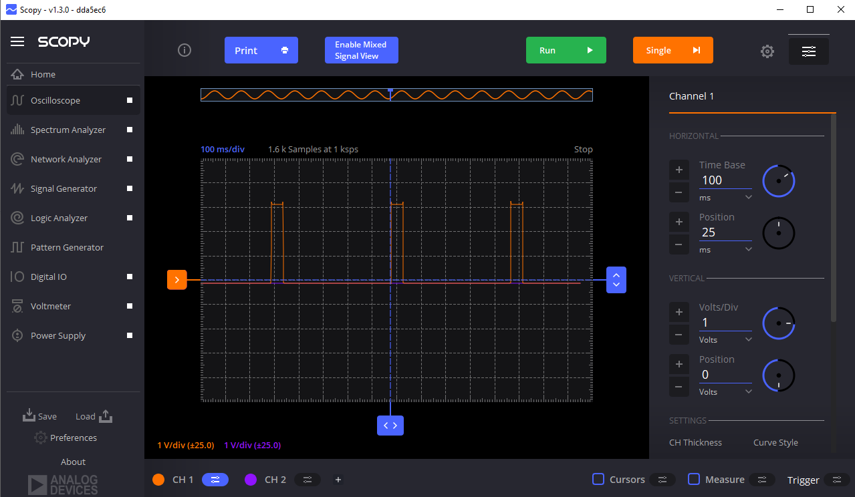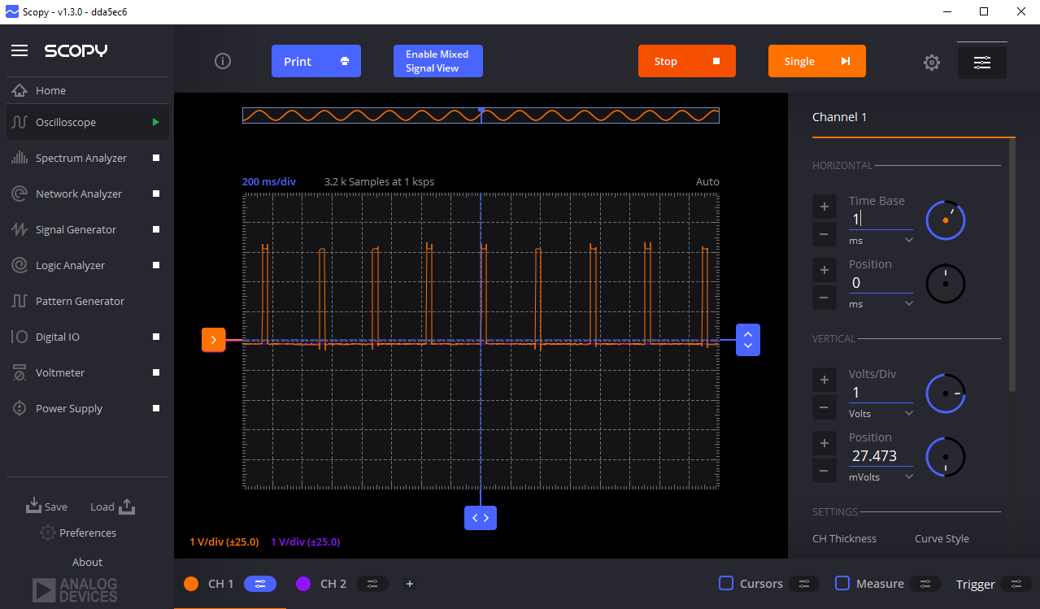

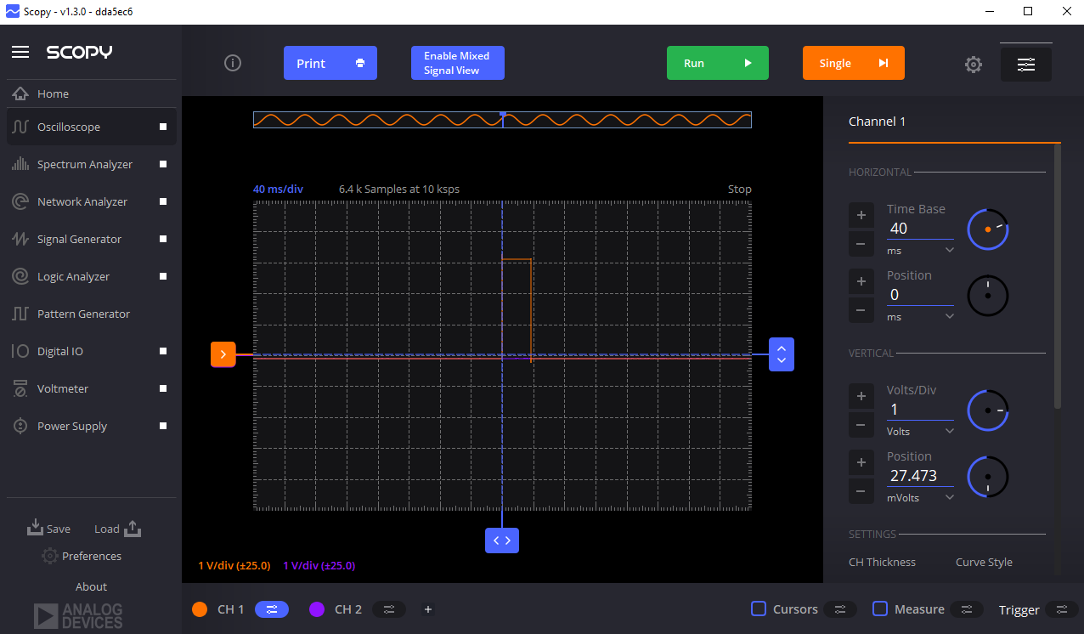

|  |  |  |
| --- | --- | --- |
|  | Calculated | Measured |
| Duty Cycle |  |  |
| Period |  |  |
| Frequency |  |  |

1. Draw a level 0 block diagram and UML diagram for the above implementation (5+10=15 pts)
2. Upload your code in your GitHub account with a ReadMe file and proper comment. (10 pts)

Q3: Generate a hardware PWM, controlling the LED brightness with a 20% duty cycle and 250ms period.

1. Visualize your PWM signal using a logic analyzer (you already have ADALM2000 from your previous class). What are the total period and duty cycle here you observed? Did it match your calculation? Show the calculation (handwritten image is fine). Make a table with the calculated and observed values. Add the image of your signal with a proper description. (20 pts)

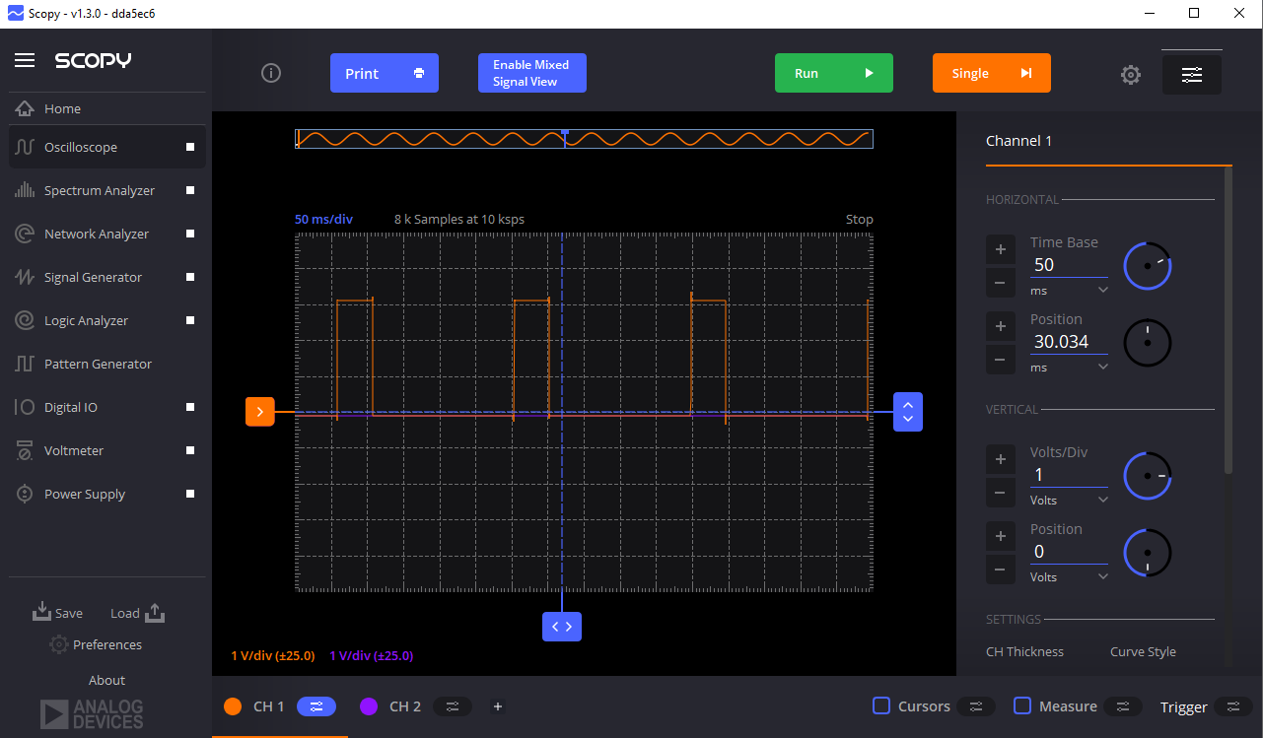

|  |  |  |
| --- | --- | --- |
|  | Calculated | Measured |
| Duty Cycle |  |  |
| Period |  |  |
| Frequency |  |  |

1. Upload your code in your GitHub account with a ReadMe file and proper comment. (10 pts)

*No video demonstration is required.