


Project |  | Team
Nr | 19/20-C4PE |  | Benny Schröter  Jan Berger  Franziska Grausenburger  Patrick Steininger  Reinhardt Wenzina
Name | C4PE – Feedback App
Document
Nr | G02
Name | Projectanalysis

Version History
Version | Date | Author | Changes
1.0 | 19.12.2019 | Franziska Grausenburger | Preparation of the document
2.0 | 09.01.2020 | Jan Berger | G02 finsihed

Table of contents
1 Initial situation 1
2 Project goals 1
3 Environment analysis 1


1 Initial situation
The EU offered the students of the HTL Krems and their Czech partner school from Brno an opportunity to take part in a project, which aims to show them how it is to work with new people internationally.

2 Project goals
Create a fully functional back- and frontend which communicate with each other via REST API as the interface. This project then gets presented in Austria and in the Czech Republic alike.
This app will be a feedback application, which allows you to create a user in order to rate places, by giving them a 1-5 star rating and a text review. Other users can then look at a specific place they want to go to and see the user score for it and the reviews, and they can then rate those for users to decide if it’s trustworthy.

3 Environment analysis
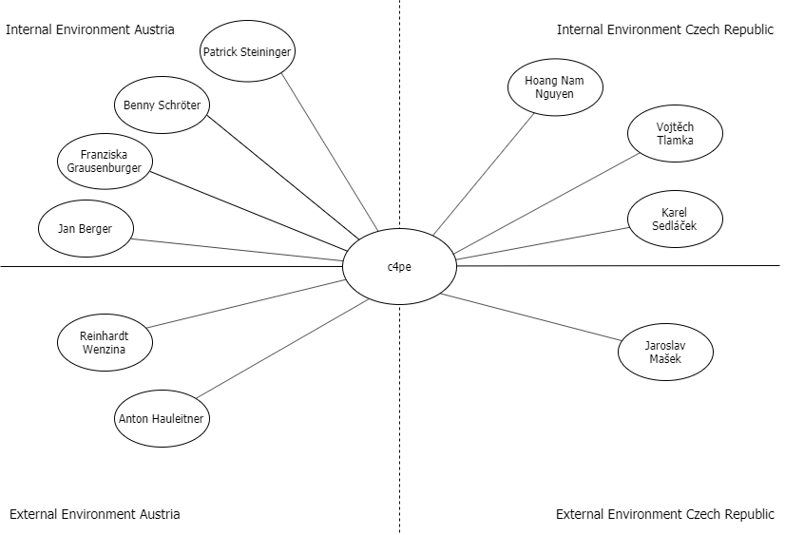

ID | Name | Description | Notes^{,2}
u01 | Benny Schröter | Backend developer | I
u02 | Jan Berger | Backend developer | I
u03 | Patrick Steininger | Backend developer | I
u04 | Franziska Grausenburger | Backend developer | I
u05 | Karel Sedláček | Frontend developer | I
u06 | Vojtěch Tlamka | Frontend developer | I
u07 | Hoang Nam Nguyen | Frontend developer | I
u08 | Reinhardt Wenzina | Project supervisor in Krems | E
u09 | Anton Hauleitner | Project supervisor in Krems | E
U10 | Jaroslav Mašek | Project supervisor in Brno | E
¹ I...internal environment, E...external environment, T…technical environment
² C...chances, look Chance Analysis; R... risks, look Risk Analysis;

