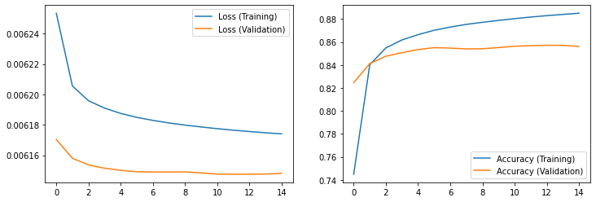Net

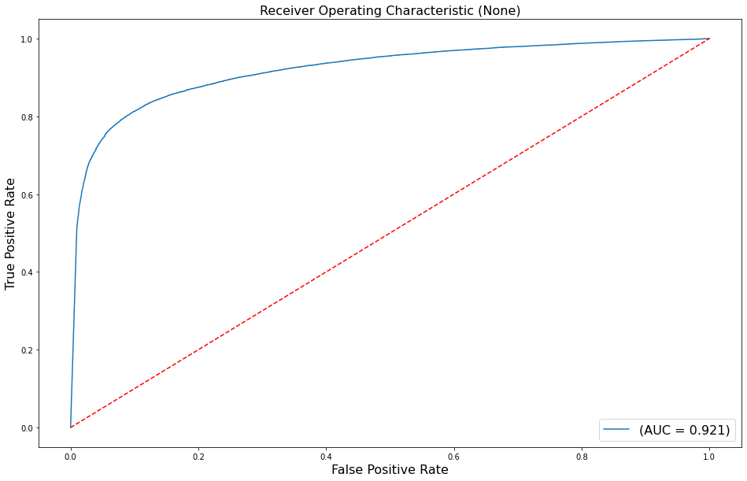

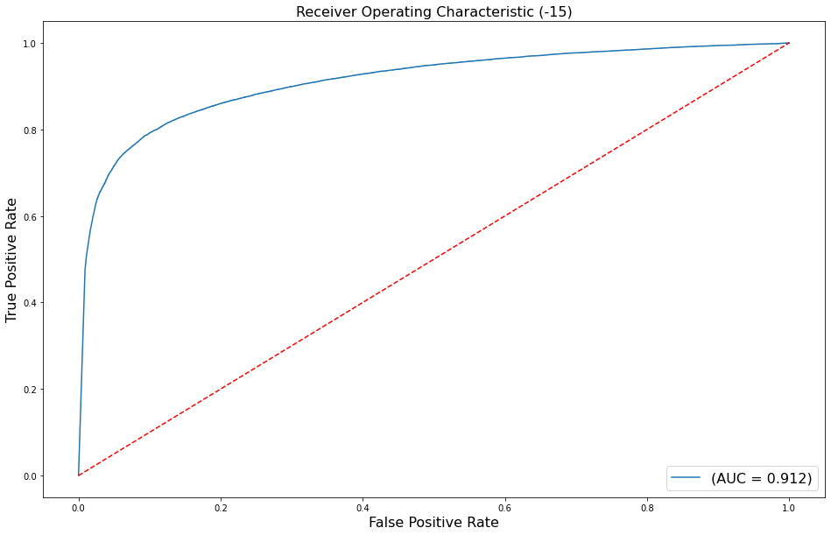

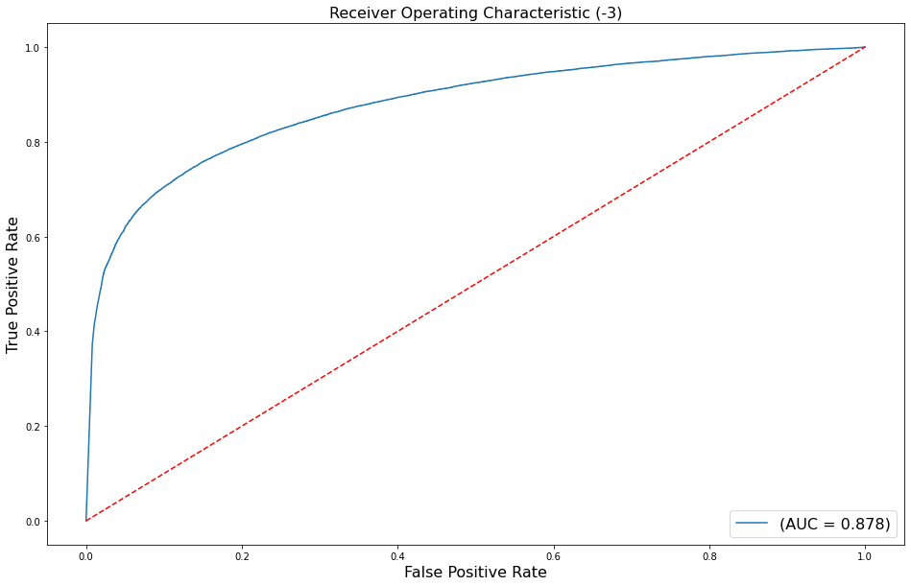

Tresholds:

Net:

Network metrics:

FAR: 39.40155388036854% for fixed FRR at6.488827299497662% with threshhold 0.0001 and noise level None

FRR: 3.725846980330994% for fixed FAR at 3.725846980330994% with threshhold 39.40155388036854% and noise level None

EER: 0.14932270456055224% with threshhold 0.16664603352546692 and noise level None

FAR: 47.17384397654738% for fixed FRR at5.612333275593279% with threshhold 1e-05 and noise level -15

FRR: 3.6132050948791266% for fixed FAR at 3.6132050948791266% with threshhold 47.17384397654738% and noise level -15

EER: 0.16119342633509517% with threshhold 0.10865053534507751 and noise level -15

FAR: 79.74179013950264% for fixed FRR at2.0474623246145853% with threshhold 1e-09 and noise level -3

FRR: 3.2492851572654016% for fixed FAR at 3.2492851572654016% with threshhold 79.74179013950264% and noise level -3

EER: 0.20304421916067353% with threshhold 0.027799410745501518 and noise level -3

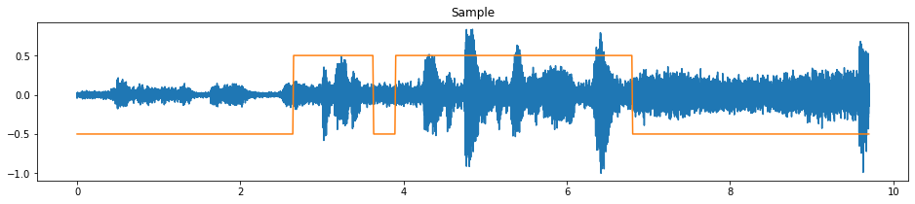

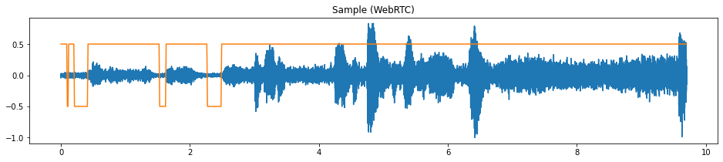

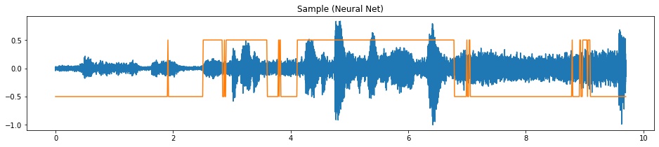

Densenet

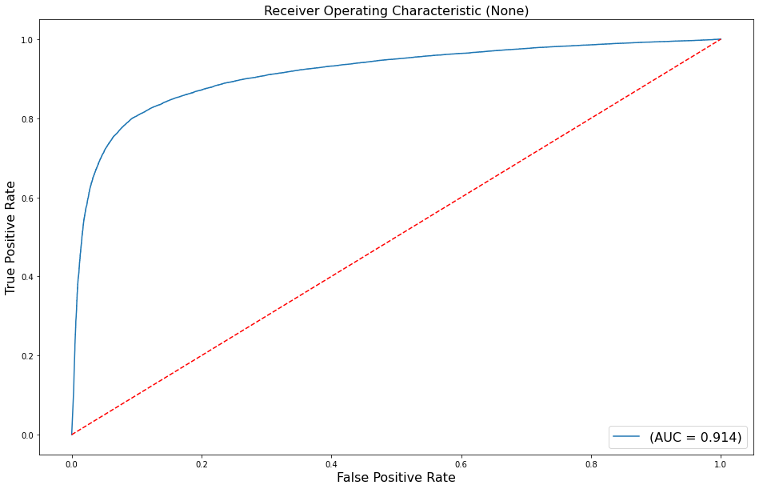

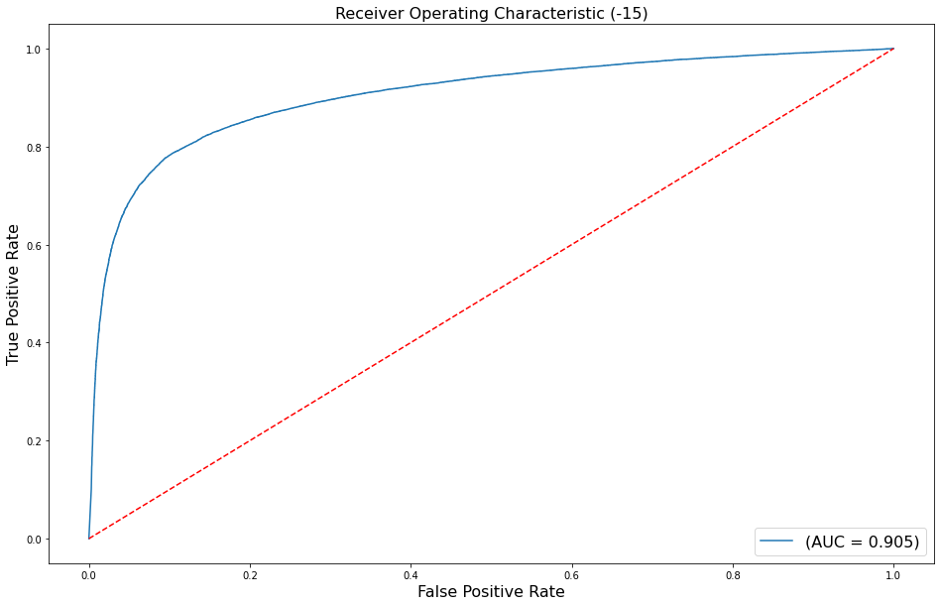

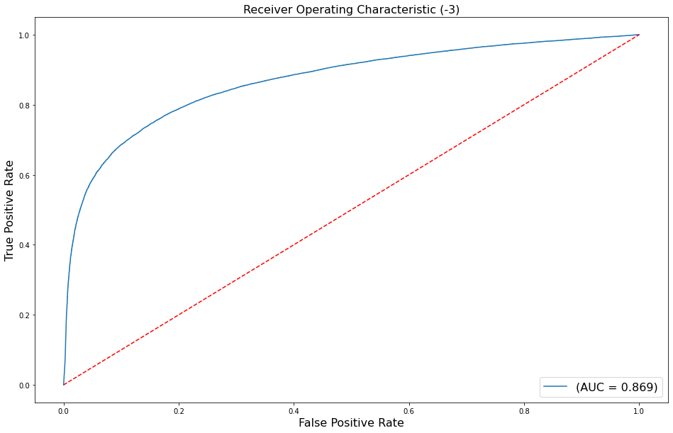

DenseNet:

Network metrics:

FAR: 32.94053086098836% for fixed FRR at 8.359605058028755% with threshhold 0.0001 and noise level None

FRR: 1.019553476013055% for fixed FAR at 1.019553476013055% with threshhold 32.94053086098836% and noise level None

EER: 0.153019669006152% with threshhold 0.02653779275715351 and noise level None

FAR: 48.29159807064668% for fixed FRR at 5.920665165425255% with threshhold 1e-05 and noise level -15

FRR: 1.0368829968518036% for fixed FAR at 1.0368829968518036% with threshhold 48.29159807064668% and noise level -15

EER: 0.1650059209196199% with threshhold 0.015502295456826687 and noise level -15

FAR: 91.41899893134621% for fixed FRR at 1.0116057509094059% with threshhold 1.5624722518287503e-07 and noise level -3

FRR: 1.0166652225399302% for fixed FAR at 1.0166652225399302% with threshhold 91.41899893134621% and noise level -3

EER: 0.2066834185368108% with threshhold 0.002660298952832818 and noise level -3





