Wallet-Component
Component for managing state for different wallets in a single page such as for multi chain applications. Can be extended in the future to support other more chains and wallets as well as become more polished with time.

Supported Chains and Wallets

Ethereum
- Metamask

Algorand
- MyAlgo

Design

Simple Wallet Store
#### Steps 1. Store composes of one or many chains saved as Store.chain1, Store.chain2, etc… 2. Chains are composed of one or many wallets saved as Chain.wallet1, Chain.wallet2, etc… 3. The wallet class will implement some common interface and be stand alone and will contain all the logic to use the wallet. 4. The client will then use the wallet directly as intended. The wallet may or may not have a state but this is not managed outside of the wallet.

Considerations
This design is the simplest and most straightforward to implement however it may become impossible to enforce stricter wallet standards. This also forces the user to manage multiple wallet states instead of having some centralized place to store the wallet thus this approach may increase in complexity as we add additional chains and wallets although at this stage it offers the most flexibility. ### Proxy Wallet Store

Steps
- The client will make a request to the Store.use('WALLET') method which will return a proxy that looks like the wallet class.
- The Proxy will pull the state cache from the store and construct a new class instance of the wallet. If the state is empty, it will generate a new state.
- If the client attempts to use some method in the Wallet class, instead of the method, some asynchronous callback function will be returned. Think of this as a wrapped method.
- When the callback function is called, the new state will be pulled from the wallet using the toJSON method.
- This will be synced with the global state cache from step 2
- The result will be returned to the client. From the client’s eyes, it will look like the Store.use method simply returns the Wallet Object and they can use it directly. However, the state is cached automatically and the Wallet object will self-destruct once it is no longer used.

Code example
- Backend
const use = () => new Proxy({}, {
// proxy listens for prop
get(_target, prop){

// return wallet prop if not function
if(typeof Wallet[prop] !== 'function'){

// create the wallet
const target = new Wallet(this.globalState)

// return value
return target[prop]
}

// return async callback
return async (...args) => {

// create the wallet
// ensures that the wallet state is in sync with the global state
const target = new Wallet(this.globalState)

// interact with the wallet
const result = await target[prop](...args);

// save the state to the global state
setGlobalState(target.getState())

// return the result
return result;
}
}
})
- Client
// Create the Store
const store = new Store();

// Get the Wallet
const wallet = store.use("MYALGO");

// Use the Wallet directly
await wallet.signIn();
const result = wallet.getBallance(); // no error
- Using the Wallet in a persistent way
// use the store
const store = new Store();
const wallet = store.use("MYALGO");
await wallet.signIn();
const result = wallet.getBallance(); // no error

// save the state
window.storage.sync.set(
['wallet-component', store.getState()],
() => console.log("storage state updated")
);

// refresh the page...

// retrieve the state
const state = window.storage.sync.get('wallet-component')
const store = new Store({ state });
const wallet = store.use("MYALGO");

const result = wallet.getBallance(); // no error

Considerations
There is a significantly higher amount of complexity and overhead for this store to work meaning that this method might be more prone to bugs and polishing before this can be safe to use. The upside is since we are managing state in one place and all wallets are both stateless and virtual, this solution could become more scalable as we integrate more wallets. One consideration we might have is making sure that for each context and for each call to the callback, we have to make sure that the global state is in sync otherwise we could end up in a situation where two or more wallets drift out of sync with each other. Just from the complexity, this solution may also become more difficult to maintain over time.

API

WalletInterface
key | args | Returns | description
signIn | none | Promise(status) | Prompt the user to log into their wallet
signOut | none | Promise(status) | Prompt the user to log out of their wallet (does nothing if this feature is not implement for the current wallet)
getSigner | none | Promise(Signer) | Returns a Signer to sign transactions. Can be called once or as many times as required
getBallance | none | Promise(number) | Return the current supply of native coin
getAssets | none | Promise(Assets) | Returns a list of assets from the wallet which can include the native coin. Pull the Asset type directly from the class

WalletAttributes
key | type | description
state | State | the local state of the wallet. Pul the Wallet State type directly from the Wallet class

Types

Signer
Signer function that can take a list of transactions and convert it to a list of signed transactions
type Signer = (
transactions: unknown[]
) => Promise<{ signedTransaction: unknown[]; status: WALLET_STATUS }>;

Errors
name | definition
NotImplementedError | Method was not implemented

Constants/ Enums

WALLET_STATUS
name | description
OK | Operation was successful with no apparent errors
LOGIN_ERROR | User login failed either because the user rejected the request or because the method failed
WALLET_ERROR | Wallet failure or returned an unexpected code. Error was logged
EXTENSION_NOT_FOUND | Wallet Extension was not found on the browser

Road Map
- Chains
  - Ethereum
    - ☐ Metamask
      - ☐ signIn
      - ☐ signOut
      - ☐ getSigner
      - ☐ getBallance
      - ☐ getAssets
  - Algorand
    - ☐ MyAlgo
      - ☐ signIn
      - ☐ signOut
      - ☐ getSigner
      - ☐ getBallance
      - ☐ getAssets
- Features
  - ☐ Mock Next Application for testing changes in isolation (In progress)
  - ☐ React Context Component (To be confirmed)
  - ☐ Managing/ Syncing Chain Events to all Wallets
  - ☐ Wallet Connect Integration
  - ☐ HTTPS/GRPC Calls to Chain Nodes
  - ☐ Wallet Widget

Details

Mock Next Application for testing changes in isolation (In progress)
We are creating a mock react application to test the wallet-component in isolation. Once we have created a widget as well, this will be onboarded there instead.

React Context Component (To be confirmed)
Run the wallet-component as a react context then include the provider in the root of any project. The wallet state and methods should then be available on any component.

Managing/ Syncing Chain Events to all Wallets
Need a way to sync chain events such as pinging wallets whenever a new block has been added to the blockchain. That way, each wallet won’t need their own timer. Thinking of just creating an observable and passing that to each wallet. That way, consumers can create their own observables and pass that.

Wallet Connect Integration
Integrate Wallet Connect class for all chains and/or build utility for handling wallets that can be used on multiple chains (TBC). This can most likely cover a large amount of wallets. Maybe we can create a base class and any ‘wallet-connect’ compatible wallet can just inherit from that class. Or, we can use a factory to do this programmatically instead if it’s not too complicated.

HTTPS/GRPC Calls to Chain Nodes
We need to handle requests to the Chain node if we want certain functionality such as fetching the list of assets from a particular wallet for instance. Right now, discussion around this subject suggests that the wallet-component should not support this kind of functionality and it should be handled by the app instead. However, that would make the proposal for the widget impossible. Consider discussing this point further.

Wallet Widget
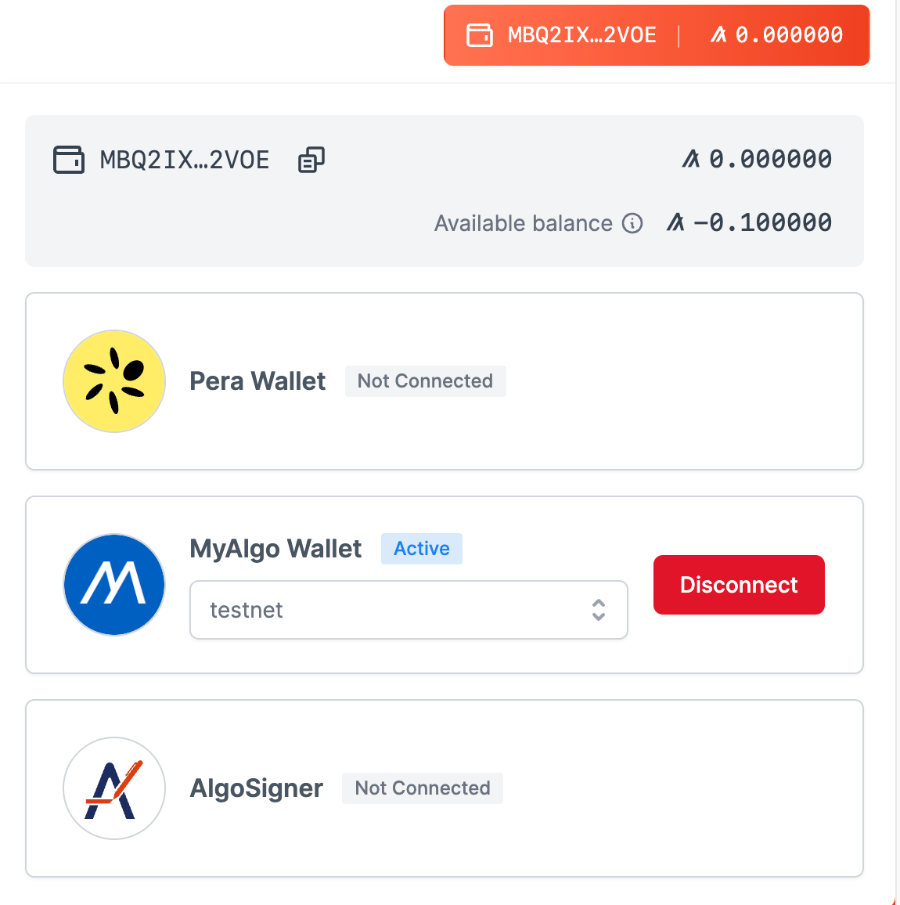
Wallet Widget
A wallet widget with a button that we can use on all our dapps moving forward. Should have the ability to connect to multiple wallets even on the same chain and manage transactions in a stateless way. Details and design for this to be confirmed in the future but we are using https://app.nf.domains/ as a reference.

