### Exercise 2.5: Django MVT Revisited

**Frontend Inspiration**

1. <https://dribbble.com/shots/19656468-Foodnetwork-App>

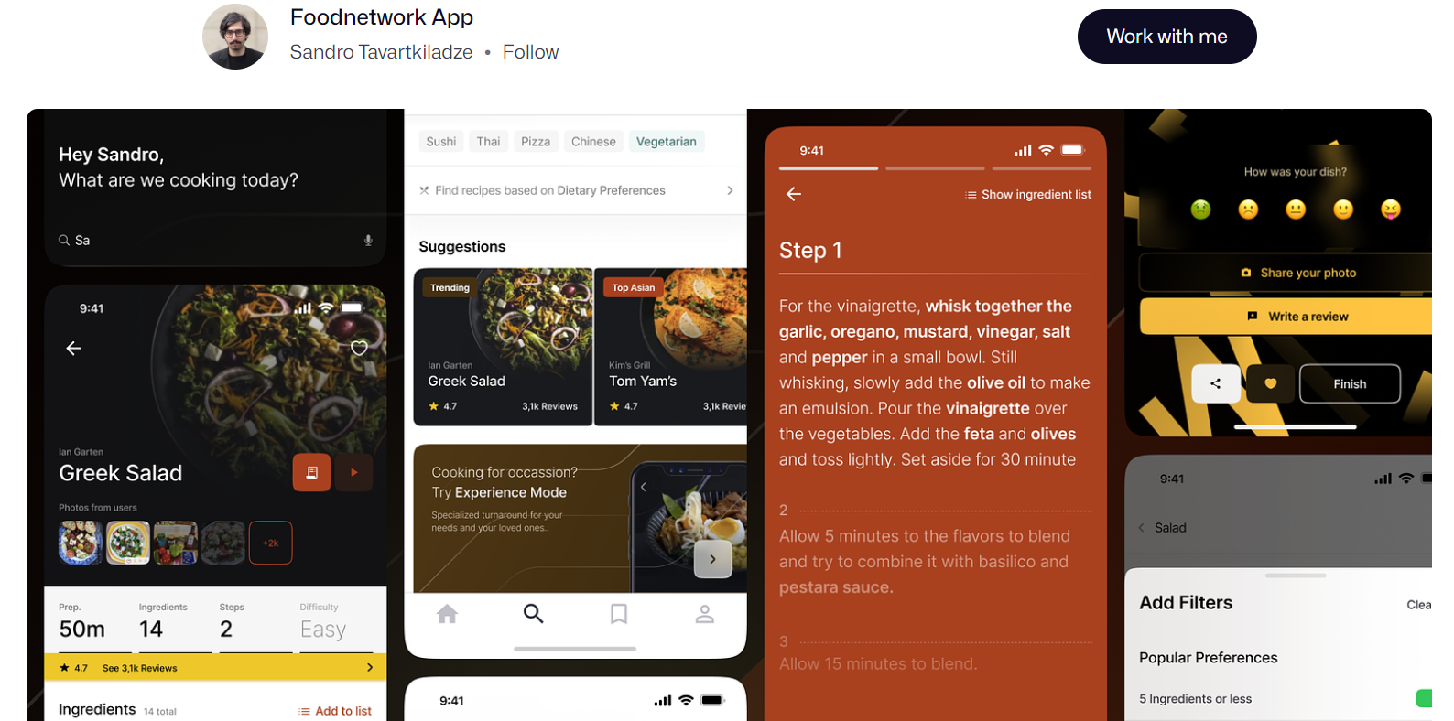

1. <https://dribbble.com/shots/15546294-Drink-Guides-App>
   1. 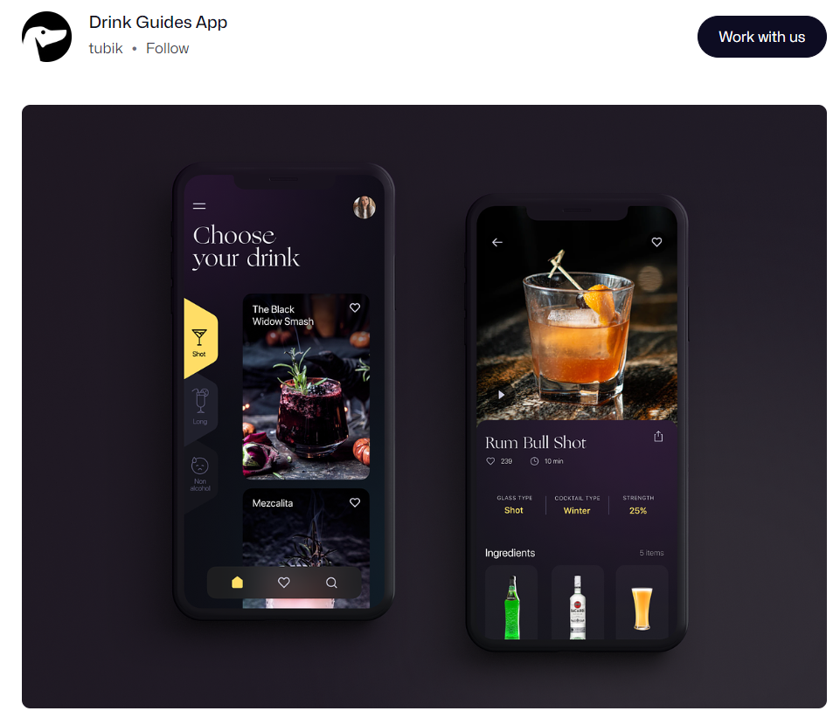
2. <https://www.motocms.com/website-templates/motocms-3-template/66522.html>
   1. 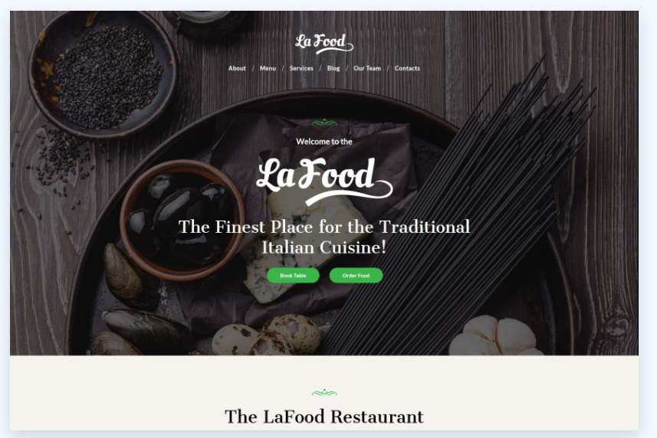

After exploring numerous examples, I've developed a liking for the dark theme featured in these app examples. These designs hold a refreshing and almost upscale restaurant-like ambiance, which aligns with my current direction. Initially, I began with a lighter, white-toned theme, which certainly had a clean feel, but through experimentation and research, I found that this particular theme resonated most with my vision. The ultimate aim is to instill users with a sense of sophistication when using this application.

1. In your own words, explain Django static files and how Django handles them.
   1. Django static files are files like CSS, JavaScript, images, and other assets that are served directly to web clients (browsers) without any processing. Django provides a built-in mechanism for managing and serving these static files, using template tags to include them in HTML templates.
2. Look up the following two Django packages on Django’s official documentation and/or other trusted sources. Write a brief description of each.

|  |  |
| --- | --- |
| **Package** | **Description** |
| ListView | A class-based view used for displaying a list or collection of objects from a database and rendering them in a template. It’s commonly used for displaying a list of products, blog posts, articles, etc. |
| DetailView | A class-based view used for displaying detailed information about a single object retrieved from a database. It takes a primary key or a unique identifier as a parameter and fetches the corresponding object. It’s commonly used for displaying the details of an object, such as a product description. |

1. You’re now more than halfway through Achievement 2! Take a moment to reflect on your learning in the course so far. How is it going? What’s something you’re proud of so far? Is there something you’re struggling with? What do you need more practice with? You can use these notes to guide your next mentor call.

Overall, I think I’m doing pretty okay. I’m really enjoying creating the front end of my application and working on creative ways to display all of the elements.