### Exercise 2.5: Django MVT Revisited

Frontend Inspiration

1. <https://dribbble.com/shots/19656468-Foodnetwork-App>

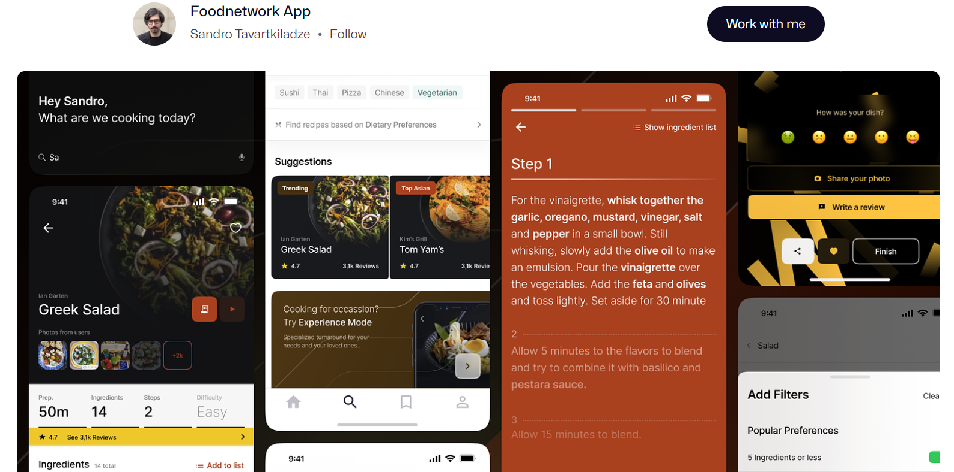

1. <https://dribbble.com/shots/15546294-Drink-Guides-App>
   1. 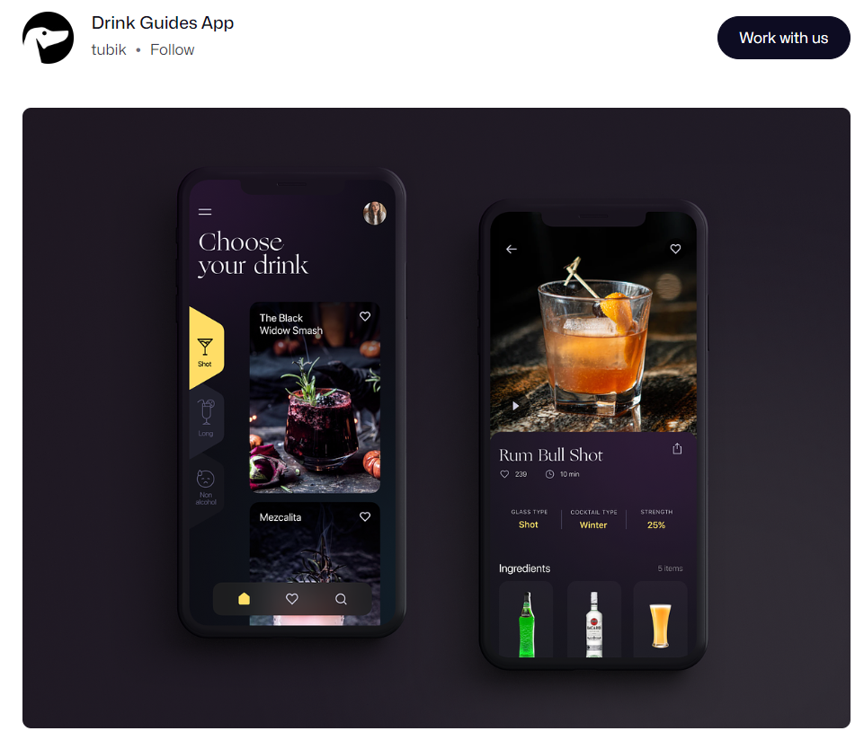
2. <https://www.motocms.com/website-templates/motocms-3-template/66522.html>
   1. 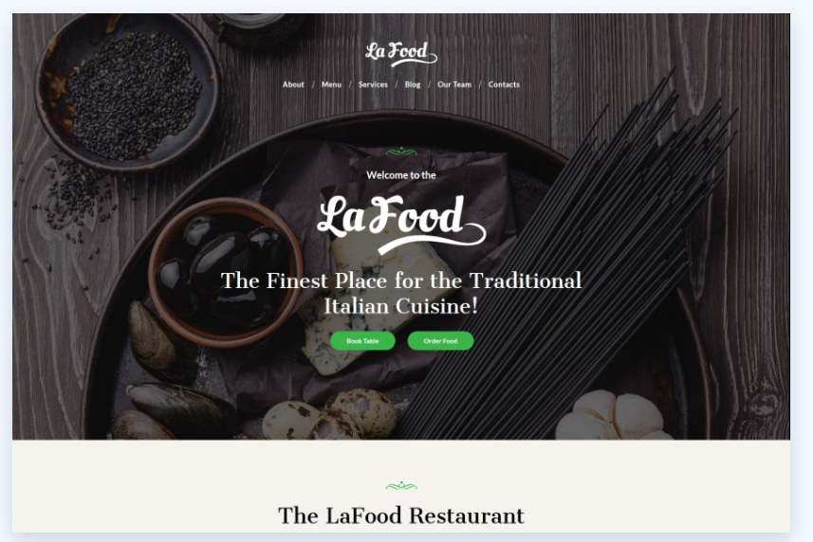

After exploring numerous examples, I've developed a liking for the dark theme featured in these app examples. These designs hold a refreshing and almost upscale restaurant-like ambiance, which aligns with my current direction. Initially, I began with a lighter, white-toned theme, which certainly had a clean feel, but through experimentation and research, I found that this particular theme resonated most with my vision. The ultimate aim is to instill users with a sense of sophistication when using this application.

1. In your own words, explain Django static files and how Django handles them.
   1. Django static files are files like CSS, JavaScript, images, and other assets that are served directly to web clients (browsers) without any processing. Django provides a built-in mechanism for managing and serving these static files, using template tags to include them in HTML templates.
2. Look up the following two Django packages on Django’s official documentation and/or other trusted sources. Write a brief description of each.

|  |  |
| --- | --- |
| Package | Description |
| ListView | A class-based view used for displaying a list or collection of objects from a database and rendering them in a template. It’s commonly used for displaying a list of products, blog posts, articles, etc. |
| DetailView | A class-based view used for displaying detailed information about a single object retrieved from a database. It takes a primary key or a unique identifier as a parameter and fetches the corresponding object. It’s commonly used for displaying the details of an object, such as a product description. |

1. You’re now more than halfway through Achievement 2! Take a moment to reflect on your learning in the course so far. How is it going? What’s something you’re proud of so far? Is there something you’re struggling with? What do you need more practice with? You can use these notes to guide your next mentor call.

Overall, I think I’m doing pretty okay. I’m really enjoying creating the front end of my application and working on creative ways to display all of the elements. One thing I had definitely been struggling with was designing the models to work together. I probably over-complicated it a bit by making three models that could have been two, but this is the only way I was able to get it to work without getting an error. I also of course struggle a bit with time management, but after taking a little break, I think I’ll be able to really focus for the remainder of this course. Especially since the remainder is finalizing the project and making it user-ready, which I’m very much looking forward to!

I will say I’m pretty proud of how the application is turning out visually and how the data is able to be displayed. This assignment definitely took me the longest to complete compared to all of the previous tasks, but overall it has been enjoyable creating the app how I want to!