**Instructions to unpack a 7-Zip multi-volume archive**

1. Put all of the constituent files of a multi-volume archive in **one folder**.

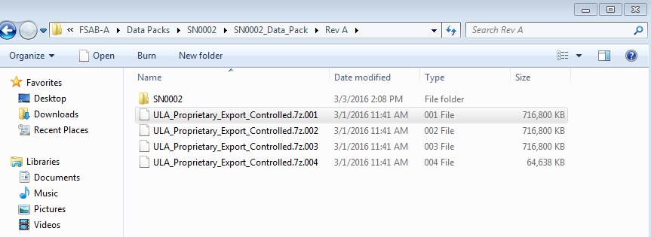

1. Right-click on the file with the extension **.7z.001**. Select **7-Zip,** and the desired extract option.

One may select **Extract Here** to unpack the archive in the same folder as the original the files –not recommended.

