Troubleshooting ACTIVITY DIAGRAM

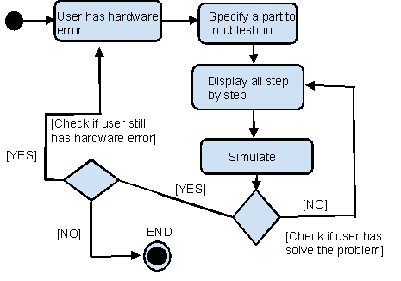

FIGURE 2

Assembling Activity Diagram

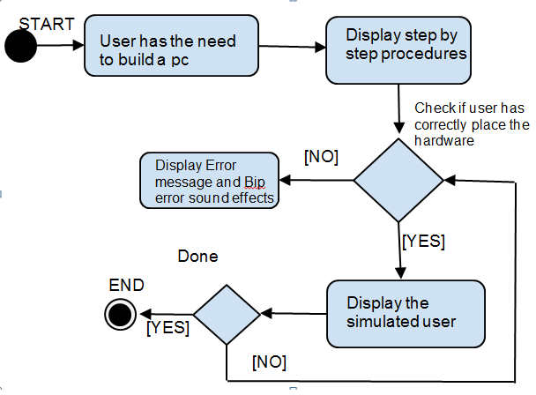

FIGURE 3

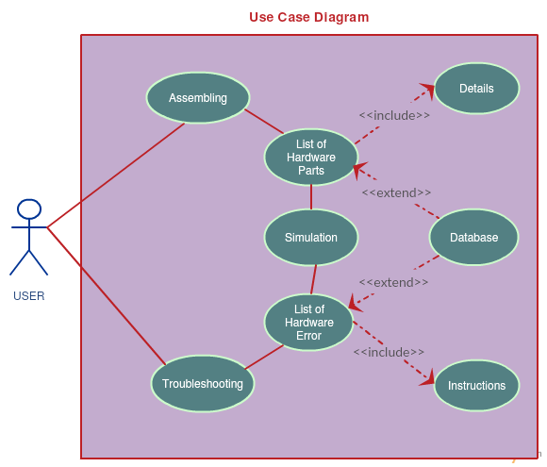

FIGURE 4

GANTT CHART

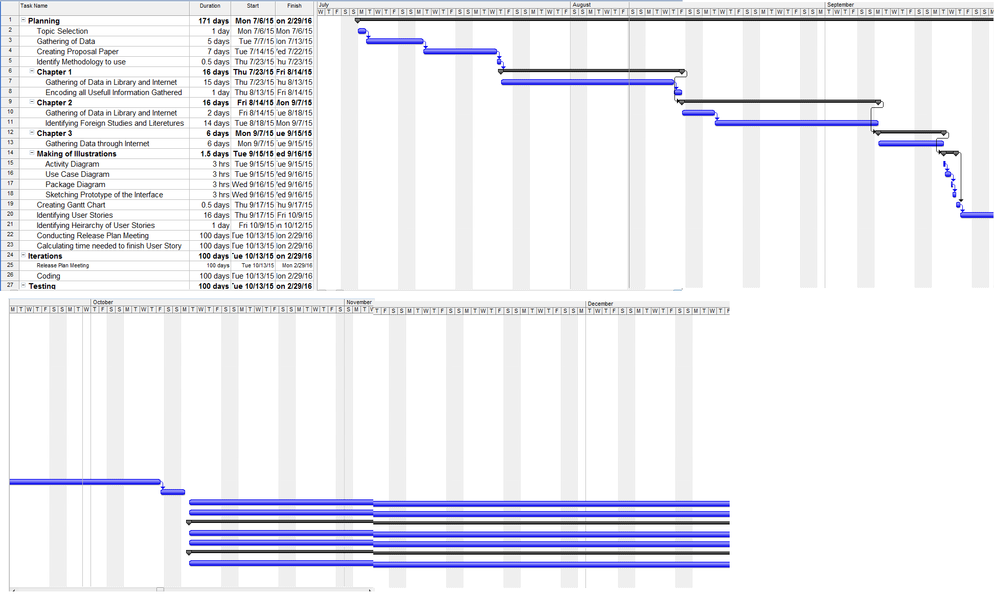

FIGURE 5