Botrytis Disease_Severity_lm

Yao Liu

2023-06-01

# load Harvest 2005-2022 all data_cases.xlsx

Severity = Botrytis (kg)/ Total kg  
All data :1818 Non-nan Severity data: 1416 Group_by(block,pruning,Variety,Date) and mean: 264

All Sauvignon blanc : 155 2-cane,3-cane,4-cane, Sauvignon blanc: 121

2-cane,Sauvignon blanc at Oyster Bay,Booker,Seaview, Squire :61

# Make a regression (Sauvignon blanc)

### Fig. 1 Severity and sev1 linear regression Plot

##   
## Call:  
## lm(formula = Severity ~ sev1, data = result_sau, na.action = na.omit)  
##   
## Residuals:  
## Min 1Q Median 3Q Max   
## -0.11433 -0.05752 -0.03340 0.00831 0.85150   
##   
## Coefficients:  
## Estimate Std. Error t value Pr(>|t|)   
## (Intercept) -0.032286 0.048097 -0.671 0.5034   
## sev1 0.017224 0.007237 2.380 0.0189 *  
## ---  
## Signif. codes: 0 '***' 0.001 '**' 0.01 '*' 0.05 '.' 0.1 ' ' 1  
##   
## Residual standard error: 0.1405 on 117 degrees of freedom  
## Multiple R-squared: 0.04618, Adjusted R-squared: 0.03803   
## F-statistic: 5.665 on 1 and 117 DF, p-value: 0.01892

##   
## Number of bootstrap replications R = 999   
## original bootBias bootSE bootMed  
## (Intercept) -0.032286 -0.00210554 0.028610 -0.033680  
## sev1 0.017224 0.00045733 0.005432 0.017409

## 2.5 % 97.5 %  
## (Intercept) -0.127539139 0.06296808  
## sev1 0.002892073 0.03155542

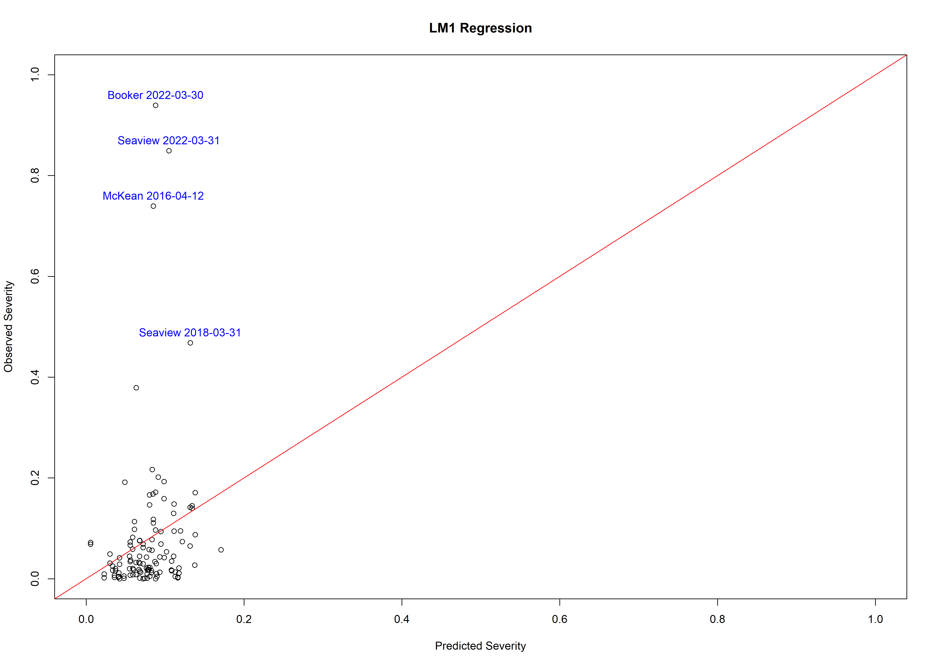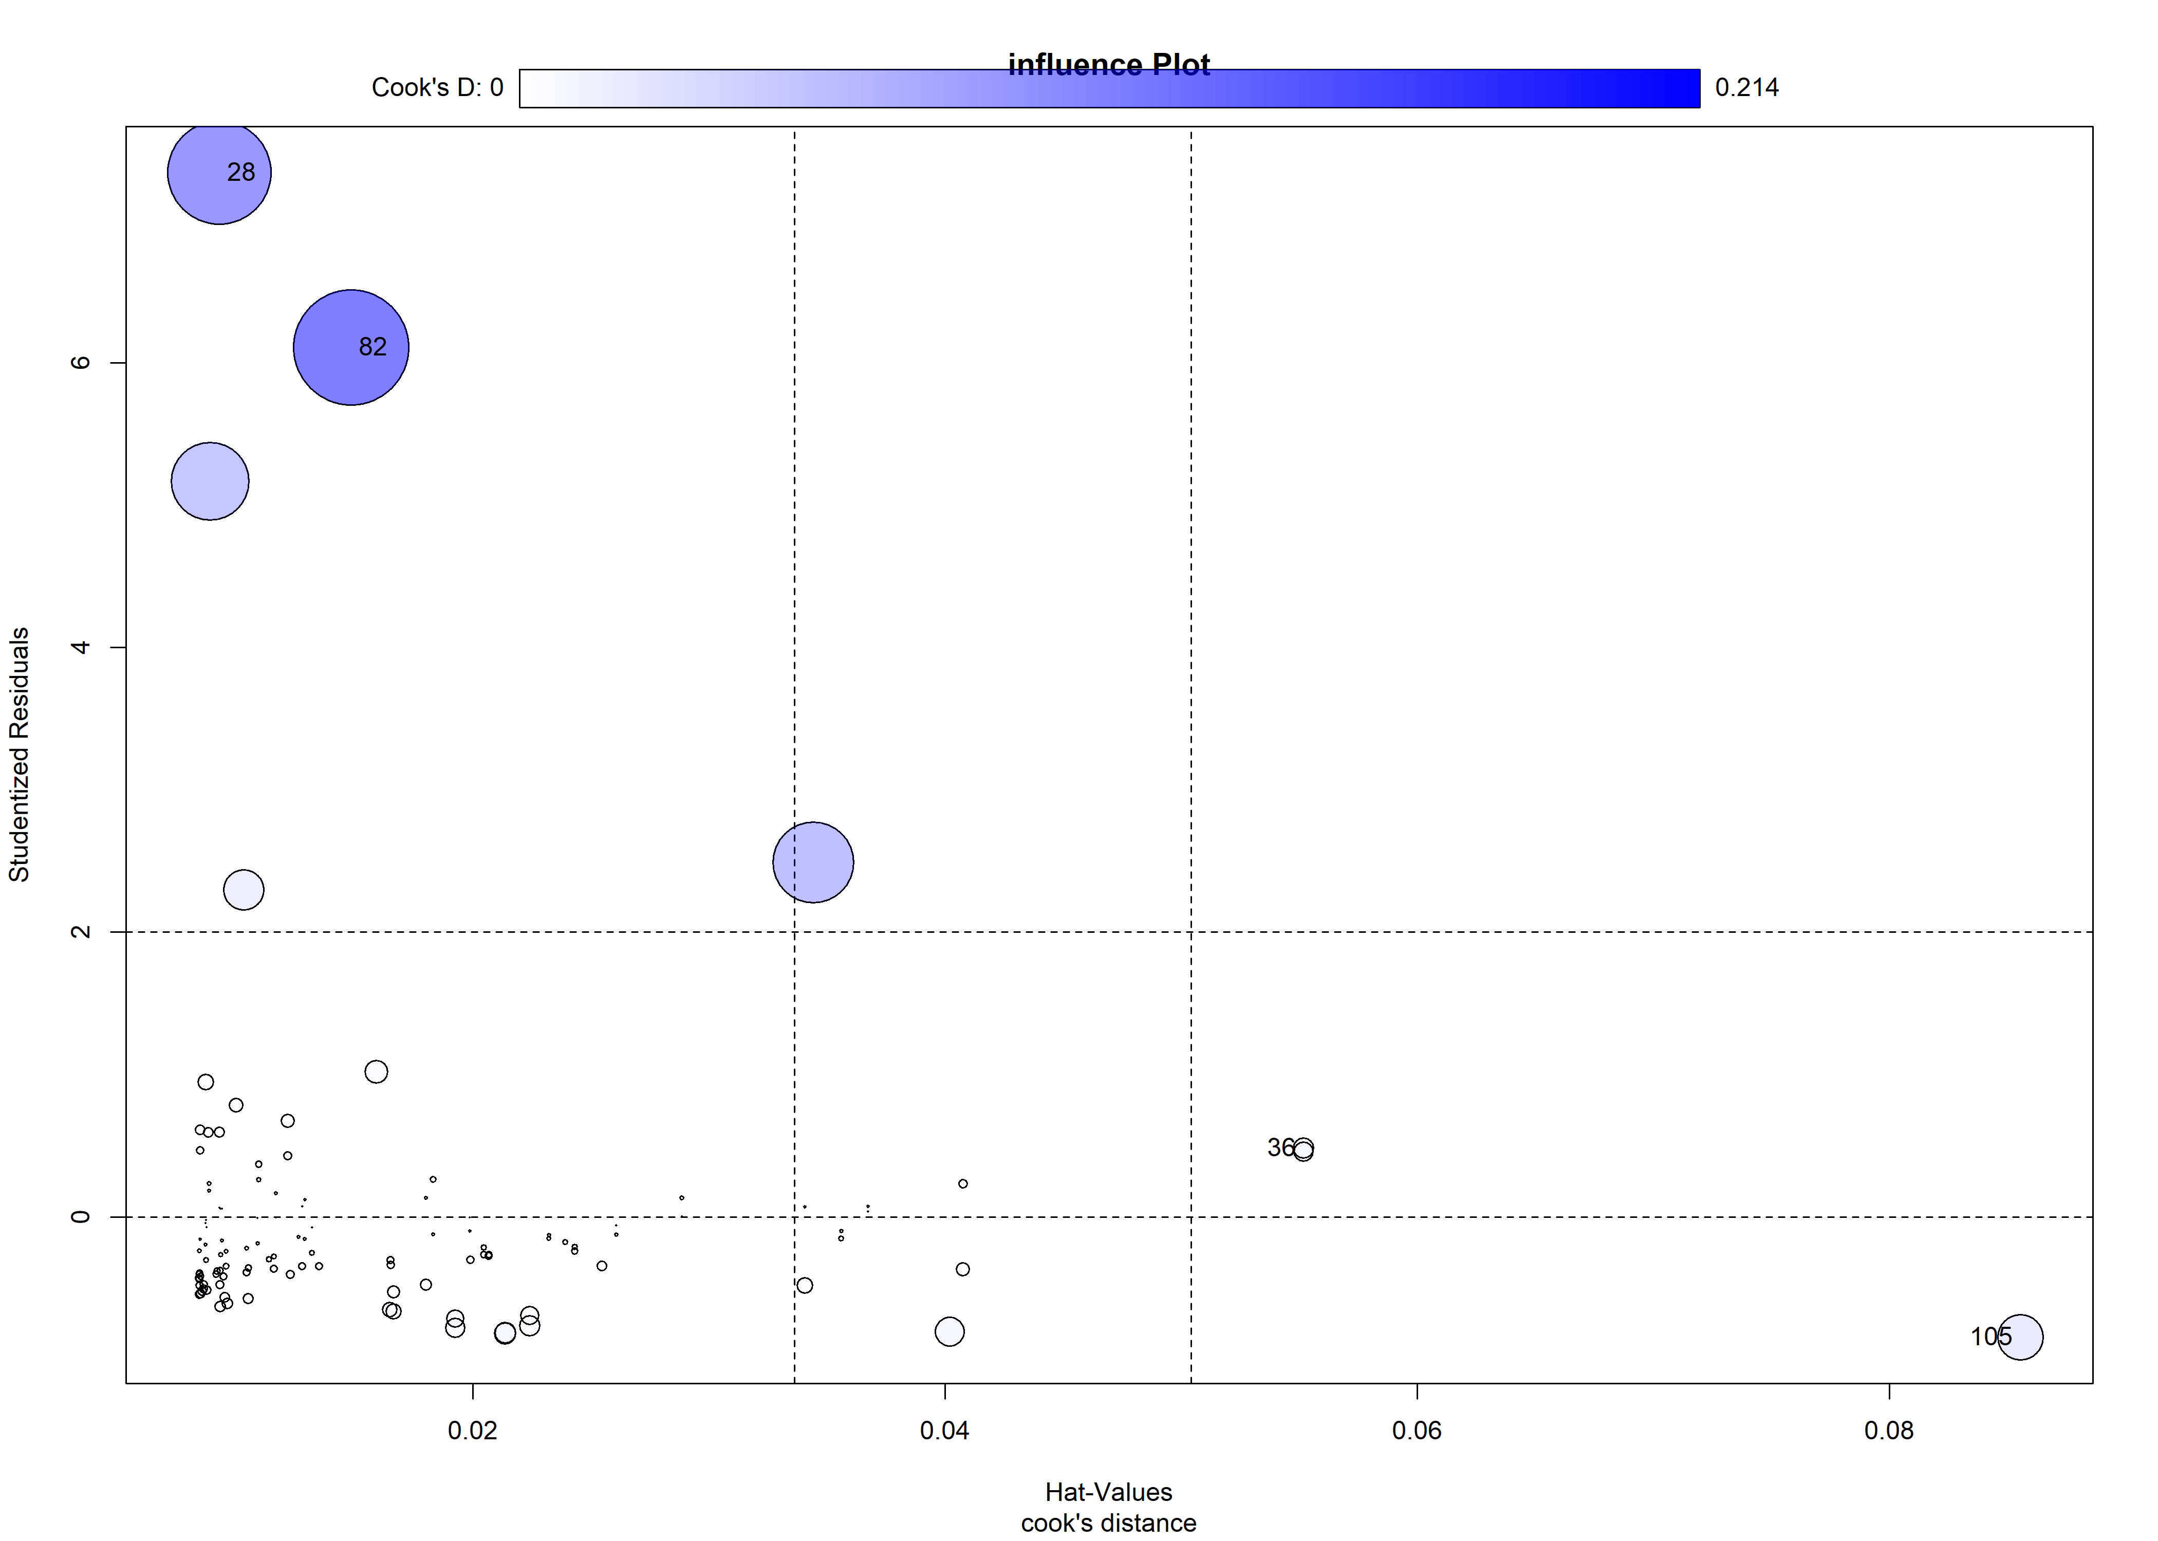

## StudRes Hat CookD  
## 28 7.3329173 0.009276889 0.173497925  
## 36 0.4815870 0.055182040 0.006817568  
## 82 6.1066197 0.014843712 0.214426722  
## 105 -0.8442359 0.085544043 0.033418905

### Fig. 1 Severity and sev2 linear regression Plot

##   
## Call:  
## lm(formula = Severity ~ sev2, data = result_sau, na.action = na.omit)  
##   
## Residuals:  
## Min 1Q Median 3Q Max   
## -0.16868 -0.05645 -0.02998 0.01722 0.76536   
##   
## Coefficients:  
## Estimate Std. Error t value Pr(>|t|)   
## (Intercept) -0.03786 0.03117 -1.214 0.227   
## sev2 0.07500 0.01853 4.048 0.0000931 ***  
## ---  
## Signif. codes: 0 '***' 0.001 '**' 0.01 '*' 0.05 '.' 0.1 ' ' 1  
##   
## Residual standard error: 0.1348 on 117 degrees of freedom  
## Multiple R-squared: 0.1229, Adjusted R-squared: 0.1154   
## F-statistic: 16.39 on 1 and 117 DF, p-value: 0.00009308

##   
## Number of bootstrap replications R = 999   
## original bootBias bootSE bootMed  
## (Intercept) -0.037859 -0.0019162 0.032175 -0.036734  
## sev2 0.074996 0.0015092 0.026638 0.073978

## 2.5 % 97.5 %  
## (Intercept) -0.09959868 0.02388017  
## sev2 0.03830593 0.11168564

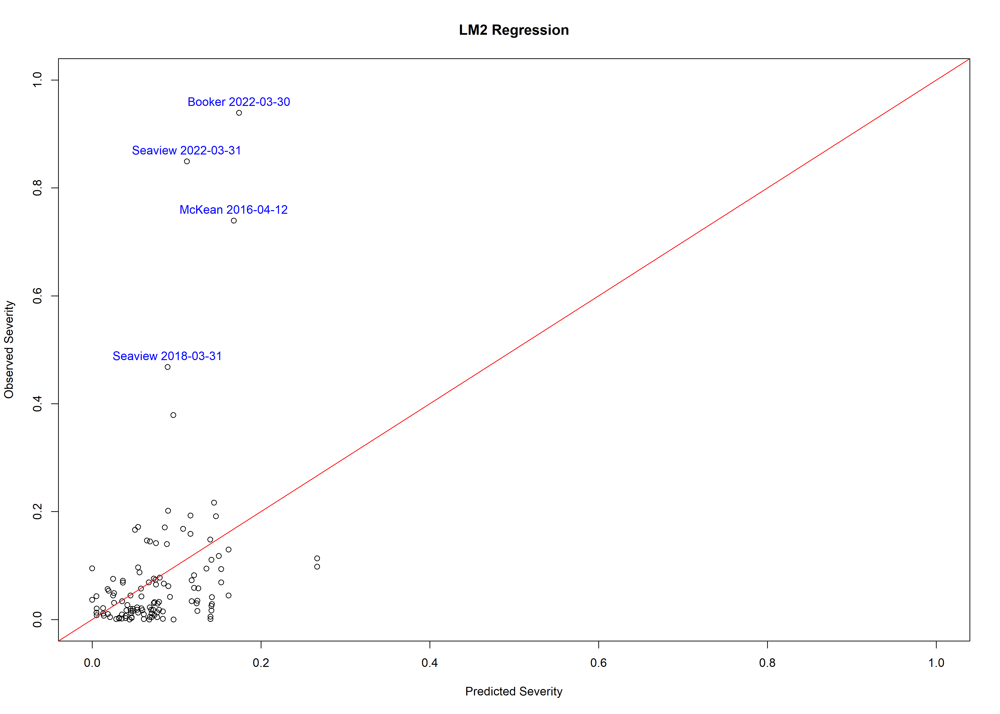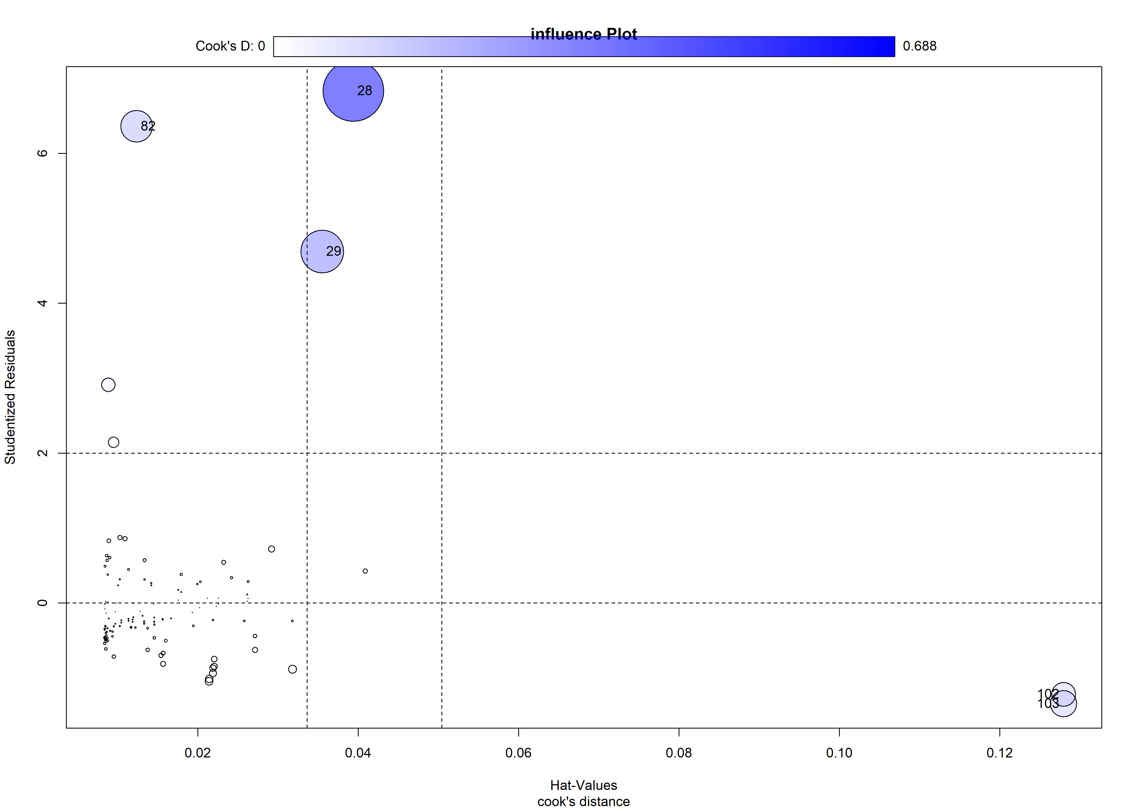

## StudRes Hat CookD  
## 28 6.832855 0.03938534 0.6883201  
## 29 4.691087 0.03550223 0.3433668  
## 82 6.360902 0.01235752 0.1892861  
## 102 -1.219913 0.12794559 0.1087180  
## 103 -1.344952 0.12794559 0.1317872

### Fig. 1 Severity and sev3 linear regression Plot

##   
## Call:  
## lm(formula = Severity ~ sev3, data = result_sau, na.action = na.omit)  
##   
## Residuals:  
## Min 1Q Median 3Q Max   
## -0.23099 -0.03249 -0.00873 0.01864 0.62324   
##   
## Coefficients:  
## Estimate Std. Error t value Pr(>|t|)   
## (Intercept) 0.0005079 0.0140849 0.036 0.971   
## sev3 0.0744638 0.0090308 8.246 0.000000000000275 ***  
## ---  
## Signif. codes: 0 '***' 0.001 '**' 0.01 '*' 0.05 '.' 0.1 ' ' 1  
##   
## Residual standard error: 0.1144 on 117 degrees of freedom  
## Multiple R-squared: 0.3675, Adjusted R-squared: 0.3621   
## F-statistic: 67.99 on 1 and 117 DF, p-value: 0.0000000000002749

##   
## Number of bootstrap replications R = 999   
## original bootBias bootSE bootMed  
## (Intercept) 0.00050791 0.00054923 0.013437 0.00099794  
## sev3 0.07446383 -0.00073626 0.021170 0.07321616

## 2.5 % 97.5 %  
## (Intercept) -0.02738656 0.02840239  
## sev3 0.05657872 0.09234894

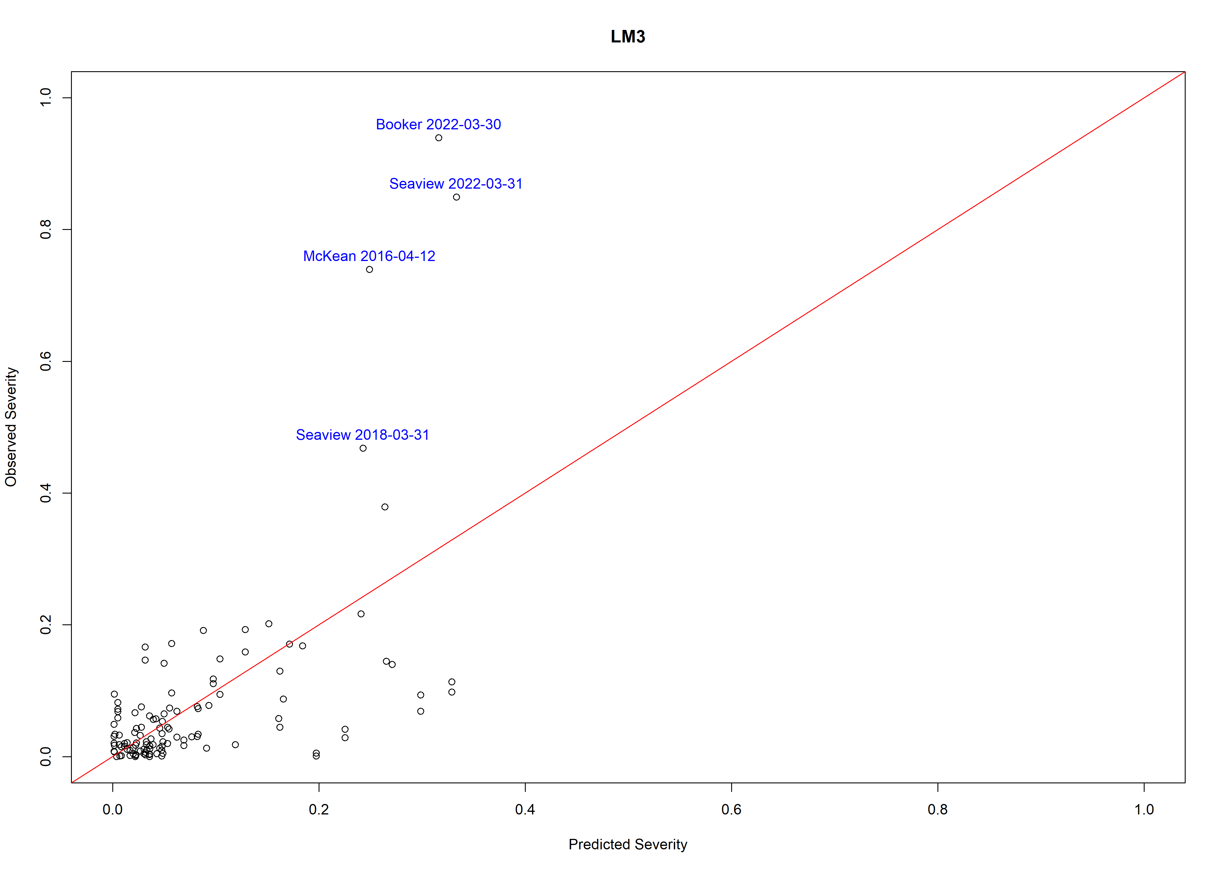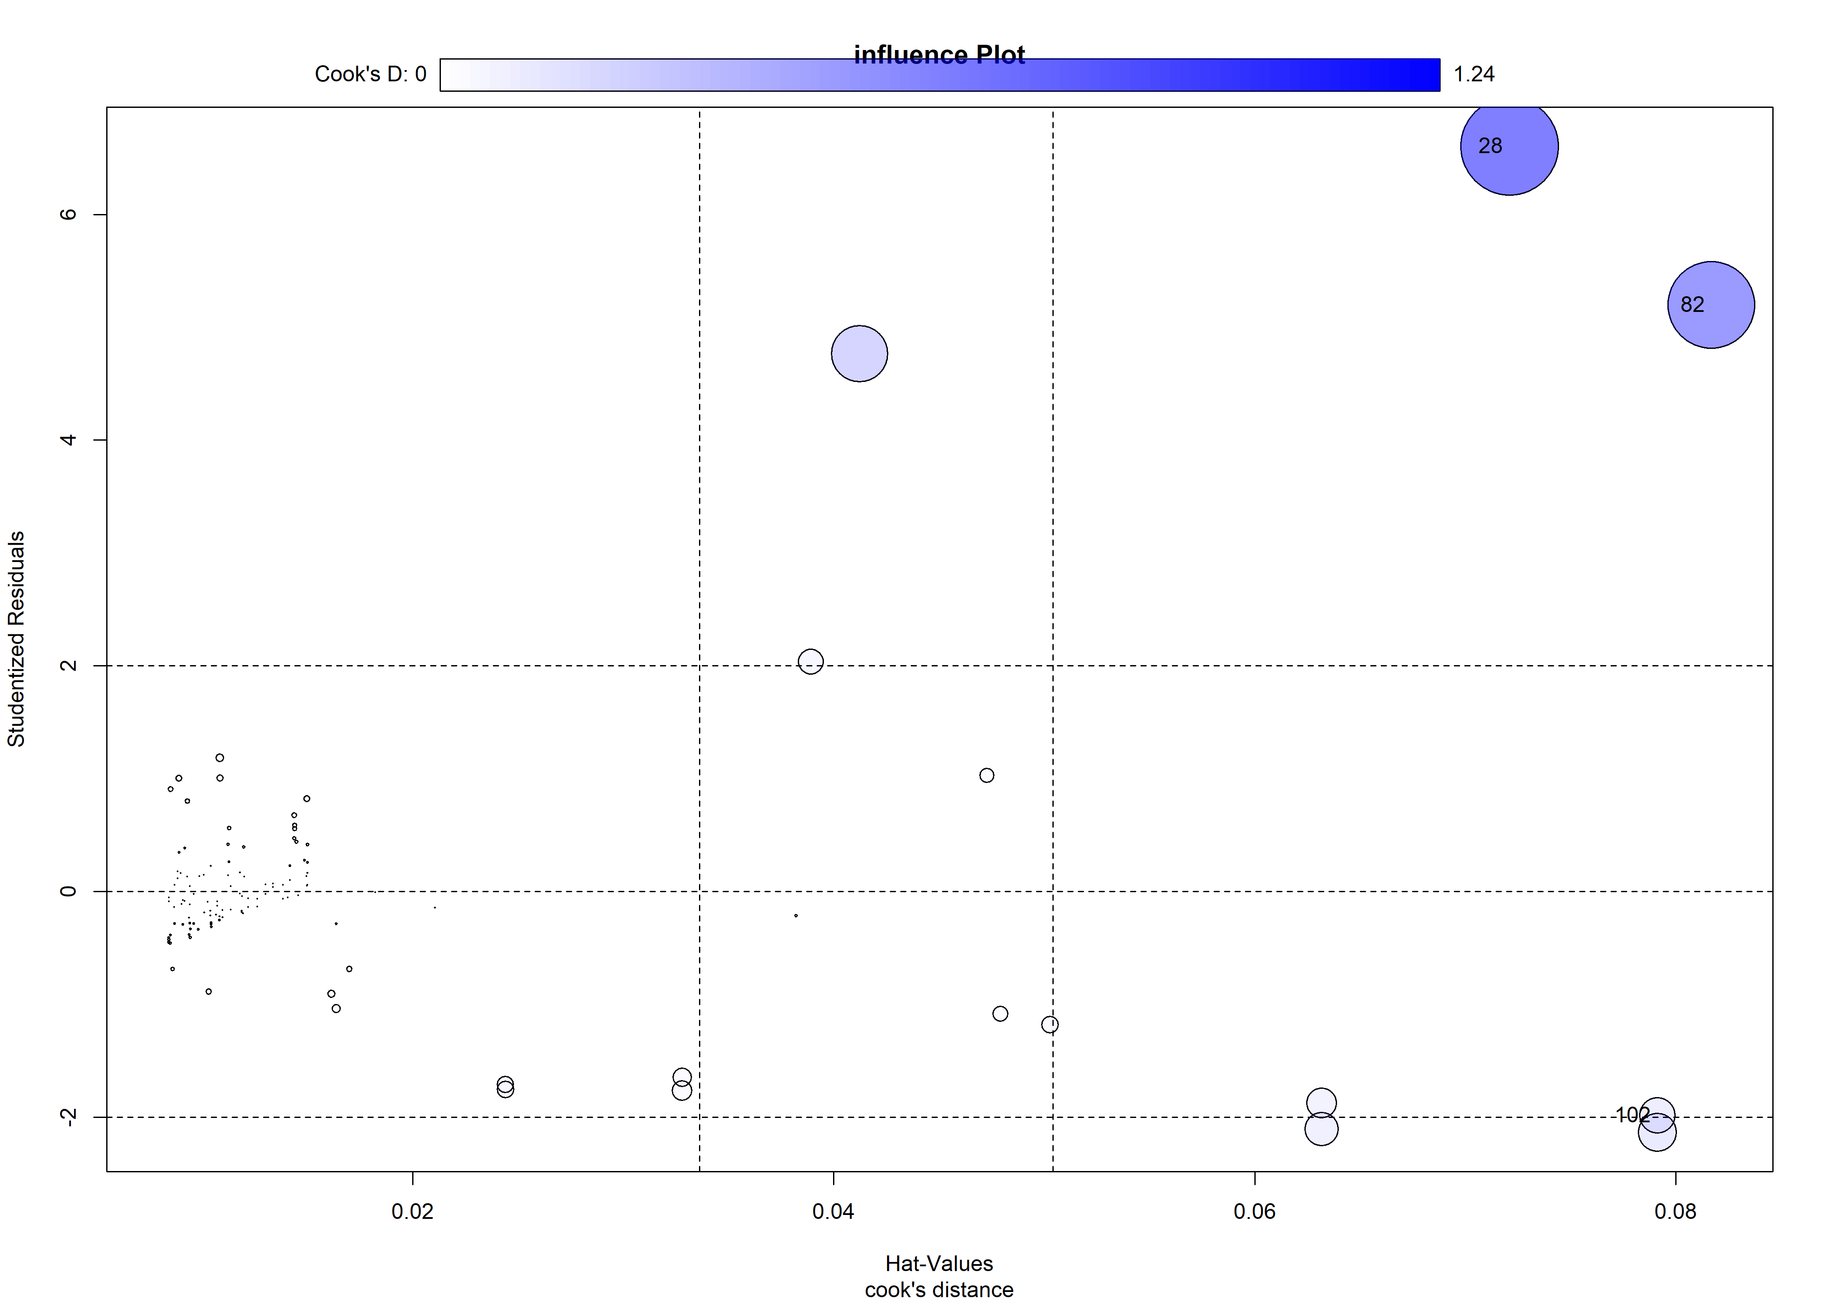

## StudRes Hat CookD  
## 28 6.603616 0.07210064 1.2419489  
## 82 5.197846 0.08168682 0.9830474  
## 102 -1.987099 0.07912495 0.1654675

### Fig. 1 Severity and sev2, sev3 linear regression Plot

##   
## Call:  
## lm(formula = Severity ~ sev2 + sev3, data = result_sau, na.action = na.omit)  
##   
## Residuals:  
## Min 1Q Median 3Q Max   
## -0.23613 -0.03058 -0.00903 0.02081 0.62304   
##   
## Coefficients:  
## Estimate Std. Error t value Pr(>|t|)   
## (Intercept) 0.03575 0.02843 1.257 0.211   
## sev2 -0.03129 0.02196 -1.425 0.157   
## sev3 0.08705 0.01261 6.906 0.000000000284 ***  
## ---  
## Signif. codes: 0 '***' 0.001 '**' 0.01 '*' 0.05 '.' 0.1 ' ' 1  
##   
## Residual standard error: 0.1139 on 116 degrees of freedom  
## Multiple R-squared: 0.3784, Adjusted R-squared: 0.3677   
## F-statistic: 35.31 on 2 and 116 DF, p-value: 0.000000000001055

##   
## Number of bootstrap replications R = 999   
## original bootBias bootSE bootMed  
## (Intercept) 0.035747 -0.0018831 0.027882 0.035320  
## sev2 -0.031289 0.0021186 0.025585 -0.029184  
## sev3 0.087053 -0.0015897 0.025371 0.086274

## 2.5 % 97.5 %  
## (Intercept) -0.02056193 0.09205511  
## sev2 -0.07478157 0.01220277  
## sev3 0.06208596 0.11202055

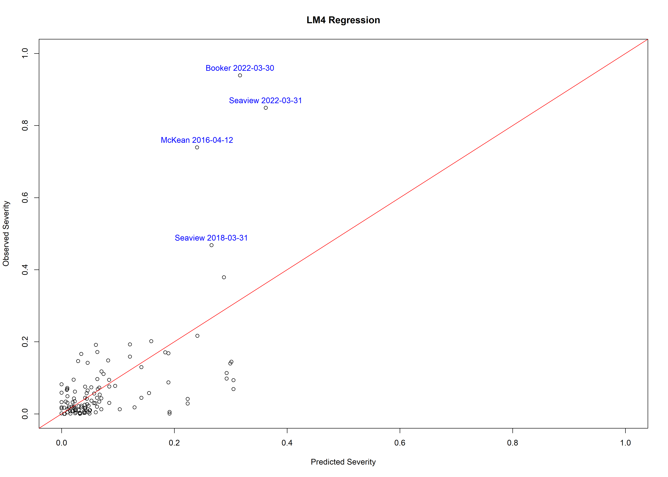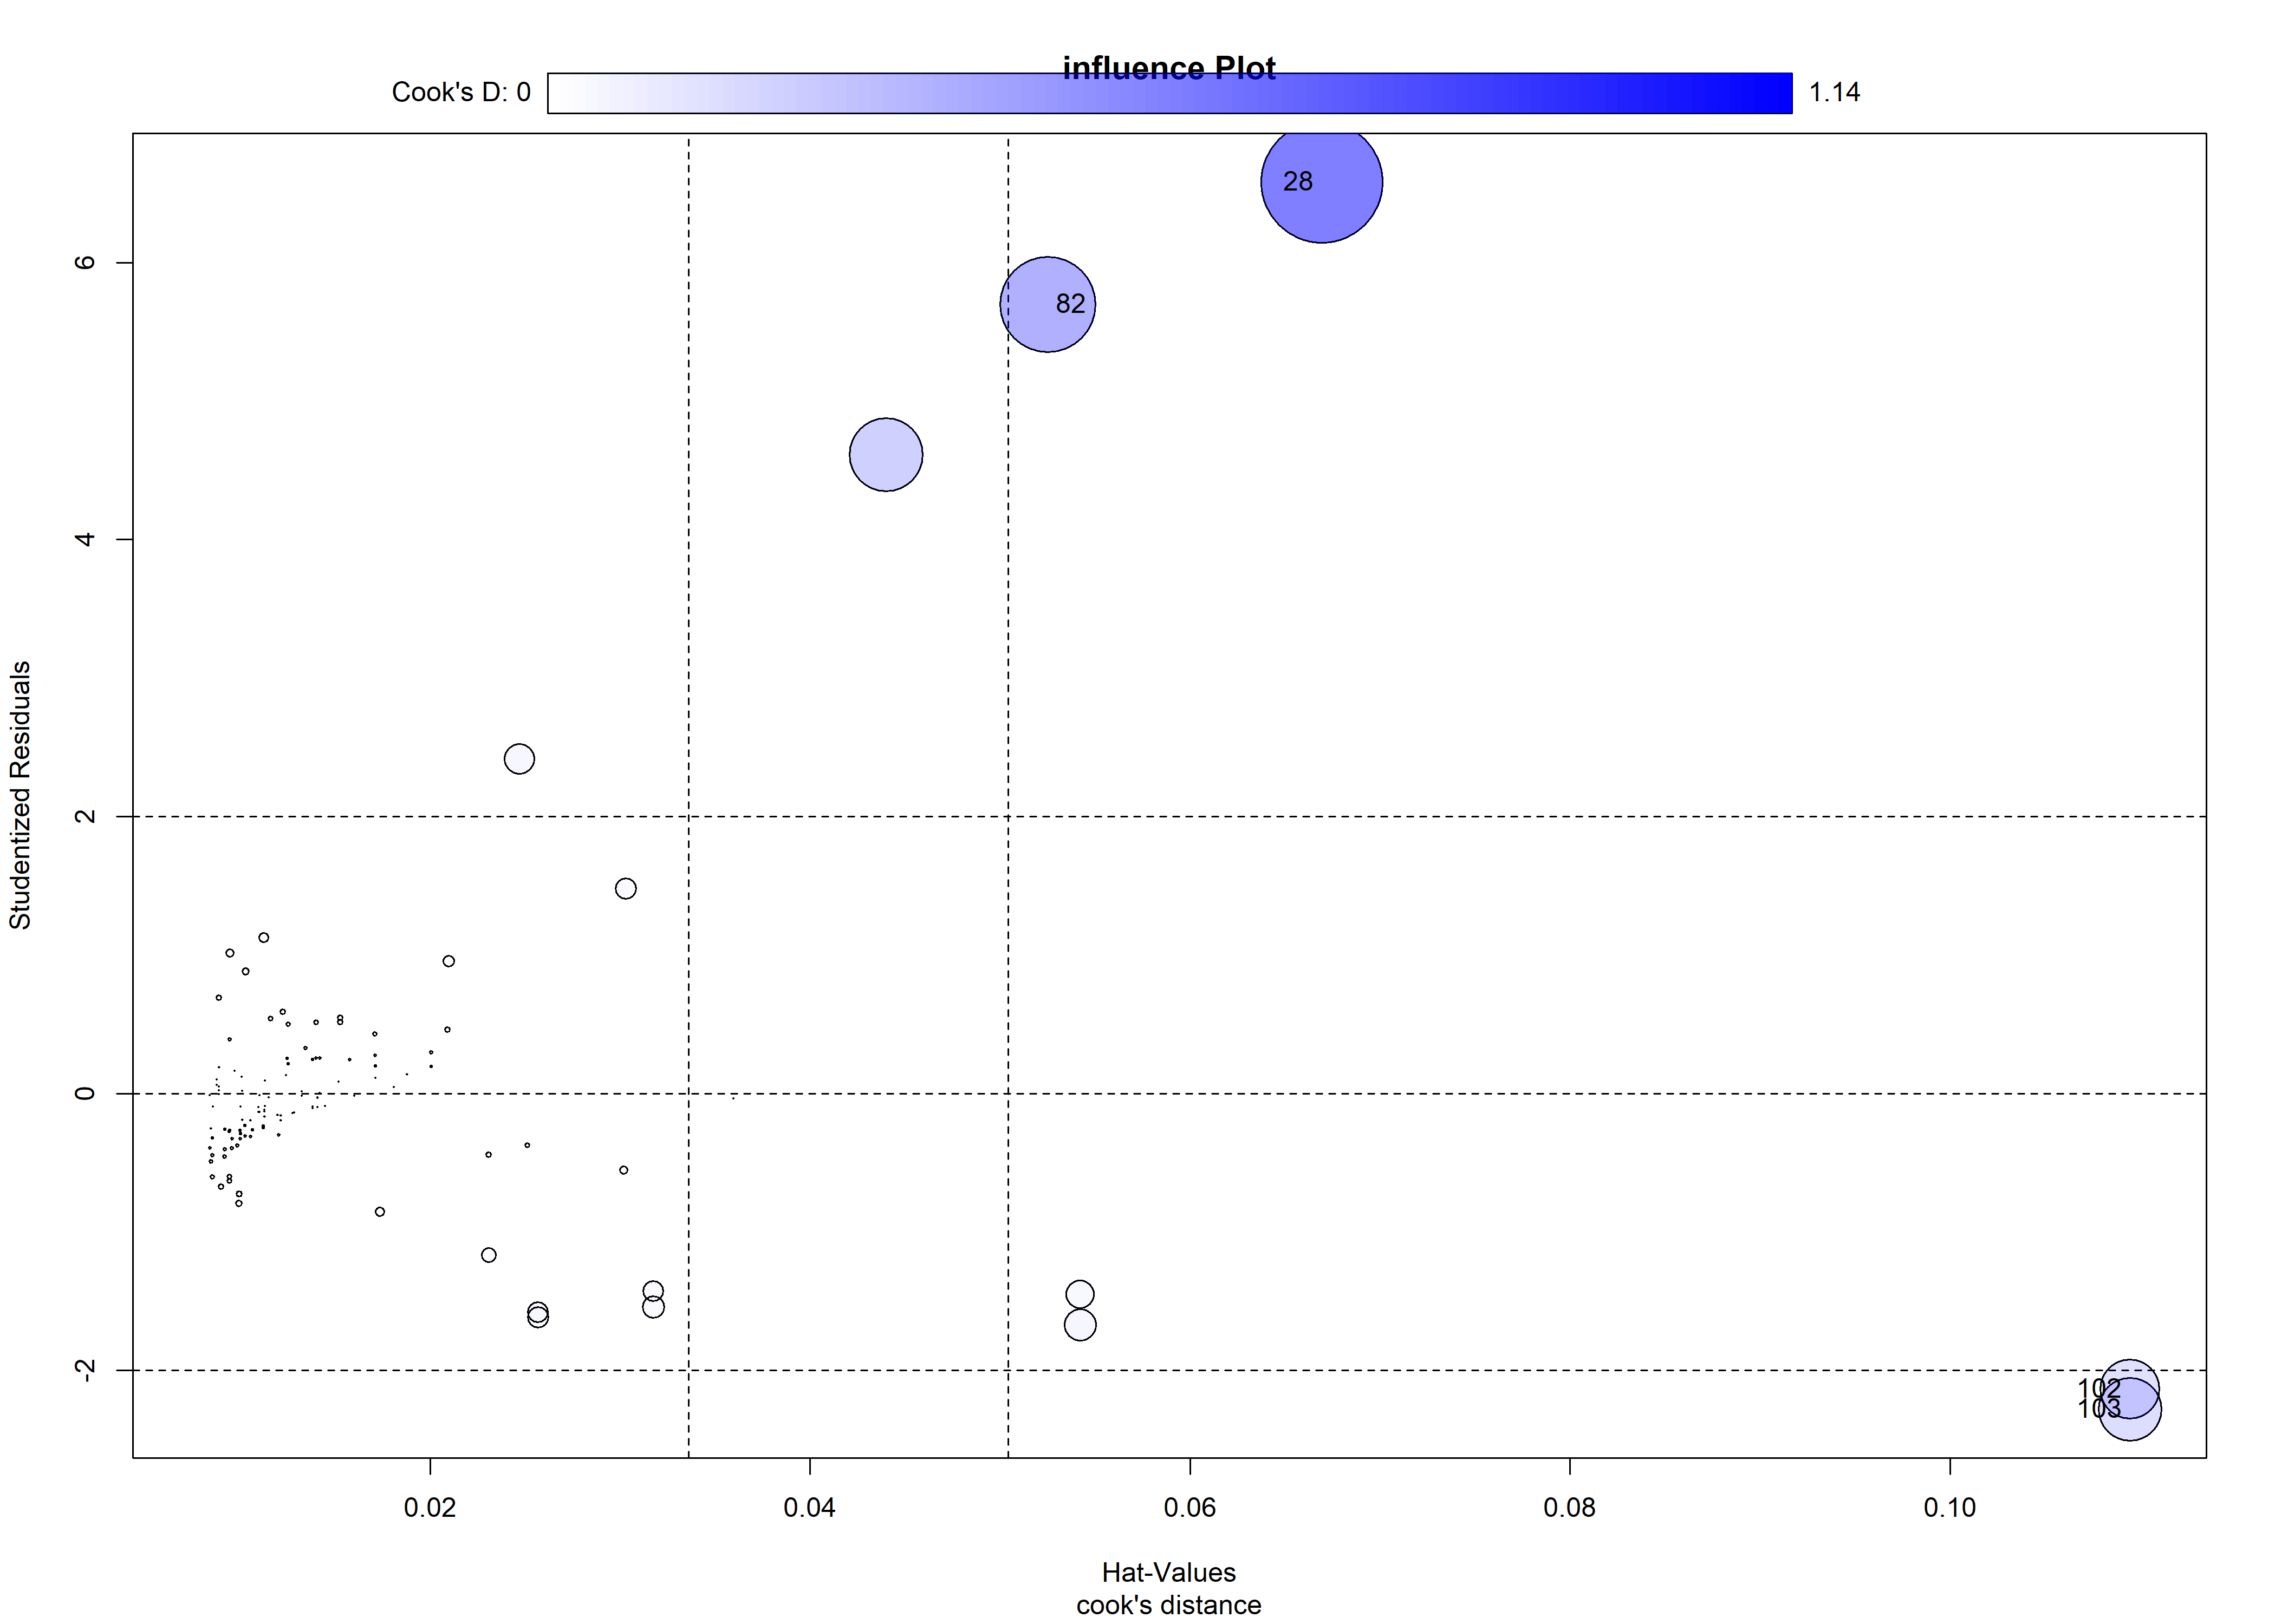

## StudRes Hat CookD  
## 28 6.580844 0.06693027 1.1407521  
## 82 5.696761 0.05250809 0.7087177  
## 102 -2.135397 0.10946116 0.2719677  
## 103 -2.280217 0.10946116 0.3084715

### Fig. 1 Severity and sev1, sev23 linear regression Plot

##   
## Call:  
## lm(formula = Severity ~ sev1 + sev23, data = result_sau, na.action = na.omit)  
##   
## Residuals:  
## Min 1Q Median 3Q Max   
## -0.23305 -0.04295 -0.01242 0.02080 0.65499   
##   
## Coefficients:  
## Estimate Std. Error t value Pr(>|t|)   
## (Intercept) -0.105072 0.042070 -2.498 0.0139 *   
## sev1 0.010526 0.006203 1.697 0.0924 .   
## sev23 0.044736 0.006507 6.875 0.000000000331 ***  
## ---  
## Signif. codes: 0 '***' 0.001 '**' 0.01 '*' 0.05 '.' 0.1 ' ' 1  
##   
## Residual standard error: 0.119 on 116 degrees of freedom  
## Multiple R-squared: 0.3223, Adjusted R-squared: 0.3106   
## F-statistic: 27.58 on 2 and 116 DF, p-value: 0.0000000001585

##   
## Number of bootstrap replications R = 999   
## original bootBias bootSE bootMed  
## (Intercept) -0.105072 0.00025711 0.0386890 -0.102119  
## sev1 0.010526 -0.00029386 0.0047577 0.010038  
## sev23 0.044736 0.00078236 0.0149548 0.043857

## 2.5 % 97.5 %  
## (Intercept) -0.188397115 -0.02174716  
## sev1 -0.001759716 0.02281207  
## sev23 0.031847515 0.05762378

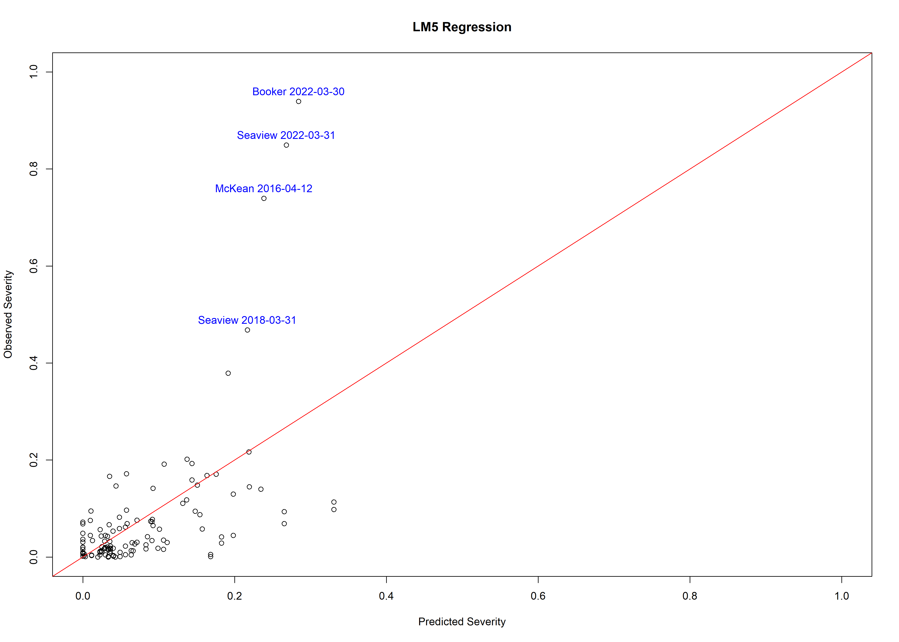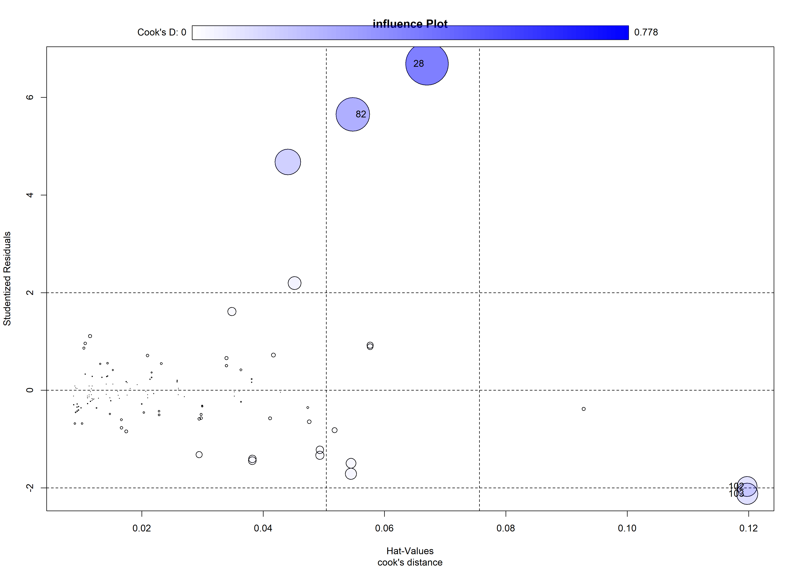

## StudRes Hat CookD  
## 28 6.688996 0.06700329 0.7777746  
## 82 5.650202 0.05479894 0.4870994  
## 102 -1.973539 0.11974914 0.1723181  
## 103 -2.119179 0.11974914 0.1976984

### Fig. 1 Severity and sev1, sev2,sev3 linear regression Plot

##   
## Call:  
## lm(formula = Severity ~ sev1 + sev2 + sev3, data = result_sau,   
## na.action = na.omit)  
##   
## Residuals:  
## Min 1Q Median 3Q Max   
## -0.23521 -0.03068 -0.01021 0.02138 0.62580   
##   
## Coefficients:  
## Estimate Std. Error t value Pr(>|t|)   
## (Intercept) -0.001858 0.050723 -0.037 0.971   
## sev1 0.005492 0.006132 0.896 0.372   
## sev2 -0.027426 0.022397 -1.225 0.223   
## sev3 0.083660 0.013173 6.351 0.00000000443 ***  
## ---  
## Signif. codes: 0 '***' 0.001 '**' 0.01 '*' 0.05 '.' 0.1 ' ' 1  
##   
## Residual standard error: 0.114 on 115 degrees of freedom  
## Multiple R-squared: 0.3827, Adjusted R-squared: 0.3666   
## F-statistic: 23.77 on 3 and 115 DF, p-value: 0.000000000004847

##   
## Number of bootstrap replications R = 999   
## original bootBias bootSE bootMed  
## (Intercept) -0.0018582 -0.003832565 0.0319577 -0.0049332  
## sev1 0.0054918 -0.000081946 0.0043558 0.0054802  
## sev2 -0.0274255 0.003806539 0.0242745 -0.0226189  
## sev3 0.0836596 -0.001252508 0.0254149 0.0833803

## 2.5 % 97.5 %  
## (Intercept) -0.102330366 0.09861388  
## sev1 -0.006655034 0.01763872  
## sev2 -0.071789769 0.01693873  
## sev3 0.057565848 0.10975344

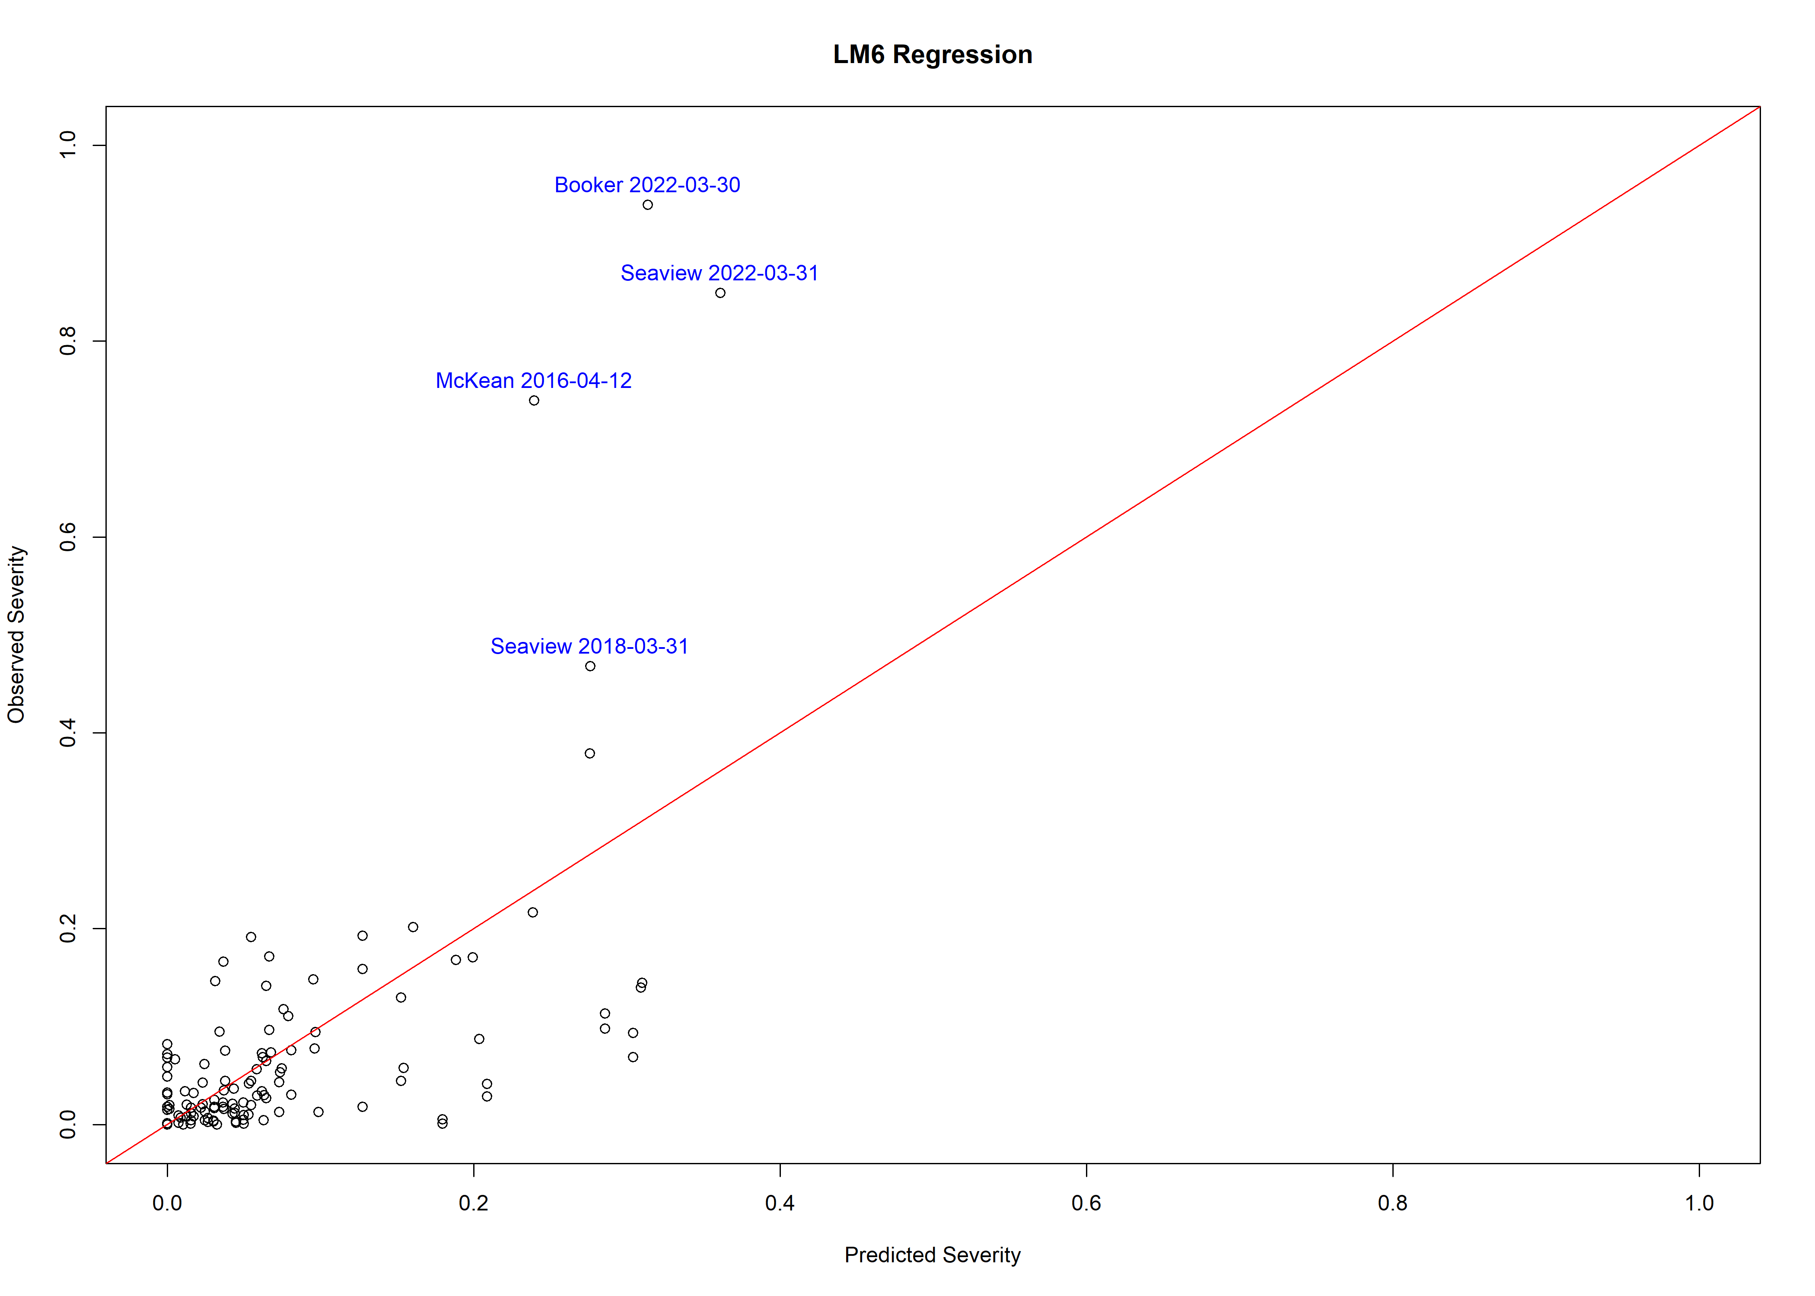

## StudRes Hat CookD  
## 28 6.688996 0.06700329 0.7777746  
## 82 5.650202 0.05479894 0.4870994  
## 102 -1.973539 0.11974914 0.1723181  
## 103 -2.119179 0.11974914 0.1976984

Results of a linear mixed model fit by maximum likelihood using the “lmerModLmerTest” function in R. The model is used to analyze the relationship between the dependent variable “Severity” and the independent variables “sev1” and “sev23” while accounting for the nested structure of the data, where observations are grouped within different “Site” levels.

### Fig. 1 Severity and sev1, sev23 and Site regression Plot

## Linear mixed model fit by maximum likelihood . t-tests use Satterthwaite's  
## method [lmerModLmerTest]  
## Formula: Severity ~ sev1 + sev23 + (1 | Site)  
## Data: na.omit(result_sau)  
##   
## AIC BIC logLik deviance df.resid   
## -168.9 -155.0 89.5 -178.9 114   
##   
## Scaled residuals:   
## Min 1Q Median 3Q Max   
## -2.1369 -0.3402 -0.0585 0.2887 5.9713   
##   
## Random effects:  
## Groups Name Variance Std.Dev.  
## Site (Intercept) 0.01391 0.1179   
## Residual 0.01110 0.1054   
## Number of obs: 119, groups: Site, 7  
##   
## Fixed effects:  
## Estimate Std. Error df t value Pr(>|t|)   
## (Intercept) -0.058686 0.060565 6.521018 -0.969 0.367   
## sev1 0.008686 0.005575 102.615691 1.558 0.122   
## sev23 0.046143 0.006029 108.433289 7.653 0.00000000000861 ***  
## ---  
## Signif. codes: 0 '***' 0.001 '**' 0.01 '*' 0.05 '.' 0.1 ' ' 1  
##   
## Correlation of Fixed Effects:  
## (Intr) sev1   
## sev1 -0.538   
## sev23 -0.205 -0.164

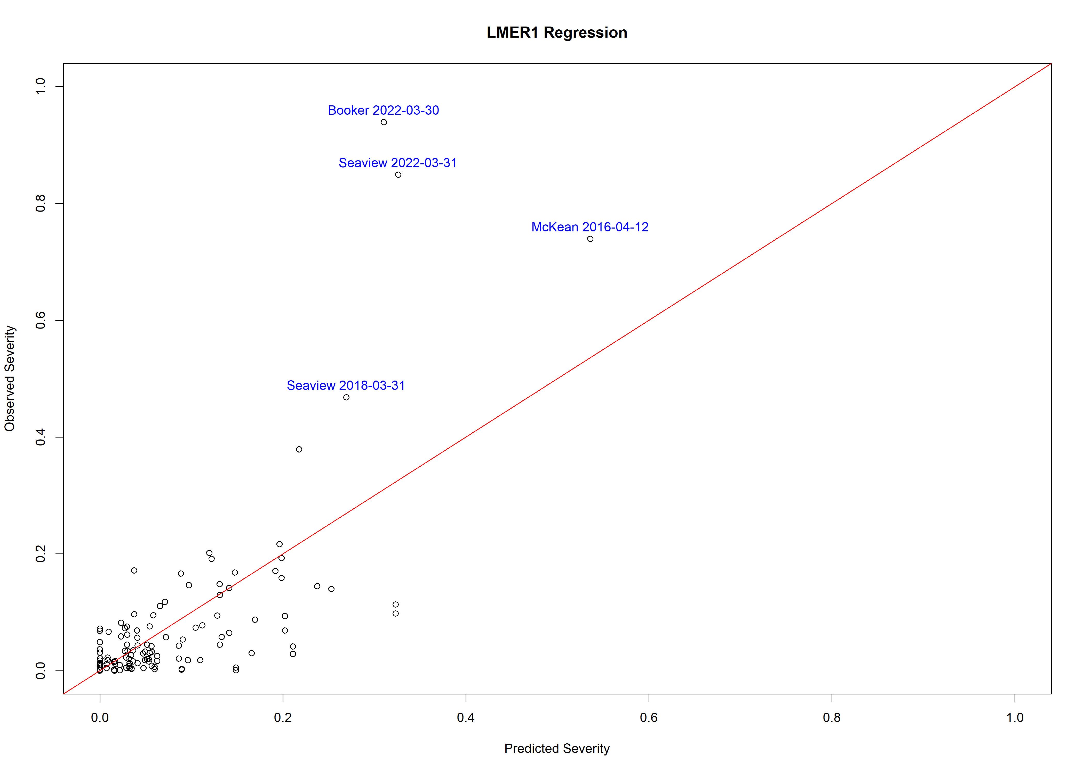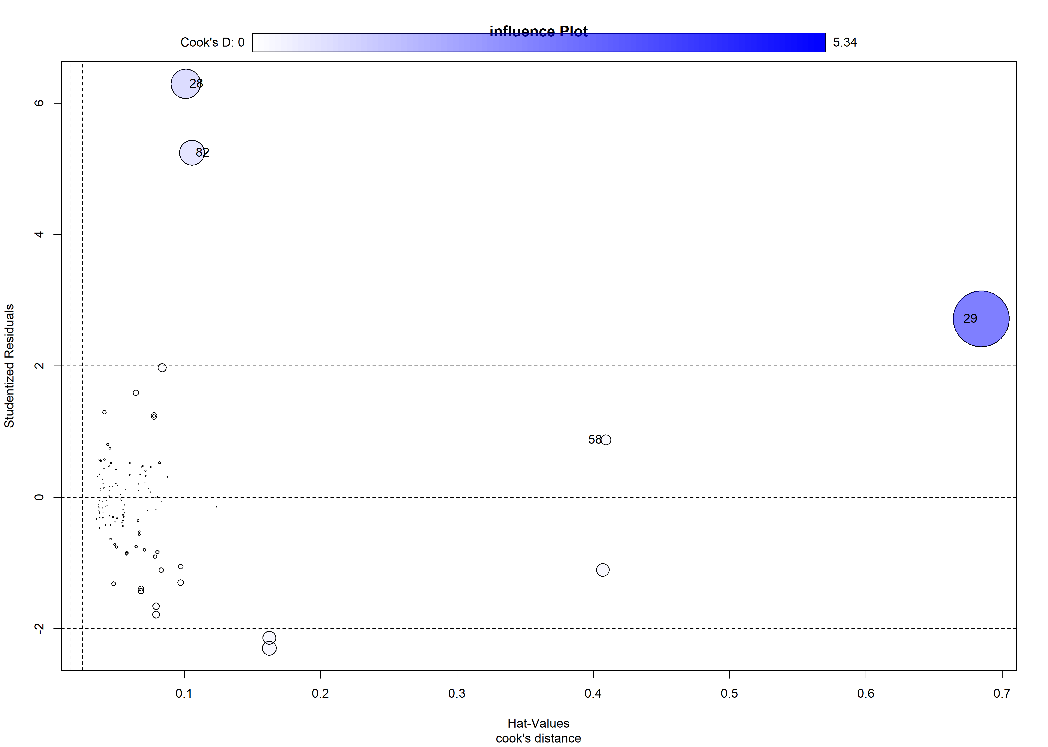

## StudRes Hat CookD  
## 28 6.2931635 0.1011052 1.4848460  
## 29 2.7167783 0.6846064 5.3404179  
## 58 0.8724597 0.4092938 0.1758058  
## 82 5.2425934 0.1055834 1.0815006

### Fig. 1 Severity and sev1, sev2,sev3 and Site regression Plot

## Linear mixed model fit by maximum likelihood . t-tests use Satterthwaite's  
## method [lmerModLmerTest]  
## Formula: Severity ~ sev1 + sev2 + sev3 + (1 | Site)  
## Data: na.omit(result_sau)  
##   
## AIC BIC logLik deviance df.resid   
## -172.9 -156.2 92.5 -184.9 113   
##   
## Scaled residuals:   
## Min 1Q Median 3Q Max   
## -1.8270 -0.3185 -0.0037 0.2486 6.1411   
##   
## Random effects:  
## Groups Name Variance Std.Dev.  
## Site (Intercept) 0.01358 0.1165   
## Residual 0.01054 0.1027   
## Number of obs: 119, groups: Site, 7  
##   
## Fixed effects:  
## Estimate Std. Error df t value Pr(>|t|)   
## (Intercept) 0.024128 0.068118 10.276678 0.354 0.730   
## sev1 0.005160 0.005616 101.489479 0.919 0.360   
## sev2 -0.009879 0.023340 108.137754 -0.423 0.673   
## sev3 0.074615 0.012913 105.052513 5.778 0.0000000778 ***  
## ---  
## Signif. codes: 0 '***' 0.001 '**' 0.01 '*' 0.05 '.' 0.1 ' ' 1  
##   
## Correlation of Fixed Effects:  
## (Intr) sev1 sev2   
## sev1 -0.575   
## sev2 -0.516 0.205   
## sev3 0.353 -0.298 -0.747

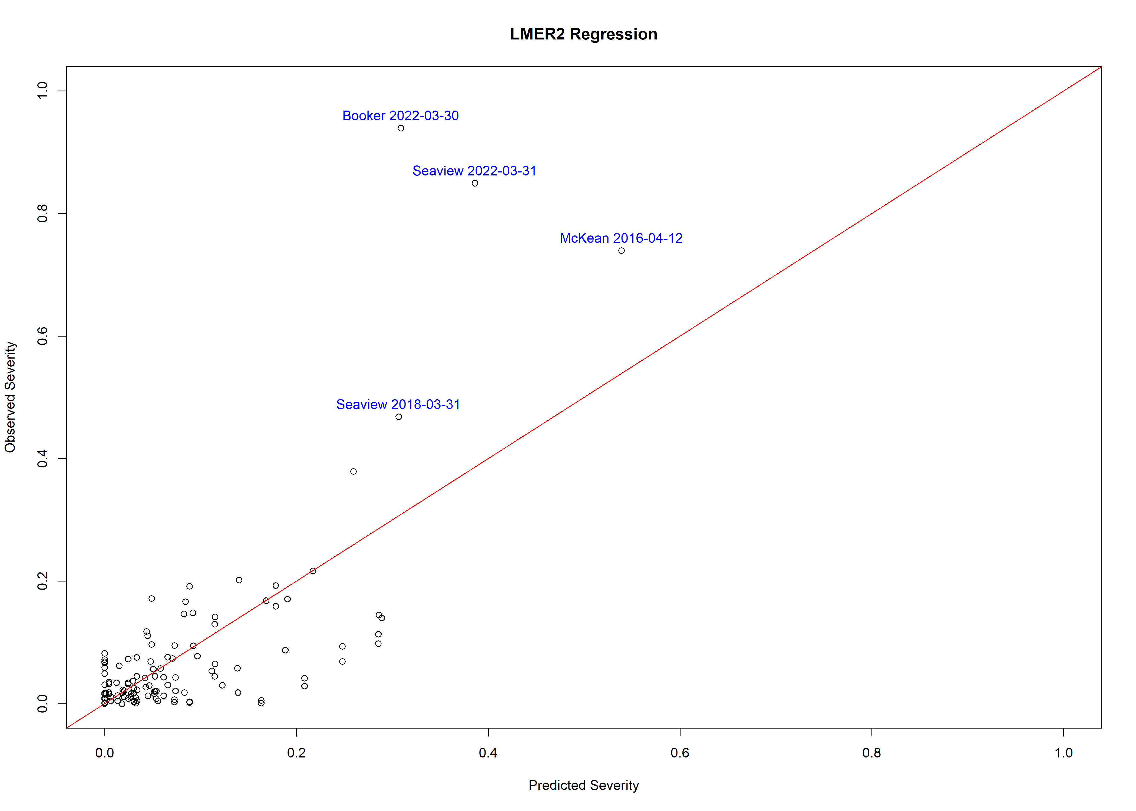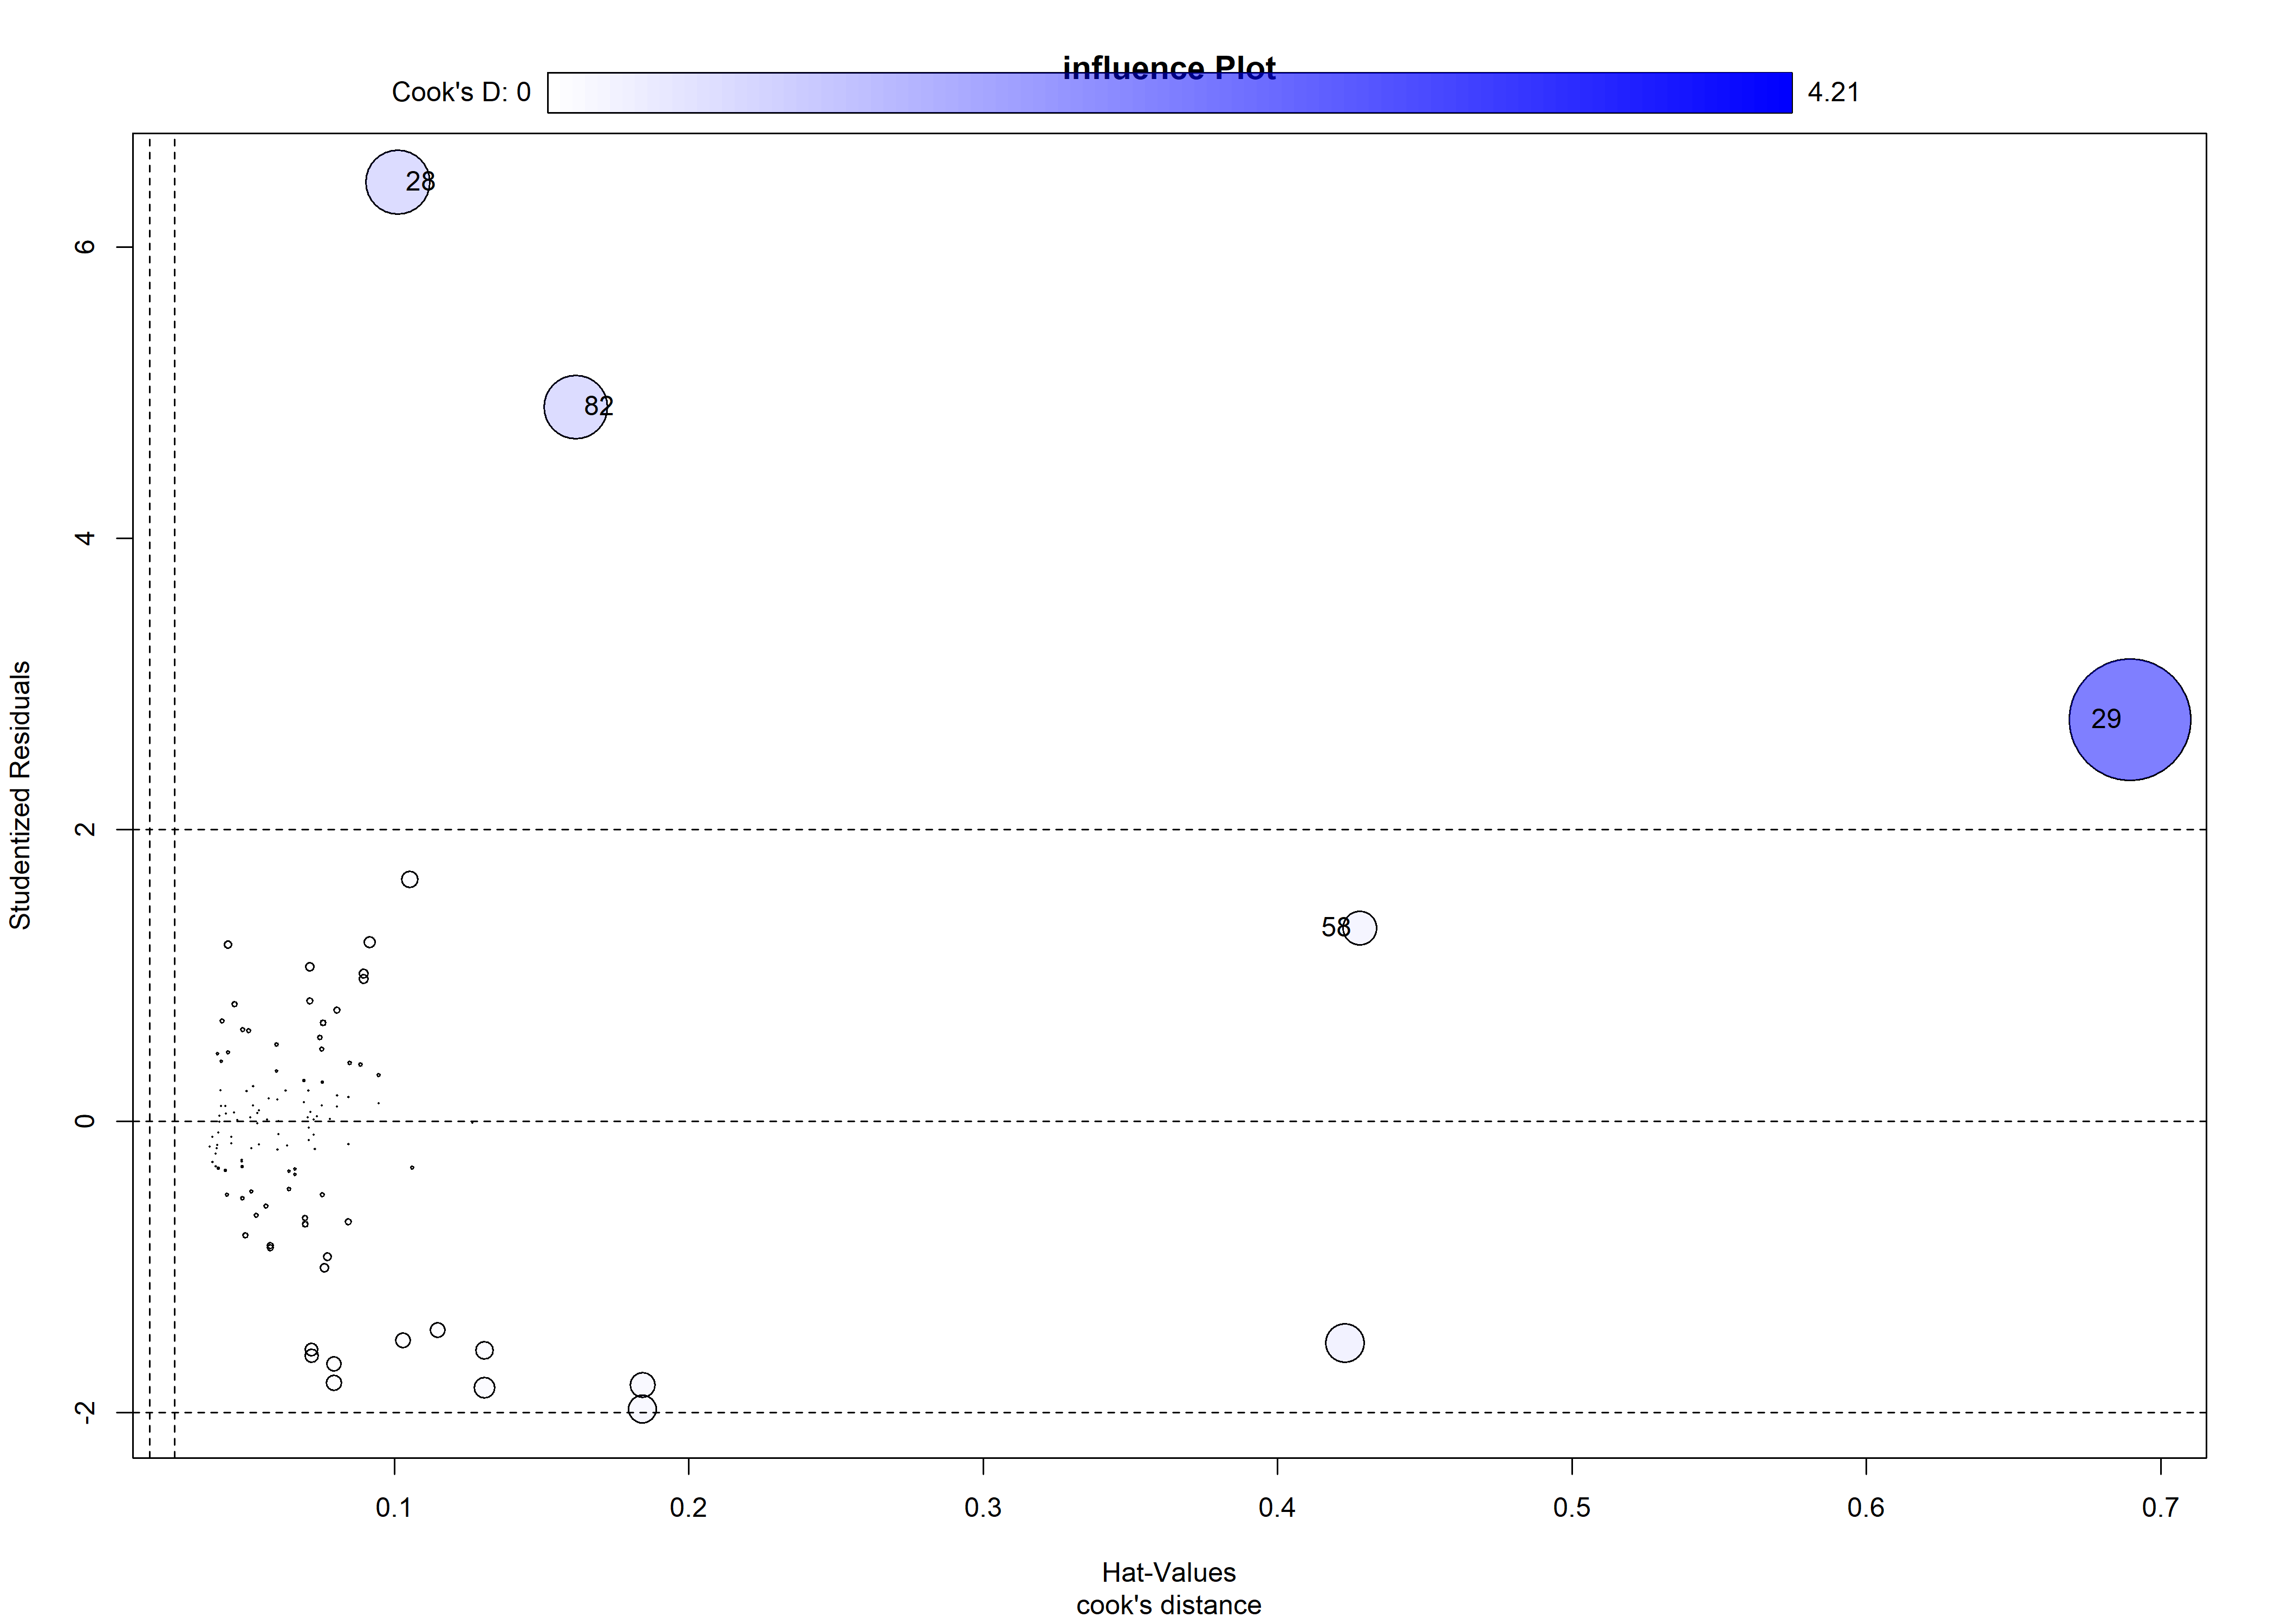

## StudRes Hat CookD  
## 28 6.446524 0.1011748 1.1694679  
## 29 2.755337 0.6894914 4.2144877  
## 58 1.326050 0.4278485 0.3287297  
## 82 4.902442 0.1615901 1.1580395

# Model back-substitution testing analysis

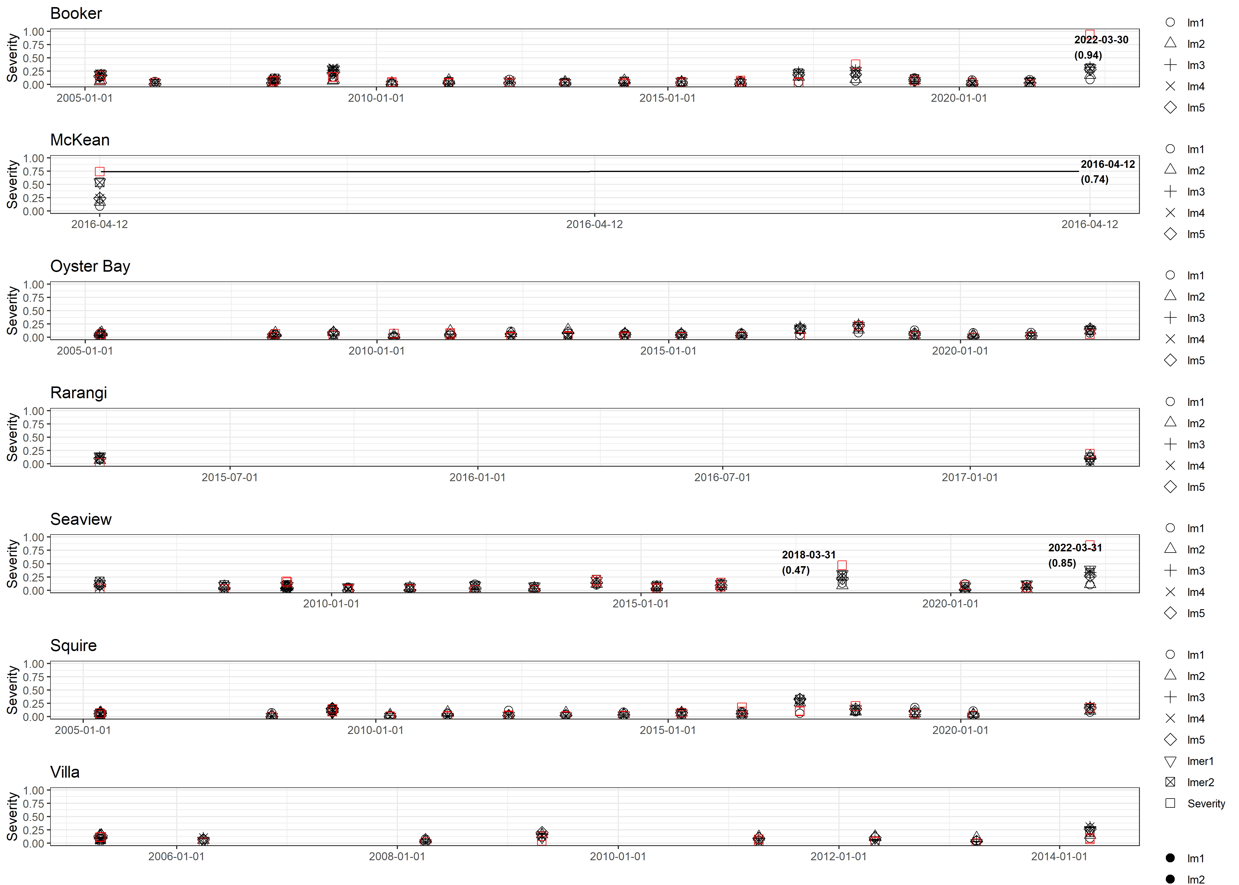

### Fig. 1 Severity and sev1, sev23 regression for each site Plot