Botrytis Disease_Severity_loess

Yao Liu

2023-06-01

# load Harvest 2005-2022 all data_cases.xlsx

Severity = Botrytis (kg)/ Total kg  
All data :1818 Non-nan Severity data: 1416 Group_by(block,pruning,Variety,Date) and mean: 264

All Sauvignon blanc : 155 2-cane,3-cane,4-cane, Sauvignon blanc: 121

2-cane,Sauvignon blanc at Oyster Bay,Booker,Seaview, Squire :61

# Fig. 1 Severity and sev1 loess regression Plot

Loess is a point-by-point weighted regression smoothing algorithm.

## Call:  
## loess(formula = Severity ~ sev1, data = result_sau, na.action = na.omit)  
##   
## Number of Observations: 119   
## Equivalent Number of Parameters: 5.37   
## Residual Standard Error: 0.1408   
## Trace of smoother matrix: 5.9 (exact)  
##   
## Control settings:  
## span : 0.75   
## degree : 2   
## family : gaussian  
## surface : interpolate cell = 0.2  
## normalize: TRUE  
## parametric: FALSE  
## drop.square: FALSE

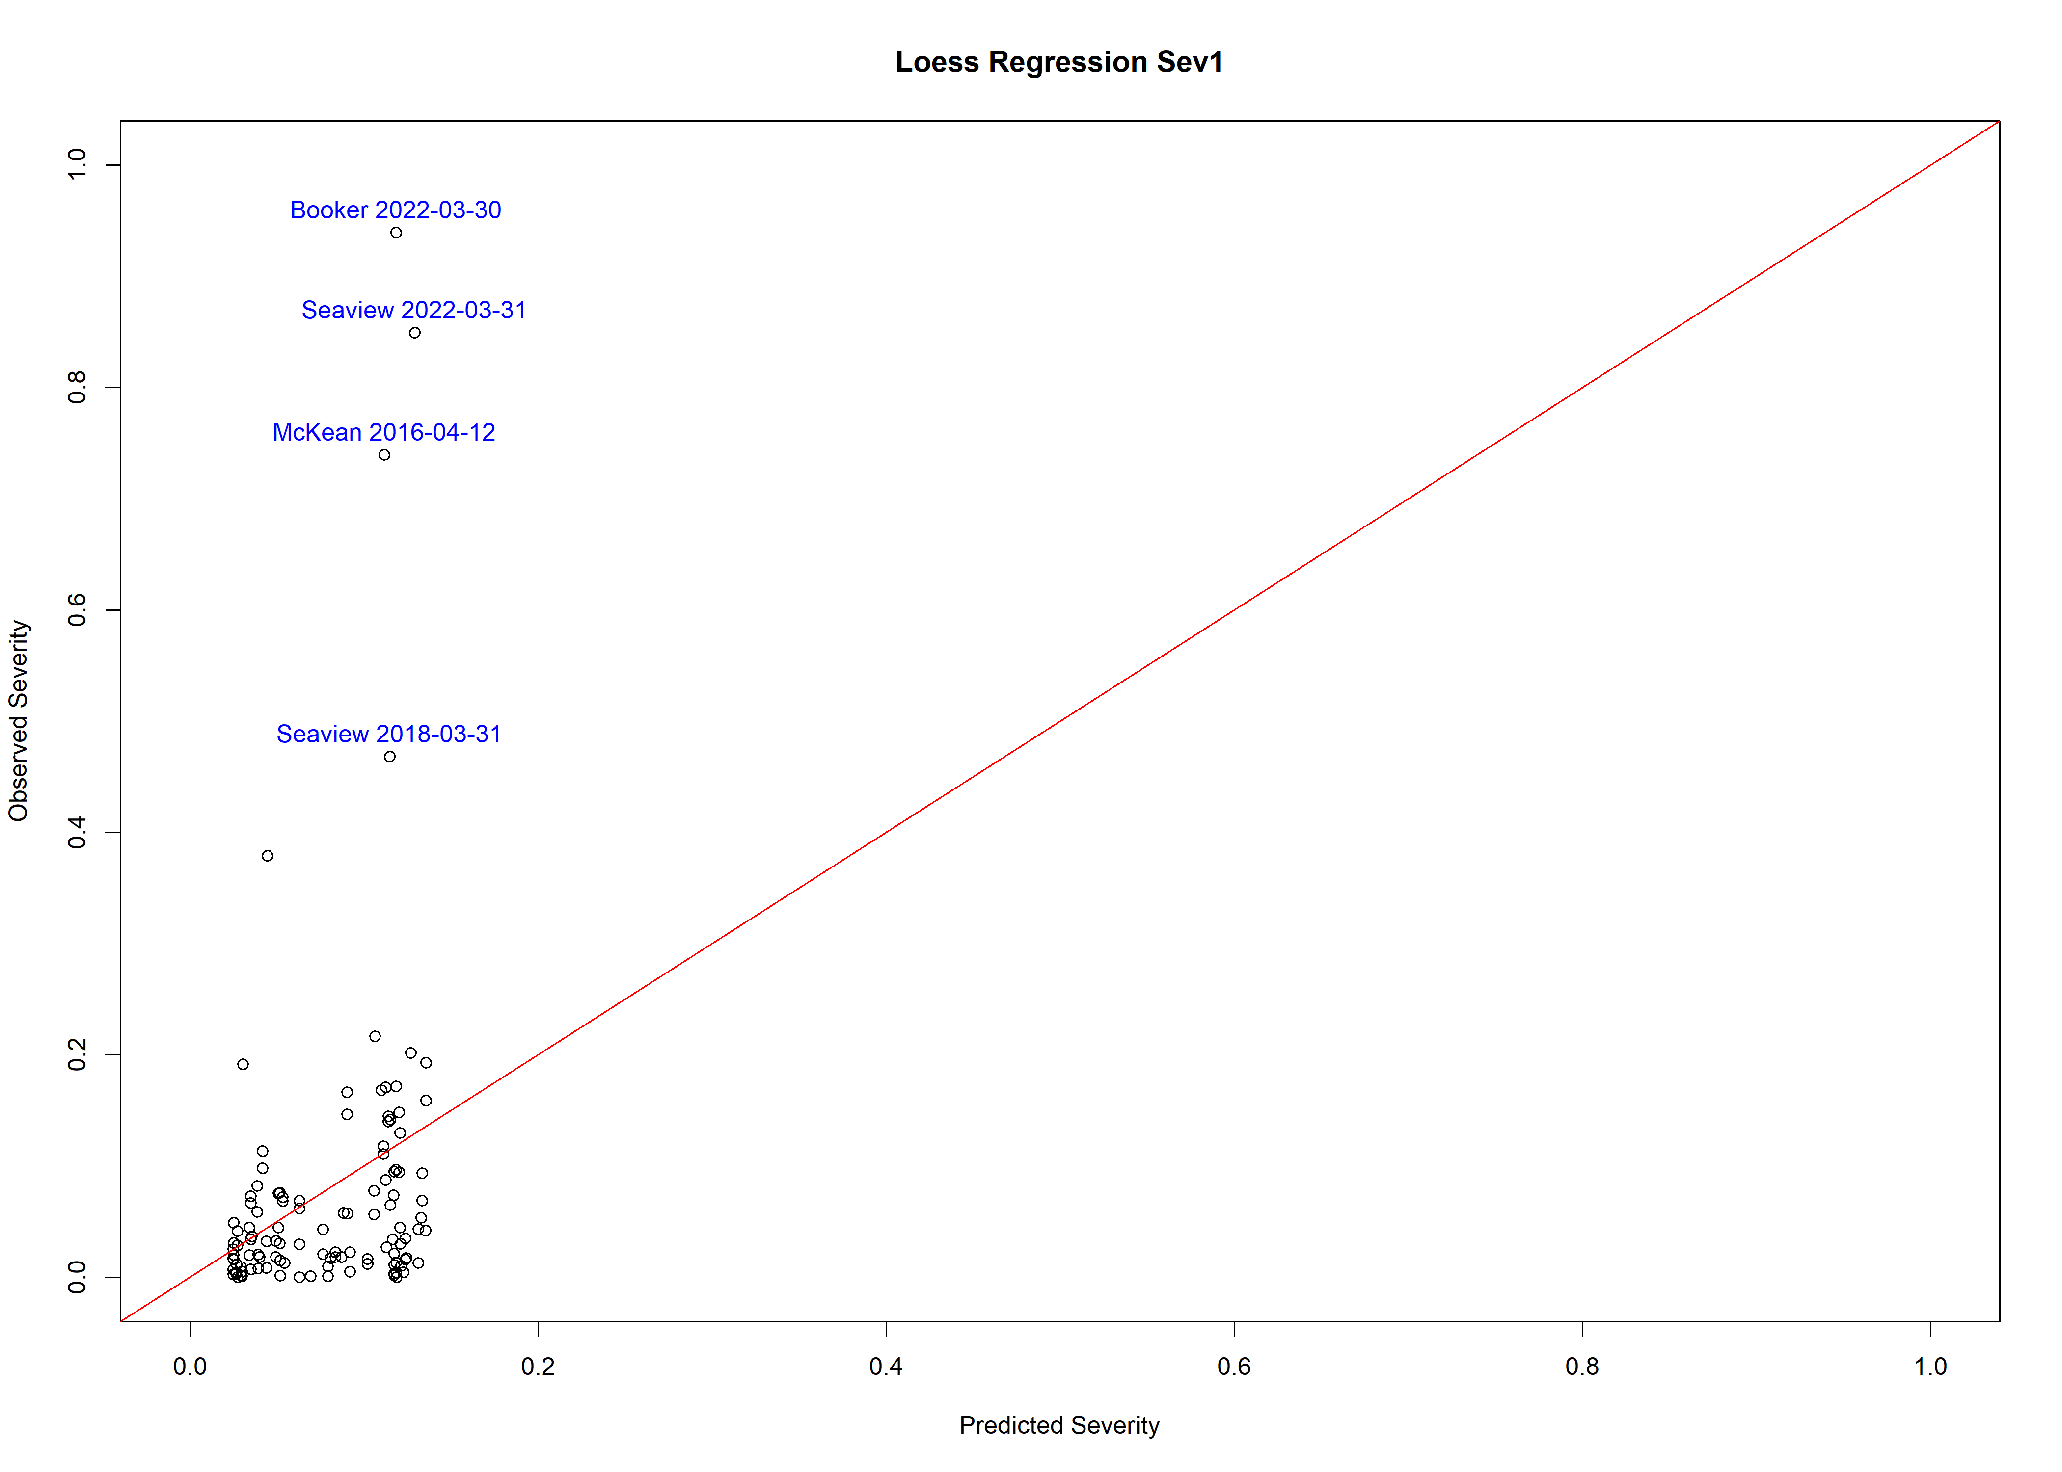

### Fig. 2 Severity and sev2 loess regression Plot

## Call:  
## loess(formula = Severity ~ sev2, data = result_sau, na.action = na.omit)  
##   
## Number of Observations: 119   
## Equivalent Number of Parameters: 5.3   
## Residual Standard Error: 0.1298   
## Trace of smoother matrix: 5.81 (exact)  
##   
## Control settings:  
## span : 0.75   
## degree : 2   
## family : gaussian  
## surface : interpolate cell = 0.2  
## normalize: TRUE  
## parametric: FALSE  
## drop.square: FALSE

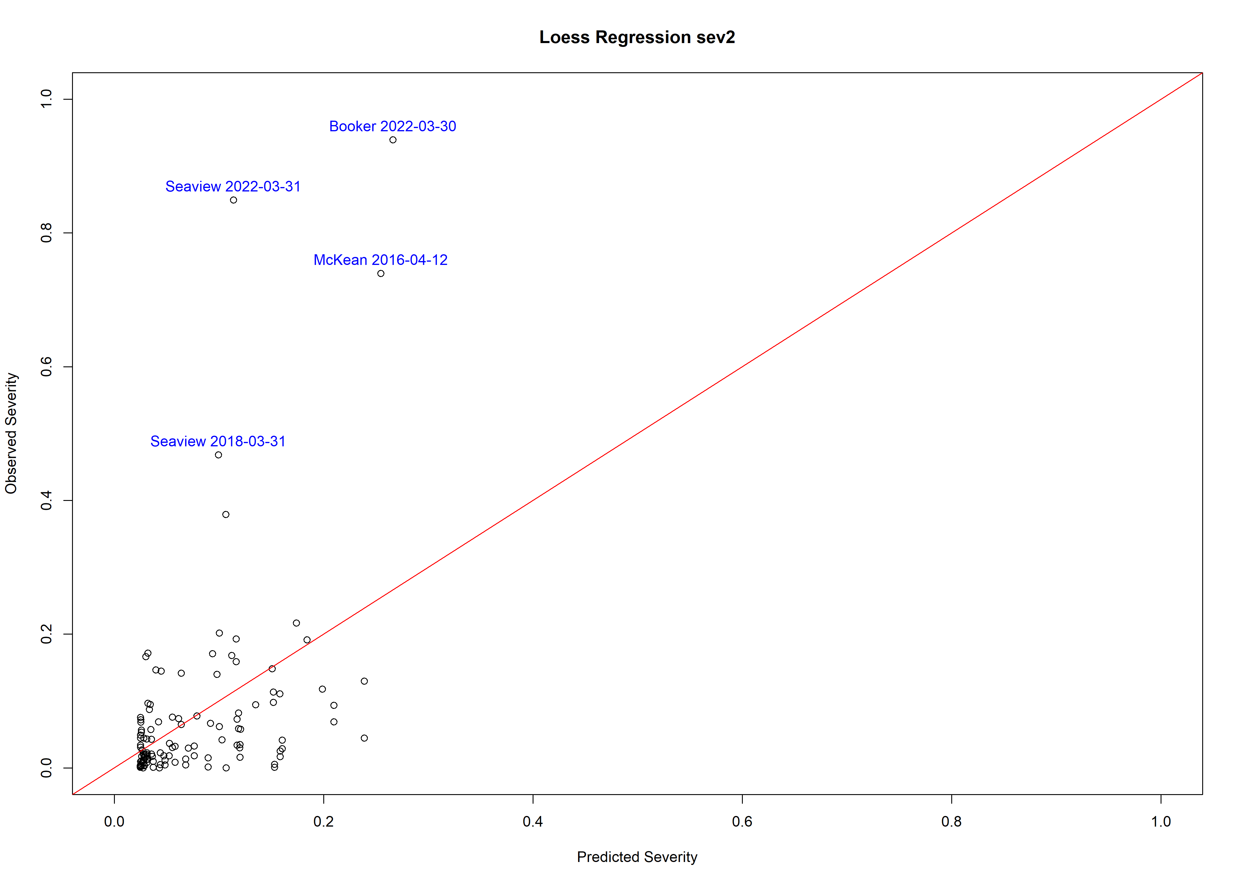

### Fig. 3 Severity and sev3 loess regression Plot

## Call:  
## loess(formula = Severity ~ sev3, data = result_sau, na.action = na.omit)  
##   
## Number of Observations: 119   
## Equivalent Number of Parameters: 5.02   
## Residual Standard Error: 0.113   
## Trace of smoother matrix: 5.5 (exact)  
##   
## Control settings:  
## span : 0.75   
## degree : 2   
## family : gaussian  
## surface : interpolate cell = 0.2  
## normalize: TRUE  
## parametric: FALSE  
## drop.square: FALSE

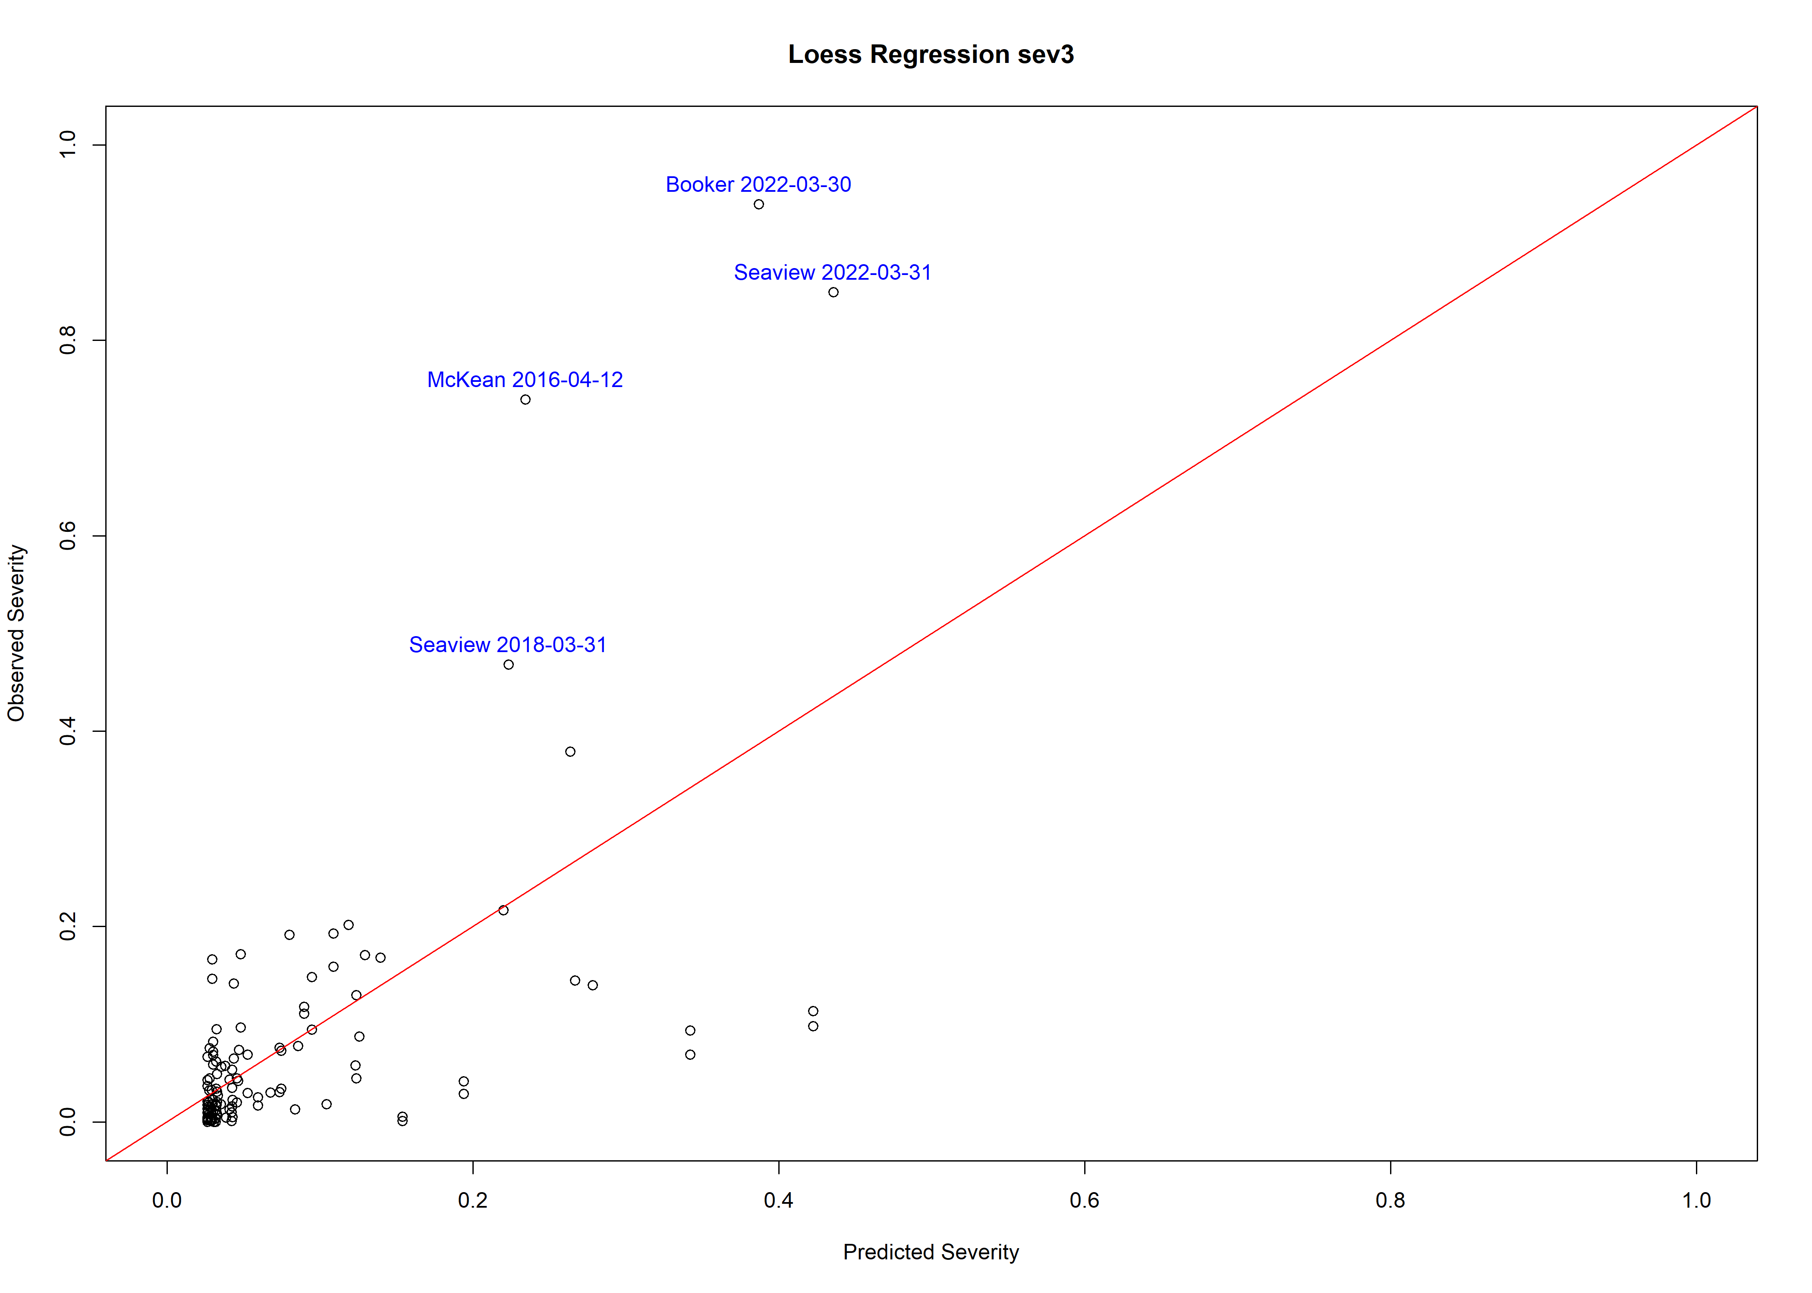

### Fig. 4 Severity and sev2 + sev3 loess regression Plot

## Call:  
## loess(formula = Severity ~ sev2 + sev3, data = result_sau, na.action = na.omit)  
##   
## Number of Observations: 119   
## Equivalent Number of Parameters: 9.83   
## Residual Standard Error: 0.1061   
## Trace of smoother matrix: 11.51 (exact)  
##   
## Control settings:  
## span : 0.75   
## degree : 2   
## family : gaussian  
## surface : interpolate cell = 0.2  
## normalize: TRUE  
## parametric: FALSE FALSE  
## drop.square: FALSE FALSE

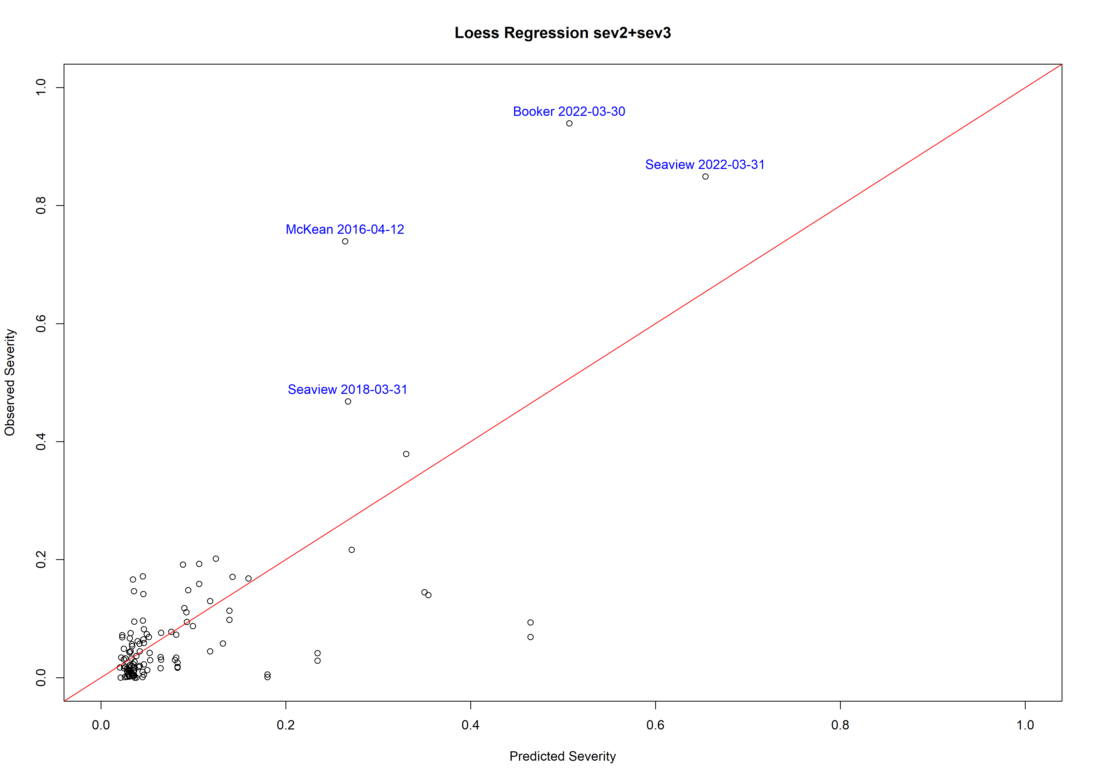

### Fig. 5 Severity and sev1+sev23 loess regression Plot

## Call:  
## loess(formula = Severity ~ sev1 + sev23, data = result_sau, na.action = na.omit)  
##   
## Number of Observations: 119   
## Equivalent Number of Parameters: 10.2   
## Residual Standard Error: 0.1046   
## Trace of smoother matrix: 11.96 (exact)  
##   
## Control settings:  
## span : 0.75   
## degree : 2   
## family : gaussian  
## surface : interpolate cell = 0.2  
## normalize: TRUE  
## parametric: FALSE FALSE  
## drop.square: FALSE FALSE

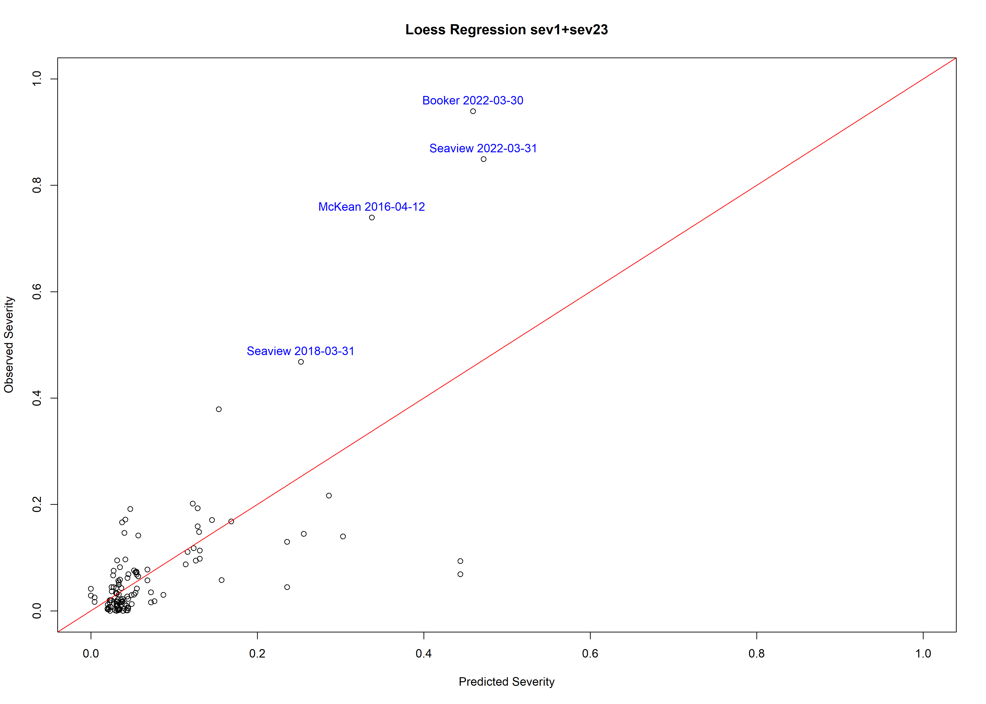

### Fig. 6 Severity and sev1+sev2+sev3 loess regression (smooth default：0.75) Plot

## Call:  
## loess(formula = Severity ~ sev1 + sev2 + sev3, data = result_sau,   
## na.action = na.omit, span = 0.75)  
##   
## Number of Observations: 119   
## Equivalent Number of Parameters: 15.56   
## Residual Standard Error: 0.1106   
## Trace of smoother matrix: 19.1 (exact)  
##   
## Control settings:  
## span : 0.75   
## degree : 2   
## family : gaussian  
## surface : interpolate cell = 0.2  
## normalize: TRUE  
## parametric: FALSE FALSE FALSE  
## drop.square: FALSE FALSE FALSE

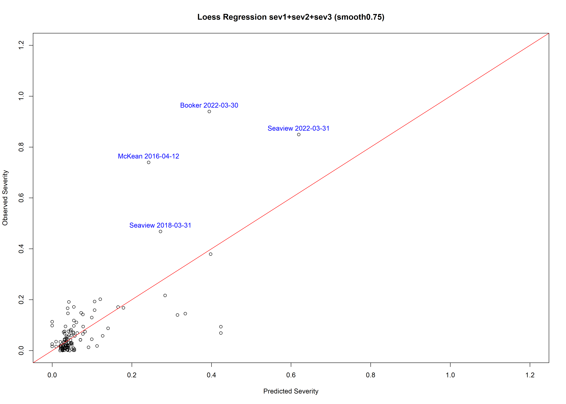

### Fig. 7 Severity and sev2+sev3+meteo loess regression Plot

## Call:  
## loess(formula = Severity ~ sev2 + sev3 + rh_sev1 + rain_sev23,   
## data = result_sau, na.action = na.omit)  
##   
## Number of Observations: 119   
## Equivalent Number of Parameters: 24.08   
## Residual Standard Error: 0.07601   
## Trace of smoother matrix: 30.78 (exact)  
##   
## Control settings:  
## span : 0.75   
## degree : 2   
## family : gaussian  
## surface : interpolate cell = 0.2  
## normalize: TRUE  
## parametric: FALSE FALSE FALSE FALSE  
## drop.square: FALSE FALSE FALSE FALSE

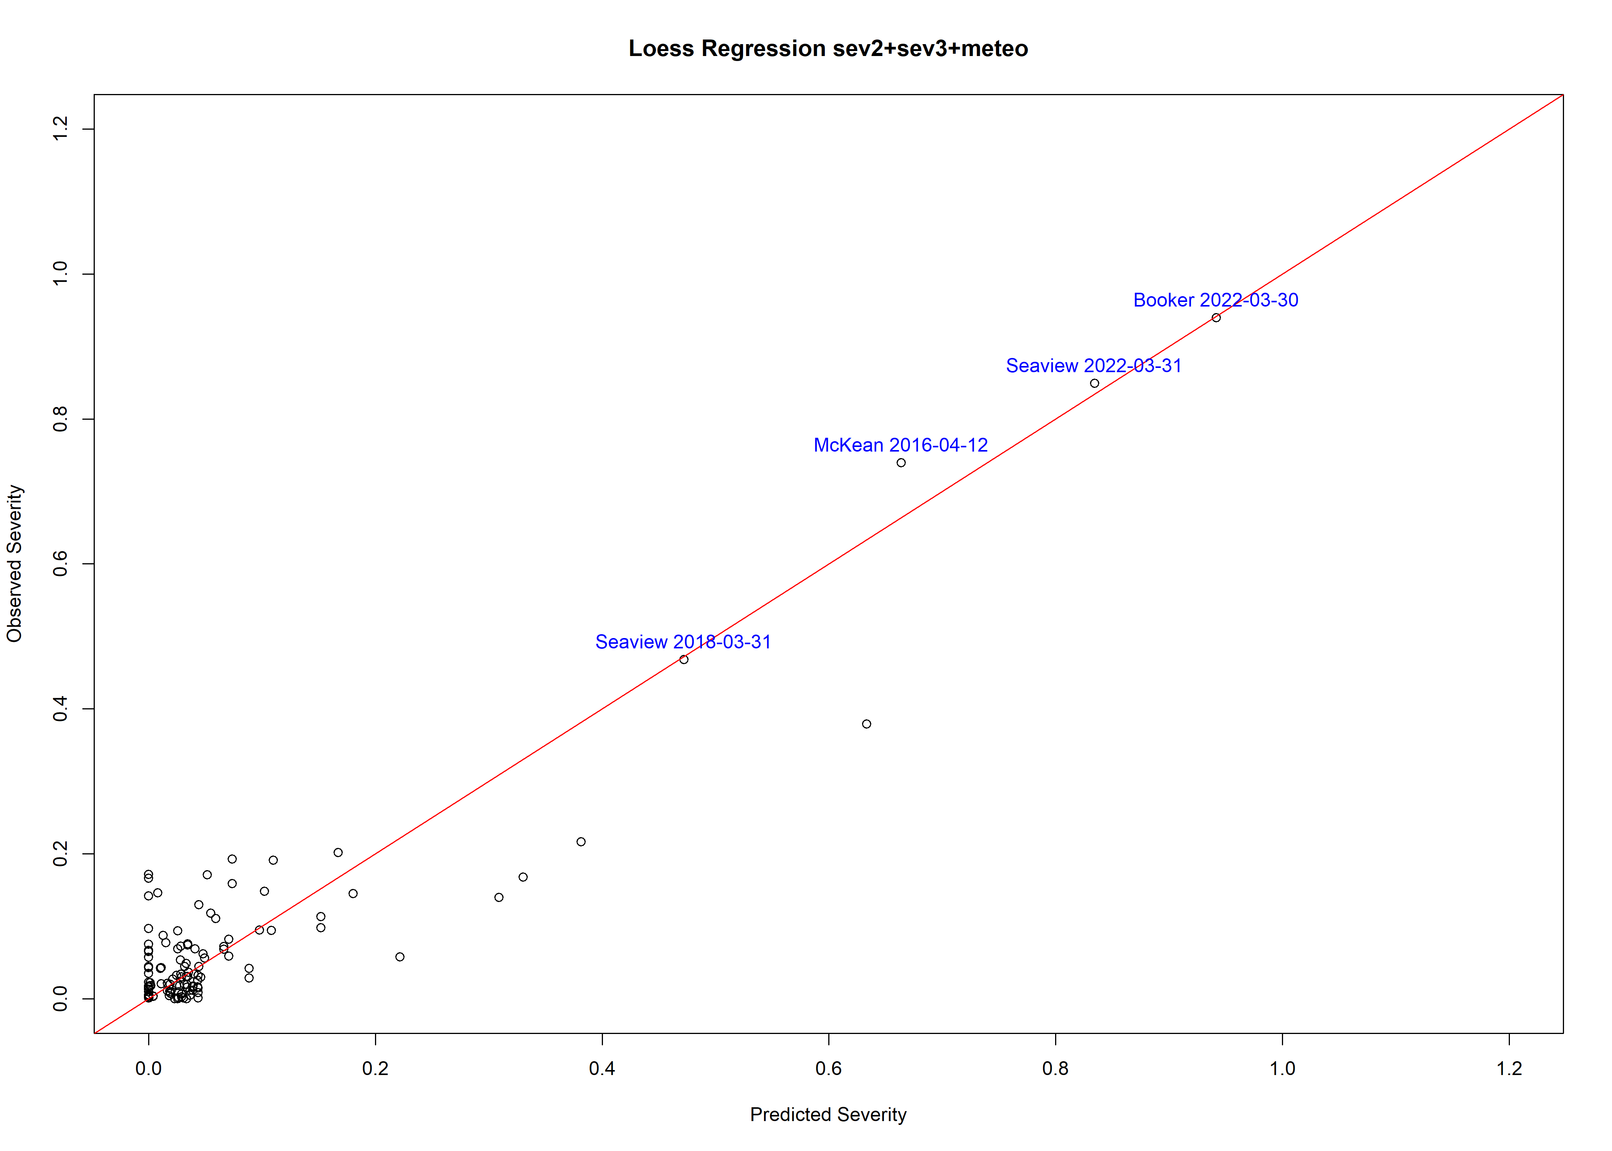

### Fig. 8 Severity and sev1+sev2+sev3 loess regression (smooth1.0) Plot

## Call:  
## loess(formula = Severity ~ sev1 + sev2 + sev3, data = result_sau,   
## na.action = na.omit, span = 1)  
##   
## Number of Observations: 119   
## Equivalent Number of Parameters: 10.92   
## Residual Standard Error: 0.1036   
## Trace of smoother matrix: 12.43 (exact)  
##   
## Control settings:  
## span : 1   
## degree : 2   
## family : gaussian  
## surface : interpolate cell = 0.2  
## normalize: TRUE  
## parametric: FALSE FALSE FALSE  
## drop.square: FALSE FALSE FALSE

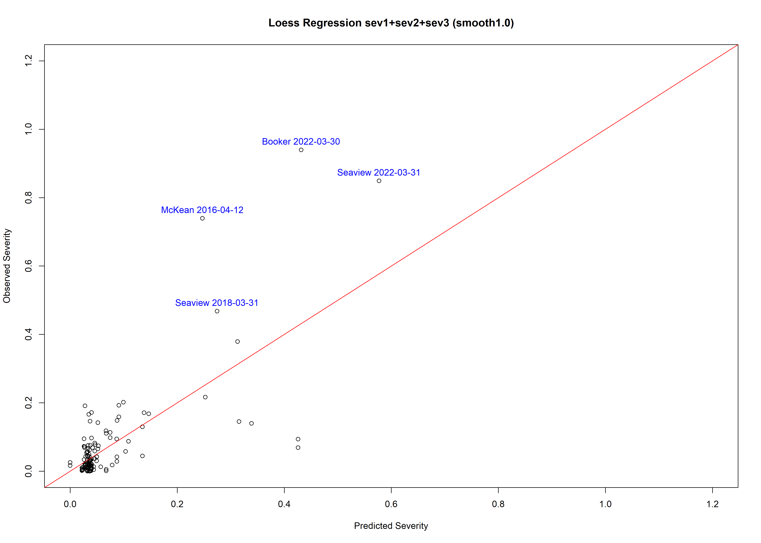

### Fig. 9 Severity and sev1+sev2+sev3 loess regression (smooth0.9) Plot

## Call:  
## loess(formula = Severity ~ sev1 + sev2 + sev3, data = result_sau,   
## na.action = na.omit, span = 0.9)  
##   
## Number of Observations: 119   
## Equivalent Number of Parameters: 13.32   
## Residual Standard Error: 0.1065   
## Trace of smoother matrix: 16.01 (exact)  
##   
## Control settings:  
## span : 0.9   
## degree : 2   
## family : gaussian  
## surface : interpolate cell = 0.2  
## normalize: TRUE  
## parametric: FALSE FALSE FALSE  
## drop.square: FALSE FALSE FALSE

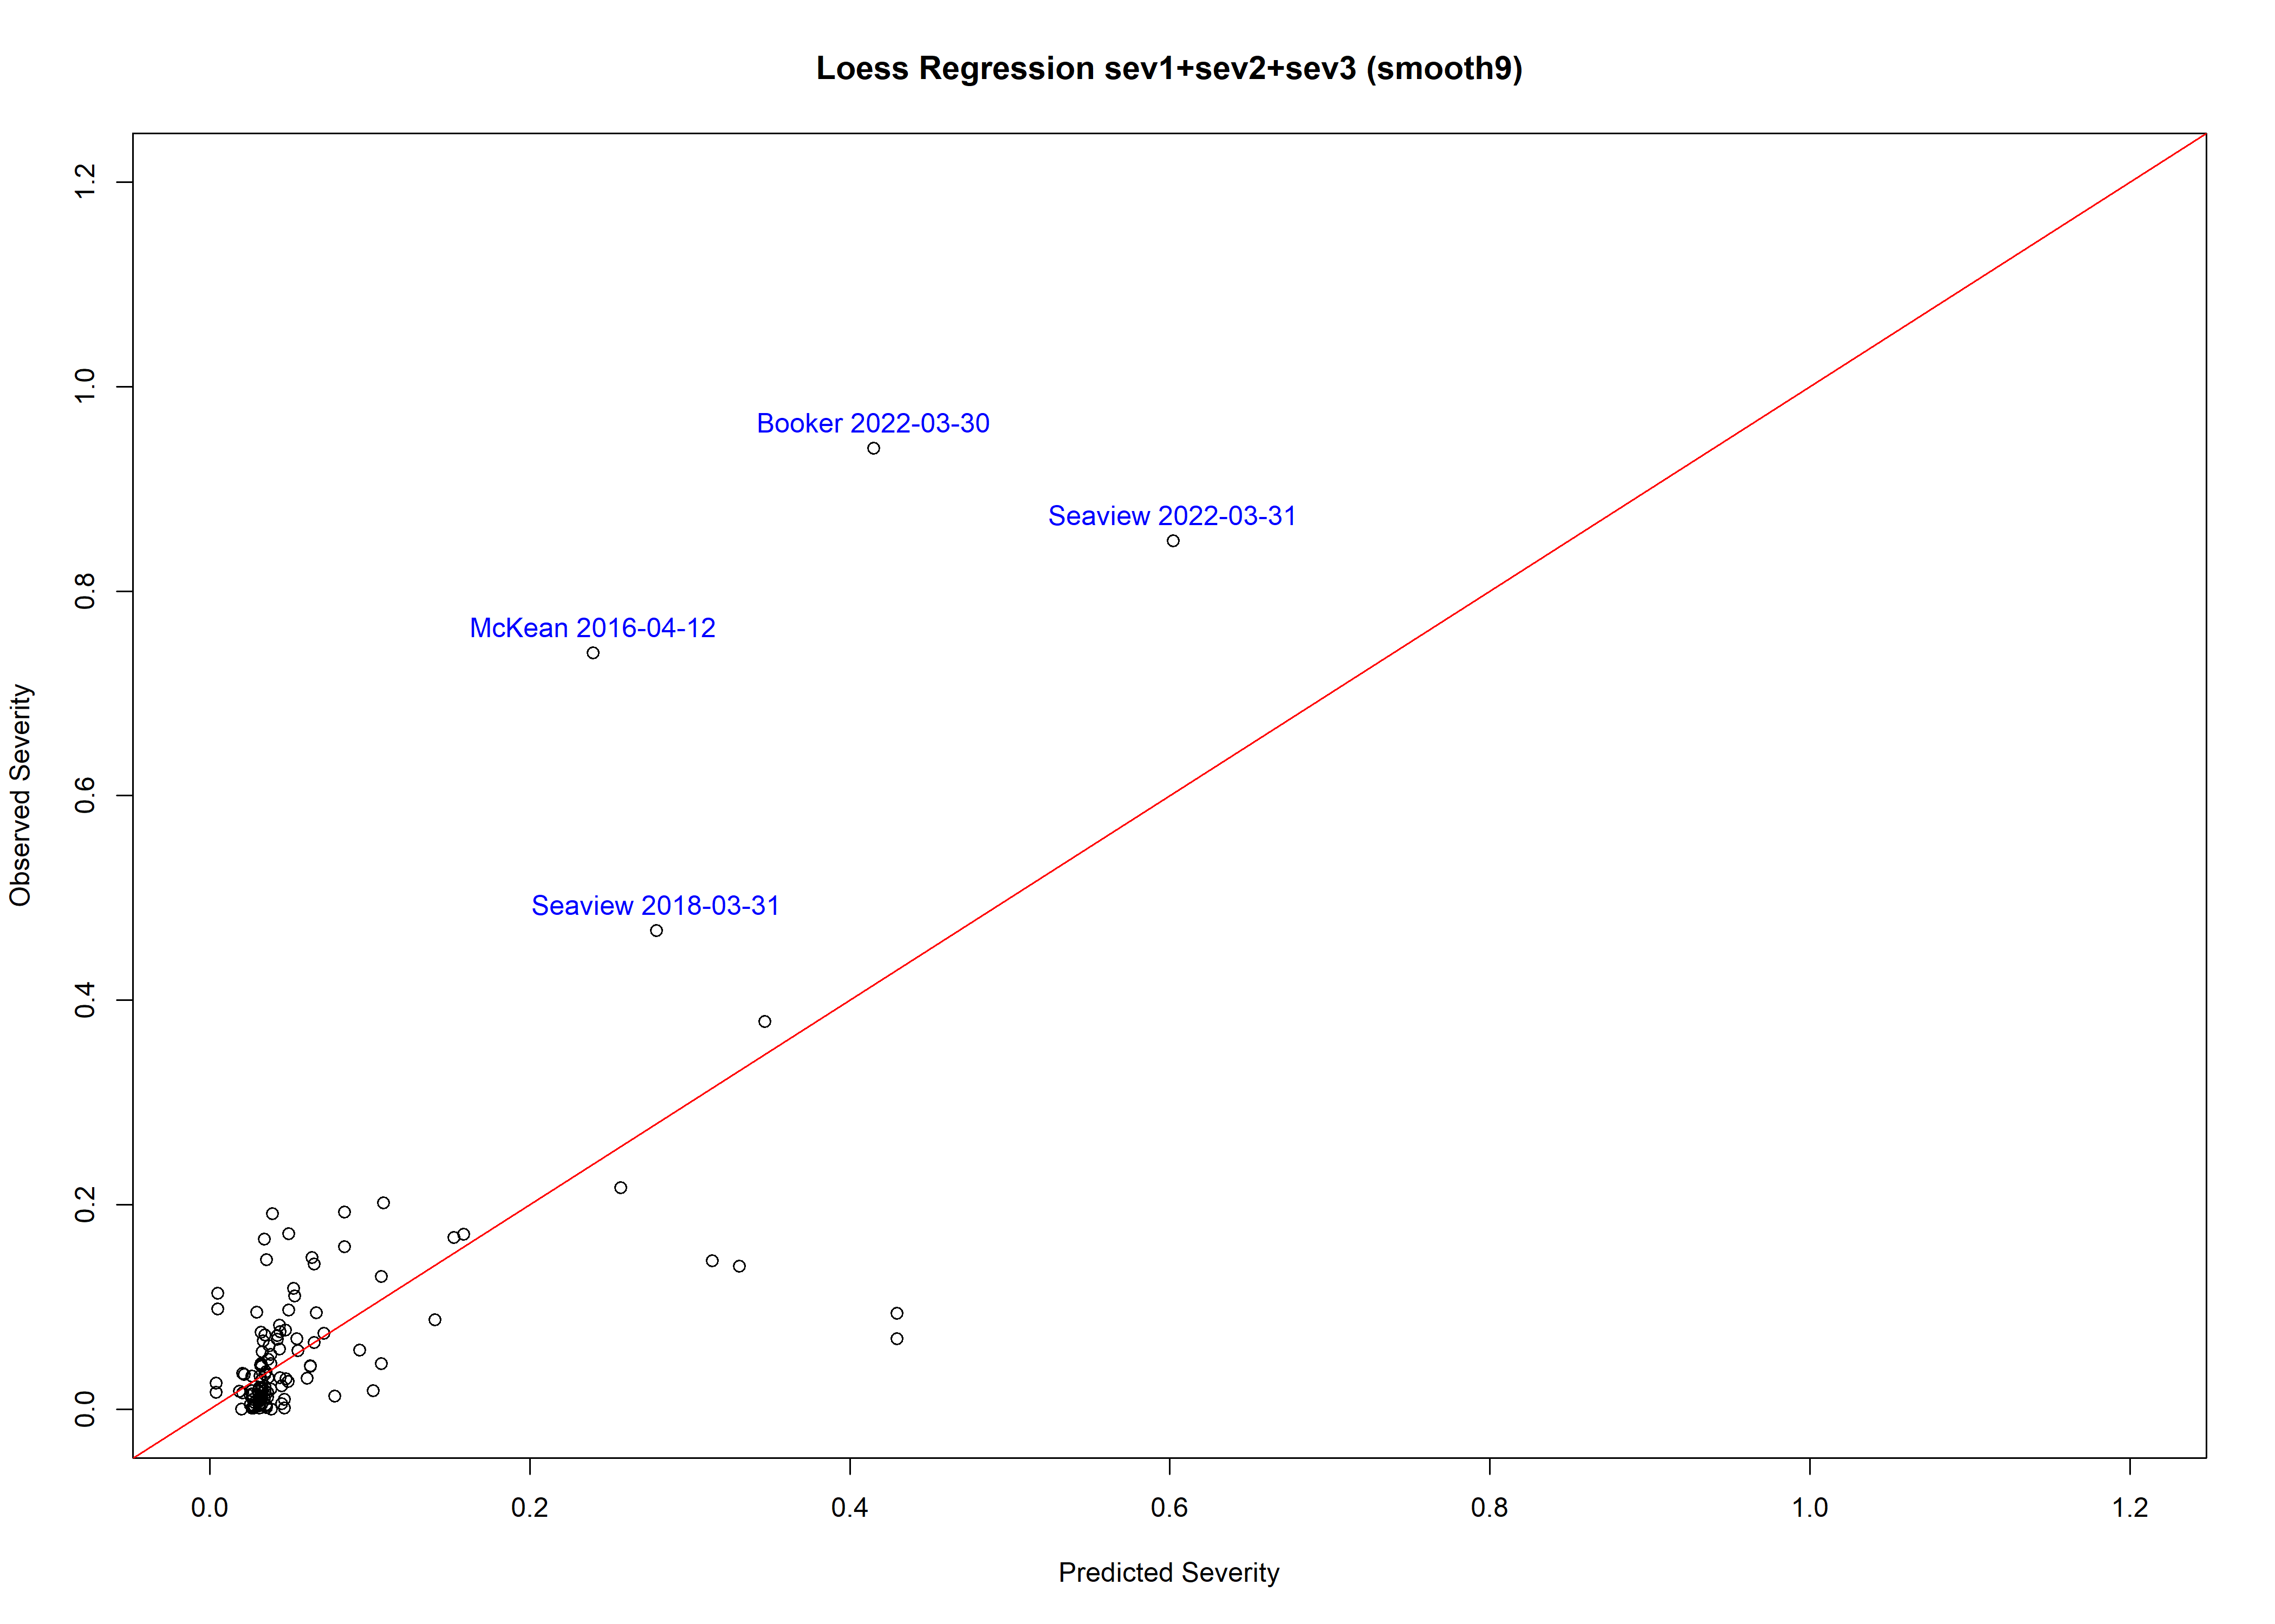

### Fig. 10 Severity and sev1+sev2+sev3 loess regression (smooth0.87) Plot

## Call:  
## loess(formula = Severity ~ sev1 + sev2 + sev3, data = result_sau,   
## na.action = na.omit, span = 0.87)  
##   
## Number of Observations: 119   
## Equivalent Number of Parameters: 13.85   
## Residual Standard Error: 0.1079   
## Trace of smoother matrix: 16.76 (exact)  
##   
## Control settings:  
## span : 0.87   
## degree : 2   
## family : gaussian  
## surface : interpolate cell = 0.2  
## normalize: TRUE  
## parametric: FALSE FALSE FALSE  
## drop.square: FALSE FALSE FALSE

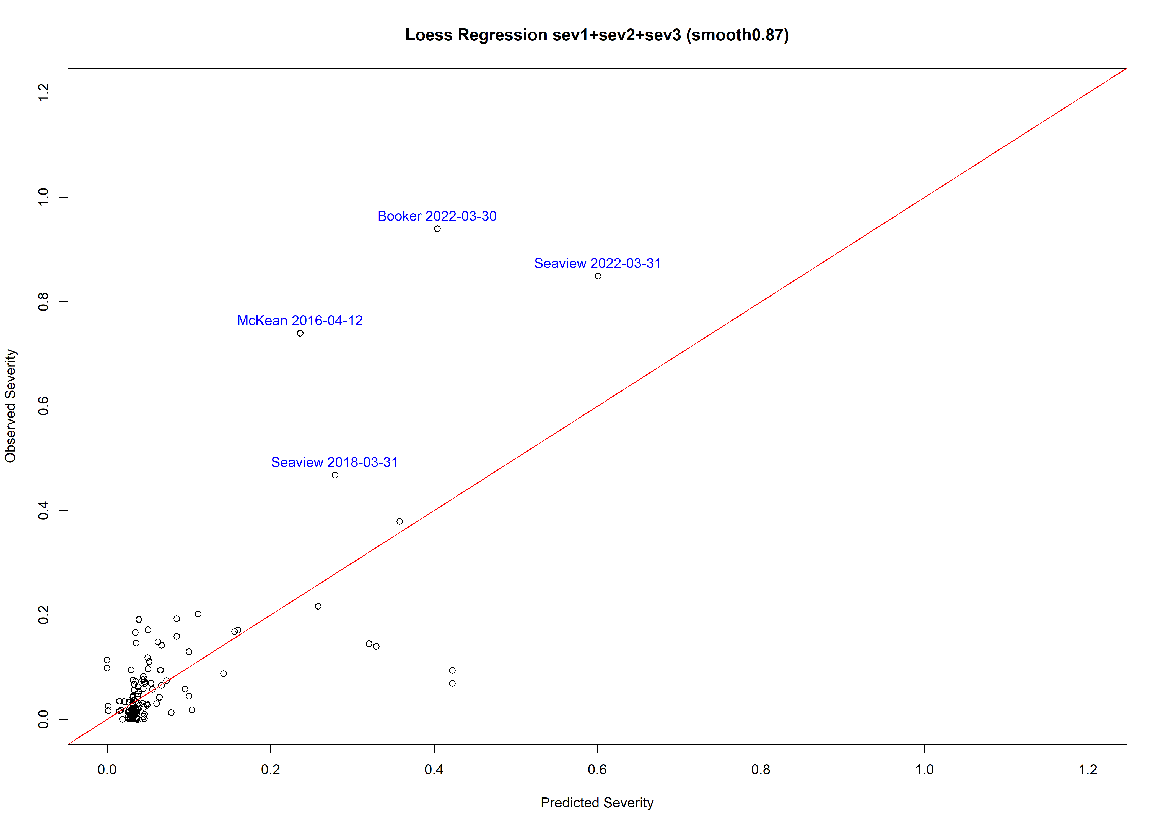

### Fig. 11 Severity and sev1+sev2+sev3 loess regression (smooth0.8) Plot

## Call:  
## loess(formula = Severity ~ sev1 + sev2 + sev3, data = result_sau,   
## na.action = na.omit, span = 0.8)  
##   
## Number of Observations: 119   
## Equivalent Number of Parameters: 14.94   
## Residual Standard Error: 0.1097   
## Trace of smoother matrix: 18.26 (exact)  
##   
## Control settings:  
## span : 0.8   
## degree : 2   
## family : gaussian  
## surface : interpolate cell = 0.2  
## normalize: TRUE  
## parametric: FALSE FALSE FALSE  
## drop.square: FALSE FALSE FALSE

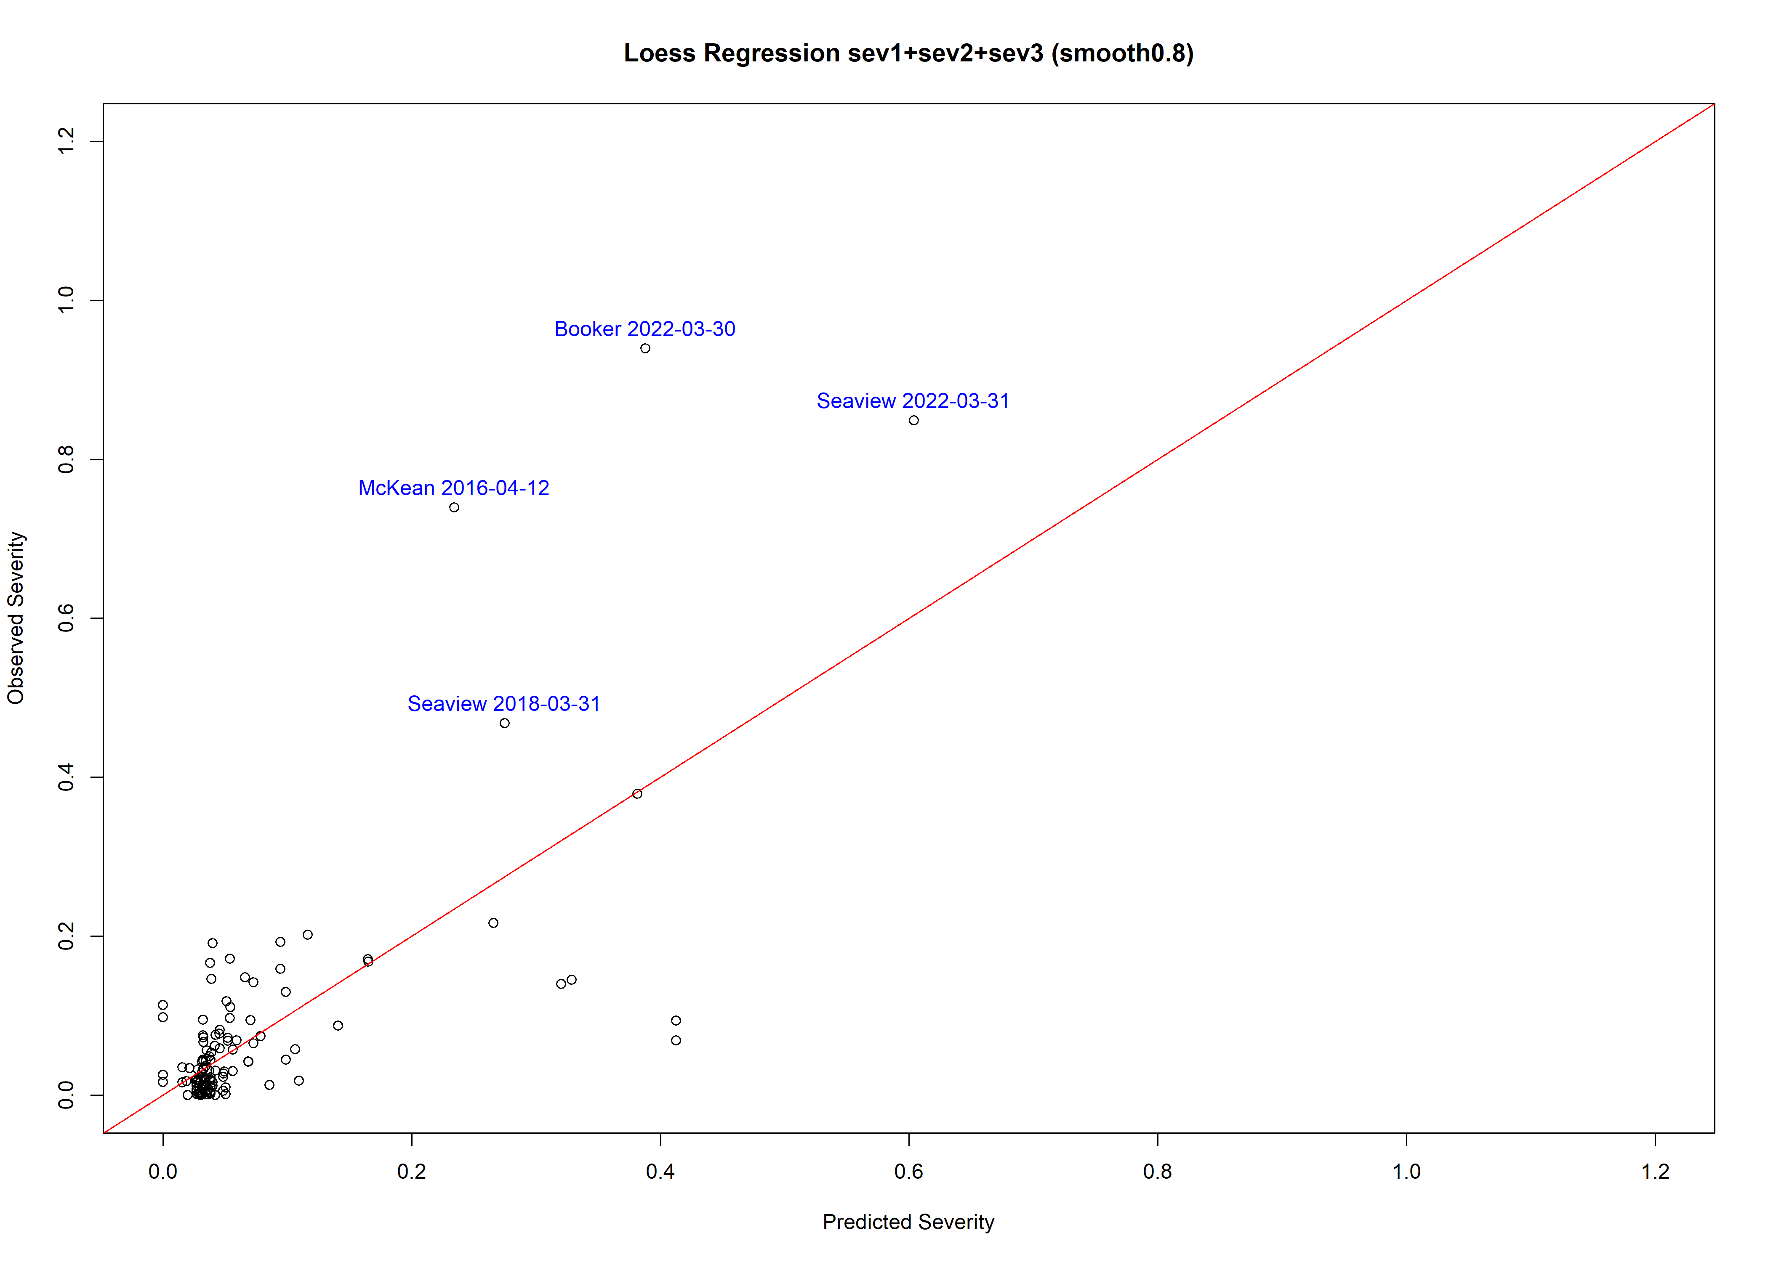

### Fig. 12 Severity and sev1+sev2+sev3 loess regression (smooth0.7) Plot

## Call:  
## loess(formula = Severity ~ sev1 + sev2 + sev3, data = result_sau,   
## na.action = na.omit, span = 0.7)  
##   
## Number of Observations: 119   
## Equivalent Number of Parameters: 16.12   
## Residual Standard Error: 0.1133   
## Trace of smoother matrix: 19.85 (exact)  
##   
## Control settings:  
## span : 0.7   
## degree : 2   
## family : gaussian  
## surface : interpolate cell = 0.2  
## normalize: TRUE  
## parametric: FALSE FALSE FALSE  
## drop.square: FALSE FALSE FALSE

