Botrytis Disease Model Regression

Yao Liu

2023-06-08

# 1. G-D model

This model is coded based on: A Mechanistic Model of Botrytis cinerea on Grapevines That Includes Weather, Vine Growth Stage, and the Main Infection Pathways Elisa González-Domínguez,Tito Caffi,Nicola Ciliberti,Vittorio Rossi Published: October 12, 2015 <https://doi.org/10.1371/journal.pone.0140444>

The mechanistic model developed by González-Domínguez et al. (2015) accounts for weather, vine growth stage, and the main infection pathways. The model considers two infection periods: the first period from “inflorescences clearly visible” to “berries groat-sized,” and the second period from “majority of berries touching” to “berries ripe for harvest.” During the first period, the model calculates the severity of infection on inflorescences and young clusters caused by conidia (SEV1). During the second period, the model calculates the severity of infection on ripening berries by conidia (SEV2) and the severity of berry-to-berry infection caused by mycelium (SEV3).

# 2. Diagram

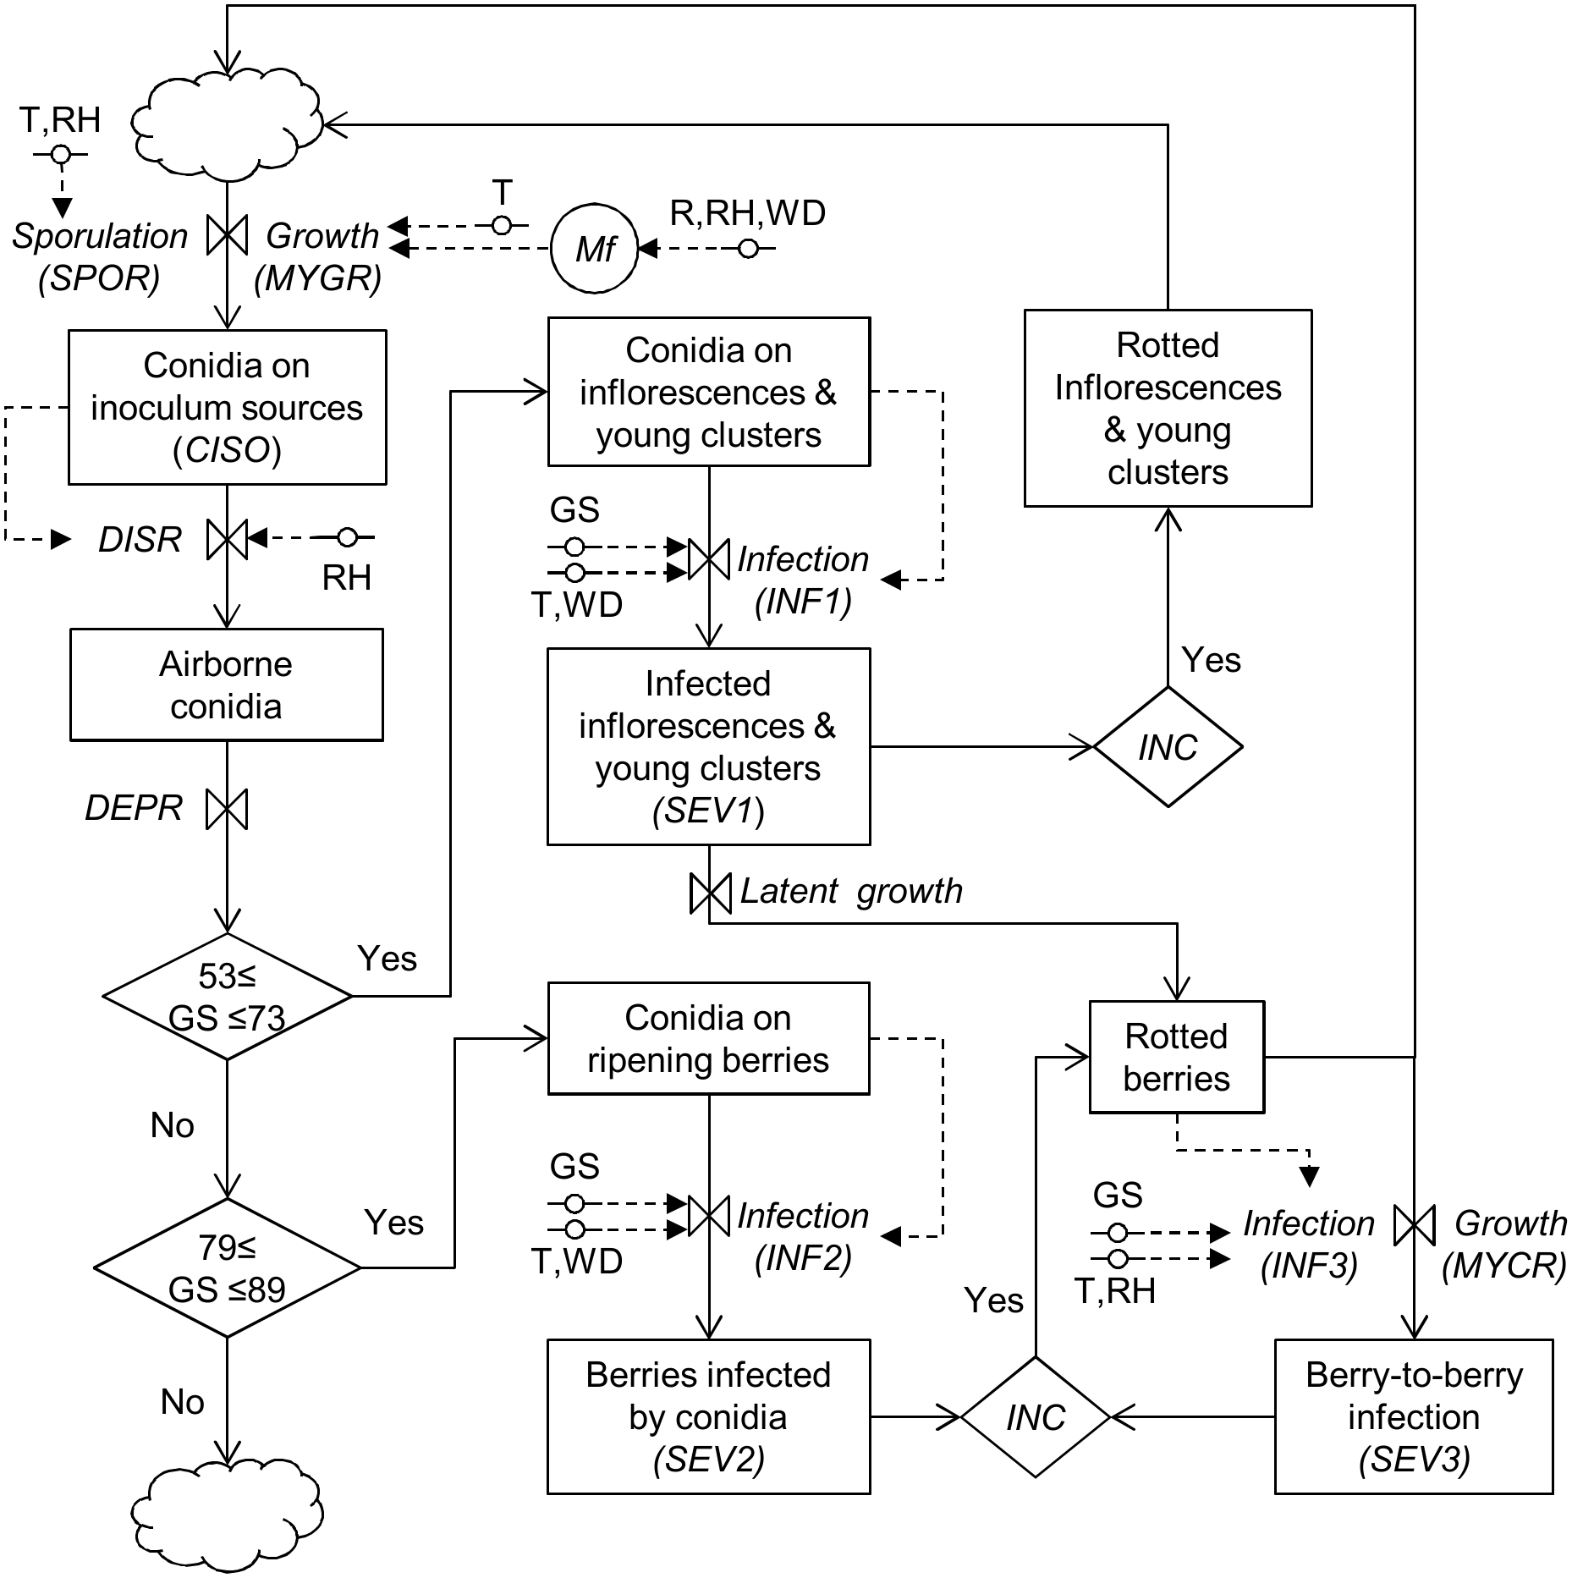

Fig.1 Relation diagram of the model simulating the life ccyle of botrytis cinerea

### Calculate CISO

The relative abundance of conidia on these sources () on any day of the grape-growing season depends on the rate at which the mycelium grows and saprophytically colonises the source tissue () and on the rate of spore production (), as follows:

with

### calculate RISk

**In the first infection window (stages 53 to 73)**, the model calculates an infection rate on inflorescences and young clusters () as:

where = temperature equivalent as described for eq (2), with = 0°C and = 35°C; = wetness duration (in hours); and

In the latter equation, = relative susceptibility of the inflorescences and young clusters, and = growth stage of the plant based on the stages of the scale of Lorenz et al. [31].

Relative infection severity in the first infection window is then calculated as:

**In the second infection window (stages 79 to 89)**, the model calculates two infection rates on ripening berries: one for conidial infection () and another for berry-to-berry infection ().Infection rate for conidial infection is calculated as follows:

where = temperature equivalent as described for eq (2) with = 0°C and = 35°C, and

Relative infection severity for conidial infection is then calculated as follows:

Infection rate for berry-to-berry infection during the second infection window is calculated as follows:

where = temperature equivalent as described in eq (2) with = 0, and = 30°C, and

Relative infection severity for berry-to-berry infection is then calculated as follows:

Daily values of relative infection severity (i.e., RIS1, RIS2, and RIS3) are finally accumulated over the time of the infection window that they refer to. These accumulated values produce new variables (named SEV1, SEV2, and SEV3, respectively), which provide a picture of the total risk of infection.

# 3. Visual Severity shown in Figure 2

Data of Booker, Oyster Bay, Seaview, Squire, Villa, Matua River Terrace, McKean, Rarangi are used to analysis, and a data with a severity equal to 1 in Villa is removed.

Fig. 2 Sauvignon Blanc severity in Marlborough

# 4. Compare different models

In this section, my objective is to compare the simulation effects of the model under different combinations of variables. The input data for severity and other variables can be found in "Sauvignon blanc Severity calculation result.csv."

Fig. 3 displays a correlation matrix chart. The diagonal represents the distribution of each variable. Below the diagonal, bivariate scatter plots with a fitted line are depicted. Above the diagonal, the correlation values are presented along with the corresponding significance levels represented by stars. The correlations of sev2, sev3, sev23, rh_sev1, rh_sev22, rain_sev23, and Severity have passed the 0.001 significance level. Additionally, the correlations of sev1, tmin_sev1, and Severity have passed the 0.05 significance level.

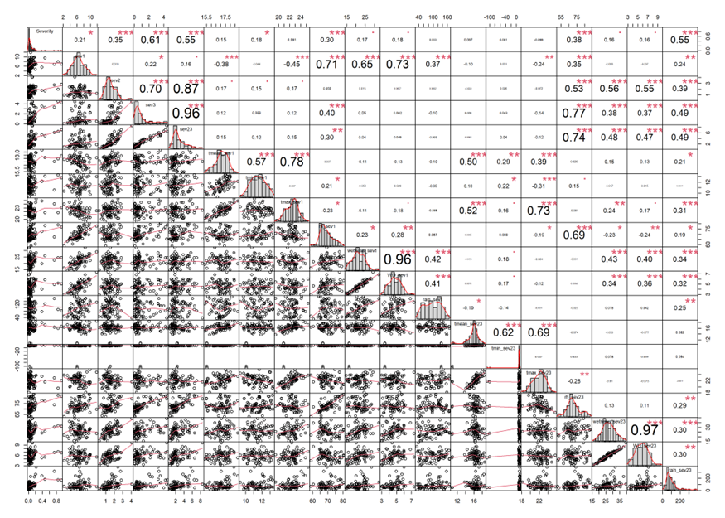

Each significance level is associated to a symbol: p-values( 0.001, 0.01, 0.05, 0.1, 1) <=> symbols(“***”, “**”, “*”, “.”, " “)

Fig. 3 Chart of correlation matrix

The top ten R2 or adjusted R2 values for the lm, lmer, and loess models are provided in Tables 1, 2, and 3, respectively. For a visual comparison of the model simulation results with Visual Severity, please refer to Figures 4, 5, and6. Additionally, all model outcomes are available in the respective files on OneDrive. Result files in OneDrive:

compare_lm_models.csv

compare_lmer_models.csv

compare_loess_models.csv

compare_gam_models.csv

compare_glm_models.csv

Upon comparing the results, it became evident that the model incorporating sev1, sev2, sev3, sev23, and meteorological variables outperforms the model relying solely on severity variables. Among the models exclusively utilizing severity variables, the combined model of sev1 and sev3 demonstrates the highest performance, achieving an adjusted R-squared value of 0.54.

In the subsequent step, I will focus on the simulation effect of the severity variables. To evaluate its impact, I will apply data transformations to the Visual Severity variable and other relevant variables, such as utilizing logarithmic or exponential functions, and examine the resulting outcomes through fitting. Following that, I will proceed to test the GAM and GLM models to determine if they yield improved results specifically when Visual Severity is approximately 0.05.

**Table 1. R2 coefficient top ten linear models**

|  |  |  |  |  |
| --- | --- | --- | --- | --- |
|  | Formula | R2 | logLik | aic |
| 1 | Severity ~ sev2+sev3+sev23+rh_sev1+rh_sev23+rain_sev23 | 0.47 | 103.05 | -192.10 |
| 2 | Severity ~ sev3+sev23+rh_sev1+rain_sev23 | 0.45 | 100.21 | -188.43 |
| 3 | Severity ~ sev2+sev3+rh_sev1+rain_sev23 | 0.45 | 100.21 | -188.43 |
| 4 | Severity ~ sev2+sev3+sev23+rh_sev1+rain_sev23 | 0.45 | 100.21 | -188.43 |
| 5 | Severity ~ sev2+sev3 | 0.37 | 91.15 | -174.30 |
| 6 | Severity ~ sev2+sev3+sev23 | 0.37 | 91.15 | -174.30 |
| 7 | Severity ~ sev1+sev2+sev3 | 0.37 | 91.56 | -173.13 |
| 8 | Severity ~ sev1+sev3 | 0.36 | 90.79 | -173.58 |
| 9 | Severity ~ sev3 | 0.36 | 90.12 | -174.23 |
| 10 | Severity ~ tmean_sev23 * rh_sev23 + rain_sev23 | 0.34 | 89.68 | -167.35 |

**Table 2. Adj_R_squared top ten linear mixed models**

|  |  |  |
| --- | --- | --- |
|  | Formula | Adj_R_squared |
| 1 | Severity ~  sev2+sev3+sev23+rh_sev1+rh_sev23+rain_sev23+(1|Site) | 0.58 |
| 2 | Severity ~sev2+sev3+rh_sev1+rain_sev23+(1|Site) | 0.55 |
| 3 | Severity ~sev2+sev3+sev23+rh_sev1+rain_sev23+(1|Site) | 0.55 |
| 4 | Severity ~sev3+sev23+rh_sev1+rain_sev23+(1|Site) | 0.55 |
| 5 | Severity ~sev1+sev2+sev3+(1|Site) | 0.52 |
| 6 | Severity ~sev1+sev3+(1|Site) | 0.51 |
| 7 | Severity ~sev2+sev3+(1|Site) | 0.51 |
| 8 | Severity ~sev2+sev3+sev23+(1|Site) | 0.51 |
| 9 | Severity ~sev3+(1|Site) | 0.51 |
| 10 | Severity ~  tmax_sev23 * tmin_sev23 + rain_sev23+(1|Site) | 0.49 |

**Table 3. Adj_R_squared top ten LOESS models**

|  |  |  |
| --- | --- | --- |
|  | Formula | Adj_R_squared |
| 1 | Severity ~sev3+sev23+rh_sev1+rain_sev23 | 0.63 |
| 2 | Severity ~tmax_sev1 + tmin_sev1 + wetness_sev1 + rain_sev1 | 0.58 |
| 3 | Severity ~sev1+sev3 | 0.54 |
| 4 | Severity ~sev1+sev2+sev3 | 0.52 |
| 5 | Severity ~sev2+sev3 | 0.51 |
| 6 | Severity ~tmax_sev1 + tmin_sev1 + rh_sev1 | 0.49 |
| 7 | Severity ~tmax_sev1 * tmin_sev1 + rh_sev1 | 0.49 |
| 8 | Severity ~sev2+sev3+sev23 | 0.49 |
| 9 | Severity ~tmax_sev23 + tmin_sev23 + rain_sev23 | 0.45 |
| 10 | Severity ~tmax_sev23 * tmin_sev23 + rain_sev23 | 0.45 |

**Linear regression Plot**

### Fig. 4 Severity and sev2,sev3,sev23,rh_sev1,rh_sev23,rain_sev23 linear regression Plot

##   
## Call:  
## lm(formula = Severity ~ sev2 + sev3 + sev23 + rh_sev1 + rh_sev23 +   
## rain_sev23, data = result_sau, na.action = na.omit)  
##   
## Residuals:  
## Min 1Q Median 3Q Max   
## -0.23294 -0.05316 -0.00233 0.03738 0.59683   
##   
## Coefficients: (1 not defined because of singularities)  
## Estimate Std. Error t value Pr(>|t|)   
## (Intercept) 0.3418030 0.2476524 1.380 0.170258   
## sev2 -0.0196922 0.0225082 -0.875 0.383488   
## sev3 0.0881999 0.0166394 5.301 0.000000578 ***  
## sev23 NA NA NA NA   
## rh_sev1 0.0064012 0.0034871 1.836 0.069032 .   
## rh_sev23 -0.0114183 0.0048620 -2.348 0.020589 *   
## rain_sev23 0.0007165 0.0001924 3.723 0.000309 ***  
## ---  
## Signif. codes: 0 '***' 0.001 '**' 0.01 '*' 0.05 '.' 0.1 ' ' 1  
##   
## Residual standard error: 0.1045 on 113 degrees of freedom  
## Multiple R-squared: 0.4911, Adjusted R-squared: 0.4686   
## F-statistic: 21.81 on 5 and 113 DF, p-value: 0.00000000000000311

##   
## Number of bootstrap replications R = 999   
## original bootBias bootSE bootMed  
## (Intercept) 0.34180305 0.0074202666 0.19158506 0.33450830  
## sev2 -0.01969224 0.0028707269 0.02152734 -0.01551607  
## sev3 0.08819988 -0.0004927992 0.02686484 0.08694096  
## rh_sev1 0.00640120 -0.0001603496 0.00372028 0.00587437  
## rh_sev23 -0.01141826 0.0000138342 0.00458785 -0.01090651  
## rain_sev23 0.00071646 -0.0000072522 0.00030393 0.00068569

## 2.5 % 97.5 %  
## (Intercept) -0.1488409757 0.832447067  
## sev2 -0.0642849792 0.024900499  
## sev3 0.0552341779 0.121165582  
## sev23 NA NA  
## rh_sev1 -0.0005073232 0.013309733  
## rh_sev23 -0.0210507997 -0.001785714  
## rain_sev23 0.0003351811 0.001097734

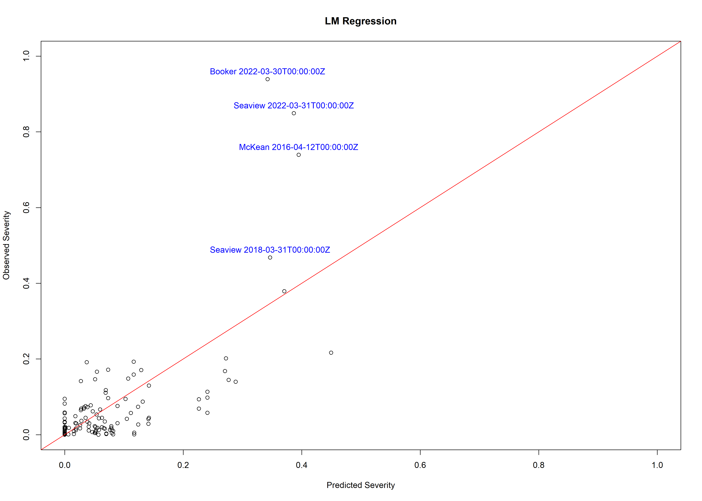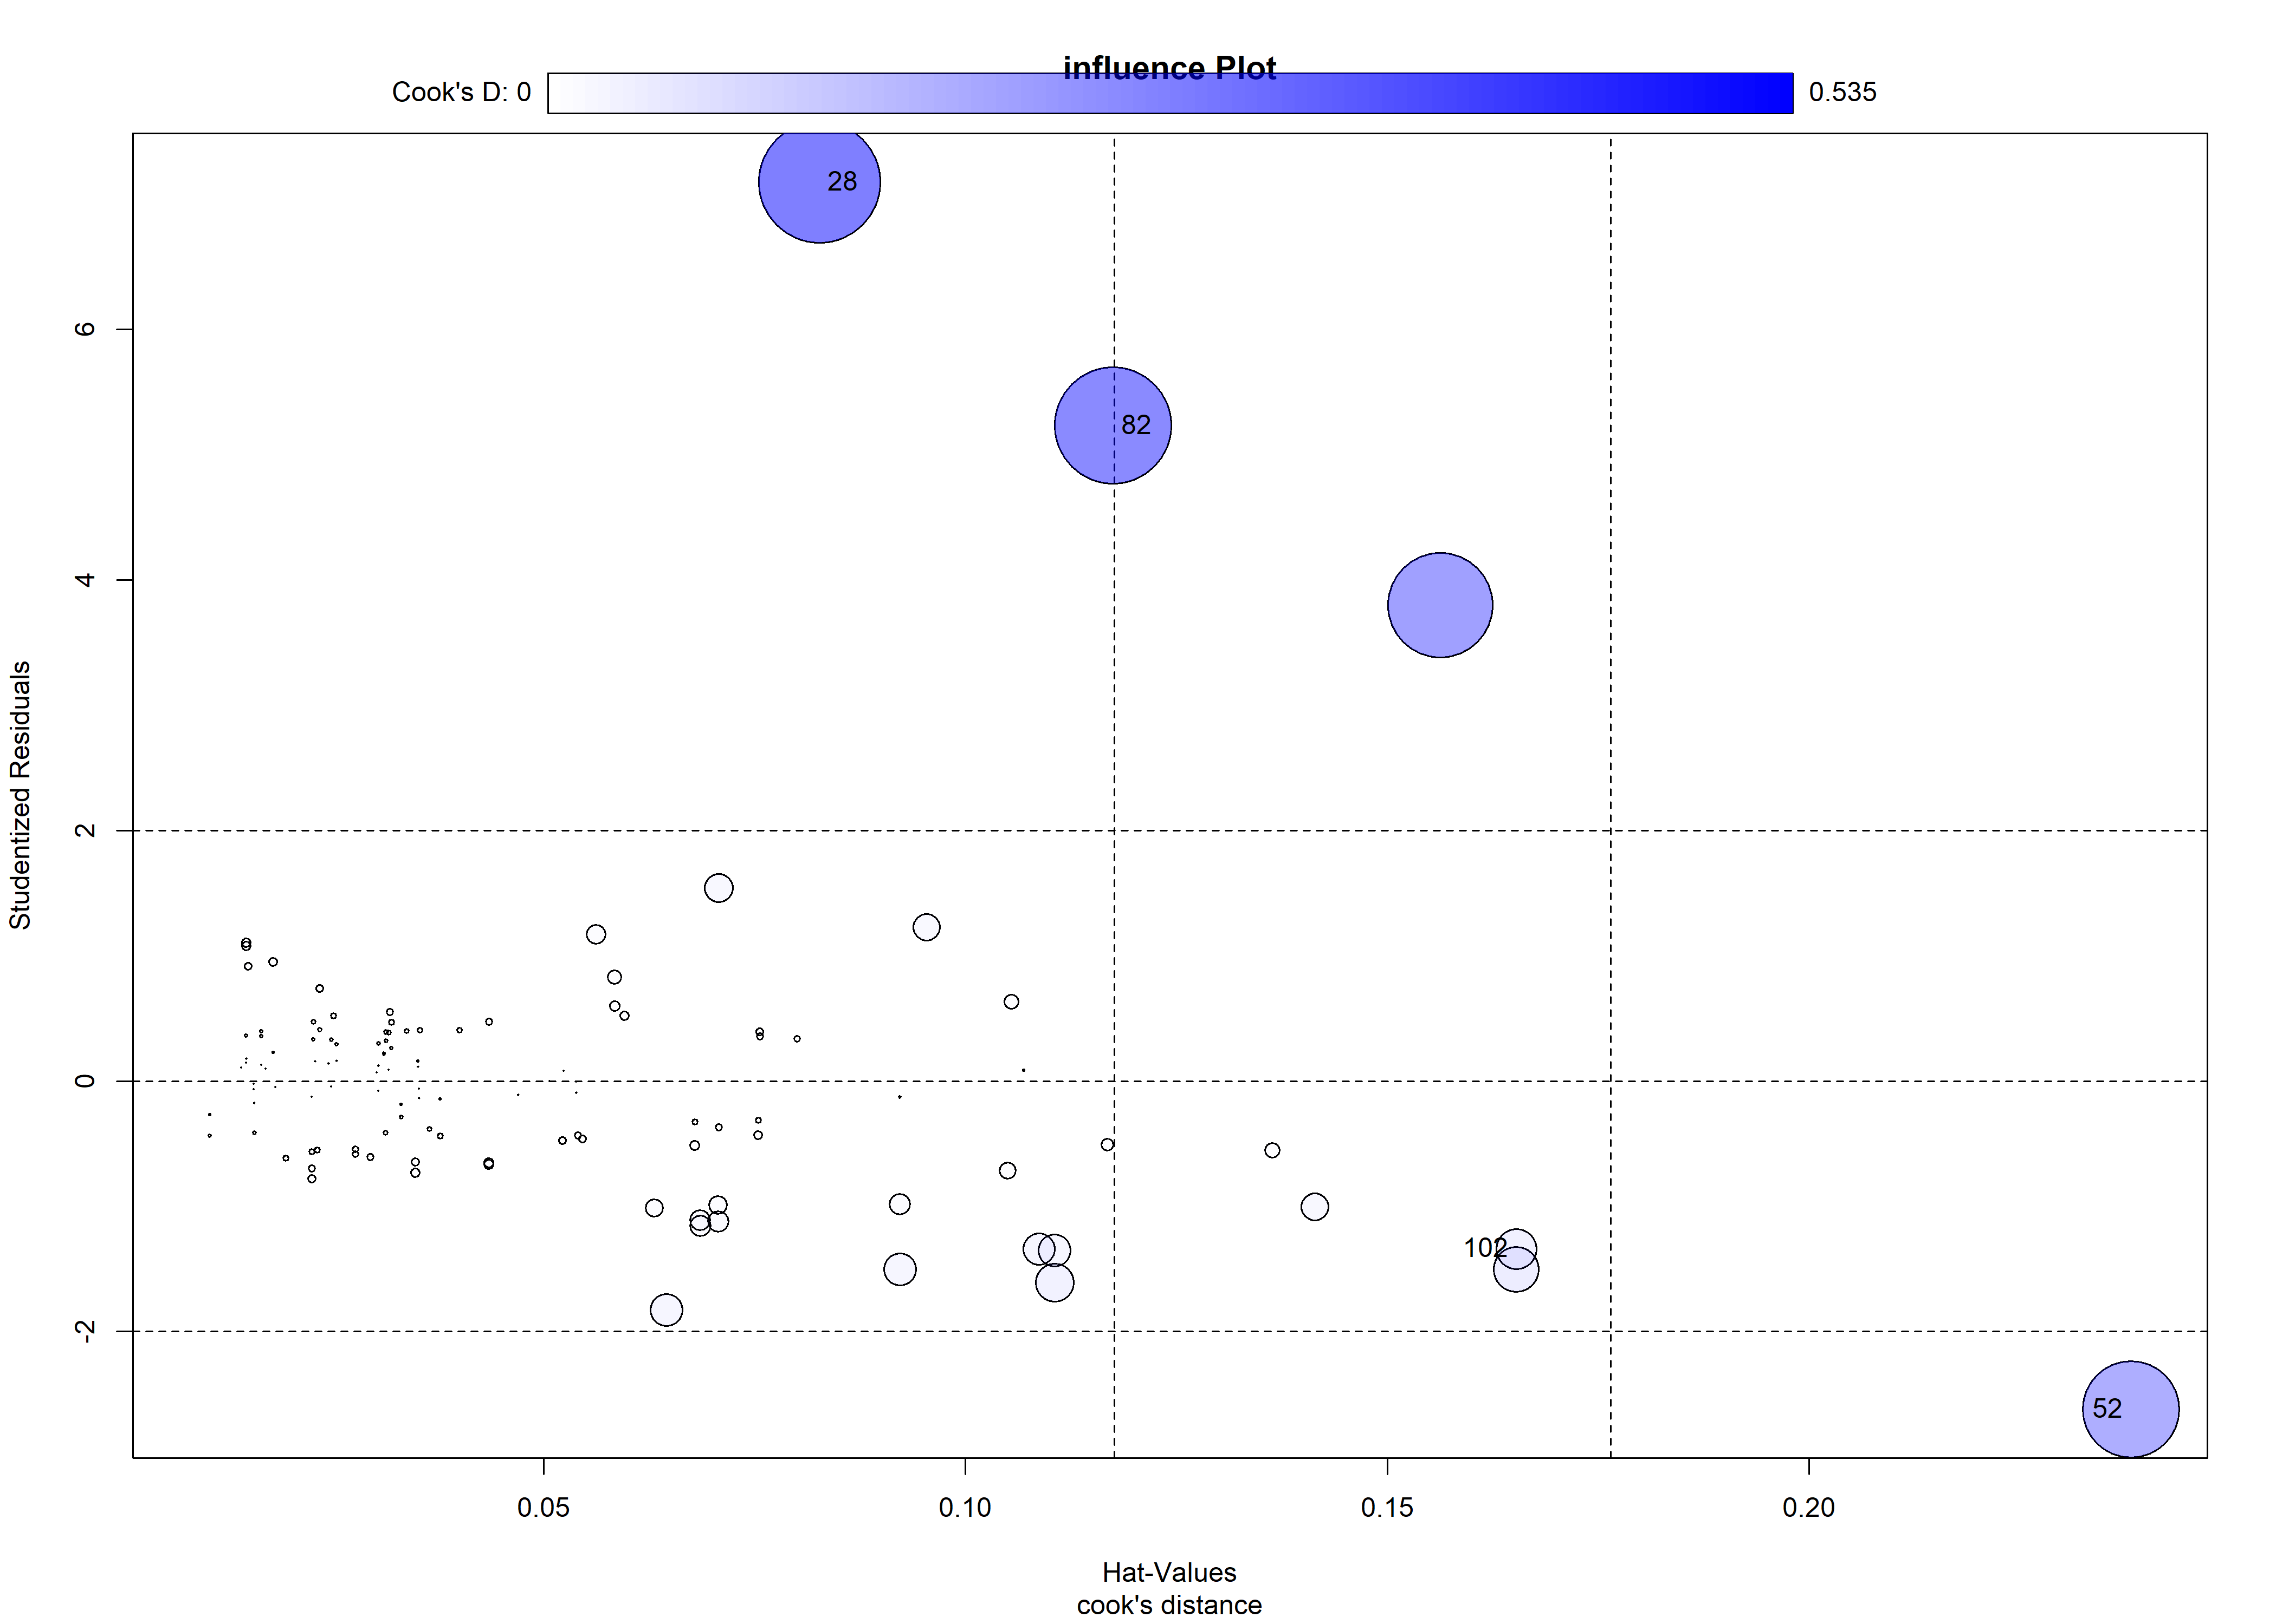

## StudRes Hat CookD  
## 28 7.176298 0.08271242 0.53490609  
## 52 -2.620452 0.23811709 0.34003327  
## 82 5.231663 0.11752722 0.49257641  
## 102 -1.340276 0.16527101 0.05886245

**Mixed linear regression Plot**

### Fig. 5 Severity and sev2,sev3,sev23,rh_sev1,rh_sev23,rain_sev23,Site regression Plot

## Linear mixed model fit by maximum likelihood . t-tests use Satterthwaite's  
## method [lmerModLmerTest]  
## Formula: Severity ~ sev2 + sev3 + sev23 + rh_sev1 + rh_sev23 + rain_sev23 +   
## (1 | Site)  
## Data: result_sau  
##   
## AIC BIC logLik deviance df.resid   
## -196.3 -174.1 106.2 -212.3 111   
##   
## Scaled residuals:   
## Min 1Q Median 3Q Max   
## -2.2427 -0.4214 -0.0221 0.3419 6.0867   
##   
## Random effects:  
## Groups Name Variance Std.Dev.  
## Site (Intercept) 0.002164 0.04651   
## Residual 0.009047 0.09512   
## Number of obs: 119, groups: Site, 7  
##   
## Fixed effects:  
## Estimate Std. Error df t value Pr(>|t|)   
## (Intercept) 0.4033508 0.2557136 111.9064085 1.577 0.11754   
## sev2 0.0059231 0.0230782 118.0260480 0.257 0.79789   
## sev3 0.0774255 0.0159318 117.4948383 4.860 0.00000367 ***  
## rh_sev1 0.0067430 0.0032541 113.6526537 2.072 0.04051 *   
## rh_sev23 -0.0129199 0.0046520 117.8026506 -2.777 0.00638 **   
## rain_sev23 0.0008180 0.0001843 118.5951892 4.438 0.00002050 ***  
## ---  
## Signif. codes: 0 '***' 0.001 '**' 0.01 '*' 0.05 '.' 0.1 ' ' 1  
##   
## Correlation of Fixed Effects:  
## (Intr) sev2 sev3 rh_sv1 rh_s23  
## sev2 -0.147   
## sev3 0.671 -0.466   
## rh_sev1 -0.092 0.444 0.035   
## rh_sev23 -0.702 -0.267 -0.514 -0.636   
## rain_sev23 -0.060 -0.072 -0.326 -0.190 0.147  
## fit warnings:  
## fixed-effect model matrix is rank deficient so dropping 1 column / coefficient

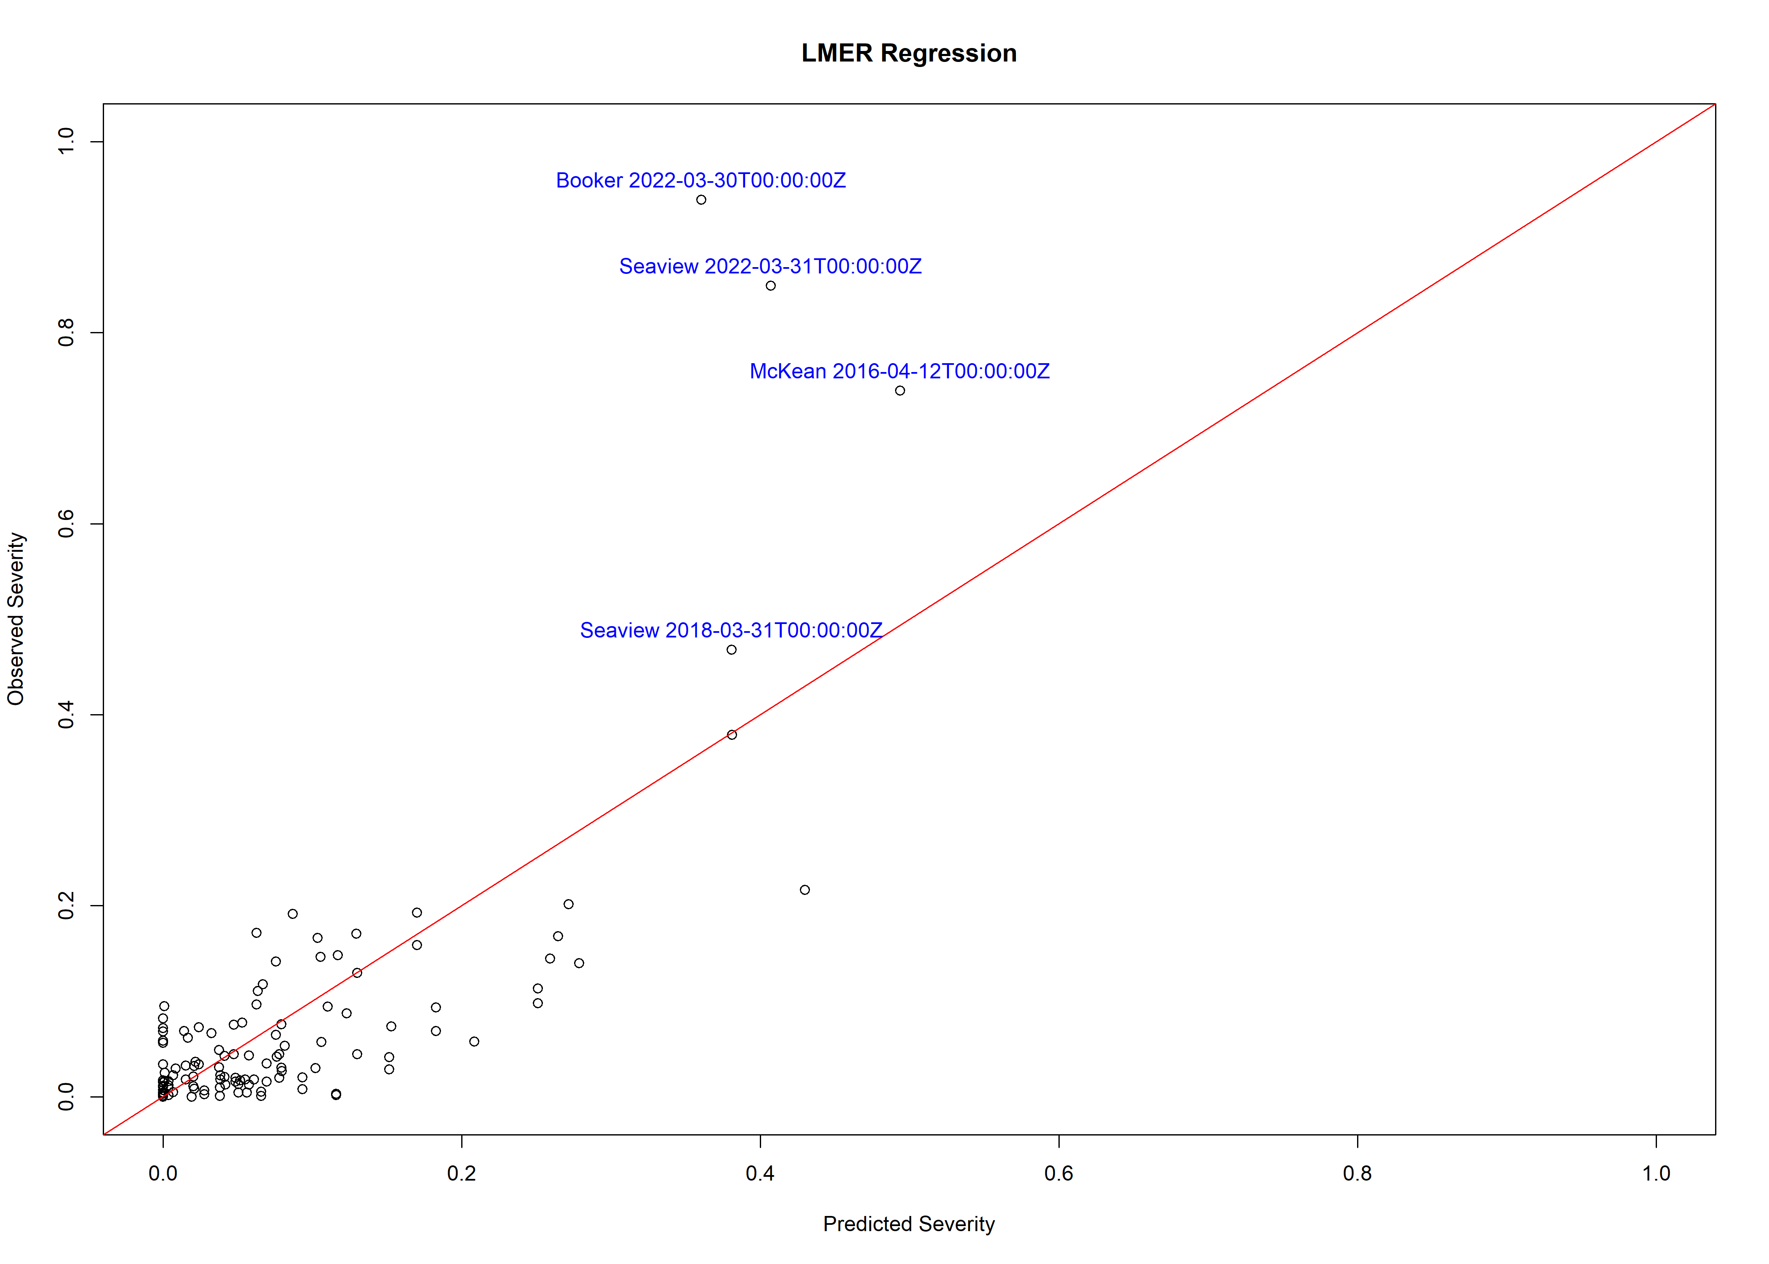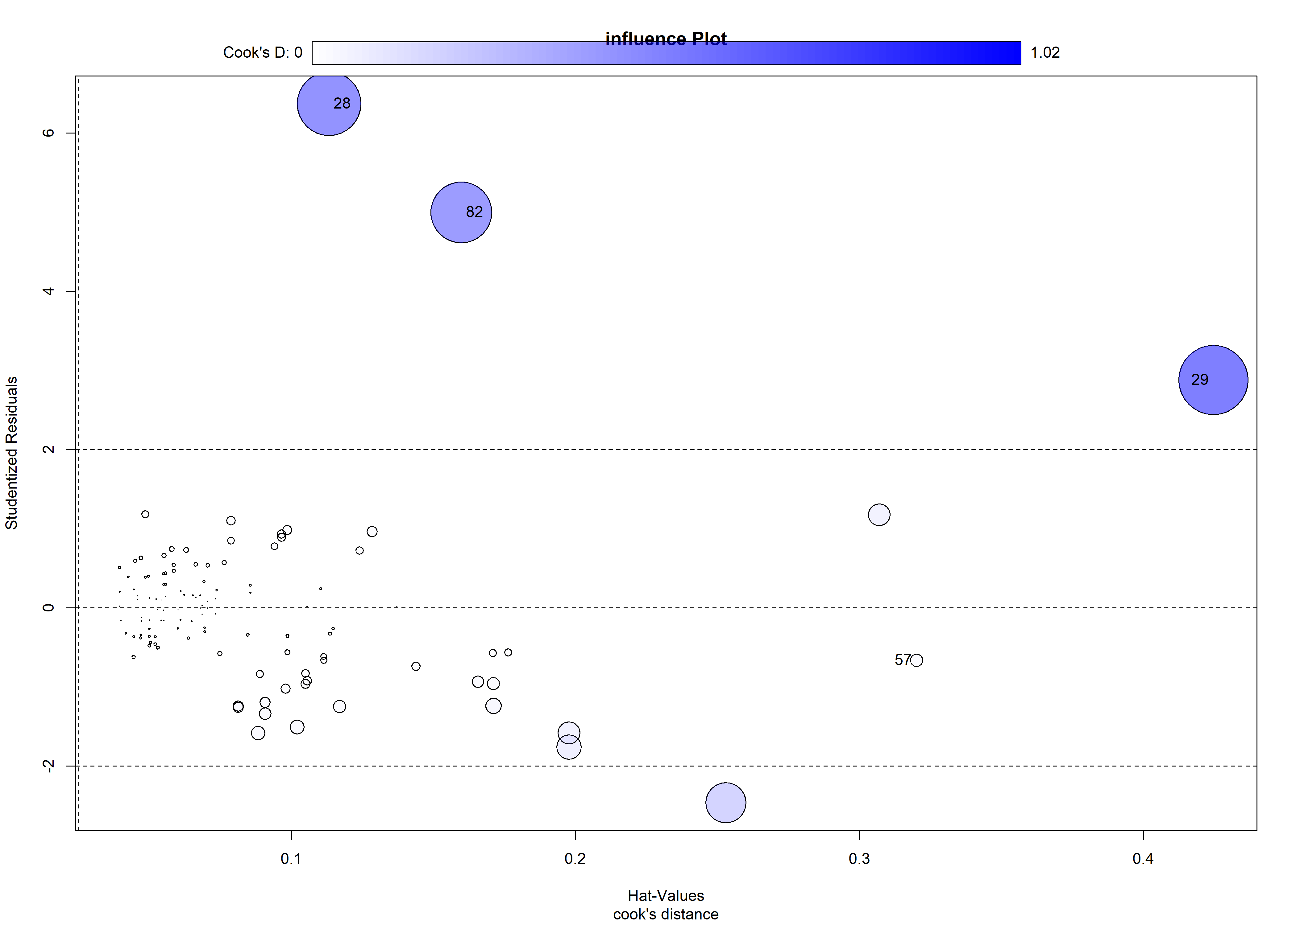

## StudRes Hat CookD  
## 28 6.3705441 0.1133381 0.86460896  
## 29 2.8785131 0.4245991 1.01904563  
## 57 -0.6633314 0.3200855 0.03452404  
## 82 4.9964844 0.1598679 0.79175609

**Loess regression Plot**

### Fig. 6 Severity sev1 and sev3 loess regression Plot

## Call:  
## loess(formula = Severity ~ sev1 + sev3, data = result_sau, na.action = na.omit)  
##   
## Number of Observations: 119   
## Equivalent Number of Parameters: 10.2   
## Residual Standard Error: 0.1034   
## Trace of smoother matrix: 11.97 (exact)  
##   
## Control settings:  
## span : 0.75   
## degree : 2   
## family : gaussian  
## surface : interpolate cell = 0.2  
## normalize: TRUE  
## parametric: FALSE FALSE  
## drop.square: FALSE FALSE

