Progress report Group 19

Plan:

Split up the simulation into three separate pdes:

**Clarice:** Simulate a spring on a pendulum with gravity acting on it.

Progress: Have it nearly done, just need to work out some kinks

with the formulas.

Split up the functionality into two classes:

**Particle** - creates and simulates a particle with forces acting on it (chooses random values for dampening, x/y velocity)

**ParticleSystem** - creates a group of the particles (if I decide to make more than one)

Particle

Particle System (inherits particle methods to make multiple particles.)

**Jon:** Simulate a Block colliding with another block attached to a spring.

Progress: developed physical equations to implement. Still need to code the solution in

Processing.

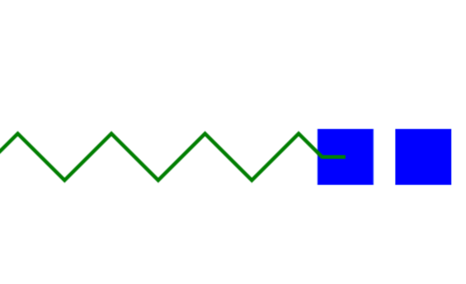

Split up the functionality into one class with two object types:

**Spring** – The spring will follow Hooke’s Law where F=ma=-kx

**Blocks –** These will follow the conservation of momentum principle where (mv)1=(mv)2

**Richard:** Simulate a rocket flying across the screen space, with the forces of gravity and air resistance imposed upon it. A particle system will be added to the posterior of the rocket, giving a smoke emission effect.

Progress: Rocket object has been constructed without the physics of gravity and air drag, particle system has also been developed.

Split into three classes:

Particle: simulates a very light particle of smoke, has values of mass and speed, which may be influenced by the rocket’s force

Particle system: Uses particles to stay positioned at the rocket and simulate multiple particles

Rocket: a rocket object that will have gravity and air resistance components using the mass and position of the rocket to simulate physics via F = ma

