DeuteRater-H ReadMe
Table of Contents
Introduction 2
Version Choice 2
Prerequisites 2
Installation 2
Exe version 2
Python Source Code Version 3
Using DeuteRater-H 3
Activating the Software 3
Create Guide File 4
Rate Calculation – General 6
Rate Calculation – Extract 9
Rate Calculation – Provide Time and Enrichment 10
Rate Calculation – Combine Extracted Files 13
Rate Calculation – Calculate Delta by Enrichment 13
Rate Calculation – Rate Calculation 13
Rate Calculation – Combine Sequence Rates 15
Settings 16
Settings Menu 16
Adjusting Defaults or non-Menu Settings 21
Guide_settings.yaml 22
Settings.yaml 23
Adjusting Resource Files 28
Adding new elements 29
Adjusting Amino Acids 29
Adjusting Post Translational Modifications 30
Adding new Labeling Schemes 32
Citations 32

Introduction
DeuteRater-H is a software tool designed to allow scientists to perform kinetic proteomic experiments on humans or other large animals. It is related to our previously published DeuteRater software package which does the same for smaller animals (available at []). The DeuteRater-H code source code is available at [] with an .exe available at []. This readme will walk through the use of the software. For proper experimental design please reference the paper [].

Version Choice
It is recommended that unless you need to alter the source code for some reason that you download the .exe as it is easy to use and should be resistant to bugs caused by the underlying python modules updating.

Prerequisites
Both versions require a Windows operating system (they have only been tested on Windows 10, but other Windows versions may work as well).
Python source code was created in Python version 3.8.1, therefore that is the minimum python version recommended. Most imports are included in the basic python install, however you must ensure the follow packages are installed:
- PyQt5
- tqdm

Installation

Exe version
Download the zip folder from []. Extract the folder to a location you can find easily on your hard drive. Inside the unzipped folder will be an .exe file:
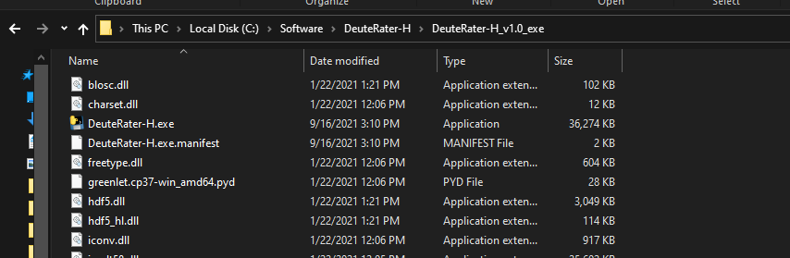
Double click this .exe (or call it from the command prompt) to open DeuteRater-H. Nothing can be removed from this folder without risk of causing an error. If the position of the .exe is inconvenient you can right click on the .exe file and select “Create shortcut”. The shortcut can be moved anywhere you desire without causing an error.

Python Source Code Version
Download the code from []. All folders must be in the same directory for the code to work. Use a command prompt to call the __main__.py using python:
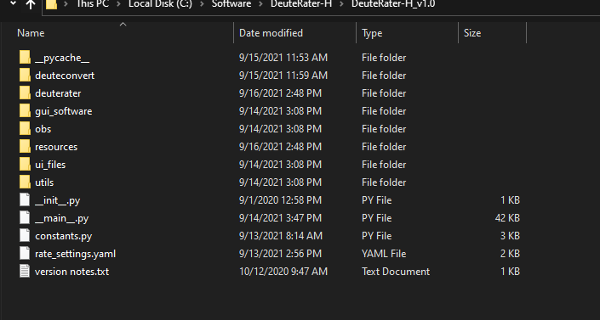
It doesn’t matter if you call the full path including __main__.py, just the parent folder path, or cd into the directory and call __main__.py from there.

Using DeuteRater-H

Activating the Software
With the .exe version, double click on the .exe file or call the .exe on the command prompt. If using the python version, call __main__.py from the command line. This will open two windows. The first is the command prompt if you did not use it to open DeuteRater-H. It will be used to display progress bars and any errors that cause DeuteRater-H to fail:
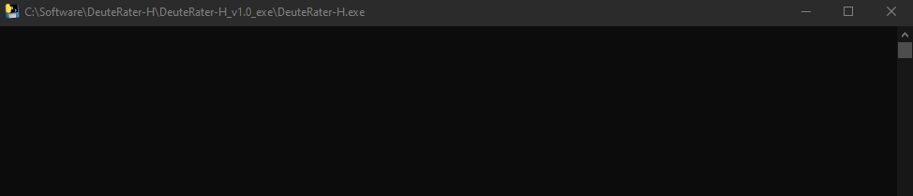
Next is the main interface window that governs all of DeuteRater-H’s operations:
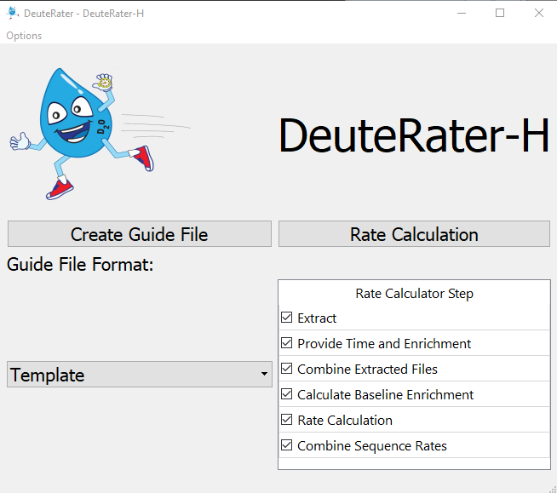
We will go through each step in the workflow with input and output requirements. The first step is to collect the information we need to start the analysis.

Create Guide File
On the left of the interface is the “Create Guide File” button. A Guide File is a file containing all of the peptides you expect to see in your mass spectrometry files along with information to assist DeuteRater-H in locating the appropriate features, such as retention time and mass, as well as data that will be needed later such as the peptide sequence.
How the guide file is created is governed by the pulldown menu below the “Create Guide File” button. The default “Template” setting is best if you have not used PEAKS to identify your msms data.
When you click “Create Guide File” with “Template” selected for the pulldown, you will be prompted for a location and a save file name. What you name this file and where you put it do not matter, so long as you can find it again. The file will be a .csv (comma separated values) file which can be opened in any spreadsheet program such as Microsoft Excel.
The following columns must be filled out or analysis will not proceed: Sequence, Protein ID, Precursor Retention Time (sec), Precursor m/z, and Identification Charge
The following columns are needed for analysis but will be filled in by DeuteRater-H if left blank (do note that if any blanks are present in any of these columns, all data in any of these columns will be overwritten): Peptide Theoretical Mass, cf, neutromers_to_extract, and literature_n
All other columns are for the user’s information and may be left blank or filled with data as you wish. A description of all columns follows:
Sequence – the amino acid sequence. It should be in the form of single letter amino acid code. Post translational modifications (PTMs) should be included here. The recognized PTMs are found in the file “aa_elem_compositions.tsv” in the resources file of your DeuteRater-H download. This will be detailed in sections “Adjusting Amino Acids” and “Adjusting Post Translational Modifications”.
Protein ID – a unique identification code for the protein this peptide belongs to.
Protein Name – common name of the parent protein
Precursor Retention Time (sec) – the middle of the elution peak for this peptide. Time unit is set in the settings menu (default is seconds)
rt_start – the start of the elution peak.
rt_end – the end of the elution peak.
rt_width – the width of the elution peak.
Precursor m/z – observed m/z of the peptide
Peptide Theoretical Mass – the theoretical neutral mass of this peptide
Identification Charge – observed charge state
ptm – post translational modifications observed
avg_ppm – the average ppm mass error in the observed peptide
start_loc – the location the peptide begins in the protein
end_loc - the location the peptide ends in the protein
num_peptides – number of peptides observed for this protein in this analysis
num_unique – number of peptides observed for this protein in this analysis
Homologous Proteins – identifiers for homologous proteins for this peptide sequence
species – the species this protein is from
gene_name – the identifier for the gene associated with this protein
protein_existence – a code to indicate the confidence that this protein is biologically relevant
sequence_version – a legacy setting from a previous version. Leave it blank.
cf – chemical formula in standard format (e.g. C34H60N10O10)
neutromers_to_extract – number of isotopes to consider
literature_n – the number of deuteriums that can be incorporated
Only peptides you put into this document will be included in the search, so if you wish to search for multiple post translational modifications, or multiple charge states each must be on a separate line.
If necessary columns are not completely filled or there is a problem autofilling the necessary columns, an error message will appear as shown below. Correct the problem, save the file, and proceed.
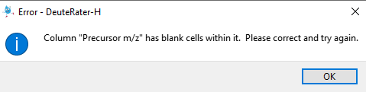

Rate Calculation – General
The main portion of DeuteRater-H is the Rate Calculation button (red box below) which starts the analysis by going through each step checked in the “Rate Calculator Step” table (blue box below):

We will go over each step individually but first, a few general rules about it. All steps that are checked must be next to each other. If there is a gap, you will get an error message:
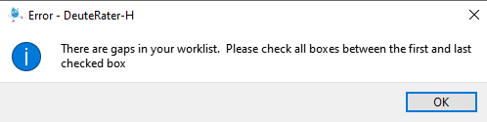
No matter which step is checked, you will be asked to select a folder at first:
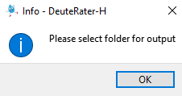

The names of the output files are always the same. If you have used the folder you select, you will get two messages. The first will notify you that there is a settings output (settings.yaml) present. You will be given the option to use the settings in the folder (“Use Settings”) or overwrite this file and use the settings you have currently set in DeuteRater-H (“Overwrite”):
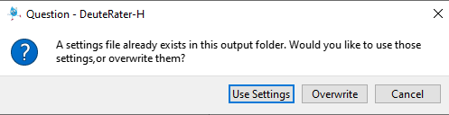
Second, if there are output files for a step that is currently checked present in your folder, you will be given a warning that you are going to overwrite output files. “Yes” overwrites the files, “No” returns you to the main DeuteRater-H interface, and “Show Details” will list the files that will be overwritten so you may make an informed decision. You can rename your files to avoid them being overwritten, but that must be done manually. DeuteRater-H will not do it for you:
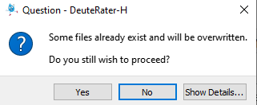
In addition to output spreadsheet files, three steps (“Provide Time and Enrichment”, “Rate Calculation”, and “Combine Sequence Rates”) produce folders of graphs. If this step is redone in the same parent folders, the graph subfolders will be deleted with all their contents.
If a file is open in another program while an overwrite is occurring, it cannot be overwritten. You will be given an error message and returned to the main interface. This will also occur if you are attempting to write to a folder which DeuteRater-H does not have permission to write to for whatever reason.
Each step will produce a .tsv output file. These are tab separated text documents which can be opened in any text editor or spreadsheet program like Microsoft Excel. The .tsv step from a one step can be used as the input file for the next step in the Rate Calculator, allowing you to start and stop if necessary (e.g. to redo part of the analysis with different settings). Be warned, that except for the guide file, DeuteRater-H will only check your input file for proper filetype and column names. It will not check that the data makes sense. Be careful changing intermediate files before re-using them as an input file for a later step, because changes may cause DeuteRater-H to error out or give nonsensical results.
When running a worklist, rate_settings.yaml will be saved in your output file. This should allow you to track what settings were used for each analysis should that be necessary.

Rate Calculation – Extract
The first step of Rate Calculation is “Extract”. The purpose of the Extract step is to find neutromers in centroided MS1 mass spectrometry data. This requires two things. The first is the Guide file that you created earlier (see “Create Guide File” section) and the second is one or more .mzml files. The .mzML files need to be centroided and ms level 1 only. If you require a utility to transform your mass spectrometry data, the msconvert tool from proteowizard can do this¹. Us the peakpicking setting to centroid.
First you will be asked to provide the guide file:
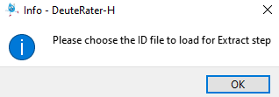
Navigate to wherever you have the guide file and select it. You will then be prompted to select your .mzML files. You may select one or several at once:
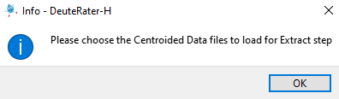
This may prompt another window warning about overwriting files if you selected files that have already been extracted. This is because DeuteRater-H does not know the filenames of the extracted outputs until you choose the .mzML files to extract, so cannot determine which files may be overwritten.
Each .mzML you provided to DeuteRater_H will have a corresponding output file. The file will have the same name as the original with a .tsv extension instead of an .mzML extension. The file will be the same as the guide file with several extra columns:
Id_index – an internal index of the file
Mz – calculated m/z value
Z – charge state
Rt – retention time in minutes
N_isos – neutromers to extract
Mass – neutral mass
Mzs – the actual mzs found in the .mzML
Abundances – the actual abundances found in the .mzML
lookback_mzs – mz of the isotope peak in front of the first neutromer extracted if the extractor is extracting on an isotope other than the first
lookback_abundances – abundance of the isotope peak in front of the first neutromer extracted if the extractor is extracting on an isotope other than the first
lookahead_mzs – mz of the isotope peak behind the last neutromer extracted if the extractor is extracting insufficient neutromers.
lookback_abundances - abundance of the isotope peak behind the last neutromer extracted if the extractor is extracting insufficient neutromers.
rt_min – minimum retention time observed
rt_max – maximum retention time observed
baseline_signal – abundance of the baseline in the area around this neutromer envelope
signal_noise – irrelevant
mads – an error metric
mzs_list – only filled for chromatography division setting.
intensities_list – only filled for chromatography division setting.
rt_list – only filled for chromatography division setting.
baseline_list – only filled for chromatography division setting.
num_scans_combined – the number of scans used to generate relevant values.
mzml_path – the path to the mzml file used for this data
Columns mzs to num_scans_combined are only filled in if data was found for this row. If data was not found, and all of these columns are blank, the rows will be discarded in step “Combine Extracted Files”.
You will see progress bars on the black command prompt that appeared with the interface (or the normal command prompt if you called the program from there). Do note that if you have “Provide Time and Enrichment” checked, you will be prompted to fill out the tables associated with that step after selecting .mzMLs but before the actual extraction happens. This is so you can walk away from the analysis without it stalling to ask for your input halfway through.

Rate Calculation – Provide Time and Enrichment
The purpose of the “Provide Time and Enrichment” is to provide information on the .mzml files you are using. If you are starting with this step you will be asked to select the output .tsvs from an extractor step, otherwise it will continue with the data that was used in the extractor. If step is checked you will be provided with a table like the following:
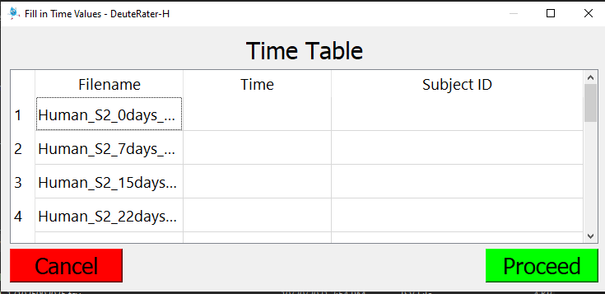
Each extracted .tsv file will be present in the “Filename” column. You must fill out the “Time” column and the “Subject ID” column.
“Time” must be the time since the beginning of deuterium labeling in the subject. Days is the best unit for time. DeuteRater-H can use any time unit so long as it is consistent, but several later filters are calibrated for time data being in units of days.
“Subject ID” is a label that will applied to your data. Different Subject IDs will not be mixed at later steps in the analysis. This can be useful for separating data from different subjects in the same analysis, separating different tissues for the same subject, or for simply providing an identifier to this data which will be preserved as a column in every output and as part of the title of every graph. Do keep in mind that to a computer “A” and “a” are different and a space “ “ is considered a character so be careful to make each Subject ID for the same subject (or whatever you wish to mark) exactly the same.
Ctrl+c for copy, Ctrl+v for paste and del and backspace for delete are enabled for this table and the next one.
Fill out the table and hit the green “Proceed” button. The red “Cancel” button will prevent further analysis and return you to the main interface. If there is a problem with the data you entered, such as a missing value or a non-numeric or negative time, a warning message will appear. You must correct the problem
After you hit proceed, another window will appear:
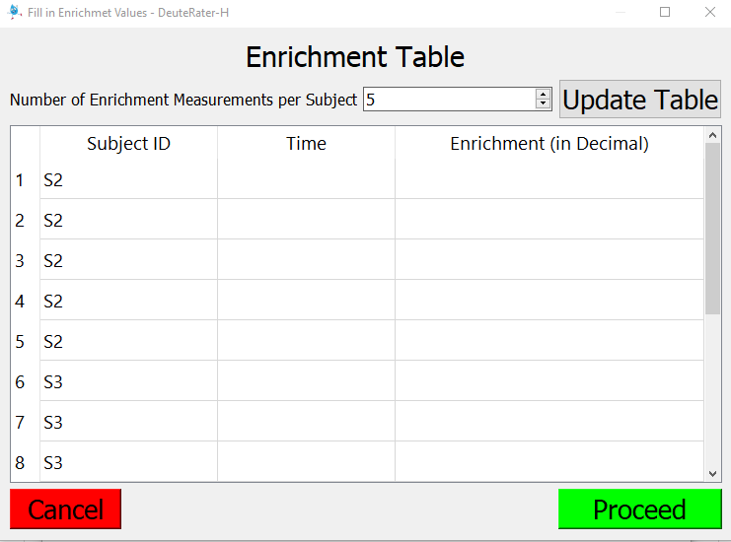
DeuteRater-H needs to know how the deuterium enrichment changes over time for each subject. To start, adjust the “Number of Enrichment Measurements per Subject” box to the maximum number of enrichment measurements any subject has and press the “Update Table” button. This will ensure each subject has enough row to fill in. If subjects have different numbers of measurements, for example if S2 in the table above has 10 measurements, but S3 has only 5, set the “Number of Enrichment Measurements per Subject” to the higher value (10) and leave the extra rows for the subject with less blank. So long as both “Time” and “Enrichment (in Decimal)” are blank, DeuteRater-H will discard the empty column with no problem.
“Time” is the Time using whatever units you used in the last table (days are the preferred unit). “Enrichment (in Decimal)” is the amount of deuterium in the body water of the subject, with natural enrichment being 0. Use decimal (so .05 not 5%). These do not have to correspond in any way to the times of the .mzML files you provided.
You must have at least 4 measurements per subject or the fitting spline will not be able to be fit. Also every row must be completely filled or blank except for Subject Id.
As with the previous table, Ctrl+c, Ctrl+v, del, and backspace are enabled. If there is an error filling out the table you will be told to correct before proceeding.
The output file is called “time_enrichment_data.tsv”. This file contains the exact contents of each table you filled out with a spacing column in between them and the second table’s Subject ID column called “Subject ID Enrichment” to differentiate the two columns.
Also created is a folder called “Enrichment_Graphs”. Inside will be a graph for every subject, with red dots indicating the data you provided and the black dotted line representing the spline fit that DeuteRater-H created. Names of graphs are subject names. Filetype is determined in the settings menu.
Warning: the next step uses the filenames in the “time_enrichment_data.tsv” file to find the extracted data. if these files have been renamed or moved since the “time_enrichment_data.tsv” you must alter the filenames to match the current position if you want to use “time_enrichment_data.tsv” as an input.

Rate Calculation – Combine Extracted Files
This button merely combines the outputs from the last two steps. It takes “time_enrichment_data.tsv” as an input file if starting from this step.
The output file is called “combined_extracted_files_output.tsv”. This output contains the “Precursor Retention Time (sec)”, “Protein ID”, “Protein Name”, “Precursor m/z”, “Identification Charge”, “Homologous Proteins”, “n_isos”, “literature_n”, “Sequence”, “cf”, “abundances”, and “mzs” from the Extract output files. It also has the “time” and “sample_id” which are the values from the “Time” and “Subject ID” column from the first Provide Time and Enrichment table. Finally, it has the “Time Enrichment” and “Enrichment Values” columns which contain the data from the “Time” and “Enrichment (in Decimal)” columns of the second Provide Time and Enrichment table.

Rate Calculation – Calculate Baseline Enrichment
This button merely calculates the baseline isotopic abundances of each sequence. It takes “combined_extracted_files_output.tsv” as an input file if starting from this step.
Output file is “delta_by_enrichment.tsv”. It is identical to “combined_extracted_files_output.tsv” except for the “Theoretical Unlabeled Normalized Abundances”. The Theoretical Unlabeled Normalized Abundances column contains the baseline isotopic abundance of a given sequence. It will also sometimes contain text saying “less than () labeling sites” where () is some number. There is a setting in the settings menu which sets a minimum number of possible deuteriums a peptide sequence must have in order to be considered further. Rows with this text will be dropped in the next step.

Rate Calculation – Rate Calculation
This step performs the actual rate calculation on the peptides. The different rows with the same peptide sequence (including modifications) and same subject will be combined, so different charge states and different times. Nothing else will be combined at this stage.
It takes “delta_by_enrichment.tsv” as an input file if starting from this step.
There are three outputs, “rate_by_sequence.csv” which has numerical data, and two graph folders, “Graph_Folder_Isotopes” and “Graph_Folder_Optimization”. Graph_Folder_Optimization is optional based on the settings.
rate_by_sequence.csv is a .csv file which should be easy to open in any spreadsheet program. It has the following columns:
Subject ID – the Subject ID for the data analyzed in this row.
Protein ID – the Protein ID for the data analyzed in this row.
Protein Name – the Protein Name for the data analyzed in this row.
Sequence – the amino acid sequence for the data analyzed in this row.
Abundance rate – the actual rate calculated for this peptide. Will be blank if rate could not be calculated for some reason.
Unique Timepoints – the number of unique times this peptide was observed in based on the times provided for your extracted .mzml files.
Number of Measurements – number of measurements (isotope data for a measured time) included in the graph. Will include different timepoints, different charge states, and replicates. Will not include any points rejected for running afoul of any of DeuteRater-H’s filters.
Approximate Variance – an error metric for the rate calculation. Smaller is better. Will be blank if rate could not be calculated for some reason.
mean of all absolute residuals – an error metric describing how far the points are from the fitted line. Smaller is better. Will be blank if rate could not be calculated for some reason.
num times – number of different times used. Will include any duplicates of unique times, but not any times that were rejected for not passing filters.
n_isos – number of isotopes used in the calculations, as in previous files
num measurements – n_isos multiplied by num times or Number of Measurements since both are the same. This is done since each isotope is a separate line, and therefore each isotope of each measurement is a point on the resulting graph.
time values – a semicolon delimited list of the times that passed the filters.
dropped points – the number of points dropped for failing any of the filters.
M0 constantly decreasing – a True or False value indicating whether M0, the isotope composed of only the lightest elements, is constantly decreasing over time. In practice this means does not go over a certain amount over its previous value (there is a setting that governs this cutoff). Since heavy water is being given to the subject, M0 should be constantly stable or decreasing. This is for the user’s information, peptides with False are not discarded unless all timepoints have only a single measurement. Will be blank if rate could not be calculated for some reason.
Error Column – contains a description of any error that occurred in processing this row. Usually insufficient timepoints, the filters dropped too many timepoints or the mean of absolute residuals was above a cutoff. Any row with text in this column will be kept out of further analysis.
The folder named Graph_Folder_Isotopes contains graphs of all the fits, with lines being the fits, diamonds being the baselines and circles being the actual points used. The legend indicates which color corresponds to which isotope peak. Graph files are named [Subject_ID]_[peptide_sequence]_isotopes.
The folder named Graph_Folder_Optimization has graphs showing the error minimization to determine k. This folder is not created by default. The blue line with points along it indicates the amount of error (y-axis) for each attempted k value (x-axis) with k being the rate. The lighter blue vertical line indicates the k-value that was actually chosen. Graph files are named [Subject_ID]_[peptide_sequence]_optimization.

Rate Calculation – Combine Sequence Rates
This button combines all the peptides without and error from the “Rate Calculation” step that come from the same subject and protein. An output file with the numerical rates “Final_Protein_Rate.csv” is produced along with a graph folder called “Graph_Folder_Protein_Averages”.
The contents of Final_Protein_Rate.csv are affected by the “verbose” setting. When this setting is turned off, columns that are not critical from understanding the output are removed improve readability of the final output file.
The columns that are present regardless of the “verbose” setting are:
Subject ID – the subject id you provided
Protein ID – the protein identifier from the guide file.
Protein Name – the common name for this Protein ID provided with the guide file
Num Sequences Used – the number of peptide sequences combined to determine this combined rate
Average Rate or Median Rate – the rate calculated for this protein. Average or Median is determined in the settings menu. If rate could not be calculated an error message will appear here.
Rate Std Dev – the standard deviation of the rate calculation. If rate could not be calculated an error message will appear here.
The additional columns from the “verbose” setting are:
Num Peptides Above Max. Allowed Rate – the number of peptides for this protein that had a rate that was too fast to be believable
Num Peptides Below Min. Allowed Rate – the number of peptides for this protein that had a rate that was too slow to be believable (including negative numbers)
number of sequences with error "insufficient non-zero timepoints" – number of peptides for this protein with an did not have enough non-zero timepoints to be fit (determined in the settings menu)
number of sequences with error "insufficient non-zero timepoints after filtering" – number of peptides for this protein that were dropped for having sufficient non-zero timepoints but losing too many in filtering.
number of sequences with error "Fit is too poor for accurate calculation" – number of peptides for this protein where the fitting function could not find an optimum value, normally due to noise.
number of sequences with error "m0 is not constantly decreasing when there is only one point per time" – the number of peptides for this protein that that were dropped for having only one measurement at each timepoint while m0 was not constantly decreasing. The upper bound on how “m0 is constantly decreasing” is defined can be found in the settings menu.
number of sequences with error "mean of the absolute residuals is too high" – the number of peptides for this protein that had a fit calculated but were rejected for having too much noise as defined by mean of the absolute residuals. This cutoff is set in the settings menu.
The folder Graph_Folder_Protein_Averages contains boxplots of the various proteins. The graph names are [Subject ID]_[Protein_ID]. Red stars are the peptide calculated rates, the blue diamond is the average rate. The boxplot has the standard boxplot meaning, median as the centerline and quartiles as the edge of the box. Empty circles represent an outlier, which is the red star immediately next to them. Do note that the points are randomly distributed in the x-axis to aid in readability by attempting to reduce overlapping points. As a result, the distribution of red stars may vary between the same graph calculated two different times with the same data. This will not affect the calculated values or the rest of the graph in any way.

Settings
DeuteRater-H has several optional settings. The most common settings to adjust are accessible from the settings menu in the main interface. This is only useful for the current run of DeuteRater-H. If you close and then re-open the program, all settings will return to their default values. Default settings and any settings not in the settings menu can be altered, but be warned that this has fewer protections than the settings menu so it is recommended to be cautious and save a backup of the relevant files before alteration. Both the settings menu and altering default values will be discussed in this section.
When running a worklist, rate_settings.yaml will be saved in your output file. This should allow you to track what settings were used for each analysis should that be necessary.

Settings Menu
The settings menu for is accessed through using the “Options” pull-down in the main interface and selecting “Rate Calculation Settings” which is currently the only thing in the pull down:

This will open the following window:

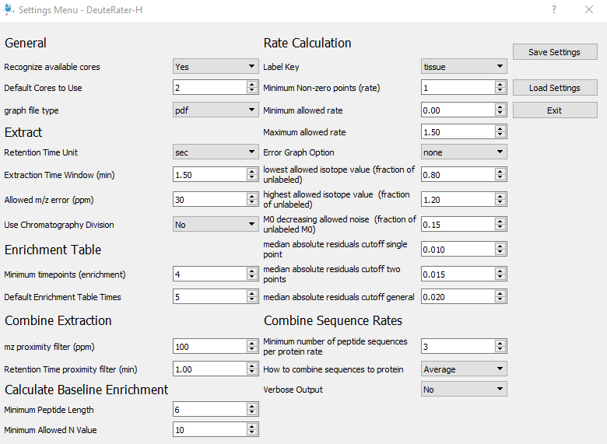
To start we will discuss the buttons on the right of the screen:
Save Settings – will save the currently displayed settings.
Load Settings – will prompt you to navigate to and select a Rate_Settings.yaml file from a previous run of DeuteRater-H. The settings from that file will then be displayed. You still must save the settings for them to be applied.
Exit – Exit the settings menu. If the settings displayed in the menu are not the same as those currently in use by DeuteRater-H, you will be prompted to save. You may choose to save or reject your changes.
The settings are grouped by the process that uses them, though the names aren’t always an exact match; Enrichment Calculation is the second table for Provide Time and Enrichment, Theory Generation is Calculate Delta by Enrichment and both Rate Calculation and Combine Sequence Rates are under the Rate Calculation header. We will go through them one at a time:
Recognize available cores – most steps of DeuteRater-H use multiprocessing to increase speed. If this setting is “Yes” DeuteRater-H will determine how many cores you have and attempt to use all of them.
Default Cores to Use – the number of processor cores to use for calculations if “Recognize available cores” is set to “No”.
Graph file type – the file type for the output graphs
Retention Time Unit – if the provided retention times in the guide file are seconds or minutes.
Extraction Time Window (min) – the guide file provides a retention time for each feature to be searched for. This is the allowed error for that retention time while searching in the .mzML files for that feature. Value is one way, so allowed error is plus or minus this value. Time unit is minutes.
Allowed m/z error (ppm) – the guide file provides a Precursor m/z for each feature to be searched for. This is the allowed error for that m/z while searching in the .mzML files for that feature. Value is one way, so allowed error is plus or minus this value. Value is ppm error.
Use Chromatography Division – this setting attempts to find the best chromatography peak for extraction. It can be turned off (“No”) used to compare the chromatography of different charge states of the same peptide within each .mzML file (“Intrafile”) or to compare the same peptide and its charge states between files (“Interfile”) This will increase calculation time, generate extra intermediate files and may remove data.
Minimum timepoints (enrichment) – the minimum number or timepoints that are required for an enrichment curve, and thus minimum entries on the second table in Provide Time and Enrichment.
Default Enrichment Table Times – the default number of rows present per Subject Id in the second table in Provide Time and Enrichment.
mz proximity filter (ppm) – there is a possibility that two different peptide sequences will have the same mass and retention time (especially if multiple charge states are considered). Because DeuteRater-H does not consider fragmentation data, there is no way to give preference to one sequence over another. Therefore, if multiple sequences are too close in both m/z and retention time, all of these sequences are deleted. M/z within this setting of another peptide are determined to be close in m/z.
Retention Time proximity filter (min) – there is a possibility that two different peptide sequences will have the same mass and retention time (especially if multiple charge states are considered). Because DeuteRater-H does not consider fragmentation data, there is no way to give preference to one sequence over another. Therefore, if multiple sequences are too close in both m/z and retention time, all of these sequences are deleted. Times within this setting of each other are considered close in time.
Minimum Peptide Length – the minimum length of a peptide to be considered for further analysis.
Minimum Allowed N Value – the minimum amount of potential deuterium sites a peptide must have to be considered for further analysis.
Label Key – the amount of deuterium incorporated into any amino acid is determined by the biochemical pathways in an organism. This may vary by organism, time of life or disease state. This tells DeuteRater-H what the potential deuterium incorporation of each amino acid is. The default “tissue” is standard adult mammalian tissue. If you wish to examine or change these values, or add a new label key see the “Adding new Labeling Schemes” portion of this read me.
Minimum Non-zero points (rate) – the number of unique times a peptide must be observed at to allow a calculation of the peptide turnover rate.
Minimum allowed rate – the lowest peptide turnover rate that is considered valid
Maximum allowed rate – the highest peptide turnover rate that is considered valid.
Error Graph Option – Whether or not to generate the Graph_Folder_Optimization folder and its associated graphs of how the error was minimized to produce the reported rate value. “none” produces no graphs. “approximate” produces a parabolic approximation of the error minimization which is slightly easier to see and faster to produce. “exact” produces the exact error minimization curve used to calculate the rate value for each peptide sequence.
Lowest allowed isotope value (fraction of unlabeled) – Noise or mis-identification can lead to points that are theoretically impossible. All peaks after M0 should be increasing above their unlabeled baseline value. To ensure this is the case we multiply the baseline value of each isotope except M0 by this value, which should be less than 1. If any of the isotopes drop below this setting multiplied by their baseline value, all isotopes of that point are dropped.
Highest allowed isotope value (fraction of unlabeled) – Noise or mis-identification can lead to points that are theoretically impossible. M0 should be decreasing below its unlabeled baseline value. To ensure this is the case we multiply the baseline value of M0 by this value, which should be greater than 1. If M0 increases above this setting multiplied by its baseline value, all isotopse of that point are dropped.
M0 decreasing allowed noise (fraction of unlabeled M0) – M0 should be constantly decreasing, or at the very least staying steady. We wish to determine if that is the case. This value is multiplied by the baseline m0 value. If any point is higher in value than the previous point + baseline M0 x this setting, it is determined that M0 is not constantly decreasing.
Median absolute residuals cutoff single point – the error metric for assessing the goodness of a peptide rate fit is determined by the distance of the points from their fit line. The median of the absolute value of these residuals is compared to a cutoff to determine if the rate curve is considered good or bad. Because single timepoints have fewer points to fit, the lines will be closer to the points in general and noise is more problematic so they need a special cutoff. This setting is that cutoff. If the median absolute residuals is above this value, the associated peptide rate will be discarded.
Median absolute residuals cutoff two points – the error metric for assessing the goodness of a peptide rate fit is determined by the distance of the points from their fit line. The median of the absolute value of these residuals is compared to a cutoff to determine if the rate curve is considered good or bad. Because two timepoints have fewer points to fit, the lines will be closer to the points in general and noise is more problematic so they need a special cutoff. This setting is that cutoff. If the median absolute residuals is above this value, the associated peptide rate will be discarded.
Median absolute residuals cutoff general – the error metric for assessing the goodness of a peptide rate fit is determined by the distance of the points from their fit line. The median of the absolute value of these residuals is compared to a cutoff to determine if the rate curve is considered good or bad. This is the cutoff for lines fit with many points. If the median absolute residuals is above this value, the associated peptide rate will be discarded.
Minimum number of peptide sequences per protein rate – the minimum number of peptide rates that must be combined together for a protein rate to be considered valid.
How to combine sequences to protein – whether to use average or median to combine peptide rates to calculate protein rates.
Verbose Output – whether or not to include extra columns in Final_Protein_Rates.csv. The extra columns are detailed in the “Rate Calculation – Combine Sequence Rates” section of this read me.

Adjusting Defaults or non-Menu Settings
In the folder containing your .exe (or your __main__.py for the python version) is a folder called “resources”:
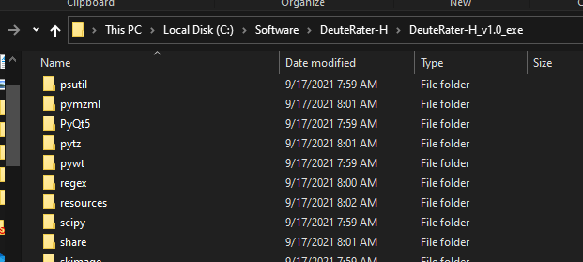
In this folder are several files that DeuteRater-H uses to load various values. These must be altered to change default values or reach settings the settings menu does not provide access to. The ones we are concerned with are settings.yaml and guide_settings.yaml:
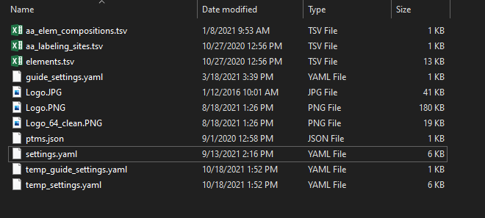
Do note that DeuteRater-H has limited checks on if these files are good, so be careful when altering them. Also in this folder you will often find temp_guide_settings.yaml and temp_settings.yaml. These are temporary files created by DeuteRater-H to store temporary changes to the settings made at run time (such as if the user adjusts a value in the settings menu) and so will be deleted and recreated every time you run DeuteRater-H. The files without the “temp_” prefix are the ones we want here.
When you open the .yaml (any code or text editor should be able to do this) you will see something like this:
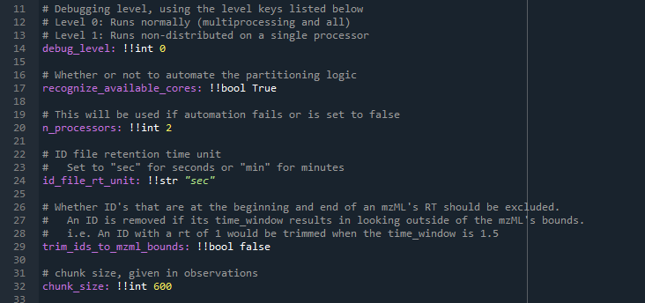
This is in a code editor to aid visualization of the different points of interest. Anything after a # (gray text in the image above) is a comment for those altering the file. DeuteRater-H will ignore them and so they may be safely added, altered or deleted.
The variable names are shown in purple above, they are on the far left side of the screen and followed by a colon. They cannot have spaces. This is the name of the variable and they should not be altered. What each variable does will be detailed after all portions of the .yaml are described.
Separated from the colon by a space are two exclamation points followed by a few letters, like !!int or !!str. this tells DeuteRater-H what kind of variable this is. !!int is and integer, !!float is a number with a decimal point in it, !!bool is either true or false, and !!str is text. These should not be altered.
Separated from the variable type by another space is the value. You may change this. You should know what the variable is in order to set reasonable values. Also the variable type must not change, so if you wish to change an integer it must still be and integer. Text must still have quotations.
If you wish to change a default value change it in these .yaml files. We will go through each setting now.

Guide_settings.yaml
Guide_settings.yaml this is related to the Create Guide File button. Most are not useful if using the “Template” option, but will be here for completeness:
Mass_cuttoffs – the mass thresholds for number of isotopes in Peaks template files. the format is [neutral mass, n_isos].
rt_proximity_tolerance – there is a possibility that two different peptide sequences will have the same mass and retention time (especially if multiple charge states are considered). Because DeuteRater-H does not consider fragmentation data, there is no way to give preference to one sequence over another. Therefore, if multiple sequences are too close in both m/z and retention time, all of these sequences are deleted. Times within this setting of each other are considered close in time. Relevant for the PEAKS settings, not Template.
mz proximity filter (ppm) – there is a possibility that two different peptide sequences will have the same mass and retention time (especially if multiple charge states are considered). Because DeuteRater-H does not consider fragmentation data, there is no way to give preference to one sequence over another. Therefore, if multiple sequences are too close in both m/z and retention time, all of these sequences are deleted. M/z within this setting of another peptide are determined to be close in m/z. Relevant for the PEAKS settings, not Template.
Start_time – the minimum retention time allowed. Relevant for the PEAKS settings, not Template.
study_type - the amount of deuterium incorporated into any amino acid is determined by the biochemical pathways in an organism. This may vary by organism, time of life or disease state. This tells DeuteRater-H what the potential deuterium incorporation of each amino acid is. The default “tissue” is standard adult mammalian tissue. If you wish to examine or change these values, or add a new label key see the “Adding new Labeling Schemes” portion of this read me. Relevant for the PEAKS settings, not Template.
aa_elemental_composition_path – the name of the file in resource file that has the amino acid elemental composition. This file is detailed in the “Adjusting Amino Acids” section of this read me.
aa_labeling_sites_path – the name of the file in resource file that has number of hydrogens for each amino acid that can be labeled with deuterium. This file is detailed in the “Adding new Labeling Schemes” section of this read me.
elements_path – the name of the file in resource file that has details on each element and their isotopes. This file is detailed in the “Adding new elements” section of this read me.
post_translational_modifications_path – the name of the file in resource file that has details on post-translational modification. This file is detailed in the “Adjusting Post Translational Modifications” section of this read me.
Min_charge_state – when making a guide file from PEAKS, charge states for each peptide will be automatically generated. This sets the minimum charge state. No function for “Template” settings.
Max_charge_state – when making a guide file from PEAKS, charge states for each peptide will be automatically generated. This sets the maximum charge state. No function for “Template” settings.

Settings.yaml
Settings.yaml contains the settings used in the “Rate Calculation” button. Some are present in the settings menu, some are not.
debug_level – if this is at 0, DeuteRater-H will run normally. If it is set at 1, it will deactivate multiprocessing for easier troubleshooting. Should only be changed from 0 if troubleshooting.
recognize_available_cores – most steps of DeuteRater-H use multiprocessing to increase speed. If this setting is “Yes” DeuteRater-H will determine how many cores you have and attempt to use all of them. Default value for “Recognize available cores” in the settings menu.
n_processors – the number of processor cores to use for calculations if “recognize_available_cores” is set to False. Default value for “Default Cores to Use” in the settings menu.
id_file_rt_unit – if the provided retention times in the guide file are seconds or minutes. Allowed values are “sec” for seconds or "min" for minutes. Any other value will cause an error. Default value for “Retention Time Unit” in the settings menu.
trim_ids_to_mzml_bounds – used in the extractor. if this is true, any id in an .mzML that is closer than the “time_window” setting to the start or end of the file, it will be discarded.
chunk_size – used in the extractor. If a file is less than "chunking_method_threshold" times "chunk_size" lines long, then split the identification file evenly among the processors. This is to preserve memory when analyzing very large .mzMLs.
chunking_method_threshold – used in the extractor. If a file is less than "chunking_method_threshold" times "chunk_size" lines long, then split the identification file evenly among the processors. This is to preserve memory when analyzing very large .mzMLs.
max_valid_angle – used in the extractor. neutromer envelopes in adjacent scans are compared to each other as vectors. If the vector of the next scan in time and the current summed scans have an angle greater than this setting, the next scan will not be incorporated into the total.
peak_ratio_denominator – used in extractor. For a neutromer envelope to be added to an id, it’s m0 value must be greater than 1/peak_ratio_denominator of the maximum m0 currently included in that id.
time_window – the guide file provides a retention time for each feature to be searched for. This is the allowed error for that retention time while searching in the .mzML files for that feature. Value is one way, so allowed error is plus or minus this value. Time unit is minutes. Default value for “Extraction Time Window (min)” in the settings menu.
ppm_window – the guide file provides a Precursor m/z for each feature to be searched for. This is the allowed error for that m/z while searching in the .mzML files for that feature. Value is one way, so allowed error is plus or minus this value. Value is ppm error. Default value for “Allowed m/z error (ppm)” in the settings menu.
label_key – the amount of deuterium incorporated into any amino acid is determined by the biochemical pathways in an organism. This may vary by organism, time of life or disease state. This tells DeuteRater-H what the potential deuterium incorporation of each amino acid is. The default “tissue” is standard adult mammalian tissue. If you wish to examine or change these values, or add a new label key see the “Adding new Labeling Schemes” portion of this read me. Default value for “Label Key” in the settings menu.
aa_labeling_sites_path – the name of the file in resource file that has number of hydrogens for each amino acid that can be labeled with deuterium. This file is detailed in the “Adding new Labeling Schemes” section of this read me.
peak_lookback – Used in the extractor. The number of peaks to look for in front of the first neutromer for troubleshooting the extractor.
peak_lookahead – Used in the extractor. The number of peaks to look for after of the last extracted neutromer for troubleshooting the extractor.
baseline_lookback – Used in the extractor. The amount of m/z to examine for the baseline calculation both before and after the precursor m/z.
min_envelopes_to_combine – Used in the extractor. If the extractor cannot find at least this number of scans to combine for a given id, no results are provided for that id.
zscore_cutoff – Used in the extractor. A median absolute deviation test is used to identify outlier scans. this is done by getting the mean absolute deviation of an m/z value compared to the median m/z for that neutromer. This is the zscore used to determine if a value is an outlier, and so the scan should be dropped.
rt_proximity_tolerance – there is a possibility that two different peptide sequences will have the same mass and retention time (especially if multiple charge states are considered). Because DeuteRater-H does not consider fragmentation data, there is no way to give preference to one sequence over another. Therefore, if multiple sequences are too close in both m/z and retention time, all of these sequences are deleted. Times within this setting of each other are considered close in time. Default value for “Retention Time proximity filter (min)” in the settings menu.
mz_proximity_tolerance – there is a possibility that two different peptide sequences will have the same mass and retention time (especially if multiple charge states are considered). Because DeuteRater-H does not consider fragmentation data, there is no way to give preference to one sequence over another. Therefore, if multiple sequences are too close in both m/z and retention time, all of these sequences are deleted. M/z within this setting of another peptide are determined to be close in m/z. Default value for “Allowed m/z error (ppm)”.
min_aa_sequence_length – the minimum length of a peptide to be considered for further analysis. Default value for “Minimum Peptide Length” in the settings menu.
min_allowed_n_values – the minimum amount of potential deuterium sites a peptide must have to be considered for further analysis. Default value for “Minimum Allowed N Value” in the setting menu.
starting_enrichment_table_timepoints – the default number of rows present per Subject Id in the second table in Provide Time and Enrichment. Default value for “Default Enrichment Table Times” in the settings menu.
max_enrichment_allowed – the maximum allowed deuterium enrichment. This is mainly to ensure the values are in decimal not percent.
error_estimation – Whether or not to generate the Graph_Folder_Optimization folder and its associated graphs of how the error was minimized to produce the reported rate value. “none” produces no graphs. “approximate” produces a parabolic approximation of the error minimization which is slightly easier to see and faster to produce. “exact” produces the exact error minimization curve used to calculate the rate value for each peptide sequence. Default value for “Error Graph Option” in the settings menu.
min_non_zero_timepoints_rate – the number of unique times a peptide must be observed at to allow a calculation of the peptide turnover rate. Default value for “Minimum Non-zero points (rate)” in the settings menu.
min_allowed_timepoints_enrichment – the minimum number or timepoints that are required for an enrichment curve, and thus minimum entries on the second table in Provide Time and Enrichment. Default value for “Minimum timepoints (enrichment)” in the settings menu.
minimum_allowed_sequence_rate – the lowest peptide turnover rate that is considered valid. Default value for “Minimum allowed rate” in the settings menu.
maximum_allowed_sequence_rate – the highest peptide turnover rate that is considered valid. Default value for “Maximum allowed rate” in the settings menu.
minimum_sequences_to_combine_for_protein_rate – the minimum number of peptide rates that must be combined together for a protein rate to be considered valid. Default value for “Minimum number of peptide sequences per protein rate” in the settings menu.
lowest_allowed_norm_isotope – Noise or mis-identification can lead to points that are theoretically impossible. All peaks after M0 should be increasing above their unlabeled baseline value. To ensure this is the case we multiply the baseline value of each isotope except M0 by this value, which should be less than 1. If any of the isotopes drop below this setting multiplied by their baseline value, all isotopes of that point are dropped. Default value for “Lowest allowed isotope value (fraction of unlabeled)” in the settings menu.
highest_allowed_norm_isotope – Noise or mis-identification can lead to points that are theoretically impossible. M0 should be decreasing below its unlabeled baseline value. To ensure this is the case we multiply the baseline value of M0 by this value, which should be greater than 1. If M0 increases above this setting multiplied by its baseline value, all isotopse of that point are dropped. Default value for “Highest allowed isotope value (fraction of unlabeled)” in the settings menu.
m0_decreasing_allowed_noise – M0 should be constantly decreasing, or at the very least staying steady. We wish to determine if that is the case. This value is multiplied by the baseline m0 value. If any point is higher in value than the previous point + baseline M0 x this setting, it is determined that M0 is not constantly decreasing. Default value for “M0 decreasing allowed noise (fraction of unlabeled M0)” in the settings menu.
median_absolute_residuals_cutoff_single_point – the error metric for assessing the goodness of a peptide rate fit is determined by the distance of the points from their fit line. The median of the absolute value of these residuals is compared to a cutoff to determine if the rate curve is considered good or bad. Because single timepoints have fewer points to fit, the lines will be closer to the points in general and noise is more problematic so they need a special cutoff. This setting is that cutoff. If the median absolute residuals is above this value, the associated peptide rate will be discarded. Default value for “Median absolute residuals cutoff single point” in the settings menu.
median_absolute_residuals_cutoff_two_points – the error metric for assessing the goodness of a peptide rate fit is determined by the distance of the points from their fit line. The median of the absolute value of these residuals is compared to a cutoff to determine if the rate curve is considered good or bad. Because two timepoints have fewer points to fit, the lines will be closer to the points in general and noise is more problematic so they need a special cutoff. This setting is that cutoff. If the median absolute residuals is above this value, the associated peptide rate will be discarded. Default value for “Median absolute residuals cutoff two points” in the settings menu.
median_absolute_residuals_cutoff_general – the error metric for assessing the goodness of a peptide rate fit is determined by the distance of the points from their fit line. The median of the absolute value of these residuals is compared to a cutoff to determine if the rate curve is considered good or bad. This is the cutoff for lines fit with many points. If the median absolute residuals is above this value, the associated peptide rate will be discarded. Default value for “Median absolute residuals cutoff general” in the settings menu.
desired_points_for_optimization_graph – if optimization graphs are created because of the error_estimation in this .yaml or “Error Graph Option” in the settings menu, this determines the number of points in the graphs.
intensity_filter – Used in the extractor. A filter used in many areas for scan combining. If a neutromer peak is below the intensity filter, it is not considered a valid scan and is discarded.
ms_level – the ms level to use for the extraction. Note that this has not been tested with values other than 1 and may lead to unexpected results if altered.
graph_output_format – the file type for the output graphs. Default value for “Graph file type” in the settings menu.
protein_combination_method – whether to use average or median to combine peptide rates to calculate protein rates. Default value for “Graph file type” in the settings menu.
verbose_output – whether or not to include extra columns in Final_Protein_Rates.csv. The extra columns are detailed in the “Rate Calculation – Combine Sequence Rates” section of this read me. Default value for “How to combine sequences to protein” in the settings menu.
sampling_rate – used in the extractor if chromatography division is used. How many scans should be looked at when performing a gaussian filter on the scan intensities. Must be an odd number. Best value will vary by instrument.
smoothing_width – used in the extractor if chromatography division is used. How many scans should be looked at when using a simple smoothing width. Best value will vary by instrument.
smoothing_order – used in the extractor if chromatography division is used. What order the simple smoothing algorithm should be used. How many scans should be looked at when using a simple smoothing width. Best value will vary by instrument.
allowed_peak_variance_min – used in the extractor if chromatography division is used. The amount of time in minutes that peaks can vary by between charges/adducts to be considered the same. Default = 0.1 for intrafile .2 for interfile. Best value will vary by instrument.
allowed_neutromer_peak_variance – used in the extractor if chromatography division is used. The amount of scans allowed between neutromer peaks to be considered a valid peak. Best value will vary by instrument.
rel_height – used in the extractor if chromatography division is used. A value used to determine how close to baseline the gaussian fitting algorithm peak widths will be chosen from. Default is .9 (90%). Best value will vary by instrument.
adduct_weight – used in the extractor if chromatography division is used. The weight that should be used for adduct reproducibility when calculating the score for chromatography peak picking. Default = 1.0. Best value will vary by instrument.
variance_weight – used in the extractor if chromatography division is used. The weight that should be used for neutromer peak variance when calculating the score for chromatography peak picking. Default = 1.0. Best value will vary by instrument.
ID_weight – used in the extractor if chromatography division is used. The weight that should be used for distance from the ID File's RT when calculating the score for chromatography peak picking. Best value will vary by instrument.
intensity_weight – used in the extractor if chromatography division is used. The weight that should be used for the intensity when calculating the score for chromatography peak picking. Best value will vary by instrument.
how_divided – used in the extractor if chromatography division is used. What created EIC should chromatography be divided on. default = "combined". Other options, "m0", "m1", "m2". Best value will vary by instrument.
use_chromatography_division – this setting attempts to find the best chromatography peak for extraction. It can be turned off (“No”) used to compare the chromatography of different charge states of the same peptide within each .mzML file (“Intrafile”) or to compare the same peptide and its charge states between files (“Interfile”) This will increase calculation time, generate extra intermediate files and may remove data. Default value for “Use Chromatography Division” in the settings menu.

Adjusting Resource Files
There are several locations in DeuteRater-H where the elemental composition of a peptide, including fixed and variable post-translational modifications, are relevant. The resource files discussed in this section are used to tell DeuteRater-H about what elements exist, what amino acids exist and what their element composition is, what post-translational modifications exist and what their elemental compositions are, and how many extra deuteriums can be biosynthetically incorporated into any amino acid or post-translational modification. All files discussed are in the “resources” subfolder of the folder containing your .exe or __main__.py version.


Adding new elements
Adding new elements has two portions. If you wish to include new elements in the “Rate Calculation” step that is only doable in the python version. Currently there is an internal location in the DeuteRater-H code which must know the element to add it. Currently, it knows, H, C, N, O, P, S, F, D (required deuterium for a standard or similar), Cl, Br, I, and Si. If you require a different element you must use the python version (the location to alter is the emass.py in the utils folder. Line 213 has the “master_isotope” dictionary. Use the other elements as a model and add to the dictionary between the curly braces).
If you are using Peaks guide file generation, the elements are used to generate the theoretical mass of the peptides. The relevant file in the resources folder is “elements.tsv” which looks like:
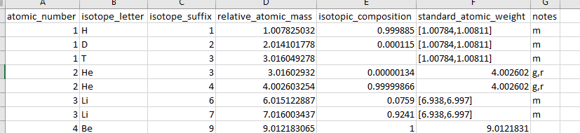
This is based on data that came with the emass algorithm². The only relevant columns are the isotope letter (the chemical symbol) and the “standard_atomic_weight” which is the atomic mass weighted by isotope abundance as you would find on the periodic table.

Adjusting Amino Acids
The relevant file here is “aa_elem_compositions.tsv”. Inside the file looks like this:
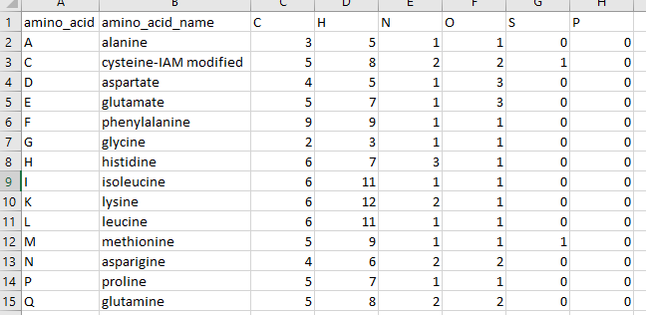
The first column lists the one letter code for the amino acid or modified amino acid. This does not have to be the traditional one letter code, or even a letter so long as it is unique and only one character long. The second column is the name, mostly for your benefit. For example, the cysteine above has the chemical formula for having an iodoacetamide modification and the name reflects this so we are not confused. All the other columns are elements that compose the amino acid. A few notes:
- the elemental composition is based on the elemental composition in the middle of a peptide chain. So the peptide bonds are formed. This is why alanine only has one Oxygen for example.
- Amino acids may be freely adjusted, renamed or have their composition changed. But remember that the change will affect all future DeuteRater-H runs until it is changed again.
- if you wish you may add a new element to the right of the table. The column must be filled but it may be filled with zeroes. It must be a known element in the “elements.tsv” file discussed in section “Adding new elements”. “X” is not valid.
- There is an internal location in the DeuteRater-H code which must know the element to add it. Currently, it knows, H, C, N, O, P, S, F, D (required deuterium for a standard or similar), Cl, Br, I, and Si. If you require a different element you must use the python version (the location to alter is the emass.py in the utils folder. Line 213 has the “master_isotope” dictionary. Use the other elements as a model and add to the dictionary between the curly braces).
- If you add a new amino acid, remember to add the deuterium amount of any new amino acids you add as described in “Adding new Labeling Schemes”

Adjusting Post Translational Modifications
Post-translational modifications can be used in two different ways. The first, required no matter what, is to adjust the “aa_elem_compositions.tsv” as described in “Adjusting Amino Acids”. As an example:
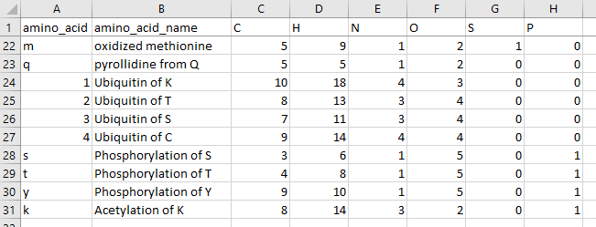
These are variable modifications. Replace the relevant amino acid in your Guide file. So, if a methionine is oxidized, replace an “M” with an “m” in the relevant peptide sequence. Fixed modifications can be represented as a separate amino acid or by altering the primary amino acid. So “C” can be altered to always have Iodoacetamide as part of its chemical formula.
If you add a new amino acid modification, remember to add the deuterium amount of any new amino acids you add as described in “Adding new Labeling Schemes”
The second file having to do with post-translational modifications is “ptms.json”. This is only relevant for creating a Guide file for peaks. This file can be opened in notepad or any coding environment. It looks like this:
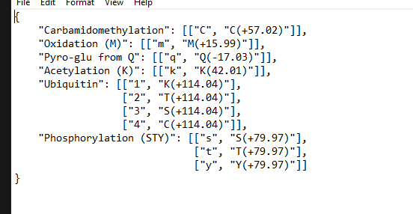
The text is the name of the modification, which will be added to the appropriate column in your guide file. Inside the brackets, the first element is the one letter code for the modification. The second element is the name for the modification produced by peaks. This allows DeuteRater-H to replace the modification name from Peaks with the one letter code DeuteRater-H recognizes. Make sure if you add to this, you also add to the “aa_elem_compositions.tsv” file as described above.

Adding new Labeling Schemes
Every amino acid has different amounts of deuterium that can be stably incorporated based on biosynthetic pathways. These should be stable covalent bonds, not ions, or hydrogen bonds capable of hydrogen exchange. The file that governs this is called “aa_labeling_sites.tsv”. It looks like this:
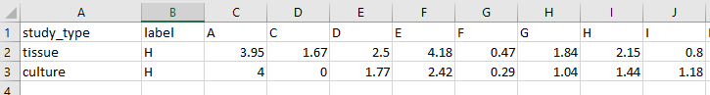
Study_type is the value that will go into the “Label Key” option in the settings menu or “label_key” in settings.yaml. the “label” column is the element being used for heavy labeling. Currently only “H” is supported. All other columns are amino acids or post-translationally modified amino acid from the file “aa_elem_compositions.tsv”. The value under an amino acid indicates the number of deuteriums that can be added. Since this is a population average, decimal values are allowed.
The two default values are “tissue” which is values from mammalian tissue and “culture” which is values from mammalian cell culture³. If new amino acids or modifications are added, be sure to add new columns to this file.

Citations
1. Kessner, D.; Chambers, M.; Burke, R.; Agus, D.; Mallick, P., ProteoWizard: open source software for rapid proteomics tools development. Bioinformatics 2008, 24 (21), 2534-6.
2. Rockwood, A. L.; Haimi, P., Efficient calculation of accurate masses of isotopic peaks. J Am Soc Mass Spectrom 2006, 17 (3), 415-9.
3. Naylor, B. C.; Porter, M. T.; Wilson, E.; Herring, A.; Lofthouse, S.; Hannemann, A.; Piccolo, S. R.; Rockwood, A. L.; Price, J. C., DeuteRater: a tool for quantifying peptide isotope precision and kinetic proteomics. Bioinformatics 2017, 33 (10), 1514-1520.

