DeuteRater v7 ReadMe
Table of Contents
Introduction 1
Version Choice 2
Prerequisites 2
Installation 2
Exe version 2
Python Source Code Version 2
Using DeuteRater v7 3
Activating the Software 3
Create Guide File 4
Rate Calculation – General 7
Rate Calculation – Extract 9
Rate Calculation – Provide Time and Enrichment 11
Rate Calculation – Combine Extracted Files 13
Rate Calculation – Calculate Baseline Enrichment 13
Rate Calculation – Rate Calculation 13
Settings 15
Settings Menu 15
Adjusting Defaults or non-Menu Settings 20
Guide_settings.yaml 21
Settings.yaml 22
Adjusting Resource Files 27
Adding new elements 28
Adjusting Amino Acids 28
Adjusting Post Translational Modifications 29
Adding new Labeling Schemes 31
Citations 31

Introduction
DeuteRater is a software tool designed to allow scientists to perform kinetic proteomic and lipidomic experiments on small mammals or cell culture. It is related to our previously published DeuteRater software package which does the same for only kinetic proteomics. The DeuteRater v7 source code is available at https://github.com/JC-Price/DeuteRater with an .exe available at https://github.com/JC-Price/DeuteRater/releases. This readme will walk through the use of the software.

Version Choice
It is recommended that unless you need to alter the source code for some reason that you download the .exe as it is easy to use and should be resistant to bugs caused by the underlying python modules updating.

Prerequisites
Both versions require a Windows operating system (they have only been tested on Windows 10, but other Windows versions may work as well).
Python source code was created in Python version 3.8.1, therefore that is the minimum python version recommended. Most imports are included in the basic python install, however you must ensure the follow packages are installed:
- PyQt5
- tqdm

Installation

Exe version
Download the v7 zip folder from Releases · JC-Price/DeuteRater (https://github.com/JC-Price/DeuteRater/releases). Extract the folder to a location you can find easily on your hard drive. Inside the unzipped folder will be an .exe file:
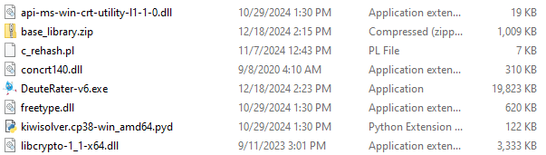

Figure 1 – Location of DeuteRater v7 executable
Double click this .exe (or call it from the command prompt) to open DeuteRater v7. Nothing can be removed from this folder without risk of causing an error. If the position of the .exe is inconvenient you can right click on the .exe file and select “Create shortcut”. The shortcut can be moved anywhere you desire without causing an error.

Python Source Code Version
Download the code from Releases · JC-Price/DeuteRater (https://github.com/JC-Price/DeuteRater). All folders must be in the same directory for the code to work. Use a command prompt to call the __main__.py using python:
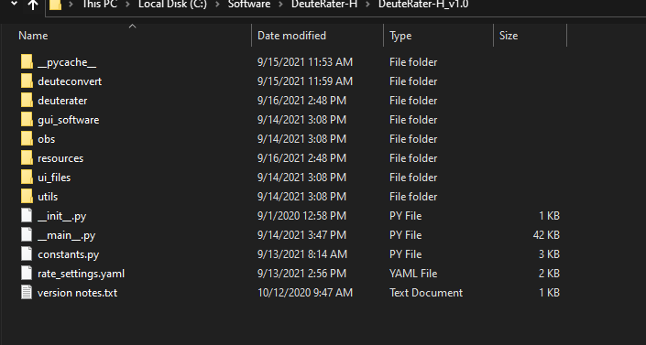

It doesn’t matter if you call the full path including __main__.py, just the parent folder path, or cd into the directory and call __main__.py from there.
If you want to use an Anaconda environment, there is a DeuteRaterEnvironment.yaml that you can import using the following command in the Anaconda Prompt: conda env create -f (path to yaml)
You can then activate the environment using: conda activate DeuteRaterEnvironment
Run the __main__.py as normal with python in the Anaconda prompt window with the proper envrionment activated.
See https://docs.conda.io/projects/conda/en/latest/user-guide/tasks/manage-environments.html for more information about managing Anaconda environments.

Using DeuteRater v7

Quick Guide
- Select a template for your guide file using the “File Format” selector.
- Create a guide file using the “Create Guide File” button.
- Fill in columns in the guide file. (guide file formatting info here)
- Optionally, click the settings button in the top left and change settings from default as needed
- Check all desired steps in the Rate Calculator Step box. (steps include Extract, Provide Time and Enrichment, Combine Extracted Files, Calculate N-Value, Calculate Baseline Enrichment, Calculate Fraction New, and Rate Calculation.)
- Once all desired steps are selected, use the “Rate Calculation” button to run. (note that all steps are dependent on previous steps. Click here for more information.)
- You will be prompted to select a file location to output the data, select a file where you would like your data stored.

Activating the Software
With the .exe version, double click on the .exe file or call the .exe on the command prompt. If using the python version, call __main__.py from the command line. This will open two windows. The first is the command prompt if you did not use it to open DeuteRater v7. It will be used to display progress bars and any errors that cause DeuteRater v7 to fail:
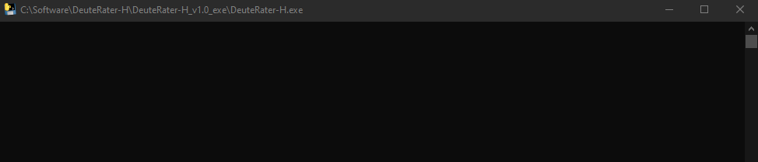
Next is the main interface window that governs all of DeuteRater v7’s operations:
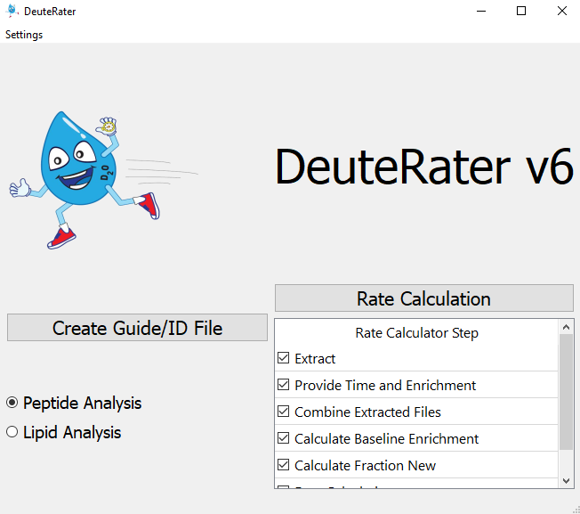
We will go through each step in the workflow with input and output requirements. We recommend closing DeuteRater and reopening the program in between runs to avoid any potential memory/RAM issues. The first step is to collect the information we need to start the analysis.

Create Guide File
On the left of the interface is the “Create Guide/ID File” button. A Guide File is a file containing all of the peptides or lipids you expect to see in your mass spectrometry files along with information to assist DeuteRater v7 in locating the appropriate features, such as retention time and mass, as well as data that will be needed later such as the peptide sequence.
How the guide file is created is governed by the options below the “Create Guide File” button. There is different template guide file for peptide and lipid data respectively. The peptide template is the default option.
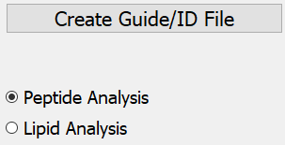
When you click “Create Guide File”, you will be prompted for a location and a save file name. What you name this file and where you put it do not matter, so long as you can find it again. The file will be a .csv (comma separated values) file which can be opened in any spreadsheet program such as Microsoft Excel.
The following columns must be filled out or analysis will not proceed:
Peptide data: Sequence, Protein ID, Precursor Retention Time (sec), Precursor m/z, and Identification Charge
Lipid data: Lipid Name, Lipid Unique Identifier, Precursor Retention Time (m/z), Precursor m/z, cf
For peptide data, the following columns are needed for analysis but will be filled in by DeuteRater v7 if left blank (do note that if any blanks are present in any of these columns, all data in any of these columns will be overwritten): Peptide Theoretical Mass, cf, neutromers_to_extract, and literature_n
All other columns, including any other columns you want to add, are for the user’s information and may be left blank or filled with data as you wish. A description of all columns included in the guide file templates are as follows:
Sequence – the amino acid sequence. It should be in the form of single letter amino acid code. Post translational modifications (PTMs) should be included here. The recognized PTMs are found in the file “aa_elem_compositions.tsv” in the resources file of your DeuteRater v7 download. This will be detailed in sections “Adjusting Amino Acids” and “Adjusting Post Translational Modifications”.

Peptide columns:
Protein ID – a unique identification code for the protein this peptide belongs to.
Protein Name – common name of the parent protein
Precursor Retention Time (sec) – the middle of the elution peak for this peptide. Time unit is set in the settings menu (default is seconds)
rt_start – the start of the elution peak.
rt_end – the end of the elution peak.
rt_width – the width of the elution peak.
Precursor m/z – observed m/z of the peptide
Peptide Theoretical Mass – the theoretical neutral mass of this peptide
Identification Charge – observed charge state
ptm – post translational modifications observed
avg_ppm – the average ppm mass error in the observed peptide
start_loc – the location the peptide begins in the protein
end_loc - the location the peptide ends in the protein
num_peptides – number of peptides observed for this protein in this analysis
num_unique – number of peptides observed for this protein in this analysis
accessions – unique identifiers assigned to specific peptides
species – the species this protein is from
gene_name – the identifier for the gene associated with this protein
protein_existence – a code to indicate the confidence that this protein is biologically relevant
sequence_version – a legacy setting from a previous version. Leave it blank.
cf – chemical formula in standard format (e.g. C34H60N10O10)
Adduct_cf – chemical formula of the protein including the adduct
neutromers_to_extract – number of isotopes to consider
literature_n – the number of deuteriums that can be incorporated

Lipid columns:
Lipid Name – common name of the parent lipid
Lipid Unique Identifier – the unique name for the specific lipid species
Precursor m/z – observed m/z of the lipid
Precursor Retention Time (sec) – the middle of the elution peak for this lipid. Time unit is set in the settings menu (default is seconds)
Identification Charge – observed charge state
cf – chemical formula in standard format (e.g. C7H16NO2)
neutromers_to_extract – number of isotopes to consider
Adduct – the molecular-ion complexes used for mass spectrometry analysis. For instance, a lipid molecule can create adducts with sodium ions, ammonium ions, or hydrogen ions, each yielding distinct m/z values while representing the same molecular species.
Adduct_cf – the chemical formula of the lipid including the adduct
literature_n – the number of deuteriums that can be incorporated. You likely won’t have literature n-values for lipids, so leave this column blank and DeuteRater will calculate empirical n-values to populate the column

Only molecules you put into this document will be included in the search, so if you wish to search for multiple post translational modifications, or multiple charge states each must be on a separate line.
If the necessary columns are not completely filled or there is a problem auto-filling the necessary columns, an error message will appear as shown below. Correct the problem, save the file, and proceed.
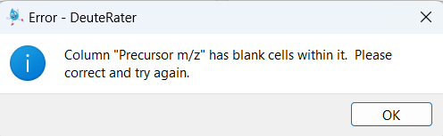

If you do not have a guide file prepared, we have a few tools available at JC-Price/DeuteRater_Tools (https://github.com/JC-Price/DeuteRater_Tools). There is one option for protein data that takes the outputs of FragPipe and creates a guide file for you. There are two versions for lipids that use the outputs from MS-Dial, one version that does not use retention time correction and one version that does. See the corresponding documentation in the GitHub repository for more details on how to use those tools.

Rate Calculation – General
The main portion of DeuteRater v7 is the Rate Calculation button (red box below) which starts the analysis by going through each step checked in the “Rate Calculator Step” table (blue box below):


We will go over each step individually but first, a few general rules about it. All steps that are checked must be next to each other. If there is a gap, you will get an error message:
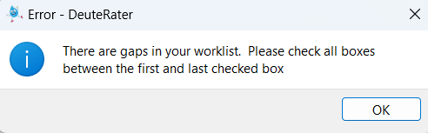
No matter which step is checked, you will be asked to select a folder at first:
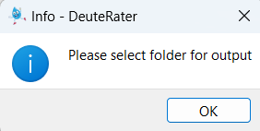

The names of the output files are always the same. If you have used the folder you select, you will get two messages. The first will notify you that there is a settings output (settings.yaml) present. You will be given the option to use the settings in the folder (“Use Settings”) or overwrite this file and use the settings you have currently set in DeuteRater v7 (“Overwrite”). Keep in mind that if you want to use a previous settings file from another folder, you might need to manually edit any file paths saved in the file.
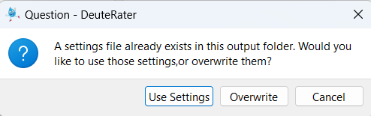
Second, if there are output files for a step that is currently checked present in your folder, you will be given a warning that you are going to overwrite output files. “Yes” overwrites the files, “No” returns you to the main DeuteRater v7 interface, and “Show Details” will list the files that will be overwritten so you may make an informed decision. You can rename your files to avoid them being overwritten, but that must be done manually. DeuteRater v7 will not do it for you:
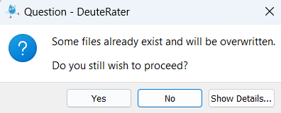
In addition to output spreadsheet files, two graph folders will be produced during the Rate Calculation step. If this step is redone in the same parent folders, the graph subfolders will be deleted with all their contents.
If a file is open in another program while an overwrite is occurring, it cannot be overwritten. You will be given an error message and returned to the main interface. This will also occur if you are attempting to write to a folder which DeuteRater v7 does not have permission to write to for whatever reason.
Each step will produce a .tsv output file. These are tab separated text documents which can be opened in any text editor or spreadsheet program like Microsoft Excel. The .tsv step from a one step can be used as the input file for the next step in the Rate Calculator, allowing you to start and stop if necessary (e.g. to redo part of the analysis with different settings). Be warned, that except for the guide file, DeuteRater v7 will only check your input file for proper filetype and column names. It will not check that the data makes sense. Be careful changing intermediate files before re-using them as an input file for a later step, because changes may cause DeuteRater v7 to error out or give nonsensical results.
When running a worklist, rate_settings.yaml will be saved in your output file. This should allow you to track what settings were used for each analysis should that be necessary.

Rate Calculation – Extract
The first step of Rate Calculation is “Extract”. The purpose of the Extract step is to find neutromers in centroided MS1 mass spectrometry data. This requires two things. The first is the Guide file that you created earlier (see “Create Guide File” section) and the second is one or more .mzml files. The .mzML files need to be centroided and ms level 1 only. If you require a utility to transform your mass spectrometry data, the msconvert tool from proteowizard can do this¹. Use the peakpicking setting to centroid.
First you will be asked to provide the guide file:
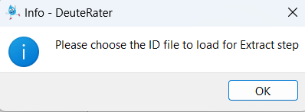
Navigate to wherever you have the guide file and select it. You will then be prompted to select your .mzML files. You may select one or several at once:
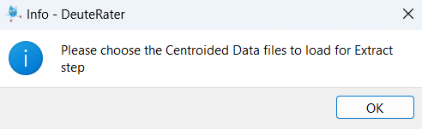
This may prompt another window warning about overwriting files if you selected files that have already been extracted. This is because DeuteRater v7 does not know the filenames of the extracted outputs until you choose the .mzML files to extract, so cannot determine which files may be overwritten.
Each .mzML you provided to DeuteRater v7 will have a corresponding output file. The file will have the same name as the original with a .tsv extension instead of an .mzML extension. The file will be the same as the guide file with several extra columns:
Id_index – an internal index of the file
mz – calculated m/z value
Z – charge state
rt – retention time in minutes
n_isos – neutromers to extract
mass – neutral mass
mzs – the actual mzs found in the .mzML
abundances – the actual abundances found in the .mzML
lookback_mzs – mz of the isotope peak in front of the first neutromer extracted if the extractor is extracting on an isotope other than the first
lookback_abundances – abundance of the isotope peak in front of the first neutromer extracted if the extractor is extracting on an isotope other than the first
lookahead_mzs – mz of the isotope peak behind the last neutromer extracted if the extractor is extracting insufficient neutromers.
lookback_abundances - abundance of the isotope peak behind the last neutromer extracted if the extractor is extracting insufficient neutromers.
rt_min – minimum retention time observed
rt_max – maximum retention time observed
baseline_signal – abundance of the baseline in the area around this neutromer envelope
signal_noise – irrelevant
mads – an error metric
mzs_list – only filled for chromatography division setting.
intensities_list – only filled for chromatography division setting.
rt_list – only filled for chromatography division setting.
baseline_list – only filled for chromatography division setting.
num_scans_combined – the number of scans used to generate relevant values.
mzml_path – the path to the mzml file used for this data
filename – path of the extracted output file
mzml_path – path of the mzML file associated with the extracted output file
name_check – used in the chromatography_division module to match groups with the correct rows
Extraction_Updated – If extraction was successful, this column will list the peaks used
Extraction_Error – displays any errors encountered during extraction process

Columns mzs to num_scans_combined are only filled in if data was found for this row. If data was not found, and all of these columns are blank, the rows will be discarded in step “Combine Extracted Files”.
You will see progress bars on the black command prompt that appeared with the interface (or the normal command prompt if you called the program from there). Do note that if you have “Provide Time and Enrichment” checked, you will be prompted to fill out the tables associated with that step after selecting .mzMLs but before the actual extraction happens. This is so you can walk away from the analysis without it stalling to ask for your input halfway through.
It is important to note that this version of DeuteRater does not attempt to distinguish or check for peptides that have extremely similar m/z and retention times. The next version of DeuteRater will be incorporating Ion Mobility and drift time, which will help with this issue.

Rate Calculation – Provide Time and Enrichment
The purpose of the “Provide Time and Enrichment” is to provide information about the .mzml files you are using. If you are starting with this step you will be asked to select the output .tsvs from an extractor step, otherwise it will continue with the data that was used in the extractor. If step is checked you will be provided with a table like the following:
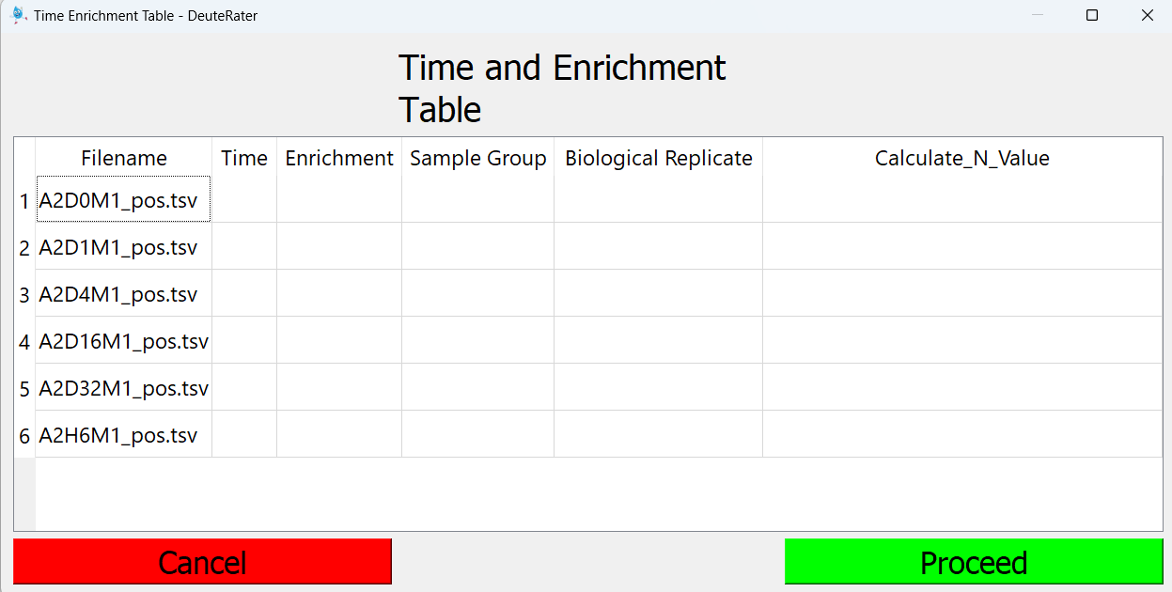
Each extracted .tsv file will be present in the “Filename” column.
“Time” must be the time since the beginning of deuterium labeling in the subject. Days is the best unit for time. DeuteRater v7 can use any time unit so long as it is consistent, but several later filters are calibrated for time data being in units of days.
“Enrichment” is the level of deuterium enrichment in decimal format (aka. 5% would be 0.05).
“Sample Group” is a label that will be applied to your data. Different Sample Groups will not be mixed at later steps in the analysis. This can be useful for separating data from different subjects in the same analysis, separating different tissues for the same subject, or for simply providing an identifier to this data which will be preserved as a column in every output and as part of the title of every graph. Do keep in mind that to a computer “A” and “a” are different and a space “ “ is considered a character so be careful to make each Subject ID for the same subject (or whatever you wish to mark) exactly the same.
“Biological Replicate” is where you would input the bio rep associated with each mzML.
“Calculate_N_Value” is a column requiring you to decide for which mzMLs you will calculate an empirical-based N-value. Generally, lipids do not have established n-values in the literature which means empirical n-values will need to be calculated. You can use either option with peptides because amino acids do have established literature n-values. If empirical is selected, it will calculate an empirical n-value for each molecule at each time point selected and then average them together. We’ve found that calculating empirical n-values for only the largest timepoints works best. So, if you had day 1, day 5, day 15, and day 32 timepoints, you could put ‘Yes’ for all of the day 32 timepoints and ‘No’ for the other timepoints. DeuteRater would then calculate empirical n-values only based on the day 32 data.
Ctrl+c for copy, Ctrl+v for paste and del and backspace for delete are enabled for this table and the next one.
Fill out the table and hit the green “Proceed” button. The red “Cancel” button will prevent further analysis and return you to the main interface. If there is a problem with the data you entered, such as a missing value or a non-numeric or negative time, a warning message will appear. You must correct the problem.
The output file is called “time_enrichment_data.tsv”. This file contains the exact contents of the table you entered previously.
Attempting to paste a selection that has more rows and/or columns will result in nothing being pasted, but the table window will stay open. Check your copied selection to make sure it matches the number of rows and columns expected.
Warning: the next step uses the filenames in the “time_enrichment_data.tsv” file to find the extracted data. if these files have been renamed or moved since the “time_enrichment_data.tsv” you must alter the filenames to match the current position if you want to use “time_enrichment_data.tsv” as an input.

Rate Calculation – Combine Extracted Files
This button merely combines the outputs from the last two steps. It takes “time_enrichment_data.tsv” as an input file if starting from this step.
The output file is called “combined_extracted_files_output.tsv”.

Rate Calculation – Calculate N-Value
If empirical n-values are selected to be computed, this step will be run as part of the “Combine Extracted Files” step.
We use the emass algorithm² to calculate theoretical isotopic distributions for each potential combination of hydrogen and deuterium of the molecule based off its chemical formula. DeuteRater then determines the delta fraction new between the empirical and theoretical peaks and calculates the standard deviation across the peaks. After calculating standard deviations for each combination, DeuteRater will select the hydrogen-deuterium combination with the lowest standard deviation and set the n-value for the molecule to be equal to the number of deuterium. There are a handful of settings associated with n-value calculations: N-Value Confidence Value Limit, Make N-Value Graphs, and Output N-Value Calculation Data. See the Settings section below for more details.

Rate Calculation – Calculate Baseline Enrichment
This button calculates the baseline isotopic abundances of each sequence. It takes “combined_extracted_files_output.tsv” as an input file if starting from this step.
Output file is “delta_by_enrichment.tsv”. It is nearly identical to “combined_extracted_files_output.tsv” except for the “Theoretical Unlabeled Normalized Abundances”. The Theoretical Unlabeled Normalized Abundances column contains the baseline isotopic abundance of a given sequence. It will also sometimes contain text saying “less than () labeling sites” where () is some number. Rows with this text will be dropped in the next step. There is a setting in the settings menu which sets a minimum number of possible deuteriums a peptide sequence must have in order to be considered further.
There will be a series of columns that will display the results of the n-value calculations. These include: n_value, n_value_stddev, median_first_derivatives, num_nv_time_points, cv, Median_FN_stddev, n_val_lower_margin, n_val_upper_margin, All_n_values, N_value_time_points, Filtered_out_N_values, Filtered_out_stddevs, Filtered_out_median_first_derivatives, Filtered_out_N_value_time_points, and Reason_for_filtering.
Information about what filters are applied to n-values can be found in the settings section of the ReadMe.

Rate Calculation – Calculate Fraction New
This step calculates the amount of turnover for each peptide or lipid constituent in each file so a rate can be calculated later. For each row in your database the unlabeled isotopic spectrum, in both abundance and m/z, will be calculated. These values will then be calculated assuming all copies of that peptide or lipid constituent have been newly synthesized with the enrichment provided for the relevant extracted file.
After the unlabeled spectra and the fully labeled spectra have been calculated, the amount of turnover that has actually occurred (fraction new) is calculated. This is done in three different ways:
Abundance: for each neutromer peak in a given row, turnover is calculated using the following equation:
$\frac{MeasuredNeutromerAbundance-FullyLabeledNeutromerAbundance}{UnlabeledNeutromerAbundance-FullyLabeledNeutromerAbundance}$
This is done on all neutromers and the results are compared. By default, the monoisotopic peak is treated as the true value because the change tends to be largest and can only move in one direction. This can be adjusted in the settings menu
Neutromer Spacing: The neutromer spacing measures the distance in m/z units between the monoisotopic peak and the other neutromer peaks. This will increase with increased labeling. The equation is the same as for abundance, instead of the abundance of a peak, the m/z difference between the peak and the monoisotopic peak is used. Because the spacing tends to be noisier than the abundance, a median absolute deviation outlier check is used, and outliers are discarded. The median of the remaining points is used as the true value.
Combined: the results of Abundance and Neutromer Spacing are considered together. All calculated values for all neutromers calculated from Abundance and Neutromer Spacing are considered, a median absolute deviation outlier check is used, and outliers are discarded. The median of the remaining points is used as the true value.
The output file is called “frac_new_output.tsv”. Note that any columns relevant to a particular calculation type, for example the abund_fn column for abundance, will not appear unless abundance calculations were performed. By default, all calculation types are performed.
Many of the columns in this file are identification columns, like “Sequence” from previous steps. The new columns are:
theory_unlabeled_abunds – this contains the sum normalized values of each neutromer. For example, if the values were .5 .3 .2 it would indicate the no extra neutron neutromer represented 50% of the signal for this peptide, the one extra neutron neutromer represented 30% of the signal for this peptide, and the two-extra neutron neutromer represented 20% of the signal for this peptide. Values are separated by a space. This column indicates the natural abundance values, with no extra deuterium added.
theory_labeled_abunds – this contains the sum normalized values of each neutromer. For example, if the values were .5 .3 .2 it would indicate the no extra neutron neutromer represented 50% of the signal for this peptide, the one extra neutron neutromer represented 30% of the signal for this peptide, and the two extra neutron neutromer represented 20% of the signal for this peptide. Values are separated by a space. This column indicates fully labeled values, at time infinity with constant deuterium addition.
normalized_empirical_abundances – this column represents the observed abundances for this peptide in the relevant file. These values are sum normalized. For example, if the values were .5 .3 .2 it would indicate the no extra neutron neutromer represented 50% of the signal for this peptide, the one extra neutron neutromer represented 30% of the signal for this peptide, and the two extra neutron neutromer represented 20% of the signal for this peptide. Values are separated by a space.
low_labeling_peaks – sometimes the maximum possible change (difference between a peak in theory_unlabeled_abunds and theory_labeled_abunds) this generally occurs for very low amounts of deuterium or if the deuterium incorporation is large enough that the neutromer peak initially increased in size and then decreased as more deuterium was incorporated (the one extra neutron neutromer peak often has this problem at 5% Deuterium incorporation). The threshold for calling a peak a low labeling peak can be adjusted. The low labeling peaks will not be included in the abundance calculations. The low labeling peaks with be indicated by M followed by the number of extra neutrons, so “M1” is the neutromer peak with one extra neutron.
frac_new_abunds – this column is the following equation used on each neutromer peak:
$\frac{MeasuredNeutromerAbundance-FullyLabeledNeutromerAbundance}{UnlabeledNeutromerAbundance-FullyLabeledNeutromerAbundance}$
frac_new_abunds_std_dev – the standard deviation of all peaks calculated in frac_new_abunds. If this value is too high, the abundance measurement will be dropped from further consideration.
abund_fn – abundance fraction new. This the actual amount of the pool of the measured peptide that has turned over since the start of label introduction. This is calculated using the frac_new_abunds column, using either the M0 (no extra neutron) peak, the average of all non-excluded peaks, or the median of all non-excluded peaks. M0 is the default. If the peptide was not calculated due to a filter of some kind, that will be indicated here.
observed_neutral_masses – the observed neutral masses of each neutromer peak for this peptide from the relevant mzml. Values are space separated.
theory_unlabeled_mzs – the calculated neutral masses for each neutromer peak if no deuterium was incorporated. Values are space separated.
theory_labeled_mzs – the calculated neutral masses for each neutromer peak at time infinity with constant deuterium incorporation. Values are space separated.
frac_new_mzs – this column is the following equation used on each neutromer peak except m0 (note that theory m0 neutral mass does not change no matter the deuterium amount):
$\frac{\left(Measuredneutralmass-measuredm0neutralmass\right)-\left(Fullylabeledneutralmass-theorym0neutralmass\right)}{\left(Unlabeledneutralmass-theorym0neutralmass\right)-\left(Fullylabeledneutralmass-theorym0neutralmass\right)}$
frac_new_mzs_outlier_checked – because distances between neutral masses are prone to noise due to how small the actual differences are, a median absolute deviation test is applied and outliers removed. This column contains the results of frac_new_mzs after the outliers have been removed.
frac_new_mzs_std_dev – the standard deviation of all peaks calculated in frac_new_mzs_outlier_checked. If this value is too high, the spacing measurement will be dropped from further consideration.
nsfn – neutromer spacing fraction new. This the actual amount of the pool of the measured peptide that has turned over since the start of label introduction. This is median of frac_new_mzs_outlier_checked.
frac_new_combined – this column is used to combine results from spacing and abundance measurements. It contains results from frac_new_abunds and frac_new_mzs. Values are space delimited.
frac_new_combined_outlier_checked – because there may be disagreements between peaks and noise in the measurements, a median absolute deviation outlier check is used on the data from frac_new_combined. The passing measurements are placed in this column. Values are space delimited.
frac_new_combined_std_dev – the standard deviation of all peaks calculated in frac_new_combined_outlier_checked. If this value is too high, the spacing measurement will be dropped from further consideration.
cfn – Combined Fraction New. This the actual amount of the pool of the measured peptide that has turned over since the start of label introduction. This is median of frac_new_combined_outlier_checked.

Rate Calculation – Rate Calculation
This step performs the actual rate calculation on the peptides or lipids. Peptides or lipids with the same id_col (Protein_ID or Lipid Unique Identifier) and group_column (sample_group) will be combined together to calculate a rate. For lipids, there is also an additional setting to decide whether to group a lipid and its adducts together (see Separate Lipid Adducts in the Settings Menu). Nothing else will be combined at this stage.
It takes the “frac_new_output.tsv” as an input file if starting from this step.
There are four outputs, “rate_by_sequence.tsv” which has numerical rate data, “rate_by_sequence_datapoints.tsv” which is essentially a copy of the “frac_new_output.tsv”, and two graph folders, “Graph_Folder (good r2)” and “Graph_folder (poor r2)”. An r-squared value is calculated for each curve and will be sorted into one of these folders based on the “R-Squared Threshold” setting. For example, if the R-Squared Threshold was set to 0.5, any curves with an r-squared value greater or equal to 0.5 would be added to the “Graph_Folder (good r2)” folder.
Note that for lipids, the rate_calculator module will solve for both the asymptote and rate of the curve since lipids can be sourced from diet. For peptides, it is assumed that the asymptote will be 1, since proteins are broken down and rebuilt by the body.
rate_by_sequence.tsv is a .tsv file which should be easy to open in any spreadsheet program. It has the following columns:
analyte_id – the Protein ID or Lipid Name for the data analyzed in this row.
analyte_name – the Protein Name or Lipid Unique Identifier for the data analyzed in this row.
group_name – the sample group you labeled the data under in the Time and Enrichment table (see Sample Group).
The rest of the columns will be prefaced by either ‘Abundance’, ‘Spacing’, or ‘Combined’, depending on what calculation type they were based off.
rate – the actual rate (abundance, spacing, or combined) calculated for this peptide. Will be blank if rate could not be calculated for some reason.
asymptote – the asymptote applied to the rate curve. Peptides will default to 1, lipids will be variable and are estimated in the rate calculation process.
std_error – the standard error of the rate calculation
95pct_confidence – the 95% confidence interval of the rate calculation
half life – The estimate half life for the molecule based on the fraction new.
R2 – the r-squared value calculated for this fitted rate curve.
files observed in – The number of files this molecule was observed in.
num_measurements – The number of measurements used for the molecule.
num_time_points – the number of unique timepoints that were used to calculate the rate and curve.
uniques – The number of unique sequences from the unique_sequence_column.
exceptions – Displays any errors or reasons why the calculations couldn’t be completed.
_rate_graph_time_points – the actual timepoints that were plotted on the rate curve.
_normed_isotope_data – normalized isotope information.
Unique Timepoints – the number of unique times this peptide was observed in based on the times provided for your extracted .mzml files.
Number of Measurements – number of measurements (isotope data for a measured time) included in the graph. Will include different timepoints, different charge states, and replicates. Will not include any points rejected for running afoul of any of DeuteRater v7’s filters.
Approximate Variance – an error metric for the rate calculation. Smaller is better. Will be blank if rate could not be calculated for some reason.
mean of all absolute residuals – an error metric describing how far the points are from the fitted line. Smaller is better. Will be blank if rate could not be calculated for some reason.
num times – number of different times used. Will include any duplicates of unique times, but not any times that were rejected for not passing filters.
n_isos – number of isotopes used in the calculations, as in previous files
num measurements – n_isos multiplied by num times or Number of Measurements since both are the same. This is done since each isotope is a separate line, and therefore each isotope of each measurement is a point on the resulting graph.

Settings
DeuteRater v7 has several optional settings. The most common settings to adjust are accessible from the settings menu in the main interface. This is only useful for the current run of DeuteRater v7. If you close and then re-open the program, all settings will return to their default values. Default settings and any settings not in the settings menu can be altered but be warned that this has fewer protections than the settings menu, so it is recommended to be cautious and save a backup of the relevant files before alteration. Both the settings menu and altering default values will be discussed in this section.
When running a worklist, rate_settings.yaml will be saved in your output file. This should allow you to track what settings were used for each analysis should that be necessary.

Settings Menu

The settings menu for is accessed through using the “Options” pull-down in the main interface and selecting “Rate Calculation Settings” which is currently the only option in the pull down:



This will open the following window:
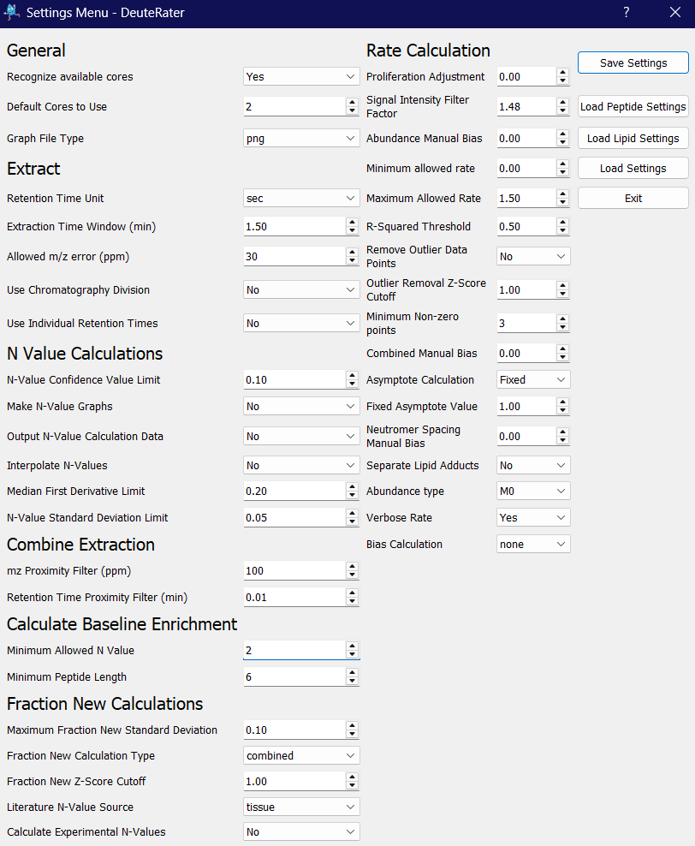

To start we will discuss the buttons on the right of the screen:
Save Settings – will save the currently displayed settings.
Load Peptide Settings – this will load default settings for running peptide data. These default settings in DeuteRater are always the default peptide settings. Some important settings to keep in mind for this option: Use Empirical N Values will default to False, Asymptote Calculation will default to Fixed, and Fraction new calculation type will default to combined.
Load Lipid Settings - this will load default settings for running lipid data. Some important settings to keep in mind for this option: Use Empirical N Values will default to True, Asymptote Calculation will default to Variable, and Fraction new calculation type will default to abundance.
Load Settings – will prompt you to navigate to and select a Rate_Settings.yaml file from a previous run of DeuteRater v7. The settings from that file will then be displayed. You still must save the settings for them to be applied.
Exit – Exit the settings menu. If the settings displayed in the menu are not the same as those currently in use by DeuteRater v7, you will be prompted to save. You may choose to save or reject your changes.
The settings are grouped by the process that uses them, though the names aren’t always an exact match; Both the N Value Calculations and Combine Extraction settings are in the Combine Extracted Files step. We will go through the settings one at a time:

General
Recognize available cores – most steps of DeuteRater v7 use multiprocessing to increase speed. If this setting is “Yes”, DeuteRater will determine how many cores you have and attempt to use all of them.
Default Cores to Use – the number of processor cores to use for calculations if “Recognize available cores” is set to “No”.
Graph file type – the file type for the output graphs. Available options are png (default), svg, and None.

Extract
Retention Time Unit – if the provided retention times in the guide file are seconds or minutes.
Extraction Time Window (min) – the guide file provides a retention time for each feature to be searched for. This is the allowed error for that retention time while searching in the .mzML files for that feature. Value is one way, so allowed error is plus or minus this value. Time unit is minutes.
Allowed m/z error (ppm) – the guide file provides a Precursor m/z for each feature to be searched for. This is the allowed error for that m/z while searching in the .mzML files for that feature. Value is one way, so allowed error is plus or minus this value. The value is ppm error.
Use Chromatography Division – this setting attempts to find the best chromatography peak for extraction. It can be turned off (“No”) used to compare the chromatography of different charge states of the same peptide within each .mzML file (“Intrafile”) or to compare the same peptide and its charge states between files (“Interfile”) This will increase calculation time, generate extra intermediate files and may remove data.
Use Individual Retention Times – use this setting if you have different retention times for a molecule for each mzML file. Additional columns will need to be populated in your guide file (one column for each mzML). Columns should be formatted like (mzml_file_name)_RT_sec (replace (mzml_file_name) with the name of your mzml files). Do not include the .mzml or file type in the name.

N Value Calculations
N-Value Confidence Value Limit – A standard deviation-based filter for n-value calculations. Calculated by dividing the n-value standard deviation by the n-value. This is later used in the fraction new calculation step to ignore any rows with a confidence value (cv) above the set limit.
Make N-Value Graphs – If turned on, this will greatly decrease the speed and performance! It most cases, it should only be used for debug purposes or if you want to visualize how DeuteRater calculates empirical n-values. It will create a graph folder and for each n-value calculation, it will save a graph showing the number of Deuteriums on the x-axis and the standard deviation on the y-axis.
Output N-Value Calculation Data – Similar to the last setting, but it won’t impact the performance as much. Will output a .tsv file containing the following features for each peptide/lipid: Index, cf (chemical formula), sample_group, n_value, std_dev (standard deviation), all_std_dev, and all_n_D_values. The last two columns can be used to generate the same graphs the previous setting generates (all_n_D_values on the x-axis and all_std_dev on the y-axis).
Interpolate N-Values – When turned on, this setting will allow the n-value calculator to calculate fractional n-values using interpolation methods. We’ve found that fast acquisition instruments have issues with this, so we tend to use this with QTOF but not Orbi-traps.
Median First Derivative Limit – This filter helps select the highest quality n-values by excluding n-values with a median first derivative less than the value selected (default is 0.2). When calculating n-values, DeuteRater plots values with the x-axis as the number of deuterium, and the y-axis as the standard deviation of the fraction new. The median of the first derivative for these points is calculated and is designed to detect how steep the curve approaches the standard deviation minimum. Steeper first derivatives tend to reflect higher quality n-values.
N-Value Standard Deviation Limit – This filter excludes any n-values that have a standard deviation higher than the value chosen (default is 0.05). Values will still be shown in the output files, but will not be included in fraction new and rate calculations.

Combine Extraction
mz proximity filter (ppm) – there is a possibility that two different peptide sequences will have the same mass and retention time (especially if multiple charge states are considered). Because DeuteRater v7 does not consider fragmentation data, there is no way to give preference to one sequence over another. Therefore, if multiple sequences are too close in both m/z and retention time, all these sequences are deleted. M/z within this setting of another peptide are determined to be close in m/z.
Retention Time proximity filter (min) – there is a possibility that two different peptide sequences will have the same mass and retention time (especially if multiple charge states are considered). Because DeuteRater v7 does not consider fragmentation data, there is no way to give preference to one sequence over another. Therefore, if multiple sequences are too close in both m/z and retention time, all these sequences are deleted. Times within this setting of each other are considered close in time.

Calculate Baseline Enrichment
Minimum Allowed N Value – the minimum amount of potential deuterium sites a peptide/lipid must have to be considered for further analysis.
Minimum Peptide Length – the minimum length of a peptide to be considered for further analysis.

Fraction New Calculation
Maximum fraction new standard deviation – Sets a limit for the maximum n-value standard deviation to accept when calculating the fraction new.
Fraction new calculation type – Determines what type of fraction new calculation DeuteRater will use. This will affect the fraction new calculations and rate calculations/graphing. Options are abundance, neutromer spacing, and combined (abundance and neutromer spacing).
Fraction New Z-Score Cutoff – The z-score cutoff for filtration of data during fraction new calculation.
Literature N Value Source – The amount of deuterium incorporated into any amino acid is determined by the biochemical pathways in an organism. This may vary by organism, time of life or disease state. This tells DeuteRater v7 what the potential deuterium incorporation of each amino acid is. The default “tissue” is standard adult mammalian tissue. If you wish to examine or change these values or add a new label key see the “Adding new Labeling Schemes” portion of this read me.
Calculate Experimental N Values – Default for peptides is “No” and the default for lipids is “Yes”. Unlike amino acids, there isn’t an established database for lipid constituent n values, so you’ll likely need to calculate them with empirical data. If you select “No”, DeuteRater will expect you to populate the literature_n column in your ID/guide file, and then transfer those values over to the n_value column for use in the workflow. If you select “Yes”, leave the literature_n column empty, and DeuteRater will populate the n_value column with empirical/experimental n values.

Rate Calculation
Proliferation Adjustment – Used to adjust for cell proliferation.
Signal Intensity Filter Factor – Adjusts how harshly noise is filtered out during rate calculation.
Abundance Manual Bias – When manual bias is selected as the bias calculation option, this will be the amount offset from the abundance fraction new values.
Minimum allowed rate – the lowest peptide/lipid turnover rate that is considered valid.
Maximum allowed rate – the highest peptide/lipid turnover rate that is considered valid.
R-Squared Threshold – finish
Remove Outlier Data Points – Whether to use the roll up option during rate calculations and remove outlier data points.
Outlier Removal Z-Score Cutoff – The z-score cutoff selected by the user. Used when outlier removal is turned on.
Minimum Non-zero points (rate) – the number of unique times a peptide/lipid must be observed to allow a calculation of the peptide turnover rate.
Combined Manual Bias – When manual bias is selected as the bias calculation option, this will be the amount offset from the combined fraction new values.
Asymptote Calculation – Either “fixed” (for peptides, default is 1.0) or “variable” (for lipids). Asymptote for the rate curves.
Fixed Asymptote Value – finish
Neutromer Spacing Manual Bias – When manual bias is selected as the bias calculation option, this will be the amount offset from the neutromer spacing fraction new values.
Separate Lipid Adducts – When turned on, each adduct will be treated as a separate lipid when calculating and graphing rates.
Abundance type - Decides how the abundance fraction new “abund_fn” is calculated. No = not calculated, M0 = use the M0’s fraction new as the abund_fn, avg = use the median fraction new as the abund_fn, highest = use the most intense neutromer’s fraction new as the abund_fn.
Verbose Rate – When turned on, the rate_calculation output file(s) will be more verbose, aka. include more detailed information.
Bias Calculation – Options are “none”, “calculated”, or “manual”. Used to offset all fraction new values to adjust for instrument bias.

Adjusting Defaults or non-Menu Settings
In the folder containing your .exe (or your __main__.py for the python version) is a folder called “resources”:
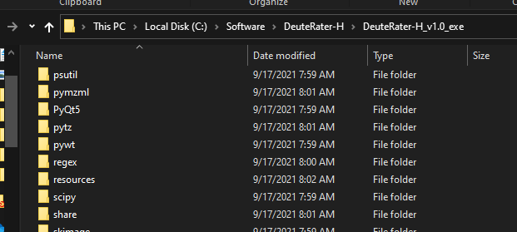

In this folder are several files that DeuteRater v7 uses to load various values. These must be altered to change default values or reach settings the settings menu does not provide access to. The ones we are concerned with are settings.yaml and guide_settings.yaml:
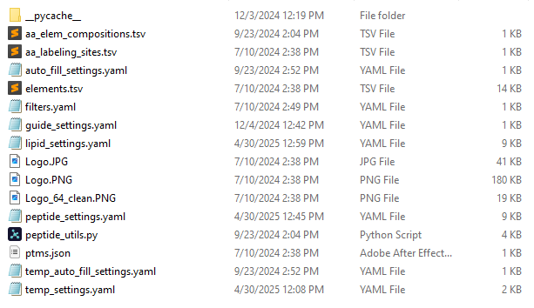

Do note that DeuteRater v7 has limited checks on if these files are good, so be careful when altering them. Also in this folder you will often find temp_guide_settings.yaml and temp_settings.yaml. These are temporary files created by DeuteRater v7 to store temporary changes to the settings made at run time (such as if the user adjusts a value in the settings menu) and so will be deleted and recreated every time you run DeuteRater v7. The files without the “temp_” prefix are the ones we want here.
When you open the .yaml (any code or text editor should be able to do this) you will see something like this:
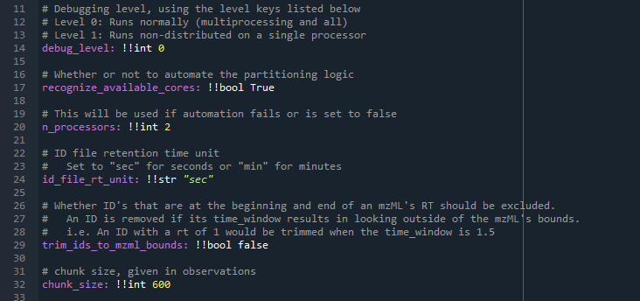
This is in a code editor to aid visualization of the different points of interest. Anything after a # (gray text in the image above) is a comment for those altering the file. DeuteRater v7 will ignore them and so they may be safely added, altered or deleted.
The variable names are shown in purple above, they are on the far left side of the screen and followed by a colon. They cannot have spaces. This is the name of the variable and they should not be altered. What each variable does will be detailed after all portions of the .yaml are described.
Separated from the colon by a space are two exclamation points followed by a few letters, like !!int or !!str. this tells DeuteRater v7 what kind of variable this is. !!int is and integer, !!float is a number with a decimal point in it, !!bool is either true or false, and !!str is text. These should not be altered.
Separated from the variable type by another space is the value. You may change this. You should know what the variable is in order to set reasonable values. Also, the variable type must not change, so if you wish to change an integer it must still be and integer. Text must still have quotations.
If you wish to change a default value change it in these .yaml files. We will go through each setting now.

Guide_settings.yaml
Guide_settings.yaml this is related to the Create Guide File button. Most are not useful if using the “Template” option, but will be here for completeness:
Mass_cuttoffs – the mass thresholds for number of isotopes in Peaks template files. the format is [neutral mass, n_isos].
study_type - the amount of deuterium incorporated into any amino acid is determined by the biochemical pathways in an organism. This may vary by organism, time of life or disease state. This tells DeuteRater v7 what the potential deuterium incorporation of each amino acid is. The default “tissue” is standard adult mammalian tissue. If you wish to examine or change these values, or add a new label key see the “Adding new Labeling Schemes” portion of this read me. Relevant for the PEAKS settings, not Template.
aa_elemental_composition_path – the name of the file in resource file that has the amino acid elemental composition. This file is detailed in the “Adjusting Amino Acids” section of this read me.
aa_labeling_sites_path – the name of the file in resource file that has number of hydrogens for each amino acid that can be labeled with deuterium. This file is detailed in the “Adding new Labeling Schemes” section of this read me.
elements_path – the name of the file in resource file that has details on each element and their isotopes. This file is detailed in the “Adding new elements” section of this read me.

Peptide_settings.yaml and lipid_settings.yaml
These files contain the settings used in the “Rate Calculation” button. Some are present in the settings menu, some are not.
debug_level – if this is at 0, DeuteRater v7 will run normally. If it is set at 1, it will deactivate multiprocessing for easier troubleshooting. Should only be changed from 0 if troubleshooting.
recognize_available_cores – most steps of DeuteRater v7 use multiprocessing to increase speed. If this setting is “Yes” DeuteRater v7 will determine how many cores you have and will attempt to use all of them. Default value for “Recognize available cores” in the settings menu.
n_processors – the number of processor cores to use for calculations if “recognize_available_cores” is set to False. Default value for “Default Cores to Use” in the settings menu.
id_file_rt_unit – if the provided retention times in the guide file are seconds or minutes. Allowed values are “sec” for seconds or "min" for minutes. Any other value will cause an error. Default value for “Retention Time Unit” in the settings menu.
trim_ids_to_mzml_bounds – used in the extractor. if this is true, any id in an .mzML that is closer than the “time_window” setting to the start or end of the file, it will be discarded.
chunk_size – used in the extractor. If a file is less than "chunking_method_threshold" times "chunk_size" lines long, then split the identification file evenly among the processors. For files larger than this, evenly splitting may cause memory issues, so a smaller default chunk size is used instead.
chunking_method_threshold – used in the extractor. If a file is less than "chunking_method_threshold" times "chunk_size" lines long, then split the identification file evenly among the processors. Like mentioned in chunk_size, this is to preserve memory when analyzing very large .mzMLs.
max_valid_angle – used in the extractor. neutromer envelopes in adjacent scans are compared to each other as vectors. If the vector of the next scan in time and the current summed scans have an angle greater than this setting, the next scan will not be incorporated into the total.
peak_ratio_denominator – used in extractor. For a neutromer envelope to be added to an id, it’s m0 value must be greater than 1/peak_ratio_denominator of the maximum m0 currently included in that id.
time_window – the guide file provides a retention time for each feature to be searched for. This is the allowed error for that retention time while searching in the .mzML files for that feature. Value is one way, so allowed error is plus or minus this value. Time unit is minutes. Default value for “Extraction Time Window (min)” in the settings menu.
ppm_window – the guide file provides a Precursor m/z for each feature to be searched for. This is the allowed error for that m/z while searching in the .mzML files for that feature. Value is one way, so allowed error is plus or minus this value. Value is ppm error. Default value for “Allowed m/z error (ppm)” in the settings menu.
label_key – the amount of deuterium incorporated into any amino acid is determined by the biochemical pathways in an organism. This may vary by organism, time of life or disease state. This tells DeuteRater v7 what the potential deuterium incorporation of each amino acid is. The default “tissue” is standard adult mammalian tissue. If you wish to examine or change these values, or add a new label key see the “Adding new Labeling Schemes” portion of this read me. Default value for “Label Key” in the settings menu.
aa_labeling_sites_path – the name of the file in resource file that has number of hydrogens for each amino acid that can be labeled with deuterium. This file is detailed in the “Adding new Labeling Schemes” section of this read me.
peak_lookback – Used in the extractor. The number of peaks to look for in front of the first neutromer for troubleshooting the extractor.
peak_lookahead – Used in the extractor. The number of peaks to look for after of the last extracted neutromer for troubleshooting the extractor.
baseline_lookback – Used in the extractor. The amount of m/z to examine for the baseline calculation both before and after the precursor m/z.
min_envelopes_to_combine – Used in the extractor. If the extractor cannot find at least this number of scans to combine for a given id, no results are provided for that id.
zscore_cutoff – Used in the extractor. A median absolute deviation test is used to identify outlier scans. this is done by getting the mean absolute deviation of an m/z value compared to the median m/z for that neutromer. This is the zscore used to determine if a value is an outlier, and so the scan should be dropped.
min_aa_sequence_length – the minimum length of a peptide to be considered for further analysis. Default value for “Minimum Peptide Length” in the settings menu.
min_allowed_n_values – the minimum amount of potential deuterium sites a peptide must have to be considered for further analysis. Default value for “Minimum Allowed N Value” in the setting menu.
minimum_allowed_sequence_rate – the lowest peptide turnover rate that is considered valid. Default value for “Minimum allowed rate” in the settings menu.
maximum_allowed_sequence_rate – the highest peptide turnover rate that is considered valid. Default value for “Maximum allowed rate” in the settings menu.
intensity_filter – Used in the extractor. A filter used in many areas for scan combining. If a neutromer peak is below the intensity filter, it is not considered a valid scan and is discarded.
ms_level – the ms level to use for the extraction. Note that this has not been tested with values other than 1 and may lead to unexpected results if altered.
graph_output_format – the file type for the output graphs. Default value for “Graph file type” in the settings menu.
sampling_rate – used in the extractor if chromatography division is used. How many scans should be looked at when performing a gaussian filter on the scan intensities. Must be an odd number. Best value will vary by instrument.
smoothing_width – used in the extractor if chromatography division is used. How many scans should be looked at when using a simple smoothing width. Best value will vary by instrument.
smoothing_order – used in the extractor if chromatography division is used. What order the simple smoothing algorithm should be used. How many scans should be looked at when using a simple smoothing width. Best value will vary by instrument.
allowed_peak_variance_min – used in the extractor if chromatography division is used. The amount of time in minutes that peaks can vary by between charges/adducts to be considered the same. Default = 0.1 for intrafile .2 for interfile. Best value will vary by instrument.
allowed_neutromer_peak_variance – used in the extractor if chromatography division is used. The number of scans allowed between neutromer peaks to be considered a valid peak. Best value will vary by instrument.
rel_height – used in the extractor if chromatography division is used. A value used to determine how close to baseline the gaussian fitting algorithm peak widths will be chosen from. Default is .9 (90%). Best value will vary by instrument.
adduct_weight – used in the extractor if chromatography division is used. The weight that should be used for adduct reproducibility when calculating the score for chromatography peak picking. Default = 1.0. Best value will vary by instrument.
variance_weight – used in the extractor if chromatography division is used. The weight that should be used for neutromer peak variance when calculating the score for chromatography peak picking. Default = 1.0. Best value will vary by instrument.
ID_weight – used in the extractor if chromatography division is used. The weight that should be used for distance from the ID File's RT when calculating the score for chromatography peak picking. Best value will vary by instrument.
intensity_weight – used in the extractor if chromatography division is used. The weight that should be used for the intensity when calculating the score for chromatography peak picking. Best value will vary by instrument.
how_divided – used in the extractor if chromatography division is used. What created EIC should chromatography be divided on. default = "combined". Other options, "m0", "m1", "m2". Best value will vary by instrument.
use_chromatography_division – this setting attempts to find the best chromatography peak for extraction. It can be turned off (“No”), to compare the chromatography of different charge states of the same peptide within each .mzML file (“Intrafile”), or to compare the same peptide and its charge states between files (“Interfile”) This will increase calculation time, generate extra intermediate files and may remove data. Default value for “Use Chromatography Division” in the settings menu.
Abundance_agreement_filter – Standard deviation filter for the agreement of the abundance/intensity fraction new peaks.
Spacing_agreement_filter – Standard deviation filter for the agreement of the neutromer spacing fraction new peaks.
Combined_agreement_filter – Standard deviation filter for the agreement of the combination of abundance and neutromer spacing fraction new peaks.
Abundance_manual_bias – When manual bias is selected as the bias calculation option, this will be the amount offset from the abundance fraction new values.
Spacing_manual_bias – When manual bias is selected as the bias calculation option, this will be the amount offset from the neutromer spacing fraction new values.
Combined_manual_bias – When manual bias is selected as the bias calculation option, this will be the amount offset from the combined fraction new values.
Asymptote – Either “fixed” (for peptides) or “variable” (for lipids). Asymptote for the rate curves.
Error_of_non_replicated_point – If a point when rolling up the time points has a zero error it will skew the graph. Should be looked at skeptically for a lack of replicates.
Error_of_zero – Error of the pre-set zero point.
Fixed_asymptote_value – If the asymptote setting is “fixed”, this will determine what the value is (default is 1.0).
Peptide_analyte_id_column – What column to sort or group by before rate calculations (default is “Protein_ID”).
Peptide_analyte_name_column – Common name for ease of identification (default is “Protein_Name”).
Lipid_analyte_id_column – What column to sort or group by before rate calculations (default is “Lipid Unique Identifier”).
Lipid_analyte_name_column – Common name for ease of identification (default is “Lipid Name”).
Minimum_nonzero_points – Minimum number of allowed non-zero points for rate calculations.
Proliferation_adjustment – Used to adjust for cell proliferation.
Remove_filters – If turned on, this will disable certain filters after extraction that could be excluded from rates.
Use_outlier_removal – Whether to use the roll up option during rate calculations and remove outlier data points.
S_n_filter – The signal-to-noise filter used in chromatography division.
separate_adducts – When turned on, each adduct will be treated as a separate lipid when calculating and graphing rates.
unique_sequence_column – Selected column to get the number of unique sequences used for a curve fit. This is used for peptide sequences in proteins, but could be used for other metrics.
use_empir_n_value – Determines if an empirically derived n-value should be calculated. When turned off, DeuteRater expects literature n-values to be provided (except for proteins, in which case as long as an amino acid sequence is provided, the chemical formula, theoretical mass, and literature n-value will be calculated).
abundance_type – Decides how the abundance fraction new “abund_fn” is calculated. No = not calculated, M0 = use the M0’s fraction new as the abund_fn, avg = use the median fraction new as the abund_fn, highest = use the most intense neutromer’s fraction new as the abund_fn.
bias_calculation – Options are “none”, “calculated”, or “manual”. Used to offset all fraction new values to adjust for instrument bias.
verbose_rate – When turned on, the rate_calculation output file(s) will be more verbose, aka. include more detailed information.
y_intercept_of_fit – Allows you to adjust the y-intercept if needed.
max_fn_standard_deviation – Sets a limit for the maximum n-value standard deviation to accept when calculating the fraction new.
fraction_new_calculation – Determines what type of fraction new calculation DeuteRater will use. This will affect the fraction new calculations and rate calculations/graphing. Options are abundance, neutromer spacing, and combined (abundance and neutromer spacing).
n_value_cv_limit – Used to filter out n-values that have a high cv ratio (standard deviation / n-value). Happens right before rate calculations.
r2_threshold – Used to separate graphs into two folders: “good” r-squared values and “poor” r-squared values.
graph_n_value_calculations – When turned on, n-value calculation graphs will be generated and saved into the “N-Value Calculation Graphs” folder. This should only be done in rare cases since it greatly increases the time and resources needed for n-value calculations.
save_n_value_data – When turned on, n-value calculation information will be output into a separate .tsv file.
max_allowed_enrichment – Represents the highest amount of enrichment allowed. Typically 1.0 (aka. 100%).
use_individual_rts – use this setting if you have different retention times for a molecule for each mzML file. Additional columns will need to be populated in your guide file (one column for each mzML). Columns should be formatted like (mzml_file_name)_RT_sec (replace (mzml_file_name) with the name of your mzml files). Do not include the .mzml or file type in the name.
interpolate_n_values – When turned on, this setting will allow the n-value calculator to calculate fractional n-values using interpolation methods. We’ve found that fast acquisition instruments have issues with this, so we tend to use this with QTOF but not Orbi-traps.
med_derivative_limit – This filter helps select the highest quality n-values by excluding n-values with a median first derivative less than the value selected (default is 0.2). When calculating n-values, DeuteRater plots values with the x-axis as the number of deuterium, and the y-axis as the standard deviation of the fraction new. The median of the first derivative for these points is calculated and is designed to detect how steep the curve approaches the standard deviation minimum. Steeper first derivatives tend to reflect higher quality n-values.
nv_stddev_limit – This filter excludes any n-values that have a standard deviation higher than the value chosen (default is 0.05). Values will still be shown in the output files, but will not be included in fraction new and rate calculations.

Adjusting Resource Files
There are several locations in DeuteRater v7 where the elemental composition of a peptide, including fixed and variable post-translational modifications, are relevant. The resource files discussed in this section are used to tell DeuteRater v7 about what elements exist, what amino acids exist and what their element composition is, what post-translational modifications exist and what their elemental compositions are, and how many extra deuteriums can be biosynthetically incorporated into any amino acid or post-translational modification. All files discussed are in the “resources” subfolder of the folder containing your .exe or __main__.py version.


Adding new elements
Adding new elements has two portions. If you wish to include new elements in the “Rate Calculation” step that is only doable in the python version. Currently there is an internal location in the DeuteRater v7 code which must know the element to add it. Currently, it knows, H, C, N, O, P, S, F, D (required deuterium for a standard or similar), Cl, Br, I, and Si. If you require a different element you must use the python version (the location to alter is the emass.py in the utils folder. Line 213 has the “master_isotope” dictionary. Use the other elements as a model and add to the dictionary between the curly braces).
If you are using Peaks guide file generation, the elements are used to generate the theoretical mass of the peptides. The relevant file in the resources folder is “elements.tsv” which looks like:
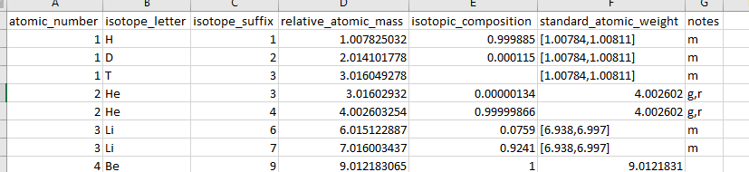
This is based on data that came with the emass algorithm². The only relevant columns are the isotope letter (the chemical symbol) and the “standard_atomic_weight” which is the atomic mass weighted by isotope abundance as you would find on the periodic table.

Adjusting Amino Acids
The relevant file here is “aa_elem_compositions.tsv”. Inside the file looks like this:
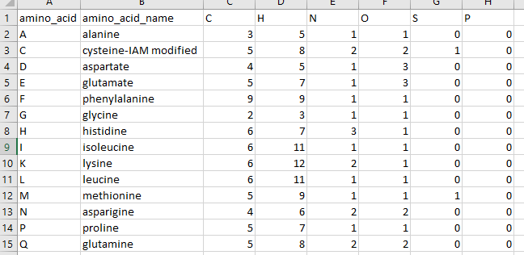
The first column lists the one letter code for the amino acid or modified amino acid. This does not have to be the traditional one letter code, or even a letter so long as it is unique and only one character long. The second column is the name, mostly for your benefit. For example, the cysteine above has the chemical formula for having an iodoacetamide modification and the name reflects this so we are not confused. All the other columns are elements that compose the amino acid. A few notes:
- the elemental composition is based on the elemental composition in the middle of a peptide chain. So the peptide bonds are formed. This is why alanine only has one Oxygen for example.
- Amino acids may be freely adjusted, renamed or have their composition changed. But remember that the change will affect all future DeuteRater v7 runs until it is changed again.
- if you wish you may add a new element to the right of the table. The column must be filled but it may be filled with zeroes. It must be a known element in the “elements.tsv” file discussed in section “Adding new elements”. “X” is not valid.
- There is an internal location in the DeuteRater v7 code which must know the element to add it. Currently, it knows, H, C, N, O, P, S, F, D (required deuterium for a standard or similar), Cl, Br, I, and Si. If you require a different element you must use the python version (the location to alter is the emass.py in the utils folder. Line 213 has the “master_isotope” dictionary. Use the other elements as a model and add to the dictionary between the curly braces).
- If you add a new amino acid, remember to add the deuterium amount of any new amino acids you add as described in “Adding new Labeling Schemes”

Adjusting Post Translational Modifications
Post-translational modifications can be used in two different ways. The first, required no matter what, is to adjust the “aa_elem_compositions.tsv” as described in “Adjusting Amino Acids”. As an example:
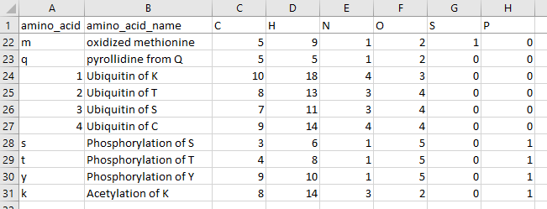
These are variable modifications. Replace the relevant amino acid in your Guide file. So, if a methionine is oxidized, replace an “M” with an “m” in the relevant peptide sequence. Fixed modifications can be represented as a separate amino acid or by altering the primary amino acid. So “C” can be altered to always have Iodoacetamide as part of its chemical formula.
If you add a new amino acid modification, remember to add the deuterium amount of any new amino acids you add as described in “Adding new Labeling Schemes”
The second file having to do with post-translational modifications is “ptms.json”. This is only relevant for creating a Guide file for peaks. This file can be opened in notepad or any coding environment. It looks like this:
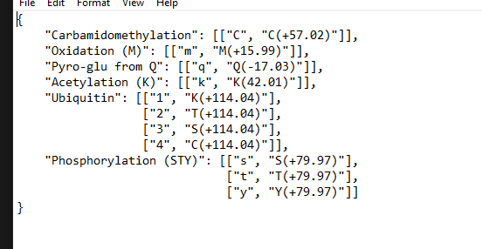
The text is the name of the modification, which will be added to the appropriate column in your guide file. Inside the brackets, the first element is the one letter code for the modification. The second element is the name for the modification produced by peaks. This allows DeuteRater v7 to replace the modification name from Peaks with the one letter code DeuteRater v7 recognizes. Make sure if you add to this, you also add to the “aa_elem_compositions.tsv” file as described above.

Adding new Labeling Schemes
Every amino acid has different amounts of deuterium that can be stably incorporated based on biosynthetic pathways. These should be stable covalent bonds, not ions, or hydrogen bonds capable of hydrogen exchange. The file that governs this is called “aa_labeling_sites.tsv”. It looks like this:
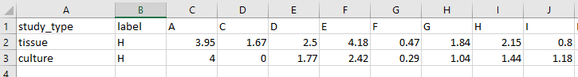
Study_type is the value that will go into the “Label Key” option in the settings menu or “label_key” in settings.yaml. the “label” column is the element being used for heavy labeling. Currently only “H” is supported. All other columns are amino acids or post-translationally modified amino acid from the file “aa_elem_compositions.tsv”. The value under an amino acid indicates the number of deuteriums that can be added. Since this is a population average, decimal values are allowed.
The two default values are “tissue” which is values from mammalian tissue and “culture” which is values from mammalian cell culture³. If new amino acids or modifications are added, be sure to add new columns to this file.

Citations
1. Kessner, D.; Chambers, M.; Burke, R.; Agus, D.; Mallick, P., ProteoWizard: open source software for rapid proteomics tools development. Bioinformatics 2008, 24 (21), 2534-6.
2. Rockwood, A. L.; Haimi, P., Efficient calculation of accurate masses of isotopic peaks. J Am Soc Mass Spectrom 2006, 17 (3), 415-9.
3. Naylor, B. C.; Porter, M. T.; Wilson, E.; Herring, A.; Lofthouse, S.; Hannemann, A.; Piccolo, S. R.; Rockwood, A. L.; Price, J. C., DeuteRater: a tool for quantifying peptide isotope precision and kinetic proteomics. Bioinformatics 2017, 33 (10), 1514-1520.

