* Tree Search +2 point
  + 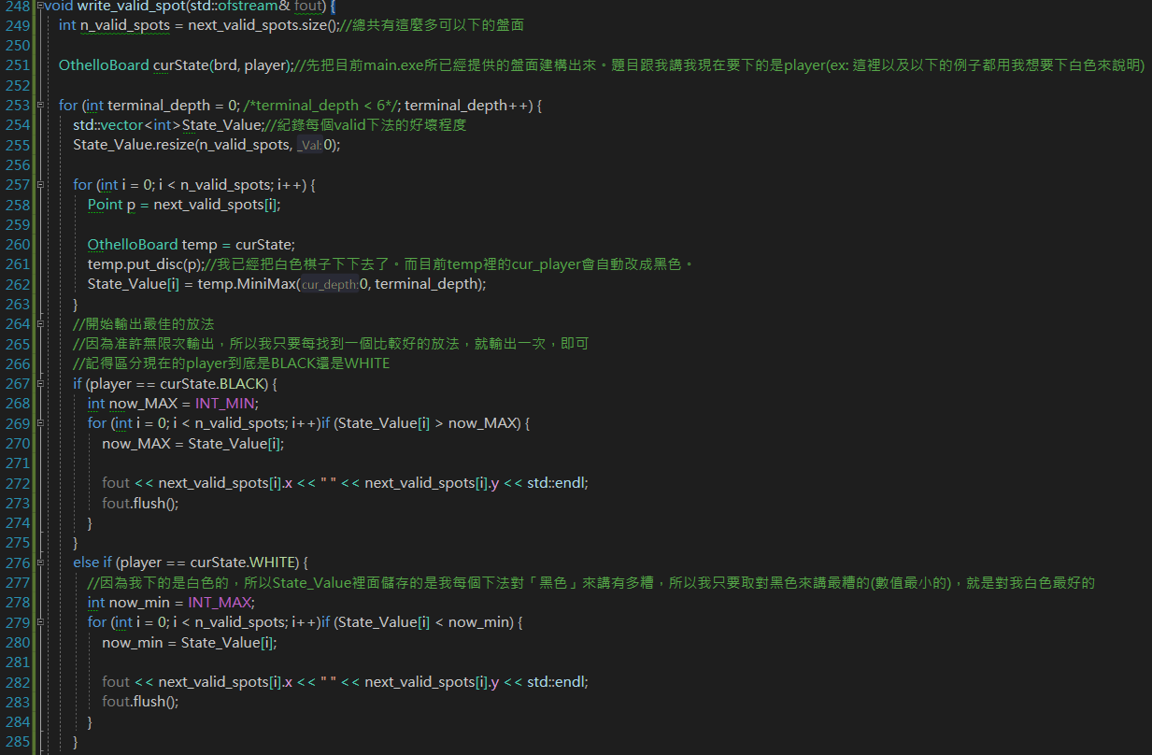

int OthelloBoard::MiniMax(int cur_depth, int terminal_depth) {

//先計算目前的valid的格子有哪些

//不管是if(cur_depth == terminal_depth)還是後面兩個，都會用到

next_valid_spots = get_valid_spots();

if (cur_depth == terminal_depth) {

int score = 0;

if (cur_player == BLACK) {

for (int i = 0; i < SIZE; i++)for (int j = 0; j < SIZE; j++) {

Point p(i, j);

if (p == Corners[0] || p == Corners[1] || p == Corners[2] || p == Corners[3]) {

if (board[p.x][p.y] == BLACK)score += Good_Corner;

else if (board[p.x][p.y] == WHITE)score += Bad_Corner;

}

else if (p.x == 0 || p.x == SIZE - 1) {

if (board[p.x][0] == BLACK && board[p.x][SIZE - 2] == BLACK)score += Four_Sides;

else if (board[p.x][0] == WHITE && board[p.x][SIZE - 2] == WHITE)score += Bad_Four_Sides;

}

else if (p.y == 0 || p.y == SIZE - 1) {

if (board[0][p.y] == BLACK && board[SIZE - 2][p.y] == BLACK)score += Four_Sides;

else if (board[0][p.y] == WHITE && board[SIZE - 2][p.y] == WHITE)score += Bad_Four_Sides;

}

if (disc_count[WHITE] + disc_count[BLACK] >= Latter_Quarter_Threshold) {

if (board[p.x][p.y] == BLACK)score += Ordinary_Disc;

else if (board[p.x][p.y] == WHITE)score += Enemy_Ordinary_Disc;

}

}

}

else if (cur_player == WHITE) {

for (int i = 0; i < SIZE; i++)for (int j = 0; j < SIZE; j++) {

Point p(i, j);

if (p == Corners[0] || p == Corners[1] || p == Corners[2] || p == Corners[3]) {

if (board[p.x][p.y] == WHITE)score += Good_Corner;

else if (board[p.x][p.y] == BLACK)score += Bad_Corner;

}

else if (p.x == 0 || p.x == SIZE - 1) {

if (board[p.x][0] == WHITE && board[p.x][SIZE - 2] == WHITE)score += Four_Sides;

else if (board[p.x][0] == BLACK && board[p.x][SIZE - 2] == BLACK)score += Bad_Four_Sides;

}

else if (p.y == 0 || p.y == SIZE - 1) {

if (board[0][p.y] == WHITE && board[SIZE - 2][p.y] == WHITE)score += Four_Sides;

else if (board[0][p.y] == BLACK && board[SIZE - 2][p.y] == BLACK)score += Bad_Four_Sides;

}

if (disc_count[WHITE] + disc_count[BLACK] >= Latter_Quarter_Threshold) {

if (board[p.x][p.y] == WHITE)score += Ordinary_Disc;

else if (board[p.x][p.y] == BLACK)score += Enemy_Ordinary_Disc;

}

}

}

if (disc_count[WHITE] + disc_count[BLACK] < Latter_Quarter_Threshold) score += next_valid_spots.size()*Mobility;

//注意return的時候，到底是誰在下棋?黑色?白色?

return (cur_player == BLACK) ? score : -score;

}

if (this->cur_player == BLACK/*MAX*/) {

//max of(a belongs to Action(cur state), MINIMAX(result of (cur state, a)))

//針對現有的盤面，去依序放上有所valid的格子，得到所有新的盤面。把所有新的盤面取MINIMAX，找最大的MINIMAX值回傳

int cur_MAX = INT_MIN;

for (int i = 0; i < next_valid_spots.size(); i++) {

OthelloBoard temp = *this;

temp.put_disc(next_valid_spots[i]);

int tmp = temp.MiniMax(cur_depth + 1, terminal_depth);

if (tmp > cur_MAX)cur_MAX = tmp;

}

return cur_MAX;

}

else if (this->cur_player == WHITE) {

//min of(a belongs to Action(cur state), MINIMAX(result of (cur state, a)))

int cur_min = INT_MAX;

for (int i = 0; i < next_valid_spots.size(); i++) {

OthelloBoard temp = *this;

temp.put_disc(next_valid_spots[i]);

int tmp = temp.MiniMax(cur_depth + 1, terminal_depth);

if (tmp < cur_min)cur_min = tmp;

}

return cur_min;

}

* }

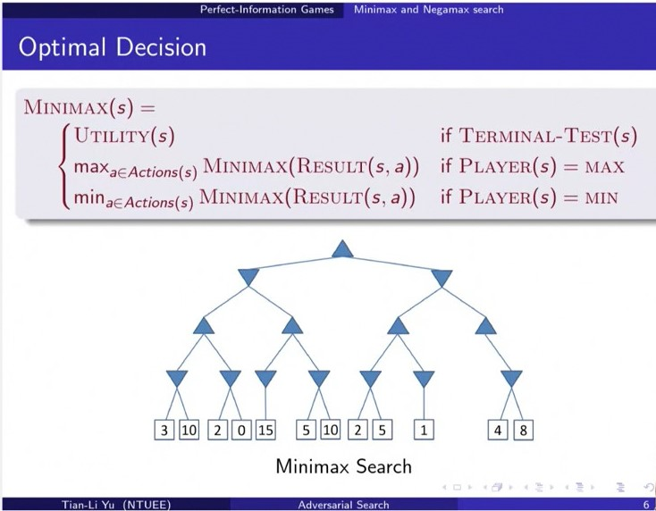

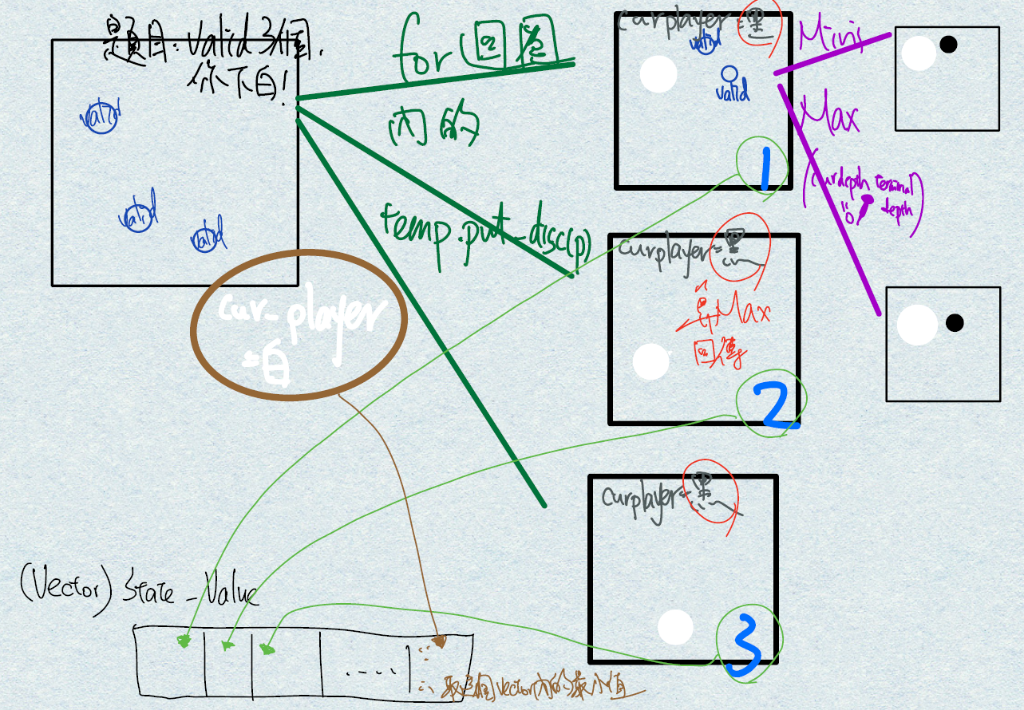

* State Value Function Design +1 point
  + 在上方文字函式的開頭處
* Alpha-beta Pruning +1 point
  + 沒有實作
* Version Control (Bonus) +1 point





Struct Point、void read_board、void read_valid_spots、int main。

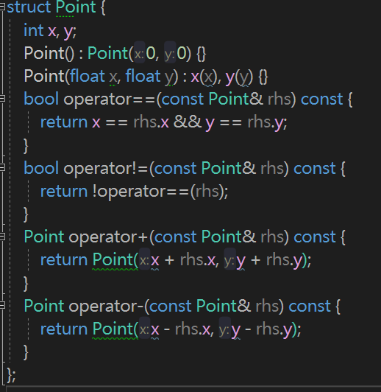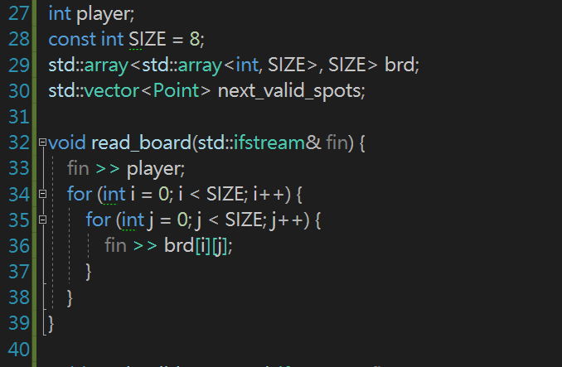

Class OthelloBoard: int get_next_player、bool is_spot_on_board。

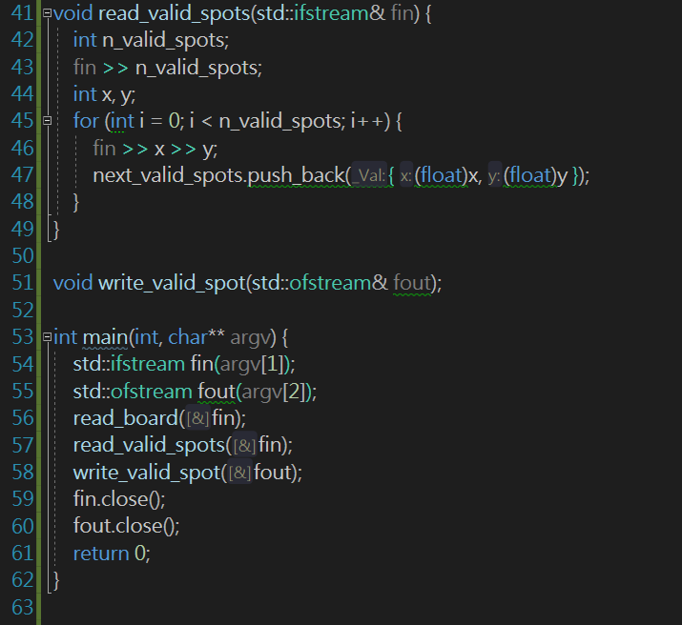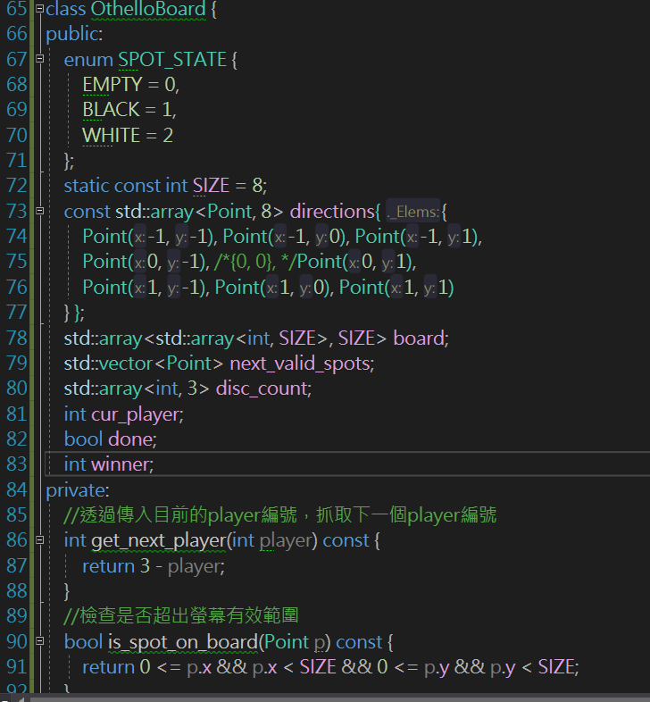

Int get_disc、void set_disc、bool is_disc_at。

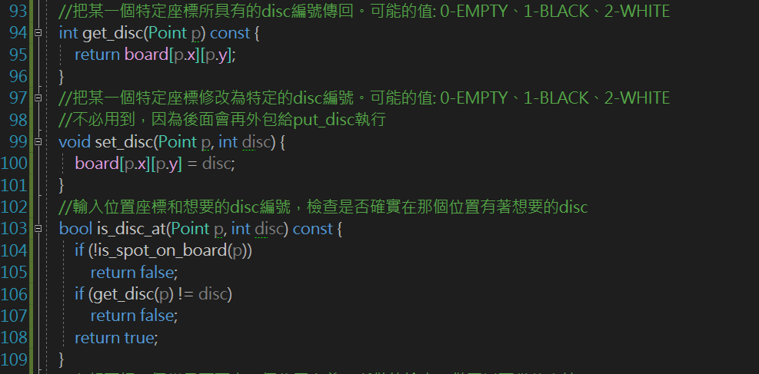

Bool is_spot_valid。

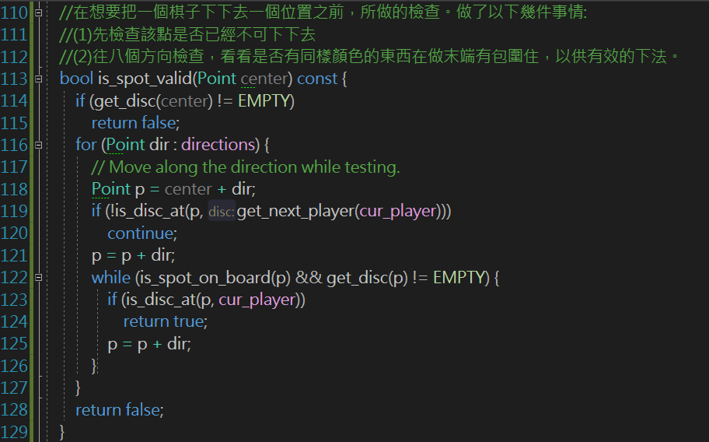

Void flip_discs。

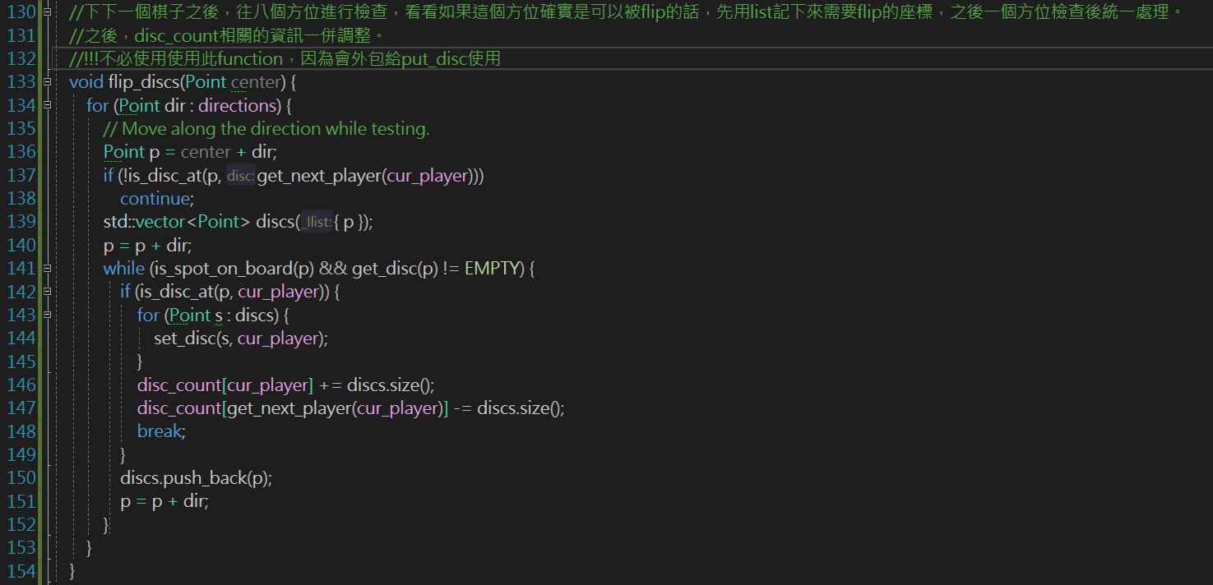

Constructor * 3。

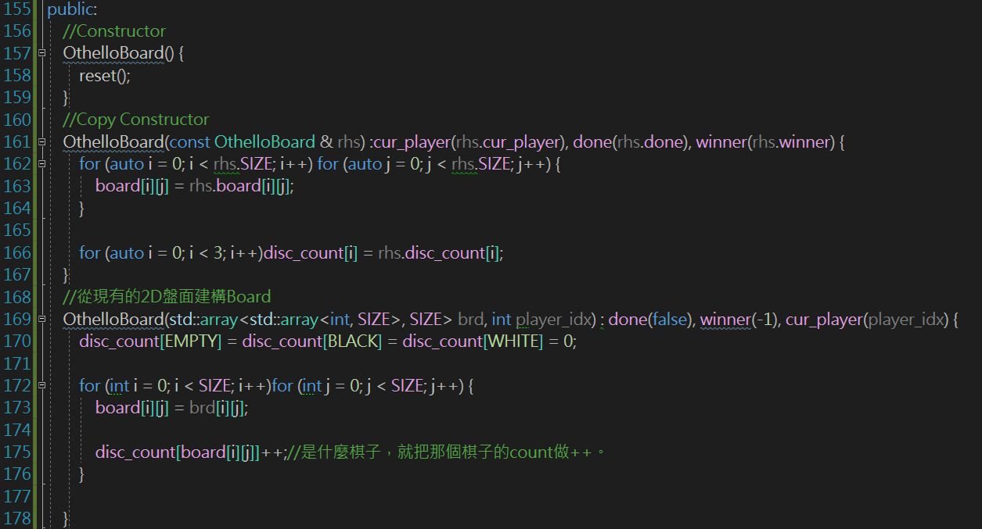

Void reset、std::vector<Point> get_valid_spots。

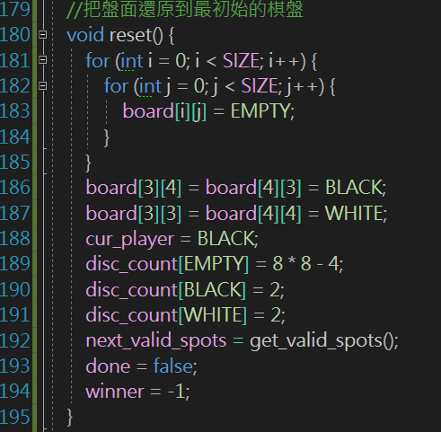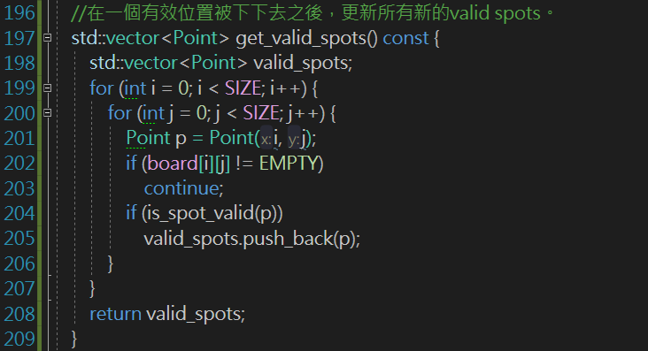

Bool put_disc。

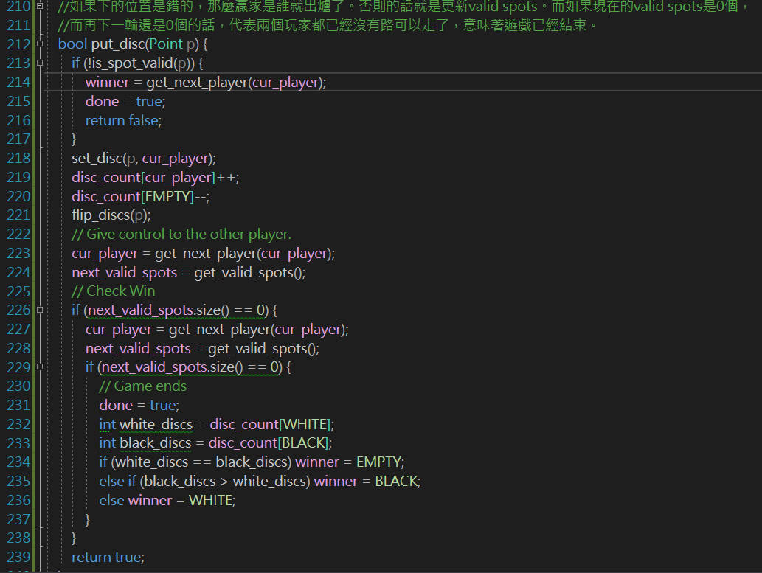

參數設定。

