香港支付服务商如 Stripe、Cybersource（Visa旗下）、或本地银行提供的收单服务（如 汇丰 PaymentOne）

https://corpuat.smartone.com/QPlXrh8o1P

https://salesportaluat.smartone.com/payment?id=3bdc9e444c1d9fbe44a5b79834cb2274b8a72545b3dce4baa70db0de14f1e0ff

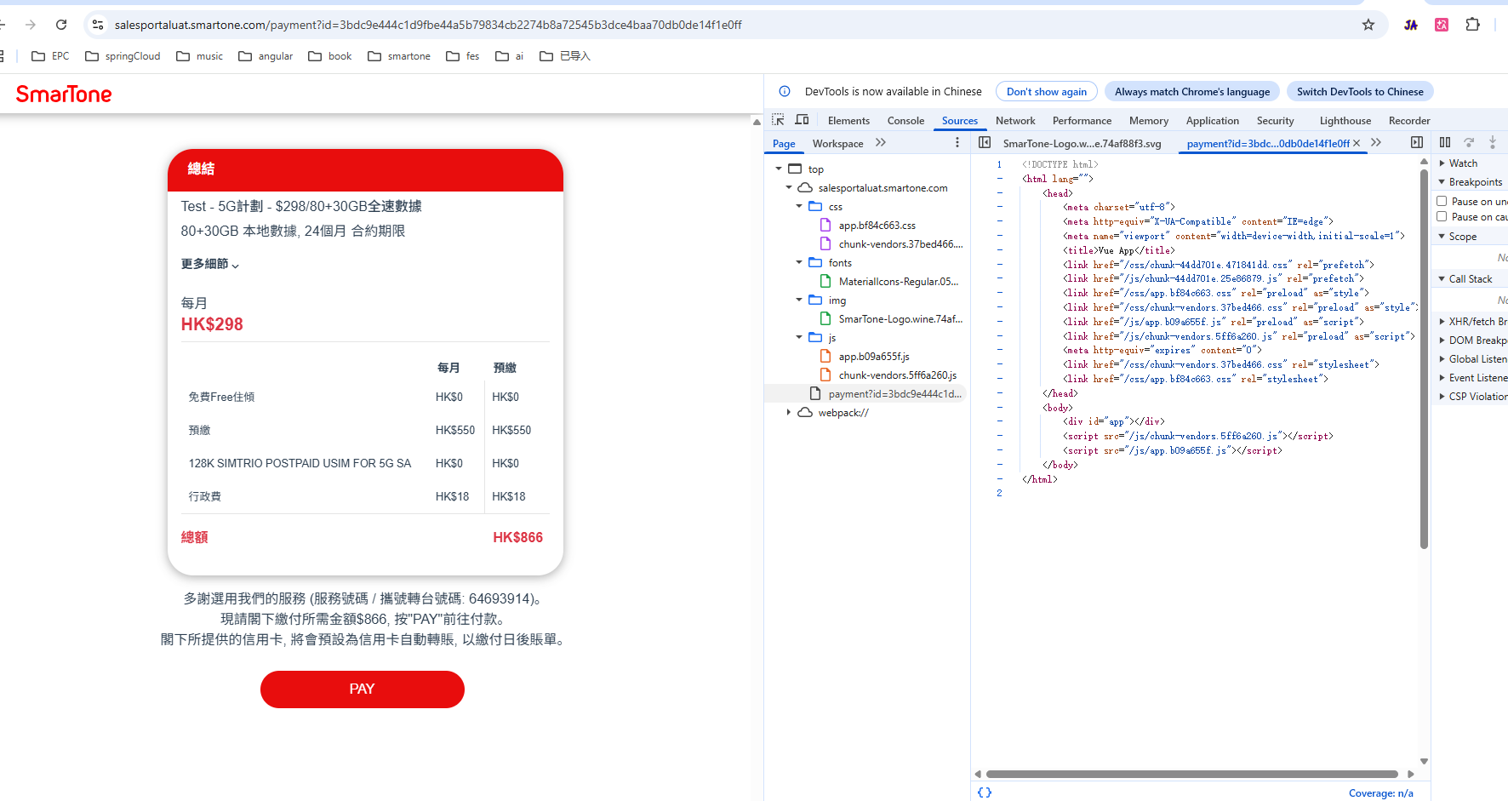

https://securepaymentstage.smartone.com/jsp/tchinese/payment.jsp?t=B02C6A6996DF6E975F19DC87FDAD7601&sid=cs_acq&type=
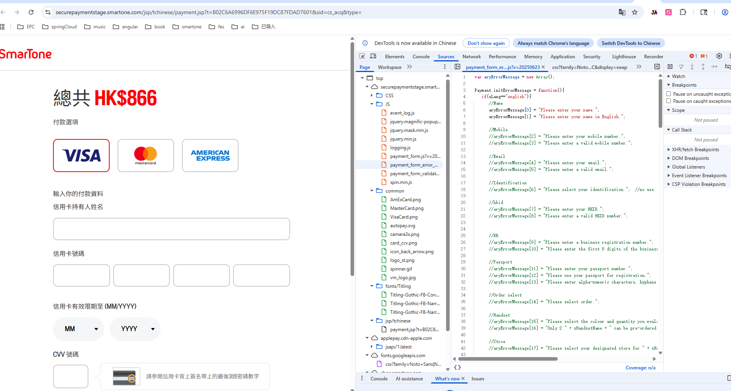

cybersource
const fetchMerchantAuthUrl = "/jsp/ApplePay/cybersource/API_authorizeMerchant.jsp";
WriteLog(sGlobal_sid,sGlobal_ecr,"session.onvalidatemerchant, fetch "+fetchMerchantAuthUrl);
await fetch(
fetchMerchantAuthUrl,
{
method: 'POST',
headers:{
'Content-Type': 'application/json'
},
body: JSON.stringify({
t:sGlobal_token,
lang:sLang,
//payment_request:joGlobal_ApplePay_paymentRequest,
validationURL:event.validationURL
})
}
)
.then(response => response.json())
.then(data => {
if (data === undefined) throw new Error("empty response");
if (isEmpty(data)) throw new Error("empty response JSON");
try{
session.completeMerchantValidation(data);
WriteLog(sGlobal_sid,sGlobal_ecr,"session.completeMerchantValidation");
}
catch(error){
bGlobal_hasError = true;
const sErrorMessage = ((sLang==="english")?"System Bussy":"系統繁忙")+"(001.2)";
WriteLog(sGlobal_sid,sGlobal_ecr,"session.completeMerchantValidation Error: " + error+", display to user:"+sErrorMessage);
ApplePay_showMessage(sErrorMessage);
session.abort();
}
})
.catch(err => {
bGlobal_hasError = true;
const sErrorMessage = ((sLang==="english")?"System Bussy":"系統繁忙")+"(001.3)";
WriteLog(sGlobal_sid,sGlobal_ecr,"fetch API_authorizeMerchant.jsp Error: " + err+", display to user:"+sErrorMessage);
ApplePay_showMessage(sErrorMessage);
session.abort();
});

