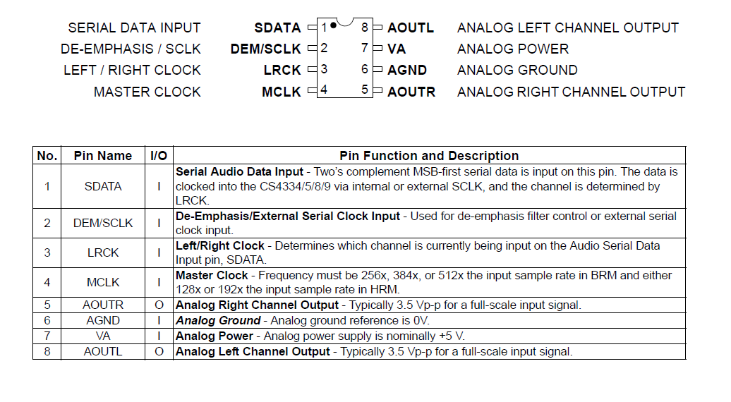

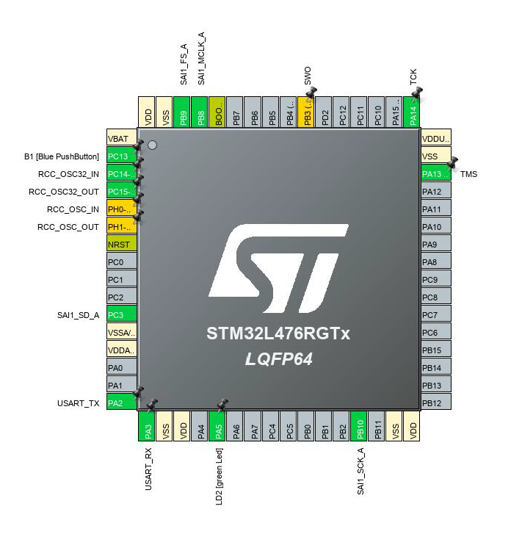

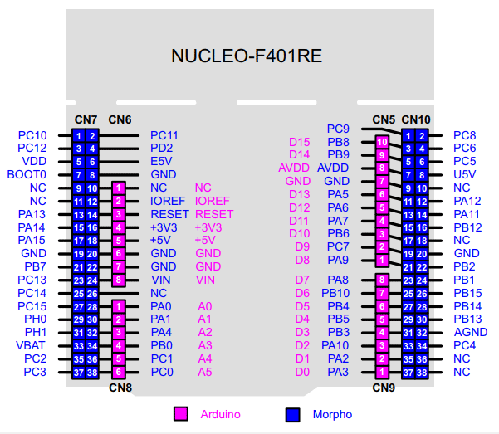



<https://blog.csdn.net/weixin_30819085/article/details/96938728>

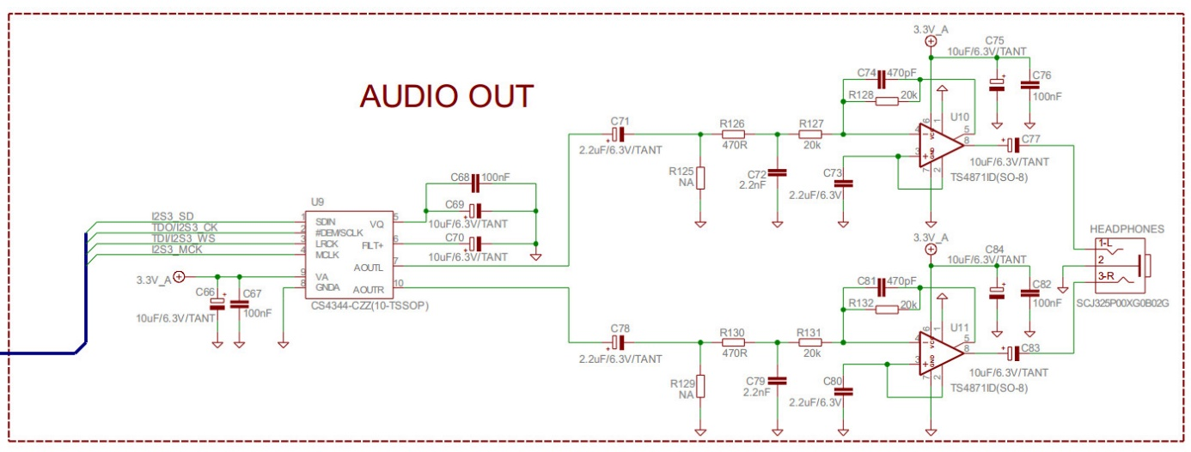

Autre source

http://www.codeforge.com/read/230160/CS4334.c__html