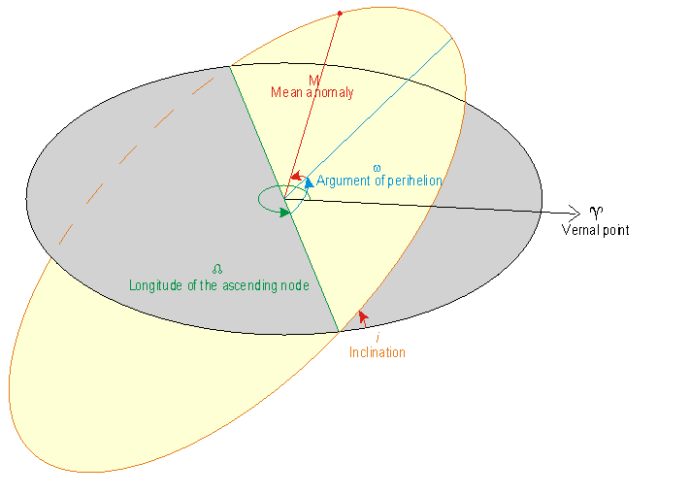
Legend:
" arcseconds
Cy Julian century
a semi-major axis
e eccentricity
i inclination
Omega longitude of the ascending node
~omega longitude of perihelion
L mean longitude

Mean Anomaly
Anomaly is a term for an angle. The Mean Anomaly is the angle which describes the position of the satellite in its orbit, relative to perigee. At perigee, the Mean Anomaly is zero, it increases to 180 degrees at apogee, then back to perigee at 360 degrees.
Since the orbit is often not a circle, the measurement of the angle is difficult, so the angle is expressed in terms of a fractional orbit (one orbit = 360 degrees). This is the reason for the mean adjective. For circular orbits, the Mean Anomaly is just the angle between perigee and the current satellite position.
A special form of the Mean Anomaly is used by AMSAT controllers - instead of 360 degrees, the orbit fraction is expressed as a number in the range 0-255. This is often referred to as "MA" and is available in the Orbit group of the Info Window.

http://home.att.net/~srschmitt/planetorbits.html

