**MEETING NOTES**

**REQUIRED TO COMPLETE THE COMPANY NAME TO THE WHOLE SYSTEM**

**HOME PAGE**

CAROUSEL

* REMOVE THE DEVELOPMENT WORD
* SMALL CAROUSEL
* 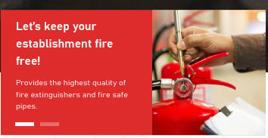

Replace the 2nd text

1st picture: Provides the highest quality of fire protection tools and equipment.

2nd picture: With the utmost quality service that the company provides for better

safety and security

* REQUEST A QUOTE BUTTON TO REMOVE IN CAROUSEL

**OUR SERVICES**

* TESTING CHANGE TO SUPPLY
* ADD THE SUPPLY

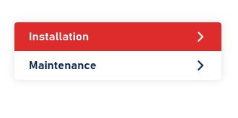

* As for the inclusion

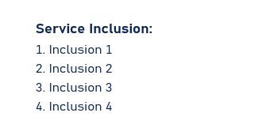

ON THE HOMEPAGE INCLUDE ONLY 4 INCLUSION BUT WHEN WE CLICK THE REQUEST A QUOTE ALL INCLUSIONS WILL BE INCLUDED

HERE ARE THE INCLUSIONS FOR INSTALLATION AND MAINTENANCE PROVIDED BY THE CLIENT

* **automatic fire sprinkler System**
* **wet and dry fire hydrant system**
* **kitchen hood fire suppression system**
* **carbon Dioxide Fire Suppression system**
* **Flooding System**
* **fire Detection and Alarm system**
* **FM200 System (Include hydraulic and flow calculation).**
* **Aragonite Fire Suppression System.**
* **Kitchen Hood Fire Protection System**
* **deluge system**
* **water mist system**
* **Dry Chemical Extinguishing system**
* **Plumbing system**

HERE ARE THE INCLUSIONS FOR SUPPLY PROVIDED BY THE CLIENT

* Chemguard made in USA Foam Products (AFFF 35 and 6% Concentration)
* Fire hoses, Fire Extinguisher, Cabinets, refilling and other Accessories; UL/FM Approved
* Alarm Valves Check Valves, Deluge Valves OS&Y Valves, Post Indicator Valves, Swing or wafer type check valves. Made in USA. UL/FM approved.
* Smoke and heat Detectors, .UL/FM and or BFP Approved.
* Fire Suppression Panel Fire Alarm Control panel, Addressable or Conventional type. UL/FM or BFP approved.
* Fire Fighting Suit and other personal safety products.
* confirm where "Schedule Appointments" button come from and what is the function

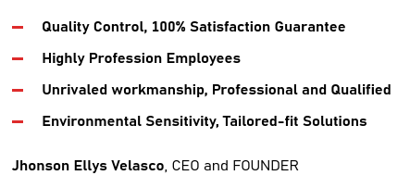

REMOVE THE 2ND BULLET AND THE CEO WILL CHANGE INTO Merle Velasco, General Manager

* NEW TERMS AND CONDITIONS WILL BE ADDED AND THE PAST TERMS AND CONDITION WILL CHANGE INTO PRIVACY POLICY
* OUR TEAM (CLIENTS QUESTION) DOES THE CLIENT CAN EDIT THIS PART AND IF POSSIBLE THE CLIENT WILL BE THE ONE TO CHANGE THAT BASED ON THEIR DATABASE?
* IS PHOTO AND INFORMATION OF TEAM IS STATIC OR DYNAMIC

**CONTACT US**

* CONFIRM WHERE THE CLIENT TESTIMONIALS WILL BE SENT

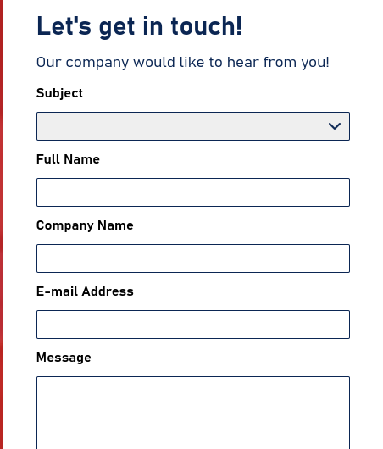

CLIENT QUESTION: THIS ONE IS FOR THE CLIENTS TESTIMONIALS?

* REMOVE INSTAGRAM ICON
* EMAIL AND NUMBER TO BE CHANGED

EMAIL: [veltechfire_14@yahoo.com](mailto:veltechfire_14@yahoo.com)

TELEPHONE NO.: ( 8 ) 950-6366

Address: Blk 6 Lot 24 Galatia St. North Olympus, Novaliches, Quezon City

Opening Hours

Mon-Sat - 8:00 AM - 5:00 PM

Facebook link: <https://www.facebook.com/profile.php?id=100086709789324>

**FOOTER**

* REMOVE REQUEST A QUOTE IN FOOTER



**REQUEST A QUOTE**

* REMOVE AND TECHNOLOGIES TEXT

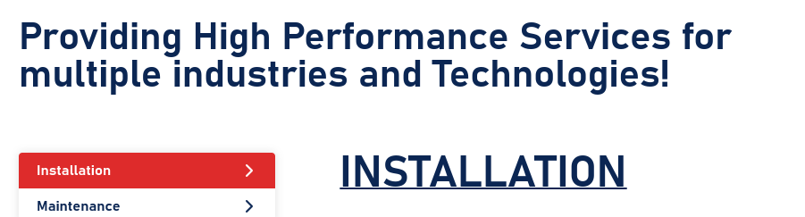

* SIZE IN SQUARE METERS TO INDICATE WIDTH X WEIGHT
* FEATURES TO BE ADDED TO CHANGE AS DROP DOWN AND ADD OTHERS TO

TAKE OTHER OPTIONS FROM USERS.

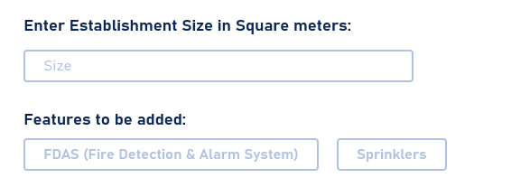

* Quotation Requests takes up to 1 to 2 business days of processing. Kindly check the quotation tab inside your profile to get the latest update.

TYPO ERRORS:



**SIGN UP**

* VELTECH COMPANY NAME MUST INCLUDE INC. AND &
* MIDDLE NAME OPTIONAL *
* NAME SUFFIX OPTIONAL
* COMPANY NAME OPTIONAL

**PASSWORD RESET TO FIX**

**DOMAIN HEROKU TO BE BOUGHT**