**“一天公益”刘猛事件**

2018年7月27日，刘丽举报“一天公益”社会工作服务中心理事长刘猛曾于2015年在温江工作站内对其实施性骚扰。她以一般人格权对刘猛提民事起诉讼并成功立案。

2018年12月，最高法新增了性骚扰侵害纠纷作为民事案由。刘丽随即提出变更案由申请，得到法院认可。

2019年7月8日，成都武侯区法院一审宣判：被告刘某存在性骚扰行为，要求被告在判决结果生效之日起十五日内，向原告当面以口头或书面方式赔礼道歉。

这是2018年以来#MeToo浪潮中第一个胜诉的案子，也是“性骚扰损害责任纠纷”写入民事案由后中国第一例以“性骚扰”案由得到受理并胜诉的案件。

On July 27, 2018, Liu Li publicly accuesed Liu Meng, director of “One Day” Social Work Service Center, sexually harassed her in 2015. She filed a lawsuit against Liu Meng for personality infringement.

In December 2018, Supreme People's Court has listed sexual harassment liability dispute as cause of actions into civil court. Liu proposed to change the legal ground and was approved by the court. On On July 8, 2019, the court ruled that Liu Meng had committed sexual harassment. He was demanded to make official apologize to the plaintiff.

This is the first winning case since the # MeToo movement in China, and also the first case that sexual harassment has been used, approved and won as the cause of actions in China.

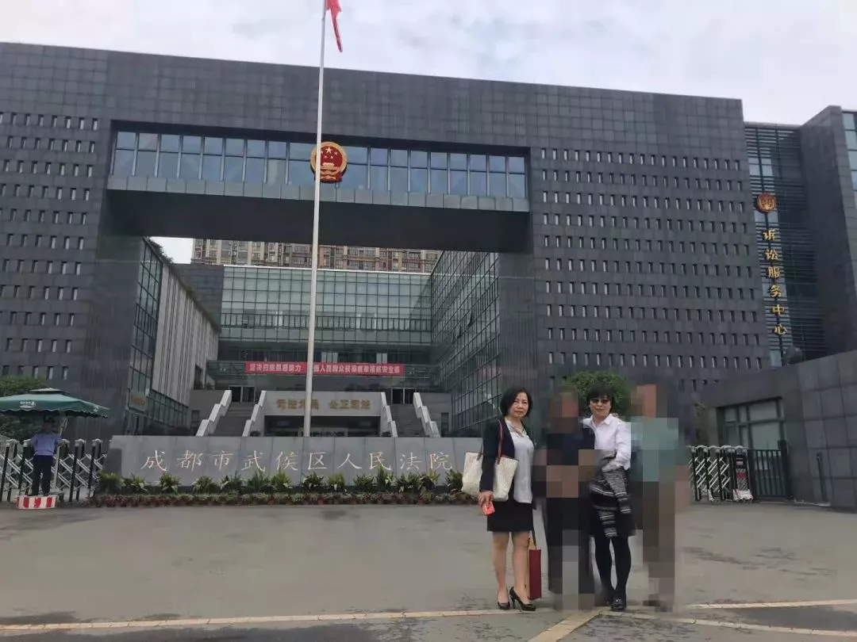

开庭当天刘丽与代理律师合照。受访者供图

Liu Li with her lawyers in front of the court.

**央视朱军事件**

2018年7月26日，原央视实习生弦子发文指控曾遭主持人朱军性骚扰，提出当年曾报警但未能立案。

2018年9月25日，朱军起诉举报者弦子和发布者麦烧名誉侵权，要求删除微博并登报致歉，同时索赔经济损失和精神损害抚慰金65万。

2018年9月25日，弦子向法院递交针对朱军的起诉书，索赔6万人民币。

2019月1月18日，弦子向法院提交了将案由改为“性骚扰损害责任纠纷”的申请。该案立案至今迟迟没有开庭。如今，半年期限已过了，弦子也没有收到延期开庭的书面通知。

On July 26 2018, Xianzi, who used to be an intern, accused the famous CCTV anchor Zhu Jun of sexual harassment. Then she was countersued by Zhu Jun for "reputation infringement." In Jan. 2019, Xianzi also sued Zhu Jun on the ground of the "dispute over liability for sexual harassment and damage" .

The case was on file in Jan. but the hearing was postopned since then. Six months has passed, no formal notice was issued.

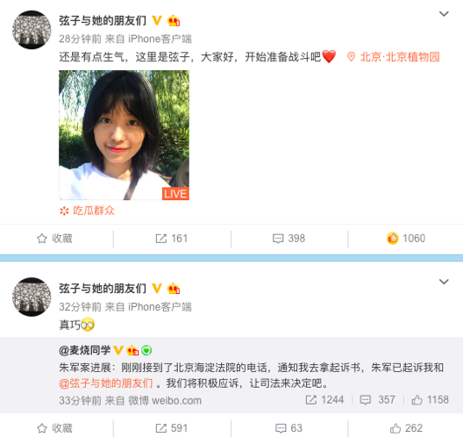

**京东刘强东事件**

2018年8月31日，京东集团创始人兼首席执行官刘强东，因涉嫌“构成犯罪的性行为”于美国明尼苏达州被捕，后被保释。京东9月6日于其英文网站承认刘强东涉嫌性侵，案件已进入调查阶段。

2018年12月21日，美国明尼阿波利斯市亨内平县检察官办公室公布刘强东事件的调查结果，因证据不足，难排除合理怀疑，决定不予起诉。女方律师表示失望，并谴责检方始终未与律师及女方交流。

2019年4月16日，案件当事女学生 Jingyao Liu 正式向明尼苏达地方法院提起民事诉讼，索赔 5 万美元。她表示，如果能打赢民事诉讼，她会全部捐出赔款。这一事件在中国国内引发了全民关注和激烈讨论。一些青年女性发起#HereForJingyao以及#我也不是完美受害者的声援活动支持Jingyao。

On Aug. 31 2018, Liu Qiangdong, a millionaire and CEO of JD.com was arrested in Minnesota on suspicion of  Criminal Sexual Conduct. At the end of December 2018, the local prosecution decided to drop the criminal case because of lack of solid evidence. On 16 April 2019, the victim Jingyao Liu formally filed a civil case in Minnesota District Court, claiming US $50, 000. She said that if she could win the civil suit, she would donate all the reparations.

A few videos were released and trying to manipulate the public opinion. Feminists initiated #HereForJingyao and #Iamnotperfectvictim campaign online to support Jingyao.

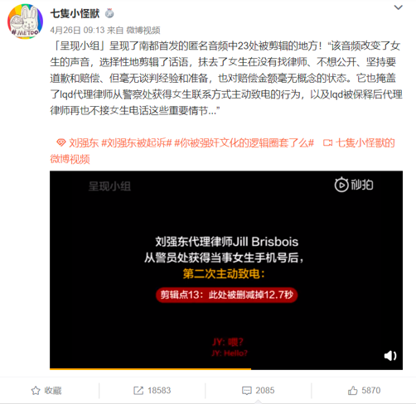

**“免费午餐”邓飞事件**

2018年7月23日，网友 “dangpu”举报“免费午餐”发起人、知名公益人邓飞曾性骚扰同伴，随后微博用户@王思璟 、微博用户@不要怕不要怂 等多位女生都站出来指认称邓飞恐为性骚扰惯犯。

2018年8月1日，女生C通过微信公号“黄章晋”、“邹思聪”、豆瓣用户鲸书发文举报邓飞性骚扰。

2018年11月15日，邓飞起诉邹思聪名誉侵权，邹思聪表示会应诉到底。

2019年7月17日，邓飞起诉邹思聪名誉侵权案在杭州互联网法院召开了庭前会议。邹思聪一方有三位证人出庭作证，涉案文章作者女生C也出庭接受询问。邹思聪当庭表达了希望公开审理的意愿。目前正等待法院下一步的审理安排。

On July 23, 2018, Deng Fei, the founder of "Free lunch", was accused of sexual harassment, and then a number of women came forward to report Deng Fei as a habitual sexual harassment offender.

On Nov. 15, 2018, Deng Fei sued Zou Sicong, who helped publish the article reporting the allegations for reputation infringement, and Zou Sicong said he would respond to the lawsuit to the end.

On July 17, 2019, the case of Deng Fei suing Zou Sicong for reputation infringement held a pre-court meeting in Hangzhou Internet Court. Zou expressed his hope for a public trial in court. It is currently awaiting the next step of the court's trial arrangements.

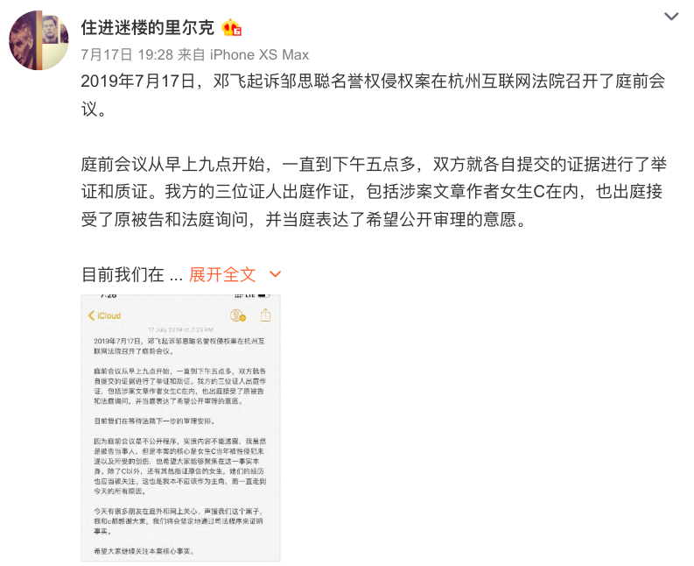

**UIUC教授徐钢事件**

2018年3月12日，美国卫斯理安大学教授王敖实名举报美国伊利诺伊香槟分校教授Xu Gary Gang（徐钢，美国籍）长期性侵、性骚扰多名学生达20年之久。

2018年4月17日，徐钢在深圳市罗湖区法院起诉，要求王敖赔礼道歉，并支付285.5万元经济损失和精神损害赔偿金10万。

2019年6月17日，该案在深圳罗湖区法院开庭审理。当日，徐刚要求申请不公开审理。徐刚更换律师却未提交合法有效的授权书证明，王敖方律师万淼焱退庭抗议，案子一再押后。

On Mar. 12, 2018, Wang Ao, who helped the students expose Xu Gang's sexual assault, was sued by Xu Gang for reputation infringement and millions of compensation in April.

On June 17, 2019, the case was held in Luohu District Court, Shenzhen. Xu Gang applied for a private hearing and his new lawyer failed to submit legal authorization in accordance with Chinese law. Wang ao's lawyer Wan Miaoyan withdrew from court to protest. The case was repeatedly postponed.

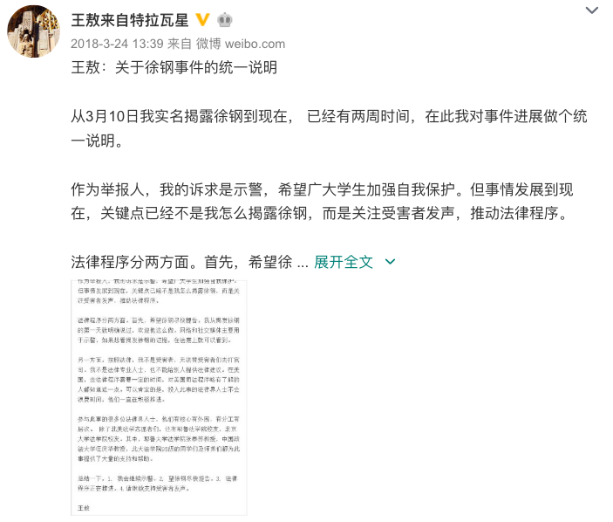

**世界自然基金会（WWF）周非事件**

2018年7月25日，世界自然基金会（WWF）前员工、微博用户@洛女王cheche 实名发文指控前上司、世界自然基金会中国区副总干事周非对其性骚扰。

2018年8月27日，周非以名誉权纠纷为案由对 @洛女王cheche 提起民事诉讼。

2018年12月3日，该案在北京市丰台区法院开庭。庭后，@洛女王cheche 发微博说，“对方要求调解，然后调解了俩小时，调解失败，择日开庭。”

On July 25, 2018, Wang Qi, former employee of WWF accused Zhou Fei, her former boss of sexual harassment. Zhou Fei sued Wang for infringement of reputation. The case was held in Fengtai District court, Beijing on Dec. 3, 2018. After the hearing, Zhou Fei asked for mediation, but failed. The case will be held at another time.

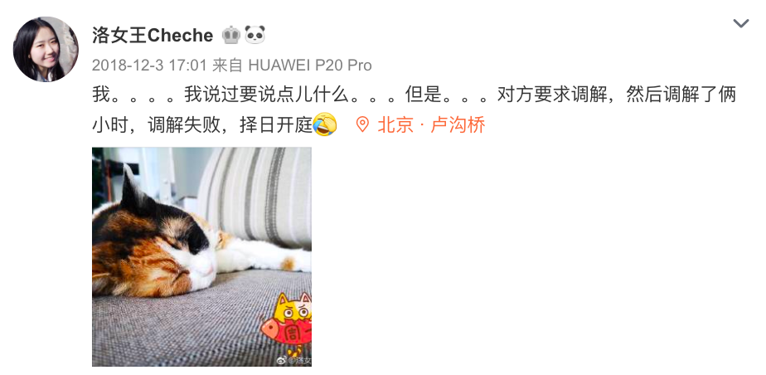

**北京迷笛周翊事件**

2018年7月28日，微博用户@我是落生 发布迷笛志愿者@再见罗丝 的私信求助，指控迷笛副总周翊性侵。

2018年8月6日，@再见罗丝 前往苏州案发地报警，苏州公安就周翊强奸案立案，目前仍在侦查阶段。由于时间跨度长以及涉及跨省办案，在公检法结束之前，当事人难以发起自诉。

2018年10月30日，周翊以名誉权纠纷为由起诉@再见罗丝、举报者@我是落生和新浪微博。目前该案暂无新进展。

On July 28, 2018, weibo user@我是落生 released a private letter from @再见罗丝 , a volunteer at the Midi Festival, accusing Midi Music Festival staff Zhou Yi of sexual assault.

On Aug 6, 2018, @再见罗丝 went to Suzhou, where the assault took place, reported rape to the police, and successfully filed the case. Because of the long time span and cross-provincial handling of the case, it is difficult for @再见罗丝 to initiate a private prosecution before the end of the investigation.

On Oct. 30, 2018, Zhou Yi sued @再见罗丝 , @我是落生 and Sina Weibo company for infringement of reputation. So far, there has been no progress of case.

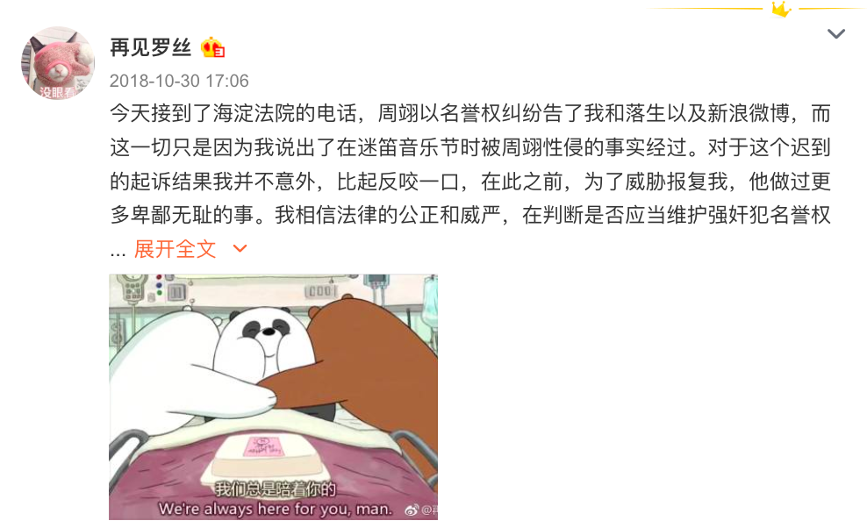

 整理：山奈