Victor Haskins
Game Programming II
Lab 09 – Shaders

Introduction

This lab was short and focused on the use and creation of shaders and how they tie into the Unity engine. The class utilizes the Shaderlab language which has a basis in C++. The class already has some experience in the use of shader creation so this class compounds upon it with having the shader communicate with the material it is connected to so an image and be wrapped around the object.

Methods

We start with creating a basic scene and add a capsule, basic material, and shader and go to the internet to grab a simple image for a texture. This will be “sampled” by the shader later and translated onto the object.

In addition to what we have come to expect with shader layout, we add a few new features. The first of which is a new property “_MainTex (“Diffuse Texture”, 2D) = “white” {}”. This is the actual interface that adds a texture input from the inspector. “_MainTex” is a Unity Engine specific component but if we were not going to be using unity elements, it could be called anything. The 2D portion of the line tells us that it will be modifying a texture. The end portion is a function that sets the base background color to white.

The next portion jumps to the user defined variables within the “Pass” section of the “SubShader”. The first is “uniform sampler2D _MainTex”. This gives the shader a way to access the property and the variable type, sampler2D is a method to sample the texture. It works in a similar way as to how the _Color property/variable is set up for use in a shader. The next variable is “uniform float4 _MainTex_ST”. This holds the tiling and offset for the earlier variable which needs to be called right before the “*_ST”.

The next portion discusses variables held in the structs used to hold the input and output information. The input struct houses the variable “float4 textureCoord: TEXCOORD0;” while the output struct has “float4 texture: TEXCOORD0”. These are used to pass the uv coordinates from the vertex function to the fragment function. UV coordinates tell how a 2D texture is wrapped around a 3D model.

The last major addition is adding the line
“float4 texture = tex2D(_MainTex, _MainTex_ST.xy * input.texture.xy + _MainTex_ST.zw);”. This is a lot of info to unpack. Obviously, first we create a float4 to hold the four-floats variable we are about to make called texture. We then call the function tex2D(...) to unwrap the texture data so we can call the input image inside the texture with _MainTex, the first parameter. Then, since the texture two dimensions, they are taken at the desired x and y coordinates of the texture inputted by the called output struct and multiplied by the tiling values in the x and y values of _MainTex_ST. Finally they are combined with the z and w values of _MainTex_ST into the new float4 and has this value returned, translated as a COLOR variable. It can then be modified in the scene by altering the color tint and/or the light source's color.

The rest of the shader plays out as before with using a _Color property/variable and having a series of calculations performed for every pixel location on the necessary object with a vertex function call and a fragment function call.

Conclusion

The new information presented shows us how the Shaderlab can interact with Unity and be used to employ other methods of applying textures. This is important for when creating tools and interactive elements for creative teams trying to apply their textures to objects in the game world.

Questions

1. Draw what a UV map might look like for the following object (Note the red lines are just for scale reference and not part of the object)
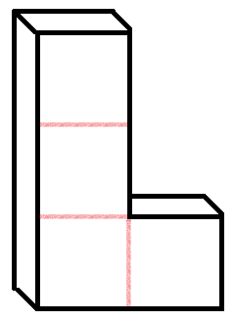
a.

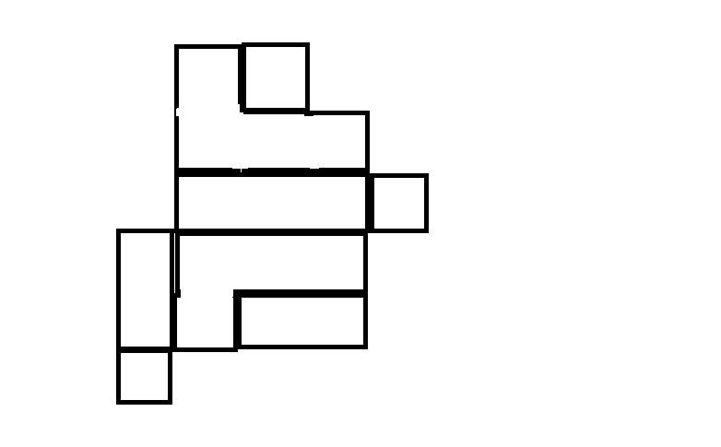

This is my approximation of what they would use based on a measure to save from empty space.

2. What meaning does a UV have in relation to a texture and/or a model?
The idea is based on how a texture would mapped to, or essentially wrapped around, a particular object.

3. What does it mean when you say that you will sample a texture?
An image/texture is used for a reference of what will be applied with a material to the shader.

4. What does it mean when you say that you are unwrapping a texture?
The texture is stored and passed along to the shader (basically encapsulated like its being tranmitted like a packet), so the shader then has to unpack that information in the proper format.

5. If I had a sampler2D named _RawrTex, what would I name the next variable to capture the tiling and offset of that sampler2D?
The answer is uniform float4 _RawrTex_ST

