Technical Design Document (TDD)

**Networking Redux**

Team Virtual Machine

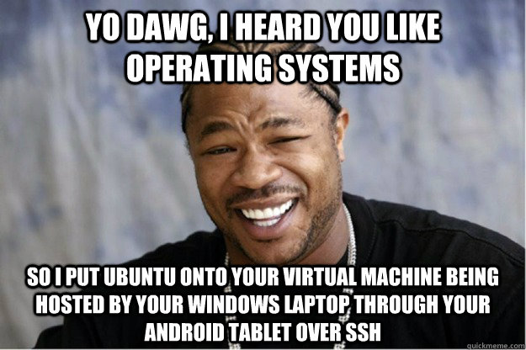

Version: 1

Created: 11/12/2015

Last Updated: 11/12/2015

**Table of Contents**

Executive Summary 2

Project 2

Technical 2

Programs 3

Market Release 3

Time to Completion 3

Estimated Cost of Completion 3

Hardware and Software 3

2D Software 3

Sound Software 3

Programming Software 3

Development Plan 3

Milestones 4

Project Goals 4

Features 4

File Formats 4

2D 4

3D 4

Audio 4

Scripts 5

Scenes 5

Other 5

Asset List          5

Audio          5

Executive Summary

**Project**

Create a basic networked game with two set levels to simulate the game Capture The Flag. There should be a flag on either side for opposing teams to collect. There will be team play, shooting, and item pickup mechanics

**Technical**

Programs

The following programs will be required for the creation of Around the World:

|  |  |  |
| --- | --- | --- |
| Program | Purpose | Cost |
| Unity3d | Game Development Environment | $1500 |
| Audacity | Sound Creation | Free |
| Microsoft Visual Studio | Debugging Environment | Free |
| G.I.M.P | 2D Image Manipulation | Free |
| Blender | 3D Graphics and Animation | Free |

Time to Completion

The total estimated completion time for user rails is two weeks.  That includes time for coding and bug testing.

Estimated Cost of Completion

|  |  |
| --- | --- |
| Unity3d | $1500 x 2 |
|  |  |
| **Total** | **$3000.00** |

Hardware and Software

**Programming Software**

|  |  |  |
| --- | --- | --- |
| Software Name | Description | Cost |
| Microsoft Visual Studio | Used to debug and create code | Free |
| MonoDevelop | Used to create prototype code | Free with Unity3D |
| Unity3D | Development Environment. Used to release to multiple platforms. | $1500 |

Development Plan

**Milestones**

|  |  |
| --- | --- |
| Date | Milestone |
| 11/13/2015 | TDD Complete |
| 11/16/2015 | Basic Level work and networking completed with movement, run, jump, fall,Health, and shooting |
| 11/20/2015 | Minimal effort added beyond initial project addition. |
| 11/21/2015 | Minimal effort added beyond initial project addition. |
| 11/23/2015 | ubmitted to Professor Fisher |

**Project Goals**

Features

Simple Character Movement and Networking game

* Character Networking
  + Character controller that is networked. Character needs to
    - Move
    - Run
    - Jump
    - Fall
    - Exist in a 3D world
    - Have Health
    - Deal damage via shooting
      * Infinite ammo, but reload time advised
      * Same amount of damage rate to all players
    - Pick up objects
    - Team Mechanics
  + Designers should be able to control as many aspects as possible
  + Game must be fully networked and have a respawn timer
* Shaders
  + Create two shaders that will be used for the different teams. With two simple tasks
    - Include texture
    - Color appropriate for team
    - Lighting
    - One other property not covered in class
* Gameplay
  + Players start with predesignated spawn points
  + Sound should be included
  + Team “bases” with flag
  + Three flag captures taken back to base for a win
  + Two hand-crafted levels
* GUI
  + Player asked to
    - Create game
      * Input min & max values for objects to spawn
    - Join Game
      * Show appropriate info and join the game
      * Places players in teams with only a variance of one.
    - Quit Game
      * Exit game
  + Players need to see their own health.
  + Respawn Timer
  + Show other players’ health and names, color coordinated to show team and non-team members.

File Formats

**Scripts**

|  |  |  |
| --- | --- | --- |
| Naming Convention | Description | Format |
| FilenameEditor | Editor script for an object script | .cs |
| Filename | A script for an object | .cs |

**Scenes**

|  |  |  |
| --- | --- | --- |
| Naming Convention | Description | Format |
| SceneName | A scene in Unity3D | .scene |

**Other**

|  |  |  |
| --- | --- | --- |
| Naming Convention | Description | Format |
| TDD_Finished | The completed Technical Design Document | .pdf |

Asset List