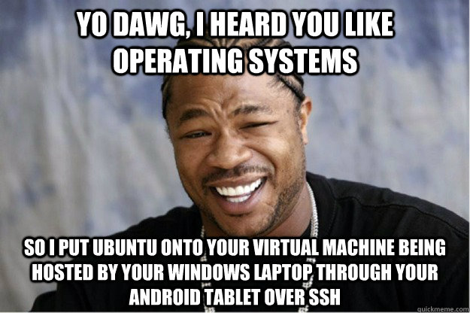
Technical Design Document (TDD)
Networking Redux
Team Virtual Machine
Version: 1
Created: 11/12/2015
Last Updated: 11/12/2015

Table of Contents

Executive Summary 2
Project 2
Technical 2
Programs 3
Market Release 3
Time to Completion 3
Estimated Cost of Completion 3
Hardware and Software 3
2D Software 3
Sound Software 3
Programming Software 3
Development Plan 3
Milestones 4
Project Goals 4
Features 4
File Formats 4
2D 4
3D 4
Audio 4
Scripts 5
Scenes 5
Other 5
Asset List 5
Audio 5

Executive Summary
Project
Create a basic networked game with two set levels to simulate the game Capture The Flag. There should be a flag on either side for opposing teams to collect. There will be team play, shooting, and item pickup mechanics
Technical
Programs
The following programs will be required for the creation of Around the World:
Program | Purpose | Cost
Unity3d | Game Development Environment | $1500
Audacity | Sound Creation | Free
Microsoft Visual Studio | Debugging Environment | Free
G.I.M.P | 2D Image Manipulation | Free
Blender | 3D Graphics and Animation | Free

Time to Completion
The total estimated completion time for user rails is two weeks. That includes time for coding and bug testing.

Estimated Cost of Completion
Unity3d | $1500 x 2
Total | $3000.00

Hardware and Software

Programming Software
Software Name | Description | Cost
Microsoft Visual Studio | Used to debug and create code | Free
MonoDevelop | Used to create prototype code | Free with Unity3D
Unity3D | Development Environment. Used to release to multiple platforms. | $1500

Development Plan
Milestones
Date | Milestone
11/13/2015 | TDD Complete
11/16/2015 | Basic Level work and networking completed with movement, run, jump, fall,Health, and shooting
11/20/2015 | Minimal effort added beyond initial project addition.
11/21/2015 | Minimal effort added beyond initial project addition.
11/23/2015 | ubmitted to Professor Fisher
Project Goals
Features
Simple Character Movement and Networking game
- Character Networking
  - Character controller that is networked. Character needs to
    - Move
    - Run
    - Jump
    - Fall
    - Exist in a 3D world
    - Have Health
    - Deal damage via shooting
      - Infinite ammo, but reload time advised
      - Same amount of damage rate to all players
    - Pick up objects
    - Team Mechanics
  - Designers should be able to control as many aspects as possible
  - Game must be fully networked and have a respawn timer
- Shaders
  - Create two shaders that will be used for the different teams. With two simple tasks
    - Include texture
    - Color appropriate for team
    - Lighting
    - One other property not covered in class
- Gameplay
  - Players start with predesignated spawn points
  - Sound should be included
  - Team “bases” with flag
  - Three flag captures taken back to base for a win
  - Two hand-crafted levels
- GUI
  - Player asked to
    - Create game
      - Input min & max values for objects to spawn
    - Join Game
      - Show appropriate info and join the game
      - Places players in teams with only a variance of one.
    - Quit Game
      - Exit game
  - Players need to see their own health.
  - Respawn Timer
  - Show other players’ health and names, color coordinated to show team and non-team members.

File Formats

Scripts
Naming Convention | Description | Format
FilenameEditor | Editor script for an object script | .cs
Filename | A script for an object | .cs

Scenes

Naming Convention | Description | Format
SceneName | A scene in Unity3D | .scene

Other
Naming Convention | Description | Format
TDD_Finished | The completed Technical Design Document | .pdf

Work Log

Marshall – 11/23/15
Project review and administrative updating.
Verified that the shaders I have offer no additional functionality
- Elapsed Time: 20 minutes

Victor – 11/23/15
Please fill in date and tasks here.
Created TDD
Uploaded base project
- Elapsed Time: 20 minutes

