**TLV5619_driver**

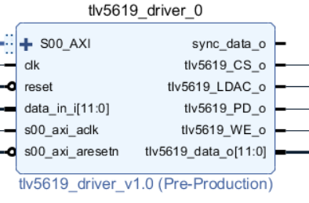

|  |  |  |
| --- | --- | --- |
| Name | Direction | Description |
| S00_AXI BUS | in | Slave AXI 4 lite Interface |
| s00_axi_aclk | in | AXI clk |
| s00_axiaresetn | in | AXI reset |
| clk | in | CLK |
| reset | in | Reset |
| data_in_i[11:0] | in | Input data |
| sync_data_o | out | 2 clk cycles previous prefetch for data_in |
| Tlv5619_CS_o | out | Chip select |
| Tlv5619_LDAC_o | out | Load DAC |
| Tlv5619_PD_o | out | Low Consuption mode |
| Tlv5619_WE_o | out | Write enable |
| Tlv5619_data_o [11:0] | out | DAC data |

The TLV5619_driver creates an interface between AXI 4 Lite and a Tlv5619 Texas Intruments DAC.

It has two modes of function

* **BRAM**: An internal 12bits x 64 Kbit memory can store up to 65536 data points inside and then load them into the DAC at a rate of 10 MHz
* **External**: The data loaded into the DAC is given by data_in_i, an auxiliary ignal sync_data generates a prefetch signal to provide the data.

The configuation of the IP is made via 4 registers:

|  |  |  |  |
| --- | --- | --- | --- |
| Position | Size (bits) | Name | Description |
| 0 | 2 | dac_mode_reg_i | Mode 0: Disabled  Mode 1: BRAM  Mode 2: External |
| 1 | 16 | dac_period_reg_i | Period of repetition when working in BRAM mode |
| 2 | 12 | dac_data_in_reg_i | Data to be stored in the BRAM |
| 3 | 2 | dac_write_ena_reg_i | Enable Writing to the BRAM |
| 4 | 16 | dac_addr_reg_i | BRAM Address |