**Status:**

**Questions:**

Jason – This is my question?

Jason - Are we hosting the website on CincySt server, or elsewhere (for free)?

I’m concerned that bob may take forever to respond & maybe we should do it elsewhere

**Current Requested Features:**

live location broadcasting of food truck. (We could work on this once we finish)

Order ahead with estimated pickup times.

Initially based off of number of orders

Could go very granular, like assigning every item a prep time, and adding them together for a number

KDS screen with drop off.

Double tap to drop, or click a button.

Will need a “recall”/ ”undo” button

Run code on a Raspberry Pi

**Bob asked for:**

Analytics based off of historical trends.

Weather, significant dates

**TruckBytes UI Needs**

**TruckBytes.db**

What do we need MenuItemTypes for as a table?

Need to change “Initials” login to “last name” login, can then ditch “initials”

**About.py**

QUESTION FOR COLE: Does this center on the screen of the pi?

The underling code is there, it just needs the correct coordinates.

**KDS**

We need a page for the KDS, correct? (Told Bob it would be)

**Credit.Card.py**

Writes to database, records total cost plus potential tip

Links back to Customer Loyalty

**Loyality.py**

SQL query for loyalty

If the info matches the db, take their intLoyalityRewardsID to the OrderingPage

If the info does not match, we show them what they entered and ask if they would like to sign up

If yes, we write their phone and email to a new intLoyaltyRewardsID

If no, the window disappears, allowing them to try to enter info again or skip loyality

Messagebox issue

after creating a new account. Hitting the OK button needs to lead to the OrderingPage.

**Our_display.py**

Turn the menubar into the same color as the titlebar

.ico does not work on the Pi

**Menu Builder**

Item details need added to the db

(Do we need a way to create submenus? I think yes)

Item Price needs validated as digits

“Requires SubMenu” combobox needs to display submenu names

**OrderingPage.py**

Display Item description.

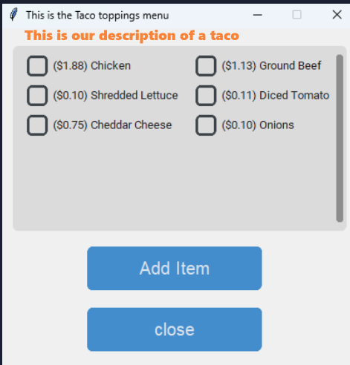

Do items that are out of stock disappear? (Told Bob it would be)

Can you auto select LTO for Sanwich toppings?

**Shift.Login.py**

Need to Query SQL Employee table, strLastName & strPassword

Need to switch from initials to strLastName (UI prompts for last name)

[additions: Make passwords the last 4 of phone number & Add Bob]

Need rejection prompt window if lastName & password do not match db.

Need the login to track time? Do we need a “clockout button”? (Told Bob it would be)

**Mgmt.py**

Done

**InventoryBuilder.py**

Done

**NEEDS FOR FINAL NIGHT**

Class room #

Extension cord?

HDMI cord for powerpoint, or web address.

Power for Pi

Wifi password