Model files in the NEURON simulation environment (v8.0) from the paper

**" Circadian modulation of neurons and astrocytes controls synaptic plasticity in hippocampal area CA1"**

by John P. McCauley, Maurice A. Petroccione, Lianna Y. D’Brant, Gabrielle C. Todd, Nurat Affinnih, Justin J. Wisnoski, Shergil Zahid, Swasti Shree, Alioscka A. Sousa, Rose M. De Guzman, Rosanna Migliore, Alexey Brazhe, Richard D. Leapman, Alexander Khmaladze, Alexey Semyanov, Damian G. Zuloaga, Michele Migliore and Annalisa Scimemi.

Cell Reports 2020

Usage:

Auto-launch from ModelDB or:

Compile the mod files with mknrndll (mswin or graphical mac) or

nrnivmodl (unix/linux)). Start the simulation by (unix/linux) typing

on the command line:

nrngui mosinit.hoc

or (mac os x) drag and dropping the mosinit.hoc file on the nrngui

icon or (mswin) double clicking on the mosinit.hoc file.

After selecting the option corresponding to the modulation of the NMDA and AMPA receptor properties, simulation will reproduce the temporal summation of composite glutamatergic EPSPs at the stimulation frequency of 10 Hz (as in fig. 6C of the paper).

Example: clicking on run “Astrocites only” on the initial window should produce the following graph:

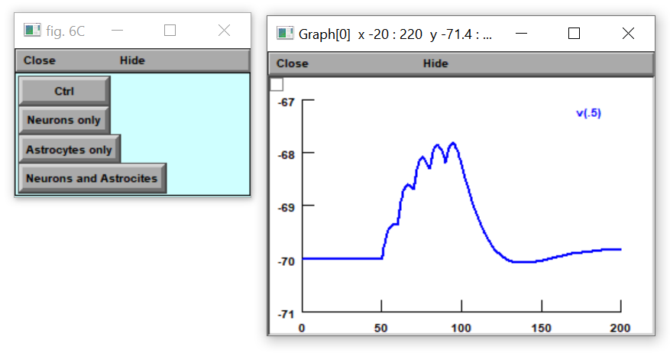

Questions on how to use this model should be directed to rosanna.migliore@cnr.it

The morphology is uploaded to the neuromorpho.org database ([www.neuromorpho.org](http://www.neuromorpho.org)).

An interactive “live paper” page is available in the Brain Simulation Platform of the Human Brain Project (https://humanbrainproject.github.io/hbp-bsp-live-papers/index.htm )

Access to this resource requires free user registration at https://www.humanbrainproject.eu/en/hbp-platforms/getting-access/

All datasets generated during and/or analyzed during the current study are also available on Open Science Framework (https://bit.ly/3jsJXrO).