ASHEN



FYP TEAM
Sumit Jethani 22F-3852
Maheen Naeem 22F-3145
Junaid Aamir Chaudhary 22F-3332

Supervised By
Dr. Ammar Rafiq
Mr. Talha Arif

Department of Computer Science
FAST – National University of Computer & Emerging Sciences
Chiniot Faisalabad Campus
2025
Table of Contents
List of Tables iv
List of Figures vi
1. Introduction 1
2. Definitions, Acronyms, and Abbreviations 1
3. Vision Document 2
3.1 Problem Statement 2
3.2 Business Opportunities 2
3.3 Objectives 2
3.4 Scope 3
3.5 Constraints 3
3.6 Stakeholder and User Description 3
3.6.1 Market Demographics 3
3.6.2 User Environment 4
3.6.3 Stakeholder Profiles 4
3.6.4 Stakeholder Summary 6
4. System Requirements Specification 7
4.1 System Features 7
4.1.1 Frontend 7
4.1.2 Backend 7
4.2 Functional Requirements 8
4.2.1 User Management 8
4.2.2 Network Scanning 8
4.2.3 Vulnerability Detection 8
4.2.4 Exploit Validation 8
4.2.5 Attack Recommender 9
4.2.6 AI-Based Remediation 9
4.2.7 Dynamic Dashboard Interface 9
4.2.8 Automated Reporting 10
4.3 Non-Functional Requirements 10
4.3.1 Performance 10
4.3.2 Usability 10
4.3.3 Security 10
4.3.4 Reliability 10
4.3.5 Scalability 11
4.3.6 Ethical Compliance 11
4.3.7 Maintainability 11
4.3.8 Compatibility 11
4.3.9 AI Governance 12
5. Design Artifacts 12
5.1 Use Case Diagram 12
5.2 High Level Use Cases 13
5.3 Expanded Use Cases 19
5.3.1 Use Case 1: Login / Sign Up 19
5.3.2 Use Case 2: Initiate Network Scan 20
5.3.3 Use Case 3: Detect Vulnerabilities 21
5.3.4 Use Case 4: Validate Vulnerabilities 22
5.3.5 Use Case 5: Recommend Attack 23
5.3.6 Use Case 6: Execute Attack 24
5.3.7 Use Case 7: Get Remediation Guidance 25
5.3.8 Use Case 8: Generate AI Remediation Guidance 26
5.3.9 Use Case 9: Generate Report 27
5.3.10 Use Case 10: Audit & Logging 28
5.3.11 Use Case 11: Manage Users and Permissions 29
5.3.12 Use Case 12: Add Authorized Target 30
5.3.13 Use Case 13: Manage System Configuration 31
5.4 Activity Diagram 33
5.5 Entity Relationship Diagram 34
5.6 System Sequence Diagram 35
5.6.1 Login / Sign Up 35
5.6.2 Initiate Network Scan 36
5.6.3 Detect Vulnerabilities 37
5.6.4 Validate Vulnerabilities 38
5.6.5 Recommend Attack 38
5.6.6 Execute Attack 39
5.6.7 Get Remediation Guidance 40
5.6.8 Generate AI Remediation Guidance 41
5.6.9 Generate Report 42
5.6.10 Audit & Logging 42
5.6.11 Manage Users and Permissions 43
5.6.12 Add Authorized Target 44
5.6.13 Manage System Configuration 45
5.7 Data Flow Diagrams 46
5.7.1 Data Flow Diagram: Level 0 46
5.7.2 Data Flow Diagram: Level 1 47
5.7.3 Data Flow Diagram: Level 2 48
5.8 Component Diagram 49

List of Tables
Table 1: Definitions, Acronyms, and Abbreviations 1
Table 2 : Summary of problems and their effects 2
Table 3 : Roles and Responsibilities of supervisors 4
Table 4: Development team members and roles 5
Table 5: Role of end users 5
Table 6: Responsibilities of administrators 6
Table 7: Overview of all key stakeholders 6
Table 8: UC - Login / Sign Up 13
Table 9: UC - Initiate Network Scan 13
Table 10: UC - Detect Vulnerabilities 13
Table 11: UC - Validate Vulnerabilities 14
Table 12: UC - Recommend Attack 14
Table 13: UC - Execute Attack 14
Table 14: UC - Get Remediation Guidance 15
Table 15: UC - Generate AI Remediation Guidance 15
Table 16: UC - Generate Report 16
Table 17: UC - Audit & Logging 16
Table 18: UC - Manage Users and Permissions 16
Table 19: UC - Add Authorized Target 17
Table 20: UC - Manage System Configuration 17
Table 21: Login / Sign Up 18
Table 22: Initiate Network Scan 19
Table 23: Detect Vulnerabilities 20
Table 24: Validate Vulnerabilities 21
Table 25: Recommend Attack 22
Table 26: Execute Attack 23
Table 27: Get Remediation Guidance 24
Table 28: Generate AI Remediation Guidance 25
Table 29: Generate Report 26
Table 30: Audit & Logging 27
Table 31: Manage Users and Permissions 28
Table 32: Add Authorized Target 29
Table 33: Manage System Configuration 30

List of Figures
Figure 1: : Visual overview of system functionalities and actors 12
Figure 2: Workflow of user interactions with the system 32
Figure 3: Database schema of entities and their connections 33
Figure 4: Shows the login and signup interaction flow between the user and the system. 34
Figure 5: Shows the interaction flow for initiating a network scan and receiving scan results. 35
Figure 6: Shows how the system analyzes scan data to detect vulnerabilities automatically 35
Figure 7: Shows the interaction flow for validating detected vulnerabilities to confirm authenticity. 36
Figure 8: Shows how the system and AI Engine interact to recommend suitable attack strategies. 36
Figure 9: Shows the sequence of actions during the execution of an attack on validated vulnerabilities. 37
Figure 10: Shows the process of requesting and receiving remediation guidance from the AI Engine. 37
Figure 11: Shows how the AI Engine generates automated remediation suggestions based on exploit data. 38
Figure 12: Shows the interaction flow for compiling, generating, and exporting a security report. 38
Figure 13: Shows how the system logs user actions and system events for auditing purposes. 39
Figure 14: Shows the administrative flow for creating, modifying, or deleting user accounts and roles. 39
Figure 15: Shows the process of adding and validating new authorized network targets by the administrator. 40
Figure 16: Shows the interaction sequence for modifying and saving system configuration settings. 40
Figure 17: High-level data flow 41
Figure 18: Intermediate detail of data processes 42
Figure 19: Detailed view of system data processes 43

Introduction
The purpose of this project is to develop an automated system called ASHEN (Automated Security & Host Exploitation Navigator) that helps cybersecurity professionals and network administrators perform vulnerability scanning, exploitation testing, and remediation using AI-powered analysis.
Traditional vulnerability assessment requires manual execution of tools like Nmap, OpenVAS, and Hydra, which can be time-consuming and error-prone. ASHEN will automate this process and provide a centralized dashboard for reporting and analysis.

Definitions, Acronyms, and Abbreviations
Table 1: Definitions, Acronyms, and Abbreviations
Term | Definition
AI | Artificial Intelligence
LLM | Large Language Model
CVE | Common Vulnerabilities and Exposures
CVSS | Common Vulnerability Scoring System
Nmap | Network Mapper; a tool used for network discovery and security auditing
OpenVAS | Open Vulnerability Assessment System; an open-source vulnerability scanner
Metasploit | A framework for developing and executing exploit code against remote targets
Hydra | A network logon cracker supporting numerous protocols
SSH | Secure Shell; a protocol for secure remote login
HTTP/HTTPS | Hypertext Transfer Protocol (Secure)
GUI | Graphical User Interface

Vision Document

Problem Statement
Table 2 : Summary of problems and their effects
Category | Description
Problem | Manual vulnerability assessment is time-consuming and error-prone; results often need human interpretation and prioritization. Tool outputs are fragmented across scanners and require consolidation.
Affects | Network administrators, security analysts, and organizations needing automated vulnerability checks.
Impact | Inconsistent security testing, delayed detection of threats, and possible exploitation by attackers.
Solution | An integrated platform that automates scan orchestration, validates exploitability in a safe environment, and provides AI-generated remediation steps prioritized by severity along an interactive dashboard.

Business Opportunities
ASHEN can be used by IT companies, security consultants, and network administrators to streamline penetration testing and vulnerability management. It can evolve into a commercial cybersecurity automation tool used in universities, security labs, and IT departments

Objectives
Following are the points of ASHEN:
- To automate vulnerability scanning and exploitation testing.
- To integrate tools like Nmap, OpenVAS, and Hydra into a single system.
- To provide AI-based recommendations for patching vulnerabilities and suggesting remediation.
- To generate detailed and exportable security reports.
- To build a secure, user-friendly dashboard for monitoring scans.

Scope
The scope of Automated Security & Host Exploitation Navigator aims to automate vulnerability assessment and exploitation testing within authorized network environments. It integrates tools like Nmap, OpenVAS, Metasploit, and Hydra into a single platform that performs network scanning, vulnerability detection, exploit validation, and AI-based remediation. Through a web dashboard, users can manage scans, select which tests to run, view results, and generate reports. The system’s AI module analyzes findings and suggests actionable fixes, reducing manual effort and improving security efficiency while maintaining ethical and controlled testing boundaries.

Constraints
- Must run tools that require Linux (Kali/Ubuntu).
- Requires administrative access to target lab environment
- LLM inference may require GPU or host with reasonable CPU/RAM
- Legal/ethical constraints limit testing to authorized networks

Stakeholder and User Description

Market Demographics
The target market comprises Organizations and educational institutions seeking automated security assessment tools that can be safely deployed in controlled or authorized environments. It is particularly beneficial for security students, researchers, and small IT teams who require an integrated framework for conducting penetration testing without the need for deep technical expertise or manual tool configuration.

User Environment
Users will access ASHEN through a secure web-based dashboard on desktops or laptops. The interface allows them to initiate scans, monitor progress, and view detailed vulnerability reports.

Stakeholder Profiles
The following section outlines the Stakeholder Profiles.

Supervisor Team
Table 3 : Roles and Responsibilities of supervisors
Representatives | Supervisor: Dr. Ammar Rafiq , Co-supervisor Mr. Talha Arif.
Description | They supervise and oversee the project development process.
Type | They are technical stakeholders. They have expertise in the project domain.
Responsibility | - Give directions to the development team.  - Ensure that the system will be completed in a given time.  - Keep track of the project’s progress.  - Ensure the project follows the documents generated during the design phase.  - Ensure that the working product is delivered correctly.
Success Criteria | The completion of features which are being committed by the development team at the start of the project.
Involvement | - Requirement reviewer  - Senior managers  - Review project progress
Comments | None

Development Team
Table 4: Development team members and roles
Representatives | Sumit Jethani 22F-3852  Junaid Chaudhary 22F-3332  Maheen Naeem 22F-3145
Description | They are involved in the development of the project.
Type | Technical stakeholders
Responsibility | - Fully involved in the development of the project.  - Specify requirements like a requirement engineer.  - Conduct research on system features to develop the model.  - Successful development of proposed model.  - Conduct market analysis and evaluate current limitations in existing systems.
Success Criteria | Successful completion of all committed features
Involvement | Research and development of the project.  Documentation and development of the project
Comments | None

End Users
Table 5: Role of end users
Representatives | End Users
Description | They are the project's end users who will use it for their specific purposes.
Type | External stakeholder
Responsibility | Use the platform to run authorized scans and interpret results.
Involvement | None
Comments | None

Admin
Table 6: Responsibilities of administrators
Representatives | Admin
Description | They maintain the application after deployment.
Type | Internal stakeholder
Responsibility | Ensuring that the ASHEN Platform functions normally after deployment.
Involvement | - Track platform performance and user activity to ensure smooth and stable operations.  - Review, validate, and moderate user- submitted content and group chats to maintain a safe environment.  - Oversee user data, manage authentication, and ensure compliance with privacy and security standards.
Comments | None

Stakeholder Summary
Table 7: Overview of all key stakeholders
Stakeholder | Description | Responsibility
Supervisors | Project Oversight | Guide and evaluate the project, review milestones, and ensure that technical and ethical standards are met throughout development
Development Team | System design and implementation | Responsible for designing, developing, testing, and documenting all modules of ASHEN, ensuring functional and performance requirements are met
Admin | Configuration and maintenance | Manages deployment environments
End Users | System Operation | Use ASHEN to perform scans, analyze vulnerabilities, validate exploits, and generate reports within authorized environments.
Institution/Organization | Beneficiary | Gains a secure, automated platform for vulnerability assessment and cybersecurity training within controlled settings

System Requirements Specification

System Features
ASHEN offers a range of critical features, including:

Frontend
- User Management: Allows users to securely register, log in, and manage accounts with role-based access control for administrators and analysts
- Dynamic Dashboard Interface: Offers an interactive, web-based dashboard that centralizes all system functionalities allowing users to launch scans, monitor live results, visualize vulnerabilities, and manage reports from a single unified view.
- Attack Recommender: After the vulnerability detection and exploit validation processes, the AI module analyzes the gathered vulnerability data to identify the most likely attack paths and exploit priorities.
- AI-Based Remediation: Once vulnerabilities are validated or successfully exploited, the AI module analyzes the system’s exposure and recommends actionable fixes to strengthen its defense posture.
- Automated Reporting: Generates detailed and customizable reports in PDF and HTML formats, including vulnerability summaries, severity levels, exploit outcomes, and recommended fixes.

Backend
- Host Discovery and Port Scanning: Automatically identifies active hosts and open ports within the specified network range using advanced scanning techniques.
- Vulnerability Detection: Detects and classifies known vulnerabilities based on CVE data and CVSS scoring standards.
- Exploit Validation: Performs safe and controlled exploitation attempts tests to confirm vulnerability impact.

Functional Requirements
The system must fulfil specific functional requirements, including:

User Management
- The system shall allow users to register, log in, and securely manage their accounts.
- The system shall authenticate users with role-based access control for administrators and analysts.

Network Scanning
- The system shall allow users to input target IP addresses or ranges for scanning.
- The system shall use Nmap to identify active hosts, open ports, and detected services.
- The scan progress and results shall be viewable in real time through the dashboard interface.

Vulnerability Detection
- The system shall initiate OpenVAS scans to detect known vulnerabilities on identified hosts.
- The system shall retrieve corresponding CVE entries and assign severity levels using CVSS scoring.
- The vulnerabilities and their severity rankings shall be visualized within the dashboard.

Exploit Validation
- The system shall safely test detected vulnerabilities using controlled, sandboxed environments and well-known tools such as Metasploit and Hydra.
Planned exploit validation tests include:
  - FTP brute-force (vsftpd)
  - SSH credential brute-force
  - Shellshock (CGI) proof-of-concept
  - MS17-010 (SMB) non-destructive check
- All exploit executions will be non-destructive unless explicitly approved by the analyst. Results will be logged and mapped to their corresponding CVEs.
- All exploit results shall be recorded and displayed on the dashboard for user review.

Attack Recommender
- The system shall use a local LLM engine (e.g., Ollama/LLaMA) to analyze scan and exploit data.
- The AI shall generate context-aware attack recommendations, such as exploit order, impact likelihood, and required conditions.
- The AI shall suggest which vulnerabilities are most critical and should be prioritized for remediation.
- Recommendations shall be displayed on the dashboard alongside detected vulnerabilities and exploit results.

AI-Based Remediation
- The system shall analyze vulnerability assessment reports to determine feasible remediation strategies.
- The AI shall suggest specific configuration changes, patching steps, or system hardening measures relevant to the exploited vulnerability.
- The remediation suggestions shall be displayed on the dashboard, linked with each exploit result.
- Users shall be able to interact with the AI module (chat or query interface) to obtain clarification or alternate solutions.

Dynamic Dashboard Interface
- The system shall provide an interactive, web-based dashboard as the central control panel for all features.
- The dashboard shall allow users to start scans, monitor progress, view vulnerabilities, review exploit results, and access AI remediation suggestions.
- The dashboard shall include data visualizations such as progress bars, severity charts, and scan summaries for ease of interpretation.
- The interface shall support filtering, searching, and exporting of results directly from the dashboard.

Automated Reporting
- The system shall generate detailed vulnerability assessment reports in PDF and HTML formats.
- Reports shall include network summaries, vulnerability details, exploit validations, AI-based recommendations, and overall risk evaluations.
- The reports shall be downloadable through the dashboard and stored in the system for future reference.

Non-Functional Requirements

Performance
- The system shall support 10 concurrent scan tasks without affecting responsiveness.
- Dashboard updates (for scan results or vulnerability lists) shall appear within 3 seconds of backend completion.
- Full report generation for a medium-scale scan (≤500 hosts) shall complete within 120 seconds.
- The system shall process and display vulnerability data for up to 1000 hosts per hour per scan worker.

Usability
- The interface shall be simple and intuitive, allowing users to initiate scans and view reports easily.
- The dashboard shall include clear visual indicators such as progress bars and vulnerability charts.

Security
- User credentials and stored data shall be encrypted.
- Scanning and exploitation shall be restricted to authorized networks and sandboxed environments.

Reliability
- The system shall automatically retry failed scan jobs up to 3 times.
- Database backups shall occur every 24 hours, with retention for 90 days.
- Upon service restart, incomplete scan sessions shall resume automatically if possible.
- The dashboard shall notify users if any worker fails or disconnects.

Scalability
The system shall allow easy addition of new modules or tools without major structural changes.

Ethical Compliance
- The system shall display a disclaimer before performing any scan or exploit.
- All operations shall comply with authorized and ethical security practices.

Maintainability
- The system shall be designed with modular architecture, allowing individual components such as scanning modules, AI engines, and dashboard interfaces to be updated or replaced without affecting other parts of the system.
- All source code shall follow clear naming conventions, inline documentation, and version control practices to simplify debugging, updates, and future enhancements.

Compatibility
- The system shall operate on Linux (Ubuntu 22.04 or later) as the primary environment.
- The dashboard shall be accessible via modern browsers (Chrome, Edge, Firefox).
- The backend shall integrate with Nmap, Masscan, Hydra, Metasploit, and OpenVAS via command or API wrappers.
- The AI subsystem shall support integration with local LLMs (Ollama, LLaMA) and cloud inference (optional).
- Reports shall be exportable in PDF, HTML, and CSV formats for interoperability with third-party tools.

AI Governance
- All AI-generated outputs (attack recommendations and remediation guidance) are advisory only; no automated remediation actions are applied without human approval.
- The system shall record the AI model version, configuration, prompt, and timestamp for every generated suggestion.
- AI responses shall pass through safety filters to block destructive or unethical instructions.
- Analysts may provide feedback (“Accept,” “Reject,” “Regenerate”) to continuously improve guidance accuracy.
- AI model updates or retraining must be logged as versioned artifacts under admin supervision.

Design Artifacts

Use Case Diagram
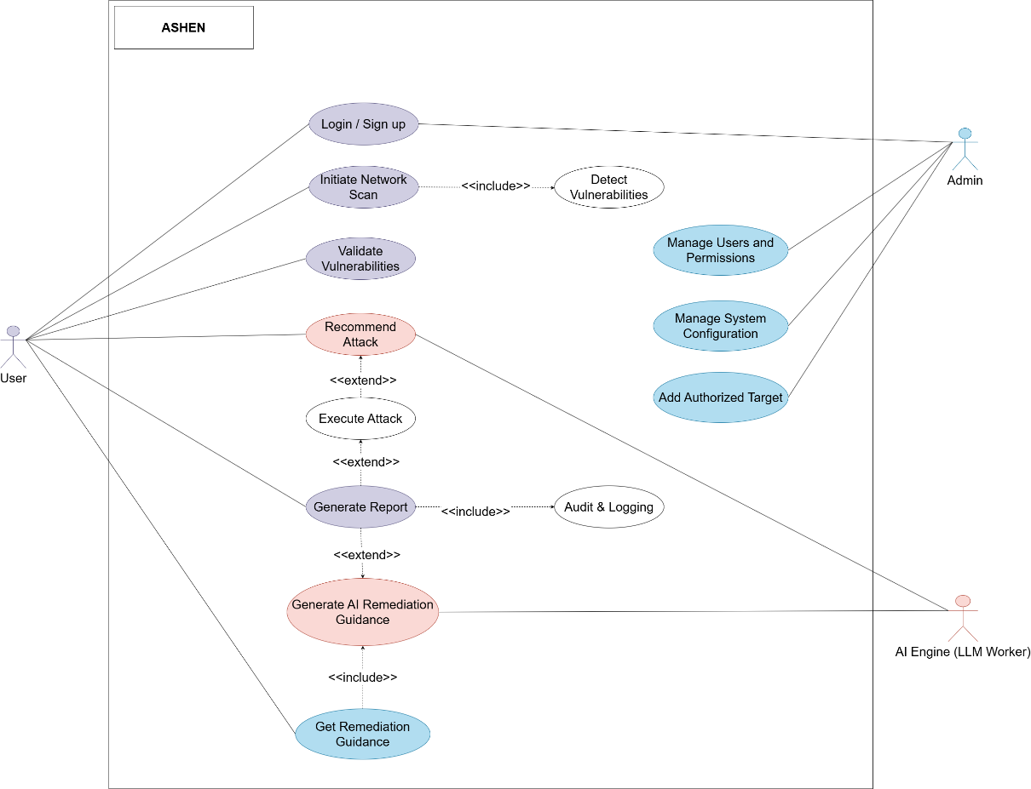
Figure 1: : Visual overview of system functionalities and actors

High Level Use Cases
Use Case 1
Table 8: UC - Login / Sign Up
Use Case ID | UC-01
Use Case Name | Login / Sign Up
Actor | User, Admin
Type | Primary
Description | Enables the user to create a new account or log in with existing credentials to access the ASHEN system securely.

Use Case 2
Table 9: UC - Initiate Network Scan
Use Case ID | UC-02
Use Case Name | Initiate Network Scan
Actor | User
Type | Primary
Description | Allows the user to perform network scans on authorized targets to identify open ports and active services.

Use Case 3
Table 10: UC - Detect Vulnerabilities
Use Case ID | UC-03
Use Case Name | Detect Vulnerabilities
Actor | User
Type | Primary
Description | Identifies vulnerabilities and weaknesses within scanned systems using automated and AI-based analysis.

Use Case 4
Table 11: UC - Validate Vulnerabilities
Use Case ID | UC-04
Use Case Name | Validate Vulnerabilities
Actor | User
Type | Primary
Description | Confirms the authenticity of detected vulnerabilities to eliminate false positives and ensure accuracy.

Use Case 5
Table 12: UC - Recommend Attack
Use Case ID | UC-05
Use Case Name | Recommend Attack
Actor | User, AI Engine (LLM Worker)
Type | Primary
Description | Suggests suitable attack techniques and exploitation methods based on validated vulnerabilities.

Use Case 6
Table 13: UC - Execute Attack
Use Case ID | UC-06
Use Case Name | Execute Attack
Actor | User, AI Engine (LLM Worker)
Type | Primary
Description | Executes selected attacks or exploit modules against validated vulnerabilities in a controlled environment.

Use Case 7
Table 14: UC - Get Remediation Guidance
Use Case ID | UC-07
Use Case Name | Get Remediation Guidance
Actor | User, AI Engine (LLM Worker)
Type | Primary
Description | Provides recommended steps and automated solutions for fixing or mitigating discovered vulnerabilities.

Use Case 8
Table 15: UC - Generate AI Remediation Guidance
Use Case ID | UC-08
Use Case Name | Generate AI Remediation Guidance
Actor | AI Engine (LLM Worker)
Type | Primary
Description | Uses AI to automatically generate detailed remediation procedures based on vulnerability data and exploit context.

Use Case 9
Table 16: UC - Generate Report
Use Case ID | UC-09
Use Case Name | Generate Report
Actor | User
Type | Primary
Description | Compiles and presents comprehensive reports summarizing scanning, validation, attack, and remediation activities.

Use Case 10
Table 17: UC - Audit & Logging
Use Case ID | UC-10
Use Case Name | Audit & Logging
Actor | System
Type | Primary
Description | Records all user actions and system events to maintain traceability and ensure accountability within ASHEN.

Use Case 11
Table 18: UC - Manage Users and Permissions
Use Case ID | UC-11
Use Case Name | Manage Users and Permissions
Actor | Admin
Type | Primary
Description | Allows administrators to create, update, or remove user accounts and define access permissions in the system.

Use Case 12
Table 19: UC - Add Authorized Target
Use Case ID | UC-12
Use Case Name | Add Authorized Target
Actor | Admin
Type | Primary
Description | Enables administrators to add, edit, or remove network targets that are authorized for penetration testing.

Use Case 13
Table 20: UC - Manage System Configuration
Use Case ID | UC-13
Use Case Name | Manage System Configuration
Actor | Admin
Type | Primary
Description | Lets administrators configure system parameters, AI settings, and operational preferences for optimal performance.

Expanded Use Cases
The Following section represents the expanded use cases for ASHEN

Use Case 1: Login / Sign Up
Table 21: Login / Sign Up
Use Case ID: | UC-01
Use Case Name: | Login / Sign Up
Created By: | Junaid Chaudhary | Last updated by:
Date Created: | 20/10/2025 | Revision Date:
Actor | User
Description | Enables users to create new accounts or log in with existing credentials to securely access the ASHEN system.
Trigger | User selects the Login / Sign Up option on the home interface.
Pre-condition | System is online; user provides valid credentials or registration details.
Post-condition | User session is established and dashboard access granted according to role.
Normal flow | - Selects Login or Sign Up.  - System authenticates or registers user.  - Access granted.
Alternative flow | 2a. Invalid credentials
Exceptions | Network or database failure during authentication.
Includes | UC-10 (Audit & Logging)
Frequency of use | High
Special Requirements | Password hashing, input validation, and session timeout handling.

Use Case 2: Initiate Network Scan
Table 22: Initiate Network Scan
Use Case ID: | UC-02
Use Case Name: | Initiate Network Scan
Created By: | Junaid Chaudhary | Last updated by:
Date Created: | 20/10/2025 | Revision Date:
Actor | User
Description | Allows the user to perform network scans on authorized targets to discover open ports, services, and vulnerabilities.
Trigger | User selects Start Scan from the dashboard.
Pre-condition | User authenticated; at least one authorized target available.
Post-condition | Scan results saved for vulnerability detection.
Normal flow | - User selects target and scan parameters.  - System verifies authorization.  - Scan executed.4. Results displayed.
Alternative flow | 2a. Unauthorized target → access denied.  3a. Scan interrupted → system resumes or restarts.
Exceptions | Target unreachable, network timeout, or invalid parameters.
Includes | UC-03 (Detect Vulnerabilities), UC-10 (Audit & Logging)
Frequency of use | Medium
Special Requirements | Efficient scanning engine, error recovery, and resource optimization.

Use Case 3: Detect Vulnerabilities
Table 23: Detect Vulnerabilities
Use Case ID: | UC-03
Use Case Name: | Detect Vulnerabilities
Created By: | Junaid Chaudhary | Last updated by:
Date Created: | 20/10/2025 | Revision Date:
Actor | User
Description | Analyzes scan results to identify potential vulnerabilities using AI-driven and rule-based methods.
Trigger | System completes a network scan.
Pre-condition | Valid scan data available.
Post-condition | Vulnerabilities list generated with severity levels.
Normal flow | - System loads scan output.  - AI analyzes data.  - Findings stored and shown to user.
Alternative flow | 2a. AI offline → fallback to rule-based detection.
Exceptions | Data corruption, permission errors.
Includes | UC-10 (Audit & Logging)
Frequency of use | Medium
Special Requirements | AI model reliability and efficient parsing of large data sets.

Use Case 4: Validate Vulnerabilities
Table 24: Validate Vulnerabilities
Use Case ID: | UC-04
Use Case Name: | Validate Vulnerabilities
Created By: | Junaid Chaudhary | Last updated by:
Date Created: | 20/10/2025 | Revision Date:
Actor | User
Description | Confirms detected vulnerabilities to remove false positives and prioritize exploitable issues.
Trigger | User selects Validate option for detected vulnerabilities.
Pre-condition | Vulnerability data exists from prior detection.
Post-condition | Validated vulnerabilities marked for exploitation or remediation.
Normal flow | - User selects items to validate.  - System executes validation tests.  - Results updated.
Alternative flow | 2a. Validation timeout
Exceptions | Network disruption or corrupted data.
Includes | UC-10 (Audit & Logging)
Frequency of use | Medium
Special Requirements | Real-time feedback and accurate validation algorithms.

Use Case 5: Recommend Attack
Table 25: Recommend Attack
Use Case ID: | UC-05
Use Case Name: | Recommend Attack
Created By: | Junaid Chaudhary | Last updated by:
Date Created: | 20/10/2025 | Revision Date:
Actor | User, AI Engine (LLM Worker)
Description | Suggests appropriate attack or exploitation techniques for validated vulnerabilities.
Trigger | User requests attack recommendations.
Pre-condition | Validated vulnerabilities available.
Post-condition | AI-generated attack list shown.
Normal flow | - User selects vulnerability.  - System sends context to AI.  - AI returns recommended attacks.  - System displays results.
Alternative flow | 3a. AI unavailable → show cached recommendations.
Exceptions | Model timeout or API failure.
Includes | UC-10 (Audit & Logging)
Frequency of use | Medium
Special Requirements | Secure AI communication and output validation.

Use Case 6: Execute Attack
Table 26: Execute Attack
Use Case ID: | UC-06
Use Case Name: | Execute Attack
Created By: | Junaid Chaudhary | Last updated by:
Date Created: | 20/10/2025 | Revision Date:
Actor | User, AI Engine (LLM Worker)
Description | Executes chosen attacks on validated vulnerabilities within a sandboxed environment.
Trigger | User initiates attack execution.
Pre-condition | Authorization confirmed; target validated.
Post-condition | Execution results stored and logged.
Normal flow | - User selects attack.  - System verifies authorization.  - AI adjusts parameters.  - Attack runs.  - Results displayed.
Alternative flow | 2a. Authorization fails → cancelled.  4a. User aborts → rollback.
Exceptions | Firewall block or sandbox crash.
Includes | UC-10 (Audit & Logging)
Frequency of use | Medium
Special Requirements | Sandbox isolation, safe rollback, and encryption of results.

Use Case 7: Get Remediation Guidance
Table 27: Get Remediation Guidance
Use Case ID: | UC-07
Use Case Name: | Get Remediation Guidance
Created By: | Junaid Chaudhary | Last updated by:
Date Created: | 20/10/2025 | Revision Date:
Actor | User, AI Engine (LLM Worker)
Description | Provides recommended mitigation steps and automated AI guidance for resolving vulnerabilities.
Trigger | User requests remediation advice.
Pre-condition | Validated or executed vulnerabilities available.
Post-condition | Remediation guidance displayed and saved.
Normal flow | - User selects vulnerability.  - System gathers data.  - AI generates solutions.  - System presents output.
Alternative flow | 3a. AI offline → use default templates.
Exceptions | Data mismatch or network error.
Includes | UC-06 (Execute Attack), UC-08 (Generate AI Remediation Guidance), UC-10 (Audit & Logging)
Frequency of use | High
Special Requirements | Reliable AI model and user-friendly presentation format.

Use Case 8: Generate AI Remediation Guidance
Table 28: Generate AI Remediation Guidance
Use Case ID: | UC-08
Use Case Name: | Generate AI Remediation Guidance
Created By: | Junaid Chaudhary | Last updated by:
Date Created: | 20/10/2025 | Revision Date:
Actor | AI Engine (LLM Worker)
Description | Uses AI to generate customized remediation procedures based on exploit results.
Trigger | Invoked by remediation or report generation module.
Pre-condition | Exploit or vulnerability data supplied.
Post-condition | AI remediation output stored.
Normal flow | - User open AI generated guidance .  - User approve the guidance  - System saves recommendations.
Alternative flow | 2a. User did not approved the guidance -> regenerate guidance
Exceptions | Model failure or timeout.
Includes | UC-10 (Audit & Logging)
Frequency of use | High
Special Requirements | Model explainability and secure storage of AI outputs.

Use Case 9: Generate Report
Table 29: Generate Report
Use Case ID: | UC-09
Use Case Name: | Generate Report
Created By: | Junaid Chaudhary | Last updated by:
Date Created: | 20/10/2025 | Revision Date:
Actor | User
Description | Produces a complete security assessment report combining scan, attack, and remediation data.
Trigger | User selects Generate Report option.
Pre-condition | All prior modules completed.
Post-condition | Final report generated and exported.
Normal flow | - User requests report.  - System aggregates data.  - AI adds summaries.  - Report formatted and shown.
Alternative flow | NA
Exceptions | File write error.
Includes | UC-06 (Execute Attack), UC-08 (Generate AI Remediation Guidance), UC-10 (Audit & Logging)
Frequency of use | Medium
Special Requirements | Export in PDF/CSV formats and digital signing of reports.

Use Case 10: Audit & Logging
Table 30: Audit & Logging
Use Case ID: | UC-10
Use Case Name: | Audit & Logging
Created By: | Junaid Chaudhary | Last updated by:
Date Created: | 20/10/2025 | Revision Date:
Actor | System (Automated Process)
Description | Tracks and records all user and system activities for traceability and compliance.
Trigger | Any system event or user action.
Pre-condition | Logging service active.
Post-condition | Logs securely stored.
Normal flow | - Event triggers log.  - Details captured.  - Stored in audit DB.
Alternative flow | NA
Exceptions | Write failure or permission error.
Includes | None
Frequency of use | High
Special Requirements | Tamper-proof storage and time-stamped entries.

Use Case 11: Manage Users and Permissions
Table 31: Manage Users and Permissions
Use Case ID: | UC-11
Use Case Name: | Manage Users and Permissions
Created By: | Junaid Chaudhary | Last updated by:
Date Created: | 20/10/2025 | Revision Date:
Actor | Admin
Description | Enables admin to add, modify, or delete user accounts and assign roles.
Trigger | Admin opens User Management.
Pre-condition | Admin authenticated.
Post-condition | Updated user and role data stored.
Normal flow | - Admin views users.  - Selects add/edit/delete.  - System updates records.  - Confirmation shown.
Alternative flow | 2a. Duplicate username → error shown.
Exceptions | DB failure or invalid input.
Includes | UC-10 (Audit & Logging)
Frequency of use | Low
Special Requirements | Secure credential storage and RBAC enforcement.

Use Case 12: Add Authorized Target
Table 32: Add Authorized Target
Use Case ID: | UC-12
Use Case Name: | Add Authorized Target
Created By: | Junaid Chaudhary | Last updated by:
Date Created: | 20/10/2025 | Revision Date:
Actor | Admin
Description | Allows admin to register or remove network targets authorized for testing.
Trigger | Admin opens Target Management.
Pre-condition | Admin logged in with privileges.
Post-condition | Target stored or updated in database.
Normal flow | - Admin inputs target info.  - System validates data.  - Target saved.  - Confirmation sent.
Alternative flow | 2a. Duplicate target → warning shown.
Exceptions | Invalid IP/domain or DB error.
Includes | UC-10 (Audit & Logging)
Frequency of use | Low
Special Requirements | Input validation and secure data handling.

Use Case 13: Manage System Configuration
Table 33: Manage System Configuration
Use Case ID: | UC-13
Use Case Name: | Manage System Configuration
Created By: | Junaid Chaudhary | Last updated by:
Date Created: | 20/10/2025 | Revision Date:
Actor: | Admin
Description: | Allows the administrator to configure and update system parameters such as scanning tool paths, AI model settings, thresholds, and concurrency limits.
Trigger: | Administrator selects “System Configuration” from the dashboard.
Pre-condition: | Administrator is authenticated with elevated privileges.
Post-condition: | Updated configurations are validated and applied system-wide without interrupting active processes.
Normal flow: | - Administrator navigates to the configuration section.  - System displays all configurable settings.  - Administrator modifies desired parameters (e.g., OpenVAS path, AI model version).  - Administrator saves changes.  - System validates and reloads configurations dynamically.
Alternative flow: | 3a. Administrator inputs invalid configuration values.  3a1. System rejects update and displays error message with corrective hints.
Exceptions: | Configuration file lock, validation failure, or permission error.
Includes: | UC-12 (Audit & Logging).
Frequency of use: | Low (performed occasionally during maintenance or updates).
Special Requirements: | Dynamic reload support without full restart, configuration versioning, rollback option, and admin confirmation prompts for critical changes.

Activity Diagram
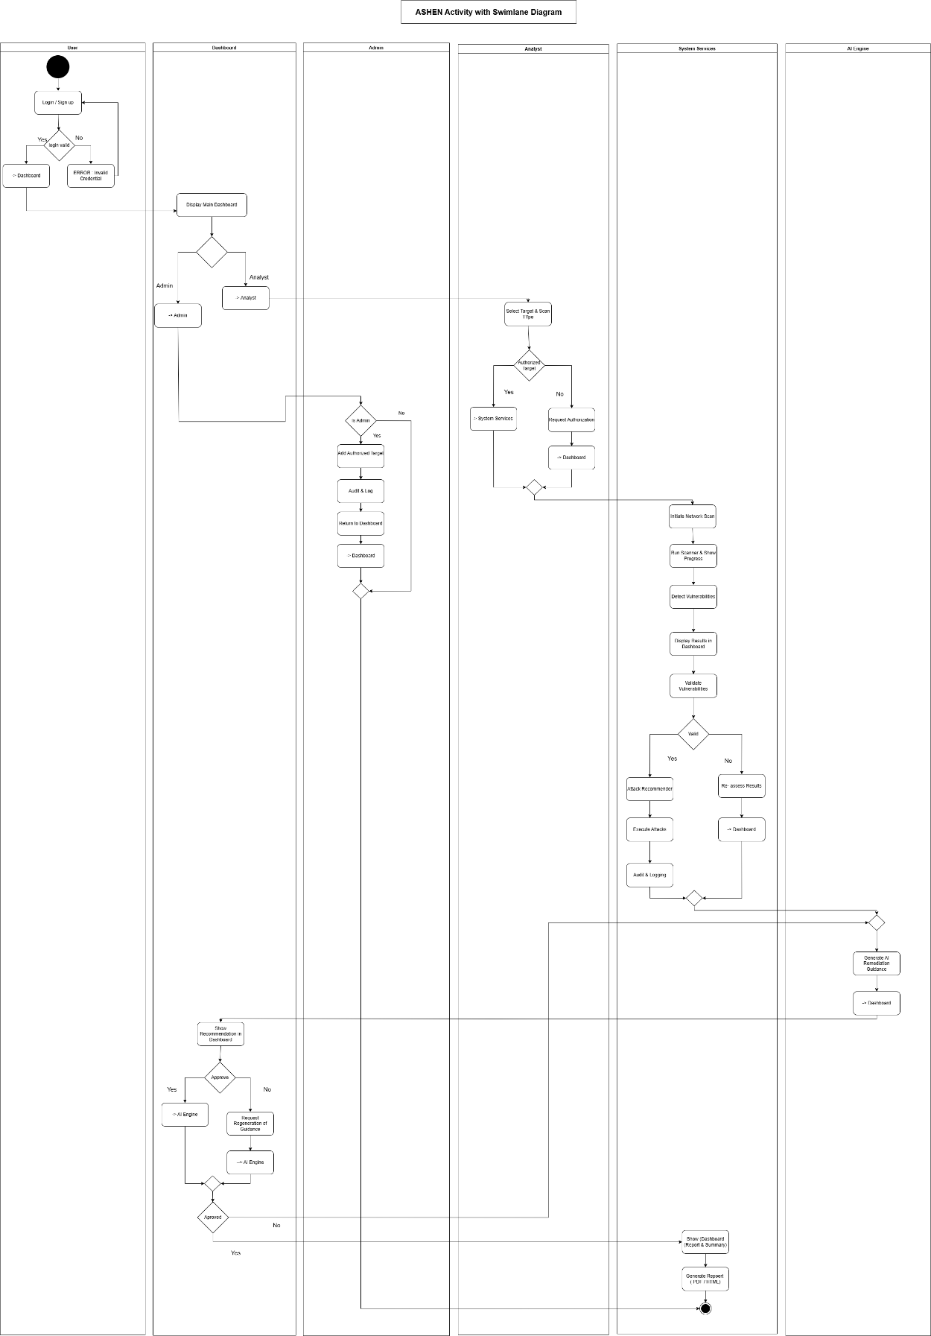
Figure 2: Workflow of user interactions with the system

Entity Relationship Diagram
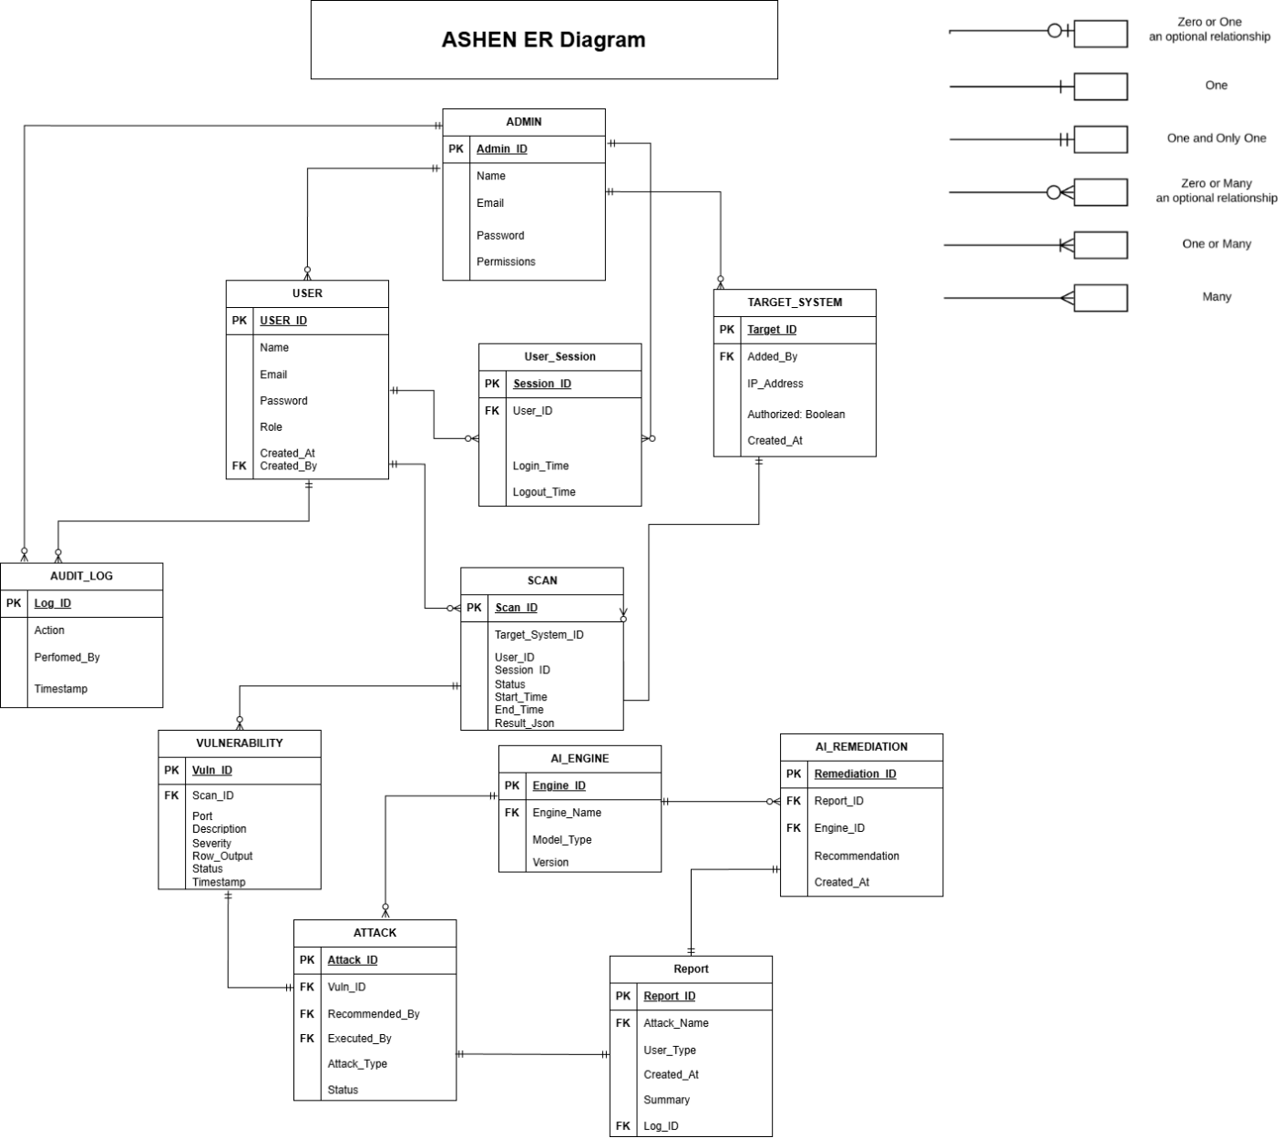
Figure 3: Database schema of entities and their connections

System Sequence Diagram
The Following section graphically illustrates the SSDs for ASHEN

Login / Sign Up
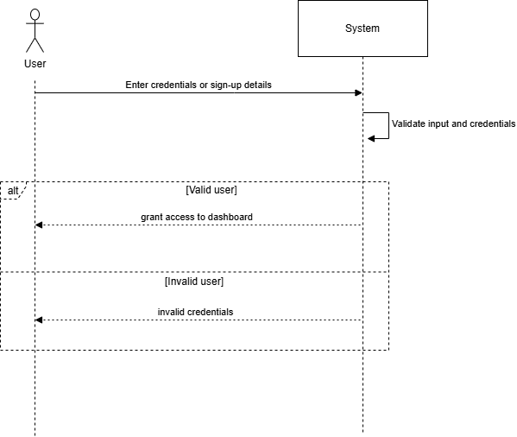
Figure 4: Shows the login and signup interaction flow between the user and the system.

Initiate Network Scan
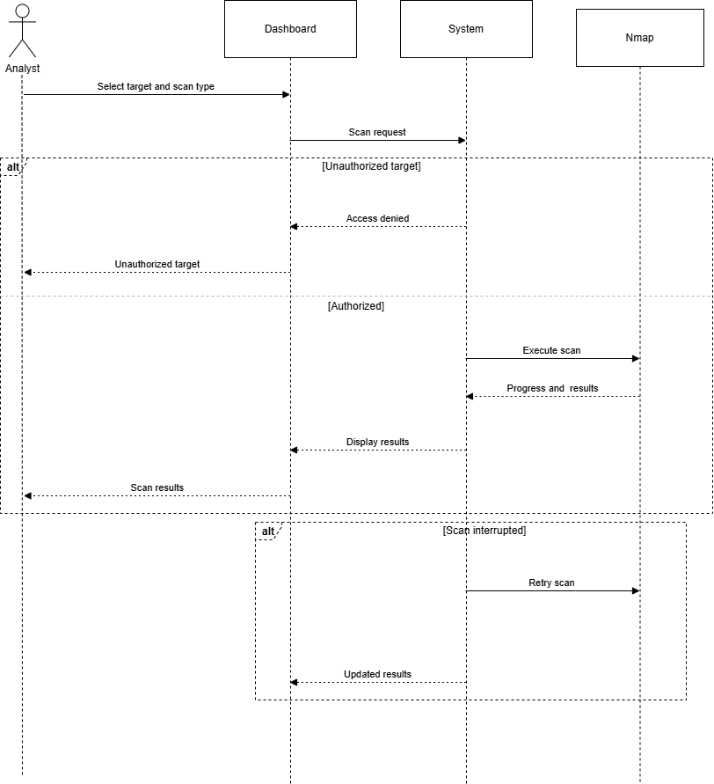
Figure 5: Shows the interaction flow for initiating a network scan and receiving scan results.

Detect Vulnerabilities
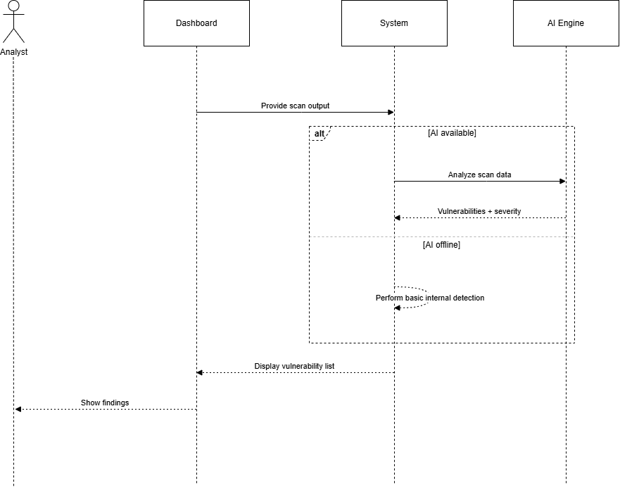
Figure 6: Shows how the system analyzes scan data to detect vulnerabilities automatically
.

Validate Vulnerabilities
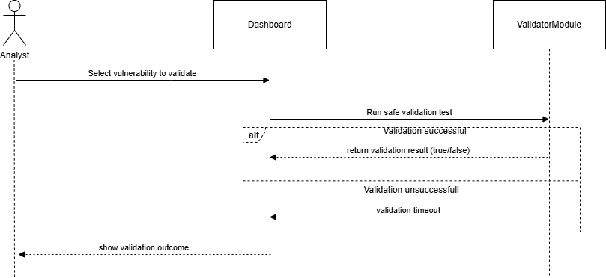
Figure 7: Shows the interaction flow for validating detected vulnerabilities to confirm authenticity.

Recommend Attack
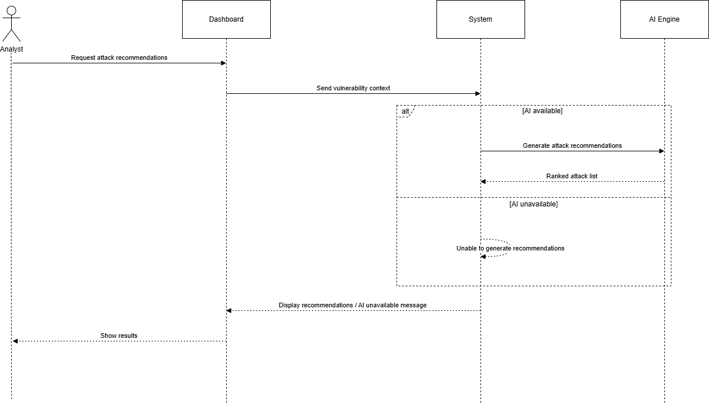
Figure 8: Shows how the system and AI Engine interact to recommend suitable attack strategies.

Execute Attack
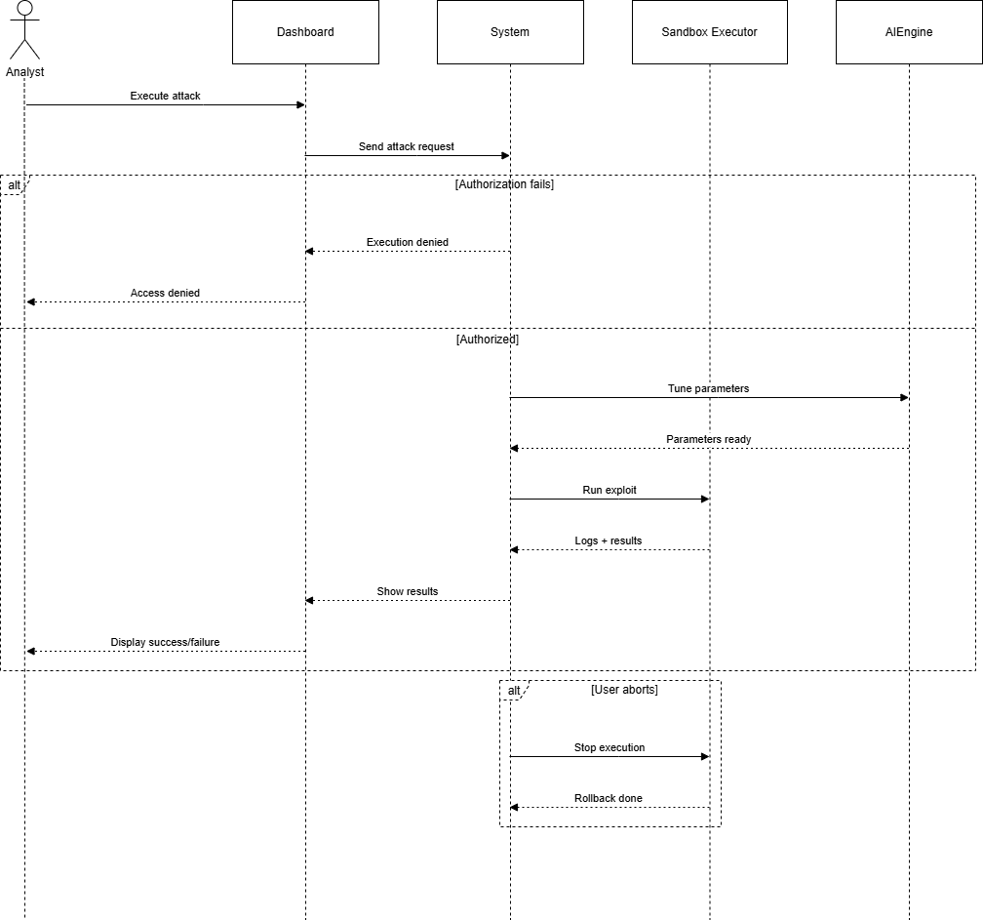
Figure 9: Shows the sequence of actions during the execution of an attack on validated vulnerabilities.

Get Remediation Guidance
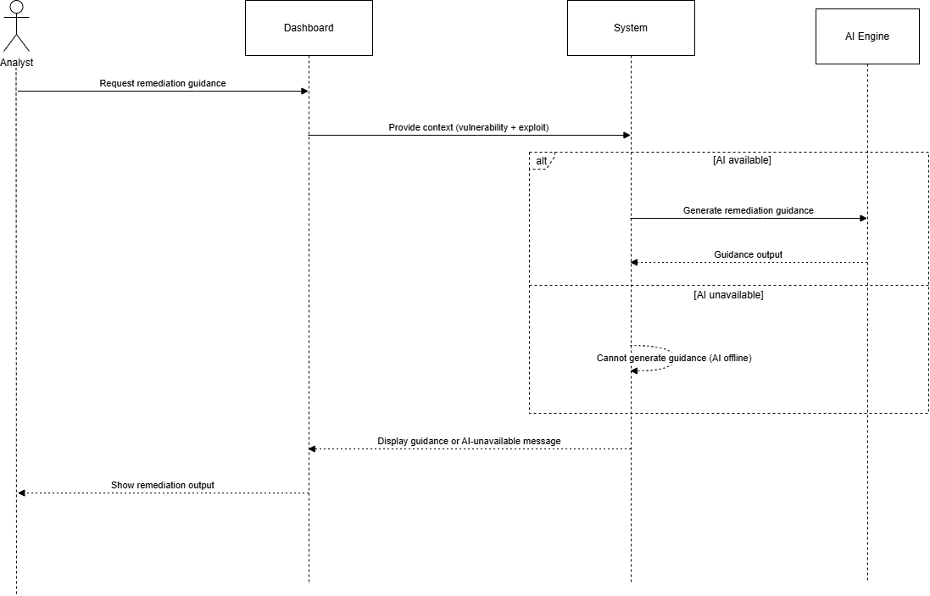
Figure 10: Shows the process of requesting and receiving remediation guidance from the AI Engine.

Generate AI Remediation Guidance
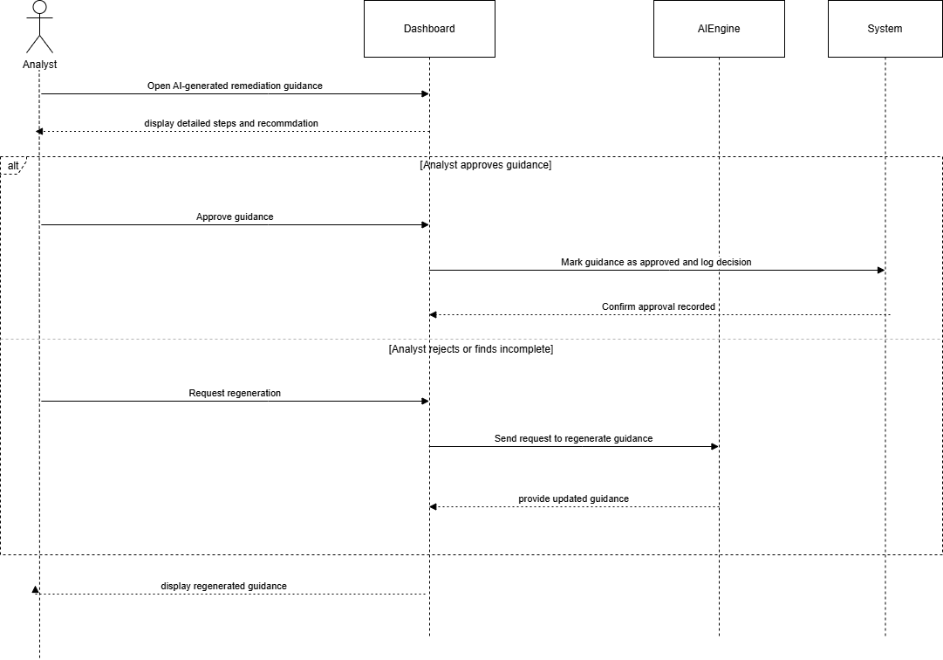
Figure 11: Shows how the AI Engine generates automated remediation suggestions based on exploit data.

Generate Report
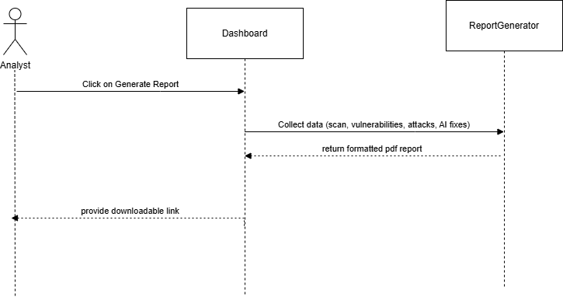
Figure 12: Shows the interaction flow for compiling, generating, and exporting a security report.

Audit & Logging
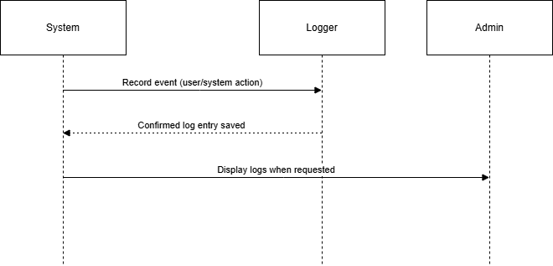
Figure 13: Shows how the system logs user actions and system events for auditing purposes.

Manage Users and Permissions
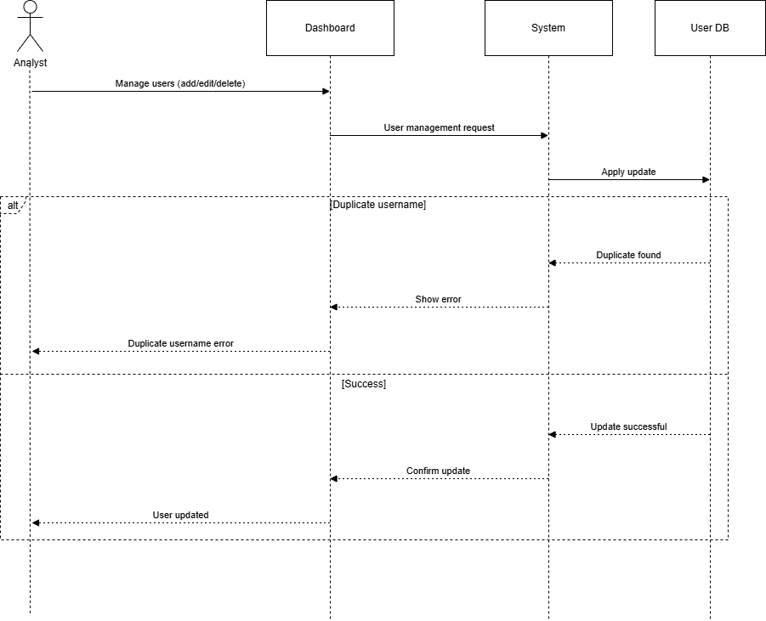
Figure 14: Shows the administrative flow for creating, modifying, or deleting user accounts and roles.

Add Authorized Target
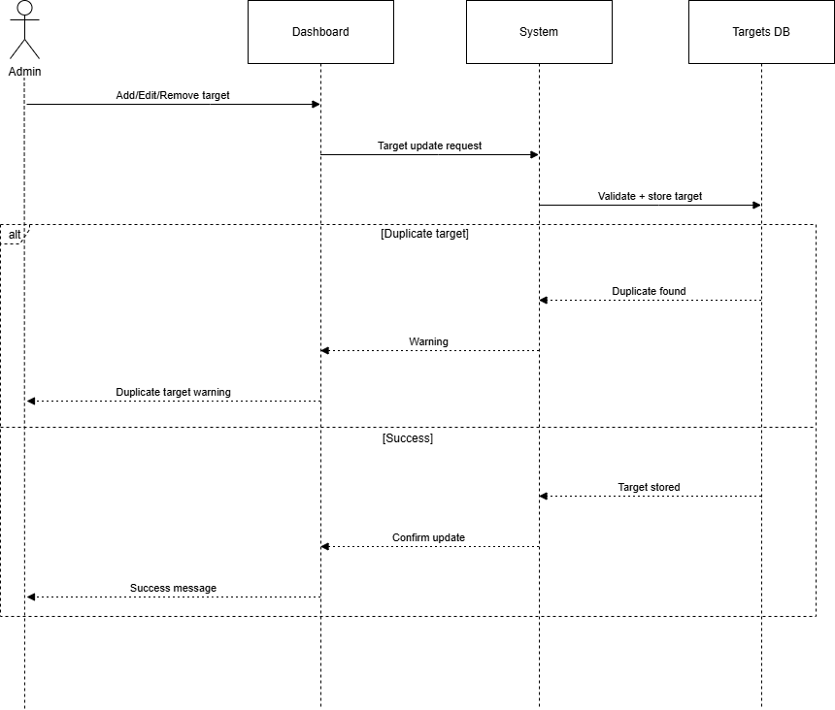
Figure 15: Shows the process of adding and validating new authorized network targets by the administrator.

Manage System Configuration
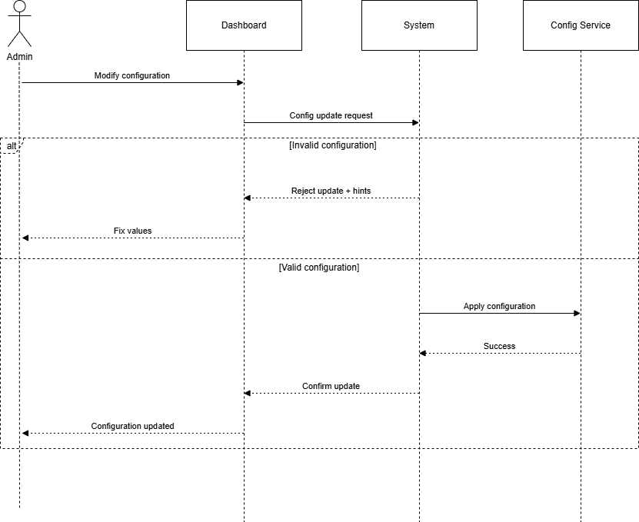
Figure 16: Shows the interaction sequence for modifying and saving system configuration settings.

Data Flow Diagrams
The Following section graphically illustrates the data flow for ASHEN.

Data Flow Diagram: Level 0
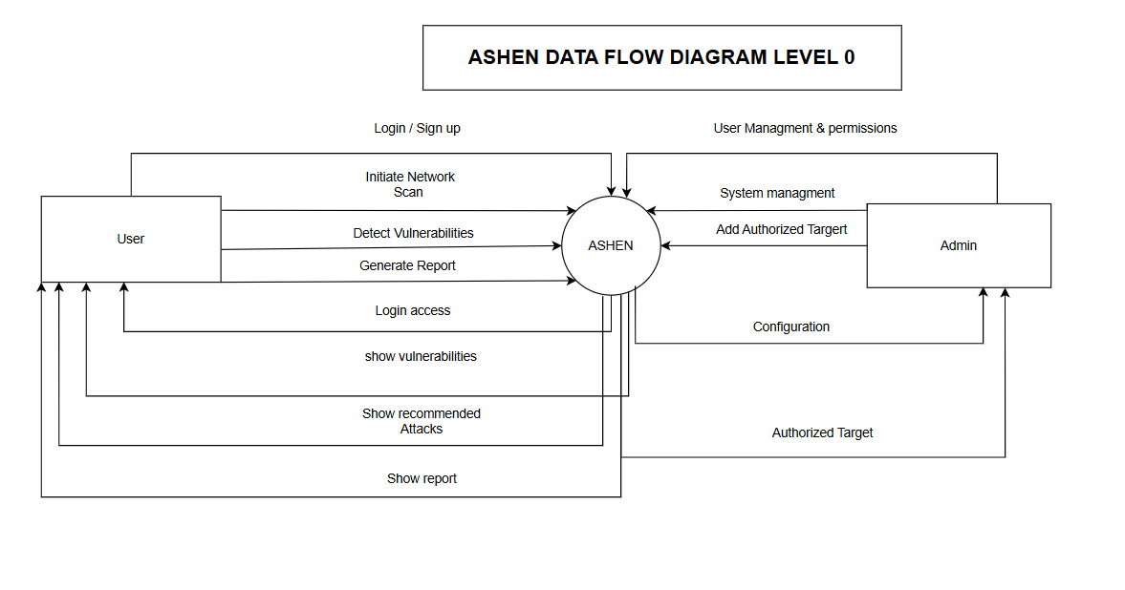
Figure 17: High-level data flow

Data Flow Diagram: Level 1
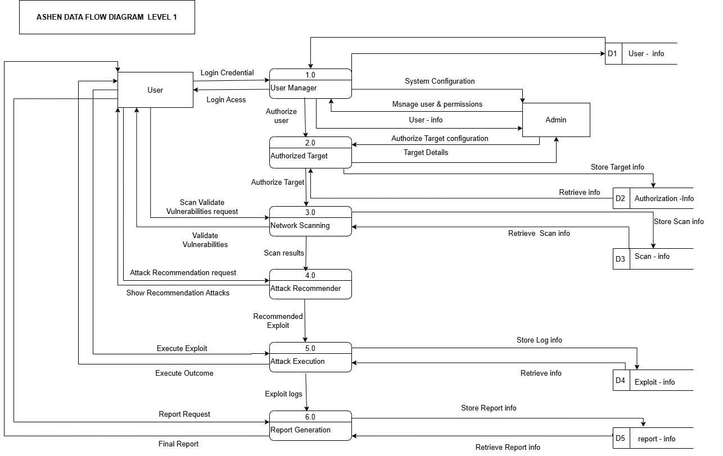
Figure 18: Intermediate detail of data processes

Data Flow Diagram: Level 2
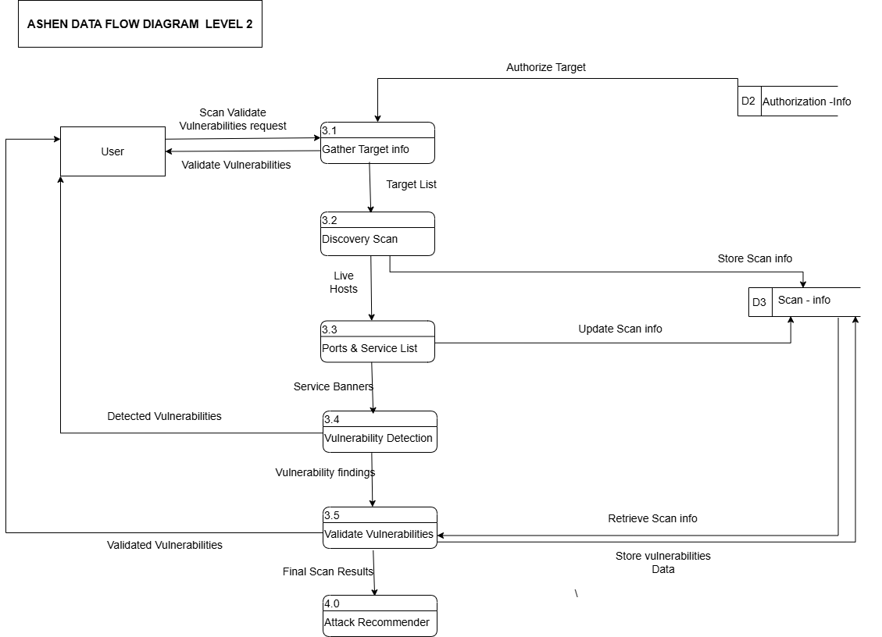Figure 19: Detailed view of system data processes

Component Diagram

