# Question 1:

Our approach to the **validation** method was to vary the ratio (or split) of the **train subset** to the **test subset** (of the training data), in a sense causing the ratio to become a hyperparameter of the model, while fixing the ratio of the **test** subset to the **validation** subset to exactly 50% (0.5). For each train subset–to–test subset ratio [**0.2, 0.3, 0.5**], the (**simple**) **Ordinary Least Squares** model was trained on the “**train + validation**” subsets (**model selection**). The model that yielded the lowest RSE was then used on the **test** subset (**model assessment**).

Displayed below and tabularized are sample scores from an instance of running validation on the training dataset.

|  |  |  |
| --- | --- | --- |
| train : validation : test | **RSE** | **R2** |
| 0.2 : 0.4 : 0.4 | 10.4374 | 0.6173 |
| 0.3 : 0.35 : 0.35 | 10.5558 | 0.5891 |
| 0.5 : 0.25 : 0.25 | 10.6471 | 0.5926 |

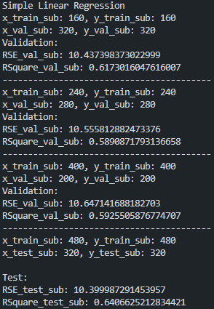

***Figure 1 – Sample results of validation***

For **cross-validation**, **model selection** was carried out by varying the hyper-parameter K, the number of folds created from the training dataset, and consequently the number of samples held out from training the model at a given moment. The average RSE and R2 values of the model’s performance for each K were calculated. Subsequently, the model with the lowest RSE (optimal hyper-parameters) was fit on the entire training dataset and run on the test set to evaluate its performance (**model assessment**).

|  |  |  |
| --- | --- | --- |
| **K** | **RSE** | **R2** |
| 2 | 10.5915 | 0.6075 |
| 3 | 10.4324 | 0.6206 |
| 5 | 10.3827 | 0.6269 |
| 10 | 10.4684 | 0.6153 |
| 15 | 10.5145 | 0.6095 |
| 20 | 10.6058 | 0.6014 |
| 30 | 10.6667 | 0.5937 |
| 50 | 10.8361 | 0.5575 |
| 100 | 11.5194 | 0.3867 |

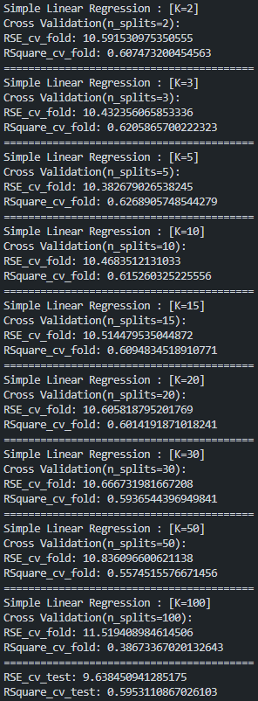

***Figure 2 – Sample results of cross-validation***

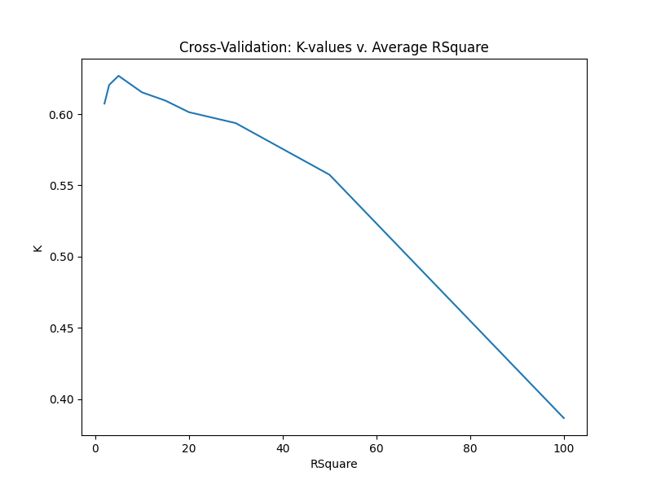

***Figure 3 – K-values v. Average R2 (cross-validation)***

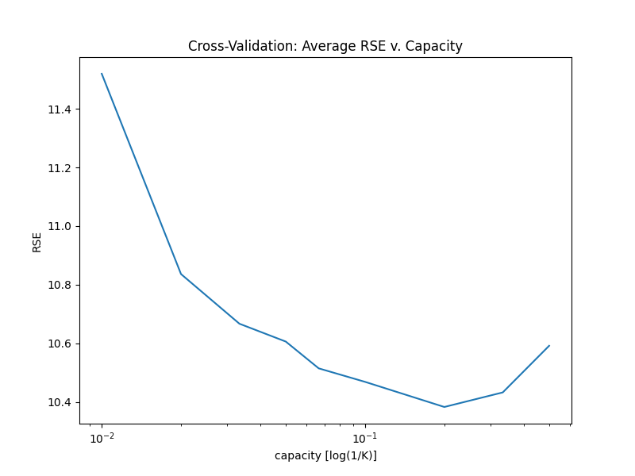

***Figure 4 – Average RSE v. Capacity (cross-validation)***

In Figure 3, as expected, the R2 peaks around K-values of 3, 5, 10 and worsens as K increases; knowing that **smaller** values of K are preferred for cross-validation when the size of the dataset, N, is **large(r).** Conversely, in Figure 4, the RSE decreases as the capacity increases.

From the same run of validation, and cross-validation, below are the results of the model assessment; for validation, running the optimal model obtained from training on “**train + validation**” subsets on the **test** subset (of the training dataset), and for cross-validation, running the optimal model obtained, from the various K-values, on the actual **test** dataset.

|  |  |  |
| --- | --- | --- |
| **Method** | **RSE** | **R2** |
| Validation | 10.4000 | 0.6406 |
| Cross-Validation | 9.6385 | 0.5953 |

***Figure 5 – Comparison of assessment of Validation and Cross-Validation methods***

As observed above, the performance of the optimal model using the validation method on the “**test**” subset of the training data surpasses the performance of the optimal model obtained using K-fold cross-validation on the actual (blind) test dataset.

# Question 2:

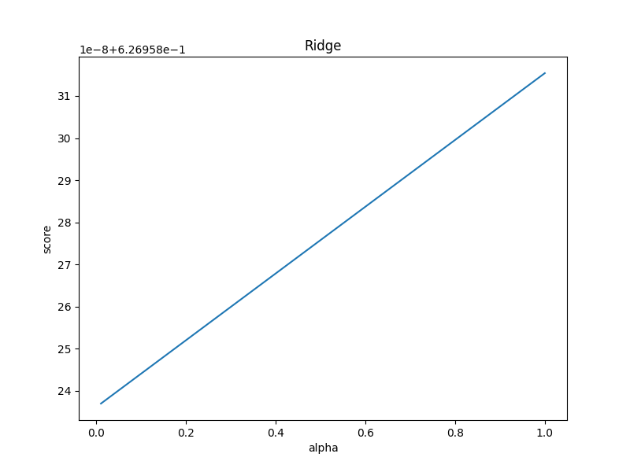

***Figure 6 – alpha values v. scores of Ridge Regression Model***

|  |  |  |
| --- | --- | --- |
| **Method** | **RSE** | **R2** |
| Simple OLE Validation | 10.4000 | 0.6406 |
| Simple OLE Cross-Validation | 9.6385 | 0.5953 |
| Ridge Regression | 9.6385 | 0.5953 |



***Figure 7 – Comparison of assessment of Simple OLE and Ridge Regression***

As observed in Figure 6, the model performance of the Ridge Regressor is directly proportional to the alpha hyper-parameters, with the performance peaking at the highest alpha value during cross-validation.

Comparing the RSE and R2 values of the Ridge Regressor using the optimal alpha value of 1, we observed approximately (to 4 d.p.) the same performance as the Simple OLE (cross-validation), but slightly worse than the Simple OLE validation (**NOTE:** Simple OLE validation was not on the actual test dataset, but on test subset of training dataset).

# Question 3:

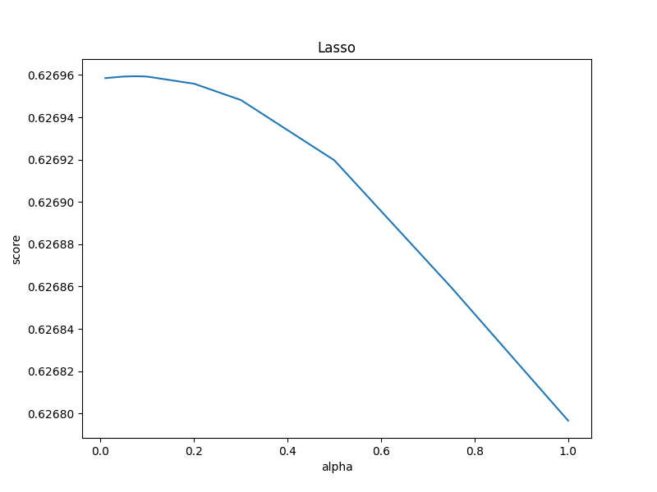

***Figure 8 – alpha values v. scores of Lasso Regression Model***

|  |  |  |
| --- | --- | --- |
| **Method** | **RSE** | **R2** |
| Simple OLE Validation | 10.4000 | 0.6406 |
| Simple OLE Cross-Validation | 9.6385 | 0.5953 |
| Ridge Regression | 9.6385 | 0.5953 |
| Lasso Regression | 9.6393 | 0.5952 |



***Figure 9 – Comparison of assessment of Simple OLE and Ridge Regression***

As observed in Figure 8, in contrast to the Ridge Regressor, the model performance of the Lasso Regressor is inversely proportional to the alpha hyper-parameters, and actually peaks somewhere around the lowest alpha value (expected based on how it optimizes the objective function).

Comparing the RSE and R2 values of the Lasso Regressor using the optimal alpha value of 0.075, we observed an extremely miniscule decrement in model performance to the Simple OLE and the Ridge Regressor.