UML Diagrams

UML Use Case Diagram
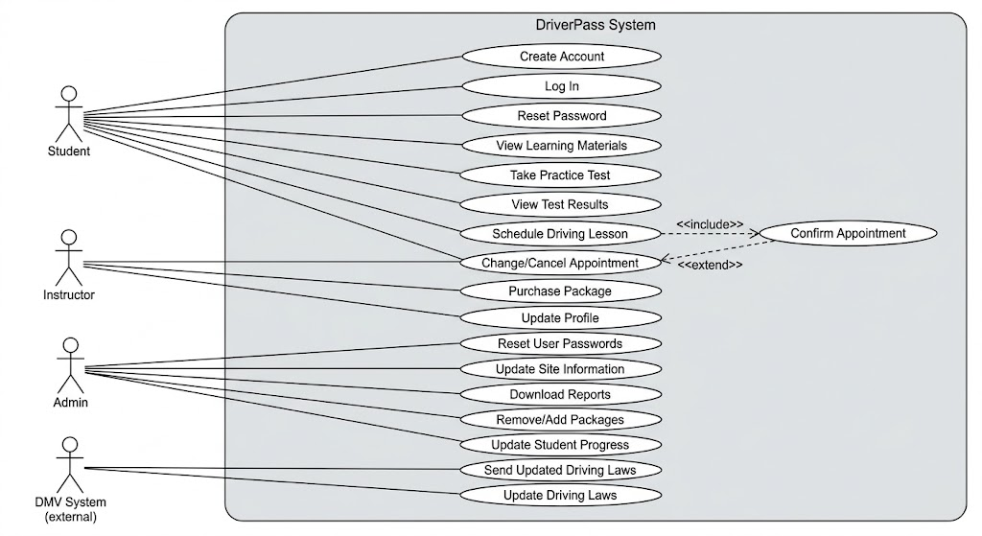

UML Activity Diagrams
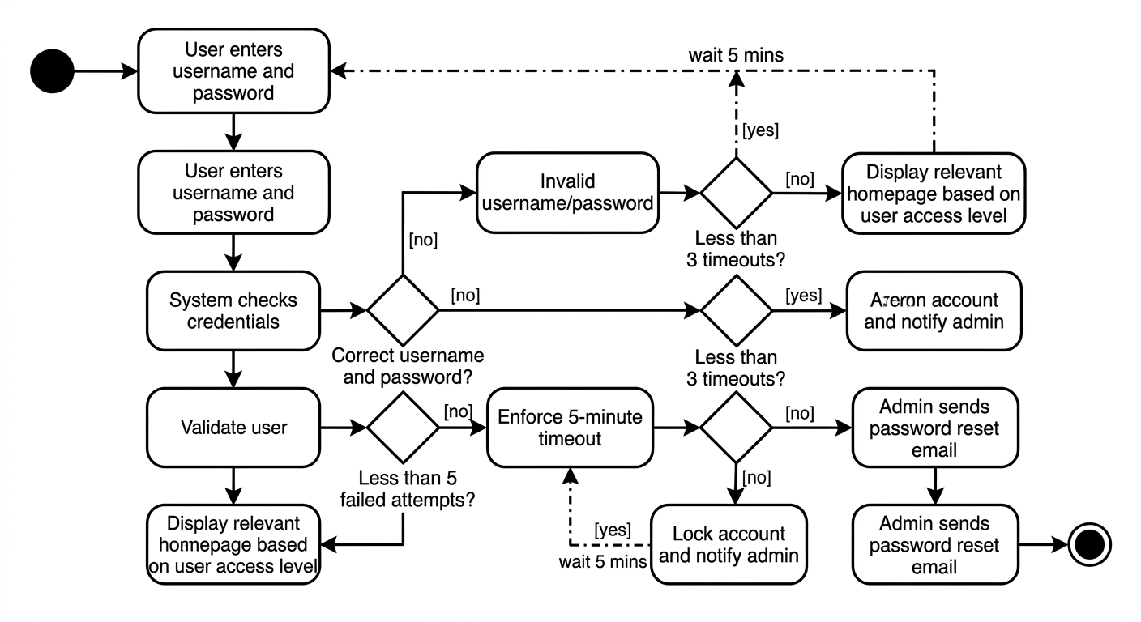
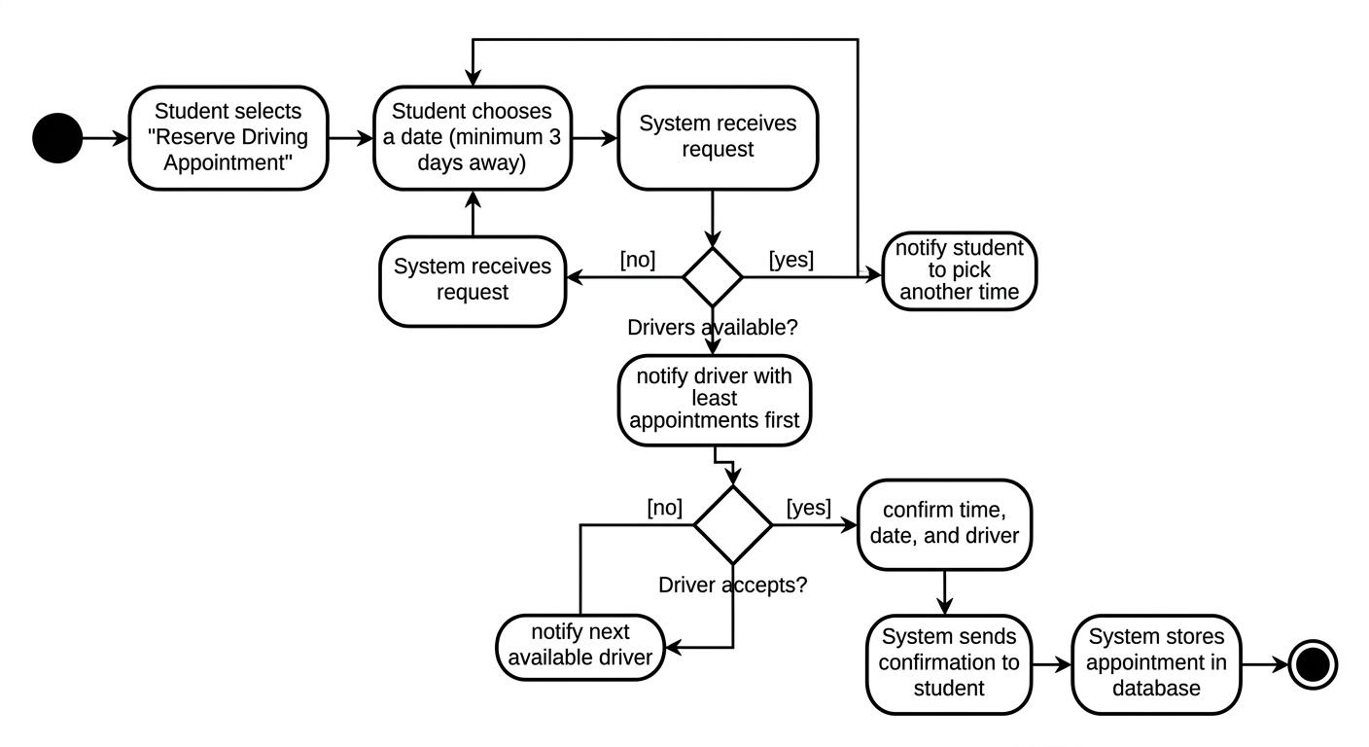

UML Sequence Diagram
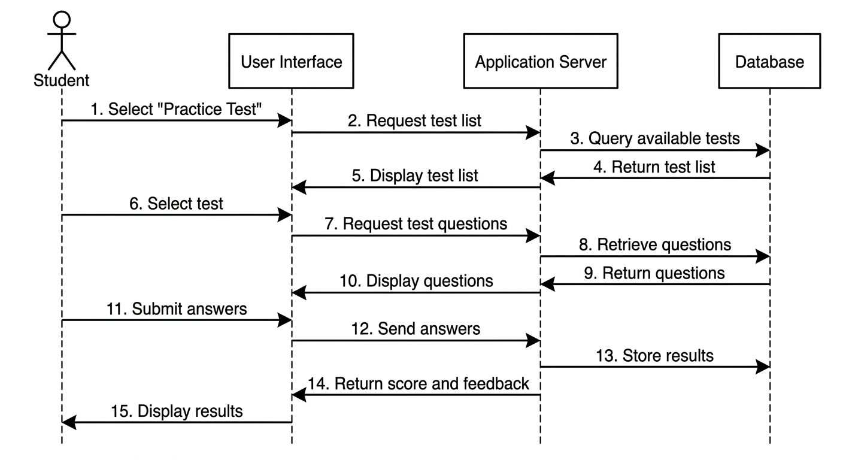

UML Class Diagram
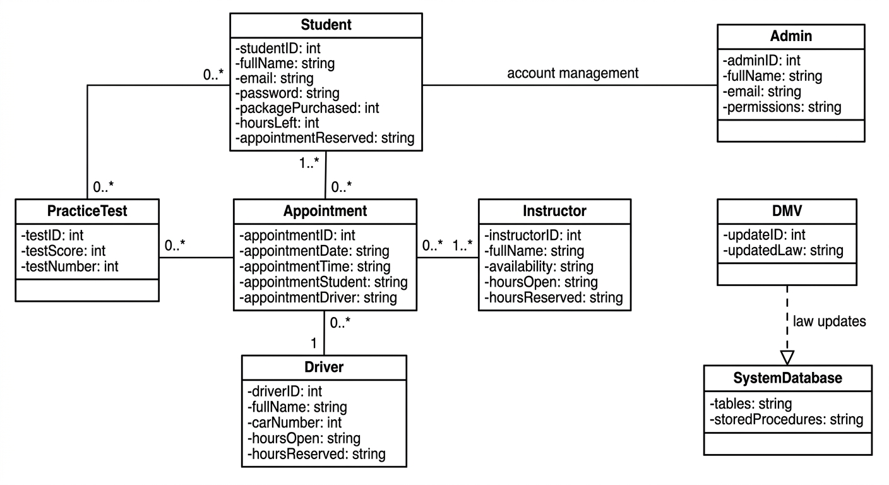

Technical Requirements
For the successful implementation of DriverPass system, there should be provision of technical environment that provides for user authentication, practice testing, lesson scheduling, administrative reporting and interface to third party systems like DMV. DriverPass system will run on a cloud based server infrastructure to provide scalability and performance reliability during peak loads when there are increased number of users. It will be necessary for the hardware environment to have adequate processing, memory and storage capacity to facilitate database transactions, user sessions and real time updating of schedule without any decrease in performance.
For the software development of the DriverPass system, it will be necessary to develop the software using an object oriented programming language in a Linux environment. There will be need to use of a web browser based software interface to access the DriverPass system via a web browser. DriverPass system will have to use HTTPS for all secure communications with other users. Relational database will be necessary to store student records, driver availability, test results, appointments, packages details and administration information.

This system should be designed to provide all necessary tools including monitoring tools for performance measurement, debugging tools for solving problems, and automated backup and restoration tools to prevent any loss of information. The infrastructure should support scaling of the system to cope with increasing user demands, guarantee continuous availability, and support interaction with other systems for obtaining up-to-date information on traffic laws and DMV. Other functional requirements include information about payment verification, appointments scheduling, packages, access to learning materials, driver notes, lesson times, photos, and results of tests.

