JFK Assassination System IdenCfication Form

Date: 10/14/20

AGENCY RECORD NUMBER :

RECORD SERIES : AGENCY FILE NUMBER :

ORIGINATOR :

FROM :

TO

: TITLE

:

DATE : PAGES :

HSCA

l 80-10086-10257 NUMBERED FILES 009046

HSCA

BROWN, JUANITA

06/01/1978

8

Agency Information

Document Information

SUBJECTS : BW 88326 Docld:32251699 Page

DOCUMENT TYPE : CLASSIFICATION : RESTRICTIONS : CURRENT STATUS : DATE OF LAST REVIEW :

OPENING CRITERIA : COMMENTS :

v9.i

BROWN, JUANITA

, ASSOCIA TION WITH OSWALD WILLIA M REILLY COFFEE CO.



eleased under the John F. Kennedy

ssassination Records Collection Act o 992 (44 USC 2107 Note). Casein:NW

OSWALD, LEE, POST RUSSIAN PERIOD, EMPLOYMENT

SUMMARY U

n c l a

s

s l

i f i e d

O

p e n

i n

F

u l l

R

e d a c t

0

6

/ 1

8

/ 1

9

9

3

Box 164.

KENNEDY

009 p86

INVESTIGATION INTERVIEW SCHEDULE

t: Identifying Information:

Name Juanita Brown Address_§é1 Andrews St. City/State Melairie, La.

Date of Birth 5-21-29 Social Securi y 3 2 19 1

. Physical Description: Height '

Date 6-1 7 Place 6J0 Magazine St.



Telephone

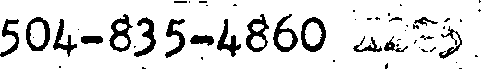M or S Spouse Children

Color EyesBrn Hair Bld

Wéight 110

aucasian Special Characteristics

Ethnicromp

1. Personal History:
   1. Present Employmen : william B. Rielly ’offee O.

Address 640 *agazine St. New Orleans, La.

Telephone 0 ’§24 6131 X 22d

* 1. Criminal Record
     1. Arrests
     2. Convictions

1. Additional Personal Information:
   1. Relative(s) : Mame



* 1. Area frequented:
  2. Remarks: Saw LHO in Alba's Garage

Investigator RObert Buraa

Date 6’’’ ’ Form #4-B



1 :

,, KENNEDY

-

OU‘£SIDE Cc0 T+4CT RE PO RT



* + 1. Identifying Information:

0 486o

Name Juanita Brown Telephone

Address 561 Andrews St. Metairie, La.

Type of Contact: Telephone

X Person

* + 1. Summary of Contact:

Mrs. Brown works in the payroll deparment of'the William B. Rielly Goffee Co. She worked there when Lee Harvey Oswald Worked for the company.* Mrs, Brown and other ladies used to go to Adrain Alba's garage next lo the company to buy a cold drink because the company did not have a drink machine. 0c- cassionally several of the ladies would go together on their

break. Mrs, Brown remembers that on a couple of occassions Oswald was in the garage office. She did not talk to him nor does she remember him ever saying anything in her presence.

She couldn't remember any of the other ladies at the time of

this contact but she will call back if she recallosfany the names.

End Of Memo

* + 1. Recommended follow-up (if any):

None

NW 8837G

DocId:3S22’5n1s6n99a ture: Form #5

Juanlta Brown

ñ-1-78

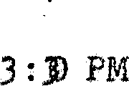¿04- 3D-A86o

561 Andrews St. Mata lrle , la

? s, Brown worbs in t1e. payroll deparment of the William B. Rielly Coffee Co. She worked there when Lee Harvey Oswald Worked for the company, Mrs. Brown and other ladies uaed to go to Adraln Alba's garage next to tho company #o tuy a sold drink because the company did not have a drink mathine. 0c cassionally several of lbe ladies would go together on their break. )as. Brown remembers that on a oouole of occassions Oswald was Inthe gum ge office.

Shed1d not Call to himnor does she remember him ever• 9ay1np• any£*:ing; in her presence.

She coutdn 't reooriber any of the other ladle s nt the tiae of. thls contact but she will call back If she recalls any of the names.

End Of memo

tlone

NW 88326 DocId:32251699 Page 4

 

Juanlea Brcwn



Pmsi Brown works in the payroll dmparment of the William B.

Rae y Coffee Go tche worked there when I.ee H‹irvey Oswald

kdd for the company, Wrs. Brown and other ladies use8 to



o

go to aB draln Alba t s garage next to the company eo buy a cold

- drink because the company did not hnv‹a a dr Ink machine Oe-

.› .•

cassiousts by severed oh the ladles uoMd go together on tholr br‹eak l4r* Brown reoenbors that on a couple of oc caesions Oswald was In I.he g;ari•ge off ce. She dld not balk £o him nor does she reneisber him over eay ink anyVli‘f.ng in her preaonca.

She couldn ' b remember any of site other ladlea aY I.he time of thla contact but she will call , hack If ahe recQ 11a ony of the names

End *OF* Demo

None

NW 8832a Docld:322S” 1tJ99 Page S

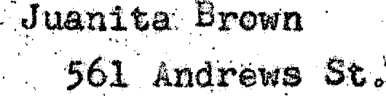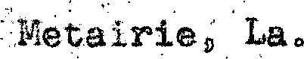

§-21 29

438-28-1991

# 6-1-78

640 ?Wgasine 3€.

5o4-8J5 A86o X2 5

»s



110’

Caucaa lan

Bra Bld

\?1111aa B› ft1eJ.1y “o2/es e•

6§0 Segamlne SSL New Orleans, La,

0¢- 24-6131 l.22§

Saw LIIO In filba 's Garage

NW 88326 DocId:32251699 Page G

Ro5ert Bur&s

# 6-1-7

Jusnita rows

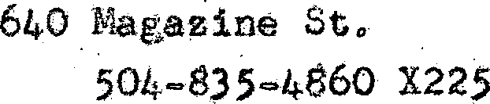§61 Andrews St. heLairle, La.

§-21-29

#@6-26-1981



110

Cnueas ian

’Bld

11111aa B. 1ie11y 'o££ee Ie.

64o âmgas 1ne SO, Xew 0c1eans, La

}0S-524-6131 X 22§

Saw LHO ln Alba's Garago

NW 88326 DocId:32251699 Page 7

Rohez’¢ Buz'as 5-1-7

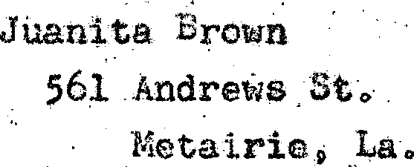

# >21-29 4Ş8-28-l98l

6-1-78

6&0 Aagamlne SŁ.

ş04-83§-486OX225

# 110

Coucaøian

Brm

IlliaœB, RìoÍly ’oífee e.

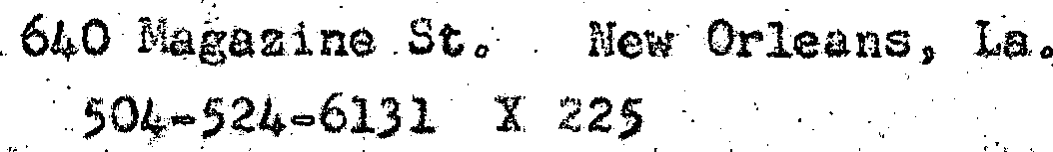



NW 88326 Docld:’322S1łi99 Page 8

RoL^ez’¢ Buz'as

6-1-78

