**Game Design Document (GDD)**

***‘Roll out’*** - Team Squa

**Table of Contents and Team Member Listing**

|  |  |  |
| --- | --- | --- |
| Table of Contents  [1 Game Overview](https://n-xovwktmtjsnaxyc2mwes2xu7pohqedmdm6zjw5q-2lu-script.googleusercontent.com/userCodeAppPanel)  [2 High Concept](https://n-xovwktmtjsnaxyc2mwes2xu7pohqedmdm6zjw5q-2lu-script.googleusercontent.com/userCodeAppPanel)  [3 Unique Selling Points](https://n-xovwktmtjsnaxyc2mwes2xu7pohqedmdm6zjw5q-2lu-script.googleusercontent.com/userCodeAppPanel)  [4 Platform Minimum Requirements](https://n-xovwktmtjsnaxyc2mwes2xu7pohqedmdm6zjw5q-2lu-script.googleusercontent.com/userCodeAppPanel)  [5 Competitors / Similar Titles](https://n-xovwktmtjsnaxyc2mwes2xu7pohqedmdm6zjw5q-2lu-script.googleusercontent.com/userCodeAppPanel)  [6 Synopsis](https://n-xovwktmtjsnaxyc2mwes2xu7pohqedmdm6zjw5q-2lu-script.googleusercontent.com/userCodeAppPanel)  [7 Game Objectives](https://n-xovwktmtjsnaxyc2mwes2xu7pohqedmdm6zjw5q-2lu-script.googleusercontent.com/userCodeAppPanel)  [8 Game Rules](https://n-xovwktmtjsnaxyc2mwes2xu7pohqedmdm6zjw5q-2lu-script.googleusercontent.com/userCodeAppPanel)  [9 Game Structure](https://n-xovwktmtjsnaxyc2mwes2xu7pohqedmdm6zjw5q-2lu-script.googleusercontent.com/userCodeAppPanel)  [10 Game Play](https://n-xovwktmtjsnaxyc2mwes2xu7pohqedmdm6zjw5q-2lu-script.googleusercontent.com/userCodeAppPanel)  [10.1 Game Controls](https://n-xovwktmtjsnaxyc2mwes2xu7pohqedmdm6zjw5q-2lu-script.googleusercontent.com/userCodeAppPanel)  [10.2 Game Camera](https://n-xovwktmtjsnaxyc2mwes2xu7pohqedmdm6zjw5q-2lu-script.googleusercontent.com/userCodeAppPanel)  [10.2.1 HUD](https://n-xovwktmtjsnaxyc2mwes2xu7pohqedmdm6zjw5q-2lu-script.googleusercontent.com/userCodeAppPanel)  [10.2.2 Maps](https://n-xovwktmtjsnaxyc2mwes2xu7pohqedmdm6zjw5q-2lu-script.googleusercontent.com/userCodeAppPanel)  [11 Players](https://n-xovwktmtjsnaxyc2mwes2xu7pohqedmdm6zjw5q-2lu-script.googleusercontent.com/userCodeAppPanel)  [11.1 Characters](https://n-xovwktmtjsnaxyc2mwes2xu7pohqedmdm6zjw5q-2lu-script.googleusercontent.com/userCodeAppPanel)  [11.2 Metrics](https://n-xovwktmtjsnaxyc2mwes2xu7pohqedmdm6zjw5q-2lu-script.googleusercontent.com/userCodeAppPanel)  [11.3 States](https://n-xovwktmtjsnaxyc2mwes2xu7pohqedmdm6zjw5q-2lu-script.googleusercontent.com/userCodeAppPanel)  [11.4 Weapons](https://n-xovwktmtjsnaxyc2mwes2xu7pohqedmdm6zjw5q-2lu-script.googleusercontent.com/userCodeAppPanel)  [12 Player Line-up](https://n-xovwktmtjsnaxyc2mwes2xu7pohqedmdm6zjw5q-2lu-script.googleusercontent.com/userCodeAppPanel)  [13 NPC](https://n-xovwktmtjsnaxyc2mwes2xu7pohqedmdm6zjw5q-2lu-script.googleusercontent.com/userCodeAppPanel)  [13.1 Enemies](https://n-xovwktmtjsnaxyc2mwes2xu7pohqedmdm6zjw5q-2lu-script.googleusercontent.com/userCodeAppPanel)  [13.1.1 Enemy States](https://n-xovwktmtjsnaxyc2mwes2xu7pohqedmdm6zjw5q-2lu-script.googleusercontent.com/userCodeAppPanel)  [13.1.2 Enemy Spawn Points](https://n-xovwktmtjsnaxyc2mwes2xu7pohqedmdm6zjw5q-2lu-script.googleusercontent.com/userCodeAppPanel)  [13.2 Allies / Companions](https://n-xovwktmtjsnaxyc2mwes2xu7pohqedmdm6zjw5q-2lu-script.googleusercontent.com/userCodeAppPanel)  [13.2.1 Ally States](https://n-xovwktmtjsnaxyc2mwes2xu7pohqedmdm6zjw5q-2lu-script.googleusercontent.com/userCodeAppPanel)  [13.2.2 Ally Spawn Points](https://n-xovwktmtjsnaxyc2mwes2xu7pohqedmdm6zjw5q-2lu-script.googleusercontent.com/userCodeAppPanel)  [14 Art](https://n-xovwktmtjsnaxyc2mwes2xu7pohqedmdm6zjw5q-2lu-script.googleusercontent.com/userCodeAppPanel)  [14.1 Setting](https://n-xovwktmtjsnaxyc2mwes2xu7pohqedmdm6zjw5q-2lu-script.googleusercontent.com/userCodeAppPanel)  [14.2 Level Design](https://n-xovwktmtjsnaxyc2mwes2xu7pohqedmdm6zjw5q-2lu-script.googleusercontent.com/userCodeAppPanel)  [14.3 Audio](https://n-xovwktmtjsnaxyc2mwes2xu7pohqedmdm6zjw5q-2lu-script.googleusercontent.com/userCodeAppPanel)  [15 Procedurally Generated Content](https://n-xovwktmtjsnaxyc2mwes2xu7pohqedmdm6zjw5q-2lu-script.googleusercontent.com/userCodeAppPanel)  [15.1 Environment](https://n-xovwktmtjsnaxyc2mwes2xu7pohqedmdm6zjw5q-2lu-script.googleusercontent.com/userCodeAppPanel)  [15.2 Levels](https://n-xovwktmtjsnaxyc2mwes2xu7pohqedmdm6zjw5q-2lu-script.googleusercontent.com/userCodeAppPanel)  [15.3 Artificial Intelligence NPC](https://n-xovwktmtjsnaxyc2mwes2xu7pohqedmdm6zjw5q-2lu-script.googleusercontent.com/userCodeAppPanel)  [15.4 Visual Arts](https://n-xovwktmtjsnaxyc2mwes2xu7pohqedmdm6zjw5q-2lu-script.googleusercontent.com/userCodeAppPanel)  [15.5 Audio](https://n-xovwktmtjsnaxyc2mwes2xu7pohqedmdm6zjw5q-2lu-script.googleusercontent.com/userCodeAppPanel)  [15.6 Minimum Viable Product (MPV)](https://n-xovwktmtjsnaxyc2mwes2xu7pohqedmdm6zjw5q-2lu-script.googleusercontent.com/userCodeAppPanel)  [16 Wish List](https://n-xovwktmtjsnaxyc2mwes2xu7pohqedmdm6zjw5q-2lu-script.googleusercontent.com/userCodeAppPanel)   |  | | --- | |  | | **Game Development Team Members**    PRODUCER  Jose Toscano    PRODUCTION MANAGER  Breana Gutierrez    PRODUCTION COORDINATOR  Ernesto Sanchez  GAME DESIGNERS  Breana Gutierrez  SYSTEMS/IT COORDINATOR  Ernesto Sanchez  PROGRAMMERS  Jose Toscano  TECHNICAL ARTISTS  Trevor Sheek  Breana Guitierrez  Jose Toscano  Ernesto Sanchez  AUDIO ENGINEERS  Trevor Sheek  UX TESTERS  Trevor Sheek |

|  |
| --- |
|  |

# 1. Game Overview

Title: Super Robot Ball

Platform: PC Standalone

Genre: Platform

Rating: (10+) ESRB

Target: Casual gamer (aging from 12 - 30)

Release date: December, 2020

Publisher: Unity

Super Robot Ball is a third person platform game that consists of a player moving a robot in the shape of a sphere to reach the finish line without falling over the platform. The player must reach the finish line before time runs out. Along the way the character will be collecting gears to accumulate points. Badges will be awarded for certain tasks completed during the game.

# 2. High Concept

Super Robot Ball initiates the player on a levitating platform, and the player must try his or her best to reach the finish line by moving the platform. The player will roll in the direction of the tilt of the platform, if the player falls over the platform the game is over. Along the way the player can collect gears to improve score and earn badges.

# 3. Unique Selling Points

* Improve coordination
* Anticipate distance and speed
* Collect badges

# 4. Platform Minimum Requirements

* PC with Windows or MAC
* Version 2012+

# 5. Competitors / Similar Titles

* Super Monkey Ball
* Myth Makers Orbs of Doom

# 6. Synopsis

The player must collect as many gears as possible and reach the finish line but be careful not to fall over.

# 7. Game Objectives

The objective of the game is to reach the finish line while collecting gears to accumulate points.

# 8. Game Rules

The player must use the arrow keys (up, down, right, left) to move the platform and the player’s character will move along at whichever direction the platform is tilting. To earn points the player must collect gears. The player must reach the finish line before time runs out to win. If the player falls over the platform or fails to reach the finish line before time expires the game will be over. Badges will be earned depending on the gears accumulated and the levels completed.

# 9. Game Structure

# 10. Game Play

## 10.1     Game Controls (PC)

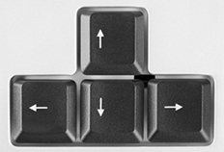

Tilt Platform Down

Tilt Platform Right

Tilt Platform Left

Tilt Platform Up

## 10.2 Game Camera

### 10.2.1 HUD

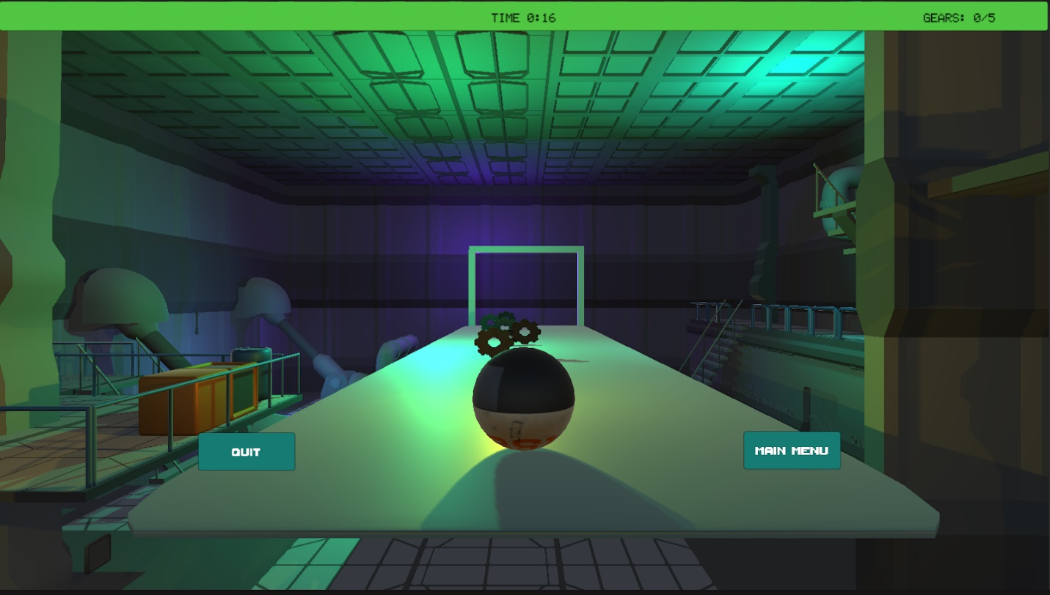

The HUD has a green background and is located on the top. It displays to the player, the time remaining, and the gears collected out of the total gears in the level.

### 10.2.2 Maps

# 11. Players

## 11.1     Characters

    Robot Ball Default character

## 11.2     Metrics

    Speed: 1

## 11.3     States

The Robot Ball will appear to be rolling whatever way the platform is tilting. When the Robot Ball collects a gear, a sound will generate.

## 11.4     Weapons

Not applicable for this game

# 12. Player Line-up

Default character of Robot Sphere

# 13. NPC

Not applicable for this game

## 13.1     Enemies

Not applicable for this game

### 13.1.1 Enemy States

Not applicable for this game

### 13.1.2 Enemy Spawn Points

Not applicable for this game

## 13.2     Allies / Companions

Not applicable for this game

### 13.2.1 Ally States

Not applicable for this game

### 13.2.2 Ally Spawn Points

Not applicable for this game

# 14. Art

## 14.1     Setting

The setting changes depending on the levels to add more aesthetics and appeal to the game. The first level’s setting represents an industrial robotic setting, and the second level’s setting indicates a galactical environment.

## 14.2     Level Design

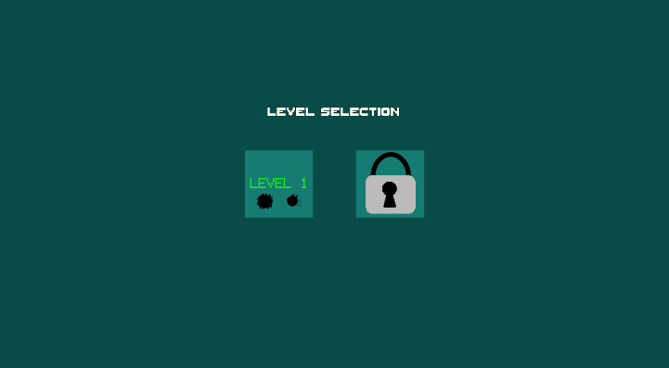There are two levels to the game. The first level is the top right corner, and the second level is bottom right corner. Level one is designed to be easier to maneuver the robot and collect the gears and the second level is unlocked once level one is completed. The second level is more difficult because the sensitivity of the platform is higher and makes it harder to move the sphere and collect the gears.

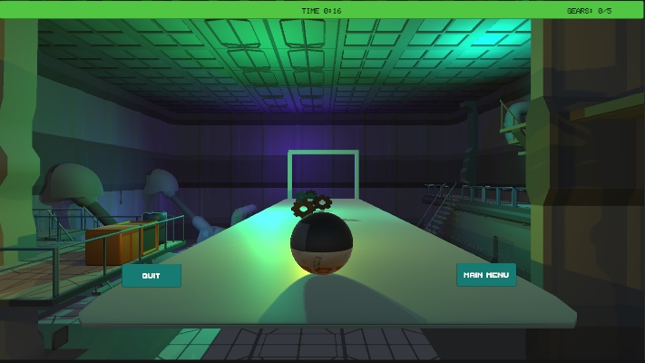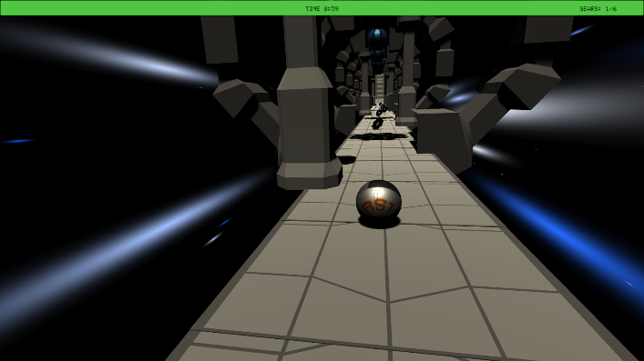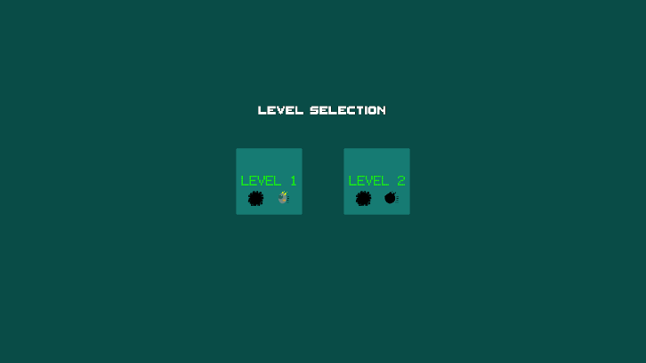

## 14.3     Audio

Audio_BG: audioblocks-dark-synth-retrowave-retrowave_rutUhN9hr

Music for the EasyGame_Scene

Zapsplat_impacts_metal_small_light_clang_ping_001_58906

Makes a clanking metal sound when the robot sphere comes into contact with the gears.

AudioSource_BG: Robot-music

Music for Losing_Scene

MusicPlayer: audioblocks-robots_SRkPHbJ_w

Music for Scene_Main_Menu

# 15. Procedurally Generated Content

Not applicable to this game

## 15.1     Environment

Not applicable to this game

## 15.2     Levels

Not applicable to this game

## 15.3     Artificial Intelligence NPC

Not applicable to this game

## 15.4     Visual Arts

Not applicable to this game

## 15.5     Audio

Not applicable to this game

## 15.6 Minimum Viable Product (MPV)

Not applicable to this game

# 16. Wish List

# Space Robot Kevin 3D model  - <https://assetstore.unity.com/packages/3d/characters/robots/space-robot-kyle-4696>

* Adding more levels with different platform settings
* Adding a character selection
* Multiplayer mode to allow other players race against each other.

# 17. Bibliography

June 10,2020. *Snaps Prototype | Sci-Fi / Industrial.* Unity Asset Store. <https://assetstore.unity.com/packages/3d/environments/sci-fi/snaps-prototype-sci-fi-industrial-136759>

Demon, R Feb 4, 2020. Robot Sphere Unity. <https://assetstore.unity.com/packages/3d/characters/robots/robot-sphere-136226>

ZapSplat. Small light metal impact. Clang, Ping 1.

<https://www.zapsplat.com/music/small-light-metal-impact-clang-ping-1/>

Sanchez, E. Dec 5 , 2020. Camera_Follow.cs

Sanchez, E. Dec 5, 2020. Spin_Sphere.cs

Sanchez, E. Dec 3, 2020. Platform_Tilt.cs

Sanchez, E. Dec 4, 2020. FallToFloor.cs

Sanchez, E. Dec 4, 2020. Pause_Key.cs

Sanchez, E. Dec 5, 2020. EasyGame_Scene

Sanchez, E. Dec 1, 2020. SplashScreen_Scene

Toscano, J. Dec 4, 2020.  Scene_Main_Menu

Toscano, J. Dec 4, 2020.  Scene_Level_Selection

Toscano, J. Dec 7, 2020.  Gear.png

Toscano, J. Dec 6, 2020.  Gears_Badge_Shadow.png

Toscano, J. Dec 6, 2020.  Gears_Badge.png

Toscano, J. Dec 6, 2020.  Speed_Badge_Shadow.png

Toscano, J. Dec 7, 2020.  Canvas_HUD

Toscano, J. Dec 6, 2020.  Speed_Badge.png

Toscano, J. Dec 4, 2020. Space_tech_theme.png

Toscano, J. Dec 6, 2020.  LevelManager.cs

Toscano, J. Dec 5, 2020.  UIManager.cs

Toscano, J. Dec 7, 2020.  TimerManager.cs

Toscano, J. Dec 6, 2020.  Gears_Badge_Spin.anim

Toscano, J. Dec 6, 2020.  Speed_Badge_Spin.anim

Gutierrez, B. 2020. gears.fbx

Gutierrez, B. 2020. space_background 1.png

Gutierrez, B. 2020. space_background.png

Gutierrez, B. 2020. arrowsKey.png

Gutierrez, B. 2020. arrowsKey_0.anim

Gutierrez, B. 2020. Losing_Scene

Gutierrez, B. 2020. Scene_HowToPlay

Gutierrez, B. 2020. Winning_Scene

Gutierrez, B. 2020. Gear_Rotate.cs

Gutierrez, B. 2020. LosingScene.cs

Sheek, Trevor.  Dec 2020 GenericButton prefab

Sheek, Trevor.  Dec 2020 1SCN_MainMenu

Sheek, Trevor.  Dec 2020 2SCN_HowToPlay Scene

Sheek, Trevor.  Dec 2020 3SCN_Level2

Sheek, Trevor.  Dec 2020 GameFunctions.cs

Sheek, Trevor.  Dec 2020 HowToPlayController.cs