Loot The Fruits: Game Design Document (GDD)

Your Game Logo

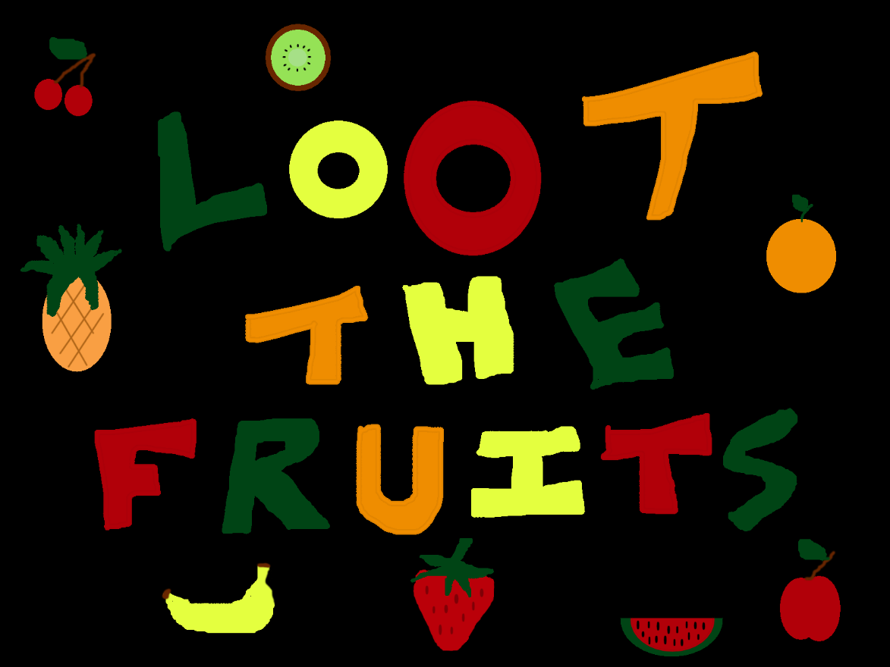

***‘When life gives you kiwis, you got to find the rest of life’s fruits’*** – Jose Toscano

This page: Table of Contents and Team Member Listing

|  |  |  |
| --- | --- | --- |
| Table of Contents  [1 Game Overview](https://n-xovwktmtjsnaxyc2mwes2xu7pohqedmdm6zjw5q-2lu-script.googleusercontent.com/userCodeAppPanel)  [2 High Concept](https://n-xovwktmtjsnaxyc2mwes2xu7pohqedmdm6zjw5q-2lu-script.googleusercontent.com/userCodeAppPanel)  [3 Unique Selling Points](https://n-xovwktmtjsnaxyc2mwes2xu7pohqedmdm6zjw5q-2lu-script.googleusercontent.com/userCodeAppPanel)  [4 Platform Minimum Requirements](https://n-xovwktmtjsnaxyc2mwes2xu7pohqedmdm6zjw5q-2lu-script.googleusercontent.com/userCodeAppPanel)  [5 Competitors / Similar Titles](https://n-xovwktmtjsnaxyc2mwes2xu7pohqedmdm6zjw5q-2lu-script.googleusercontent.com/userCodeAppPanel)  [6 Synopsis](https://n-xovwktmtjsnaxyc2mwes2xu7pohqedmdm6zjw5q-2lu-script.googleusercontent.com/userCodeAppPanel)  [7 Game Objectives](https://n-xovwktmtjsnaxyc2mwes2xu7pohqedmdm6zjw5q-2lu-script.googleusercontent.com/userCodeAppPanel)  [8 Game Rules](https://n-xovwktmtjsnaxyc2mwes2xu7pohqedmdm6zjw5q-2lu-script.googleusercontent.com/userCodeAppPanel)  [9 Game Structure](https://n-xovwktmtjsnaxyc2mwes2xu7pohqedmdm6zjw5q-2lu-script.googleusercontent.com/userCodeAppPanel)  [10 Game Play](https://n-xovwktmtjsnaxyc2mwes2xu7pohqedmdm6zjw5q-2lu-script.googleusercontent.com/userCodeAppPanel)  [10.1 Game Controls](https://n-xovwktmtjsnaxyc2mwes2xu7pohqedmdm6zjw5q-2lu-script.googleusercontent.com/userCodeAppPanel)  [10.2 Game Camera](https://n-xovwktmtjsnaxyc2mwes2xu7pohqedmdm6zjw5q-2lu-script.googleusercontent.com/userCodeAppPanel)  [10.2.1 HUD](https://n-xovwktmtjsnaxyc2mwes2xu7pohqedmdm6zjw5q-2lu-script.googleusercontent.com/userCodeAppPanel)  [10.2.2 Maps](https://n-xovwktmtjsnaxyc2mwes2xu7pohqedmdm6zjw5q-2lu-script.googleusercontent.com/userCodeAppPanel)  [11 Players](https://n-xovwktmtjsnaxyc2mwes2xu7pohqedmdm6zjw5q-2lu-script.googleusercontent.com/userCodeAppPanel)  [11.1 Characters](https://n-xovwktmtjsnaxyc2mwes2xu7pohqedmdm6zjw5q-2lu-script.googleusercontent.com/userCodeAppPanel)  [11.2 Metrics](https://n-xovwktmtjsnaxyc2mwes2xu7pohqedmdm6zjw5q-2lu-script.googleusercontent.com/userCodeAppPanel)  [11.3 States](https://n-xovwktmtjsnaxyc2mwes2xu7pohqedmdm6zjw5q-2lu-script.googleusercontent.com/userCodeAppPanel)  [11.4 Weapons](https://n-xovwktmtjsnaxyc2mwes2xu7pohqedmdm6zjw5q-2lu-script.googleusercontent.com/userCodeAppPanel)  [12 Player Line-up](https://n-xovwktmtjsnaxyc2mwes2xu7pohqedmdm6zjw5q-2lu-script.googleusercontent.com/userCodeAppPanel)  [13 NPC](https://n-xovwktmtjsnaxyc2mwes2xu7pohqedmdm6zjw5q-2lu-script.googleusercontent.com/userCodeAppPanel)  [13.1 Enemies](https://n-xovwktmtjsnaxyc2mwes2xu7pohqedmdm6zjw5q-2lu-script.googleusercontent.com/userCodeAppPanel)  [13.1.1 Enemy States](https://n-xovwktmtjsnaxyc2mwes2xu7pohqedmdm6zjw5q-2lu-script.googleusercontent.com/userCodeAppPanel)  [13.1.2 Enemy Spawn Points](https://n-xovwktmtjsnaxyc2mwes2xu7pohqedmdm6zjw5q-2lu-script.googleusercontent.com/userCodeAppPanel)  [13.2 Allies / Companions](https://n-xovwktmtjsnaxyc2mwes2xu7pohqedmdm6zjw5q-2lu-script.googleusercontent.com/userCodeAppPanel)  [13.2.1 Ally States](https://n-xovwktmtjsnaxyc2mwes2xu7pohqedmdm6zjw5q-2lu-script.googleusercontent.com/userCodeAppPanel)  [13.2.2 Ally Spawn Points](https://n-xovwktmtjsnaxyc2mwes2xu7pohqedmdm6zjw5q-2lu-script.googleusercontent.com/userCodeAppPanel)  [14 Art](https://n-xovwktmtjsnaxyc2mwes2xu7pohqedmdm6zjw5q-2lu-script.googleusercontent.com/userCodeAppPanel)  [14.1 Setting](https://n-xovwktmtjsnaxyc2mwes2xu7pohqedmdm6zjw5q-2lu-script.googleusercontent.com/userCodeAppPanel)  [14.2 Level Design](https://n-xovwktmtjsnaxyc2mwes2xu7pohqedmdm6zjw5q-2lu-script.googleusercontent.com/userCodeAppPanel)  [14.3 Audio](https://n-xovwktmtjsnaxyc2mwes2xu7pohqedmdm6zjw5q-2lu-script.googleusercontent.com/userCodeAppPanel)  [15 Procedurally Generated Content](https://n-xovwktmtjsnaxyc2mwes2xu7pohqedmdm6zjw5q-2lu-script.googleusercontent.com/userCodeAppPanel)  [15.1 Environment](https://n-xovwktmtjsnaxyc2mwes2xu7pohqedmdm6zjw5q-2lu-script.googleusercontent.com/userCodeAppPanel)  [15.2 Levels](https://n-xovwktmtjsnaxyc2mwes2xu7pohqedmdm6zjw5q-2lu-script.googleusercontent.com/userCodeAppPanel)  [15.3 Artificial Intelligence NPC](https://n-xovwktmtjsnaxyc2mwes2xu7pohqedmdm6zjw5q-2lu-script.googleusercontent.com/userCodeAppPanel)  [15.4 Visual Arts](https://n-xovwktmtjsnaxyc2mwes2xu7pohqedmdm6zjw5q-2lu-script.googleusercontent.com/userCodeAppPanel)  [15.5 Audio](https://n-xovwktmtjsnaxyc2mwes2xu7pohqedmdm6zjw5q-2lu-script.googleusercontent.com/userCodeAppPanel)  [15.6 Minimum Viable Product (MPV)](https://n-xovwktmtjsnaxyc2mwes2xu7pohqedmdm6zjw5q-2lu-script.googleusercontent.com/userCodeAppPanel)  [16 Wish List](https://n-xovwktmtjsnaxyc2mwes2xu7pohqedmdm6zjw5q-2lu-script.googleusercontent.com/userCodeAppPanel)   |  | | --- | |  | | Game Development Team Members    PRODUCER  Jose Toscano    PRODUCTION MANAGER  Jose Toscano    PRODUCTION COORDINATOR  Jose Toscano  GAME DESIGNERS  Jose Toscano  SYSTEMS/IT COORDINATOR  Jose Toscano  PROGRAMMERS  Jose Toscano  TECHNICAL ARTISTS  Jose Toscano  AUDIO ENGINEERS  Jose Toscano  UX TESTERS  Jose Toscano |

|  |
| --- |
|  |

# 1 Game Overview

Title: Loot the Fruits

Platform: PC Standalone

Genre: Side Scroller Platformer

Rating: (10+) ESRB

Target: Casual gamer (aging from 12 - 30)

Release date: November 2020

Publisher: CMango

Description: Loot the Fruits is a side scroller platformer where the main character (haven’t decided which character I want to use) is on a quest….(Need to come up with a story)

# 2 High Concept

# 3 Unique Selling Points

# 4 Platform Minimum Requirements

# 5 Competitors / Similar Titles

* Mario
* Donkey Kong
* Crash Bandicoot

# 6 Synopsis

# 7 Game Objectives

* The goal is to collect 8 unique fruits in each level (5 total levels) to move onto the next level while evading or stomping on enemies.

# 8 Game Rules

# 9 Game Structure

# 10 Game Play

## 10.1 Game Controls

## 10.2 Game Camera

### 10.2.1 HUD

The heads-up display will contain the number of lives a player has left, as well which fruits they have collected.

### 10.2.2 Maps

# 11 Players

## 11.1 Characters

## 11.2 Metrics

## 11.3 States

## 11.4 Weapons

# 12 Player Line-up

# 13 NPC

## 13.1 Enemies

### 13.1.1 Enemy States

### 13.1.2 Enemy Spawn Points

## 13.2 Allies / Companions

### 13.2.1 Ally States

### 13.2.2 Ally Spawn Points

# 14 Art

## 14.1 Setting

## 14.2 Level Design

## 14.3 Audio

# 15 Procedurally Generated Content

## 15.1 Environment

## 15.2 Levels

## 15.3 Artificial Intelligence NPC

## 15.4 Visual Arts

## 15.5 Audio

## 15.6 Minimum Viable Product (MPV)

# 16 Wish List

17 Bibliography4

Images:

Possible sources:

* <https://assetstore.unity.com/packages/2d/characters/pixel-adventure-1-155360#content>
* <https://assetstore.unity.com/packages/2d/characters/pixel-adventure-2-155418>

What I plan to create:

* Backgrounds for menus
* Button for menu options
* Items

What I have made so far:

* Game Logo

Sounds:

Possible sources:

* <https://assetstore.unity.com/packages/audio/sound-fx/free-casual-game-sfx-pack-54116>
* <https://assetstore.unity.com/packages/audio/music/orchestral/free-game-music-collection-177094>

Scripts:

Used some parts for the Character 2D Controller

* https://www.youtube.com/watch?v=44djqUTg2Sg&t=313s(“Game Dev Basics: Let's make a 2D player controller in C# and Unity!”)