<https://drive.google.com/file/d/1KTwAGGA_y45UrHvsuXGz-u_Y8zG4O3zZ/view?usp=sharing>

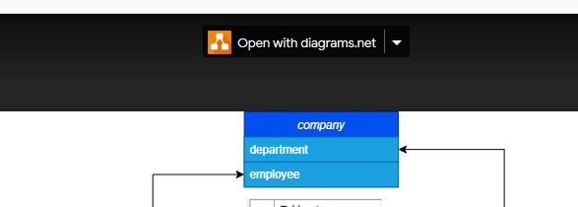I made this temp UML. If you want to edit, use the link above or leave a comment here for what to change.

* just log in to your G-Mail
* and click on open with diagrams.net

