INDUSTRIAL CONDOMINIUM
4735 DWIGHT EVANS ROAD
CHARLOTTE, NORTH CAROLINA 28217
FILE NO. 22061

MR. HERB McKOY
PACIFIC WESTERN BANK
5404 WISCONSIN AVENUE, 2nd Floor
CHEVY CHASE, MARYLAND 20815

Dear Mr. Herb Talbott,
I am appraise-man Carl.

Comparable Rental 3
Location Details
Address | 2732 Interstate St, Ste F | 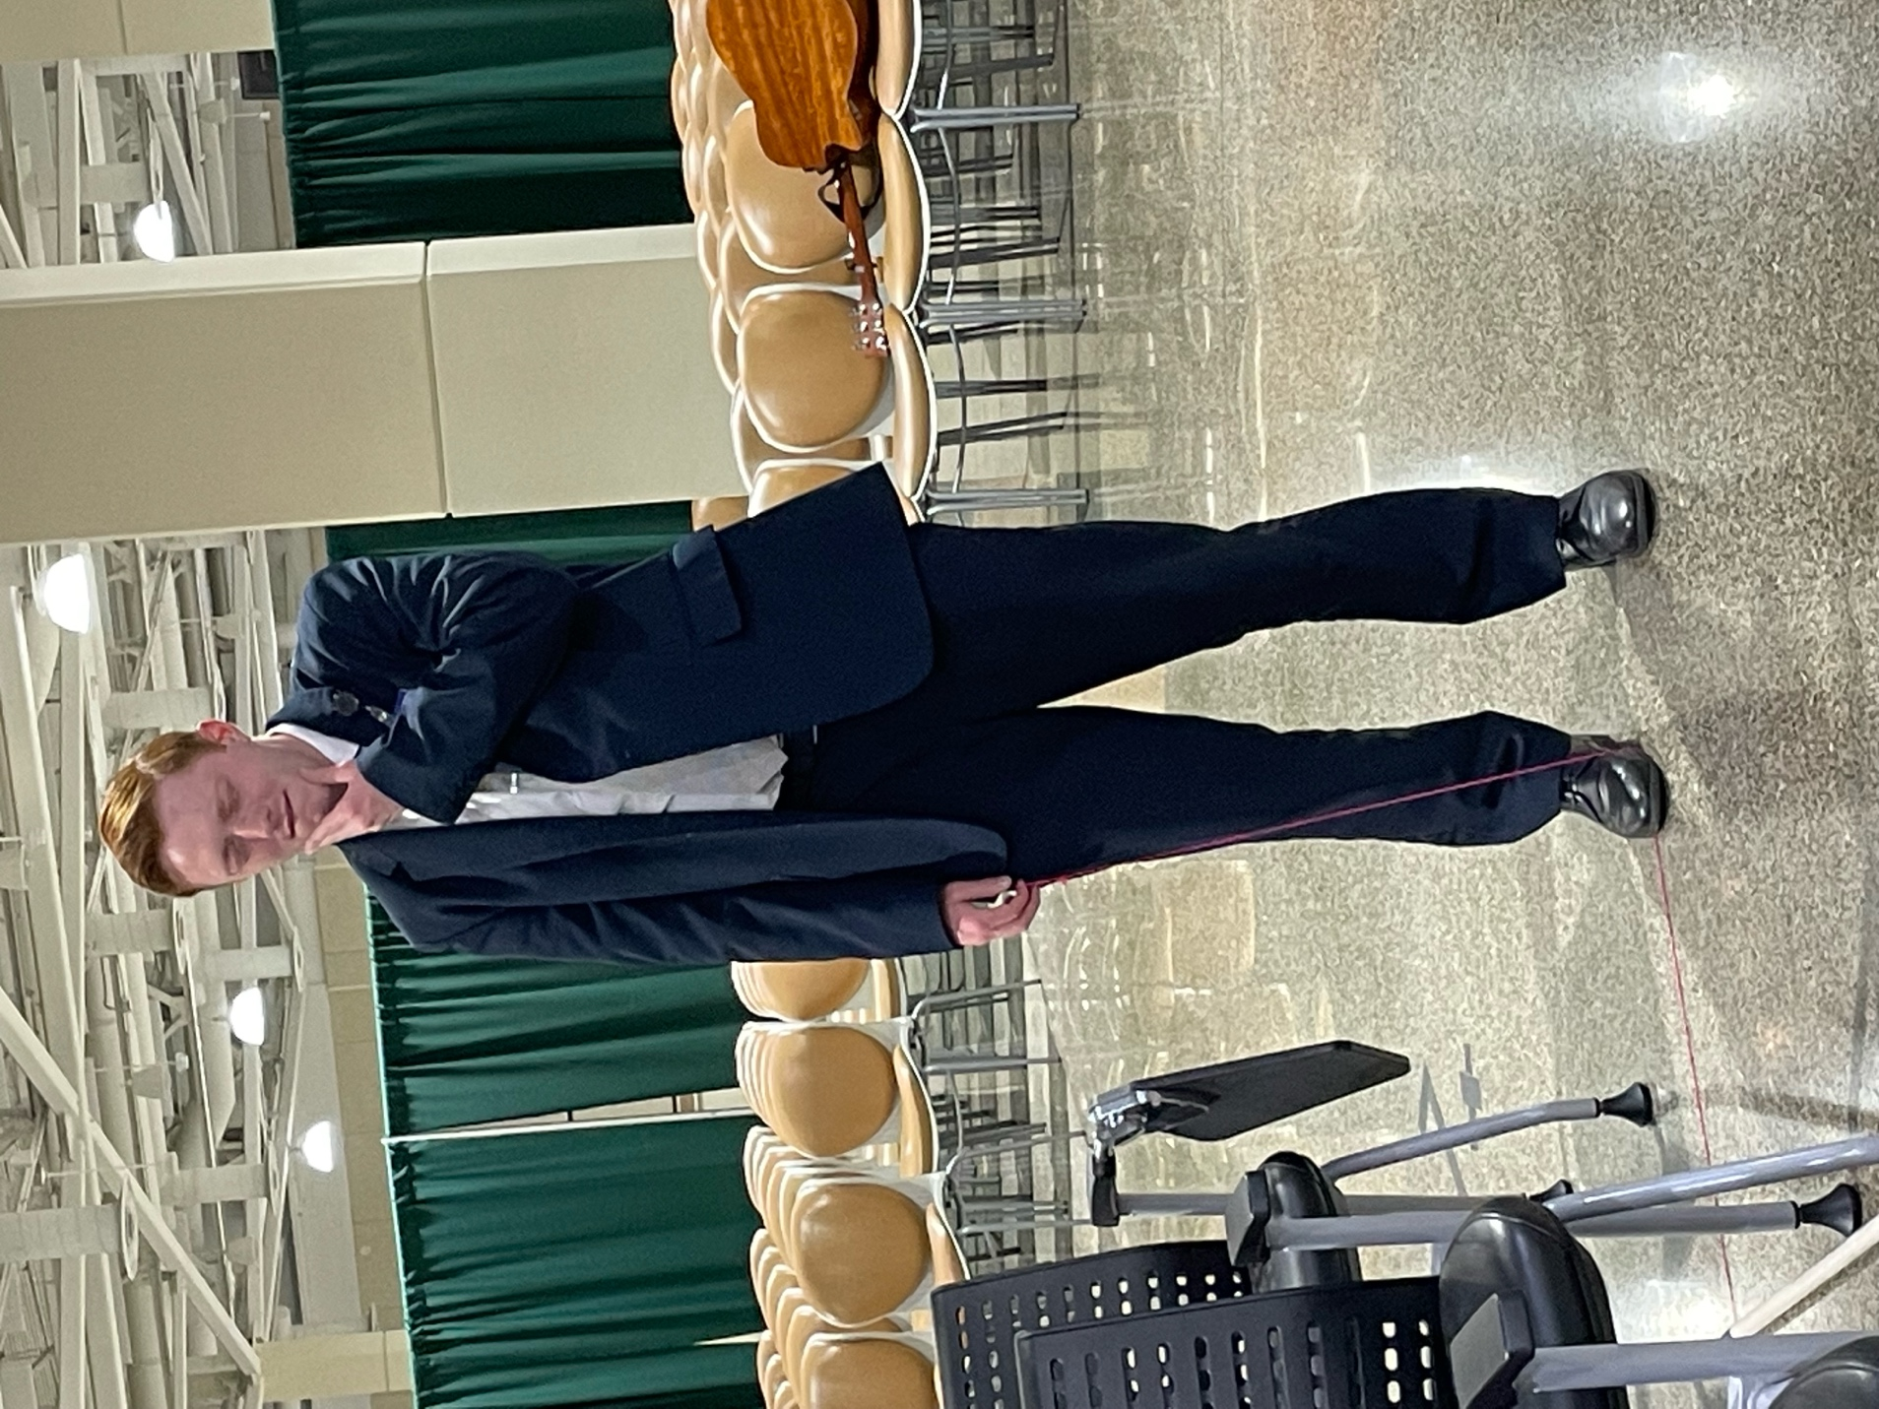
Address | Charlotte, NC
Parcel No.(s) | 061-123-12
Transaction Data
Property Rights Conveyed | [prc]
Tenant | [tenant]
Lease Type | [lease_t]
Lease Date | Jun-21
Lease Term | 36 months
Lease Rate (S/SF/Yr) | $9.76
Expense Structure | NNN
Verification | Listing Broker
Physical Attributes
Rentable Building Area (SF) | 3,628
Year Built | 1983
Quality | Good
Effective Age/Condition | 10 years
Finished Ratio | 33.1%
Access | Good
Parking Ratio | 2.11/1,000 SF
Eave Height | 16 feet
Loading | 0 GL/1 DH
Loading SF | 3,628
Building Use | Industrial
Other | None
Comments
This reflects the effective rent for space in a 26,040-square-foot, multi-tenant industrial building located in the Airport 85 Business Park just east of the Billy Graham Parkway/Interstate 85 interchange within the city limits of Charlotte in Mecklenburg County, North Carolina. The unit has approximately 1,200 square feet of office space and one dock-high door. The triple-net lease was executed turn-key with a starting rent of $9.75 per square foot per year and no escalations. The space was on the market for about 10 months with an asking rental rate of $10.00 per square foot.



Comparable Rental 3
Location Details
Address | [Address_1]
Address | [Address_2]
Parcel No.(s) | 061-123-12
Transaction Data
Property Rights Conveyed | [prc]
Tenant | [tenant]
Lease Type | [lease_t]
Lease Date | Jun-21
Lease Term | 36 months
Lease Rate (S/SF/Yr) | $9.76
Expense Structure | NNN
Verification | Listing Broker
Physical Attributes
Rentable Building Area (SF) | 3,628
Year Built | 1983
Quality | Good
Effective Age/Condition | 10 years
Finished Ratio | 33.1%
Access | Good
Parking Ratio | 2.11/1,000 SF
Eave Height | 16 feet
Loading | 0 GL/1 DH
Loading SF | 3,628
Building Use | Industrial
Other | None
Comments
This reflects the effective rent for space in a 26,040-square-foot, multi-tenant industrial building located in the Airport 85 Business Park just east of the Billy Graham Parkway/Interstate 85 interchange within the city limits of Charlotte in Mecklenburg County, North Carolina. The unit has approximately 1,200 square feet of office space and one dock-high door. The triple-net lease was executed turn-key with a starting rent of $9.75 per square foot per year and no escalations. The space was on the market for about 10 months with an asking rental rate of $10.00 per square foot.

