# Evaluation of the Responsiveness of the Winter Wear Warehouse Website

Joel Tollefson  
March 11, 2018

# **Summary**

A website was created for the Winter Wear Warehouse (WWW) LLC ; the URL is:

<https://jctoll.github.io/winter_wear_warehouse/index.html>

This is a commercial website setup to market and sell WWW’s products that specializes in cold-weather clothes for women.

Using research methods, the targeted audience (customers) was identified and the targeted devices were determined, and then using website testing, the responsive quality of this website was evaluated. Several issues were uncovered and fixed. This document provides the research and testing that was done, and how the website was updated to improve the responsivity.

# **Customer/Website Audience Classification**

The following table encapsulates the audience attributes, and the impact of the content on the customer. This table was obtained from the Website Criteria Guide (1).

|  |  |  |  |  |
| --- | --- | --- | --- | --- |
|  | **Audience attributes** | ***Example characteristics and scenarios*** | **Your audiences’ characteristics & scenarios** | **Impact**  **H, M, L** |
| **Who** | Age and age groups | *children, teenagers, baby-boomers, young adults, over 65, in their thirties* | Age group:  18-25 yrs old  26-45 yrs old  46-65 yrs old  >65 yrs old | L H  M L |
| Personal life-style | *resident, parent, single-parent, person with a disability, retired, tourist, Y-generation, school student, university student, migrant* | Stay-at-home mother’s Students – HS/University  Working women - dress for work Retired | M L H M |
| Gender | *mostly male, mostly female or both in equal numbers* | Female – almost exclusively  Male – only when shopping for gifts | H L |
| Language | *English as first language, English as a second language* | English as primary language |  |
| Education | *school, college, university, post-graduate* | High School – max. attained College Educated Post-Grad Educated | L H H |
| Learning preferences | *practical demonstrations, learns by example, likes to know the theory, free-thinker, images rather than text, systematic learner, task-oriented, left-brain vs right-brain* | Not applicable |  |
| Work attributes | *employee, home duties, shift-worker, academic, professional, business owner, executive, carer, unemployed, volunteer, specific industry sector* | Non working – non-career Working women – career centered | L H |
| Expectations | *what they expect based on their experience with similar websites* | Quick and easy navigation, searching and shopping | H |
| Existing knowledge | *how much they already know about the content, product, service* | Knowledgeable about winter clothes | M |
| Web and computer experience | *none, low, medium, high* | Medium web experience |  |
| **How** | On what device they will read it | *PC, handheld device, large monitor, small monitor* | Mobile phone IPad-type device Computer – large monitor | H  M L |
| Internet connection speed | *fast broadband, standard broadband, slow* | Standard broadband – G4 |  |
| **Where** | User’s location | *local, national, international – urban, regional, remote* | Local location – primarily used in living and working environment |  |
| Place where the page is read | *at home, school, work, public library, on the road, in the field, public places* | Work  Home  In public – while doing chores | L  H  M |
| **Why** | Why users seek the content | *to be informed, complete a task, seek an answer, buy something, entertainment, training* | Need dress clothes for cold weather  Need for fashionable wardrobe -for work  Purchase for family members (kids)  Gifts for friends & Family | M H M  L |
| Importance of the content to them | *vital, useful, interesting* | Need to shop for winter clothes – want to be fashinable |  |
| How they found the page | *Google, link from other site, word-of-mouth, enewsletter link, found it accidentally* | Google search,  Link from other sites | H |
| **When** | When it is read | *at work between 9am and 5pm, during a lunch-break, after the children are in bed, weekends, at night, early morning* | At work – 10:00 am – 4 PM  Weekdays: evenings & after kids are in bed.  Weekends – especially while doing chores | L  M  H |

# **Summary of Audience Attributes**

**Based on the research and the gathering of the attributes and rating system in the above table, a generalized profile of the typical customer/audience member is summarized as follows:**

* **Adult Women with college degree**
* **Professional working women who need fashionable winter clothing for work**
* **Typical viewer/customer is very busy and needs quick and easy access to the website while in-between tasks**
* **Users primarily will access while on-the-go – and will do so primarily on their mobile phone devices and tablets.**
* **The user is very internet savvy and experienced, and has grown up using mobile phones & devices**

# **Demographics and Devices**

**Based on the above targeted demographics, outlined in the previous section, research was done to identify what are the best targeted devices that the core demographics uses. According to research done by the Pew Research Center, “The demographics of Device Ownership” (2), smartphones are the predominant devices used by our targeted user group. The table below from this research, shows how such a large percentage our targeted users group uses smartphones – our demographics are highlighted in yellow . As a result, the website design and responsiveness will be primarily focused on smartphones (mobile devices).**

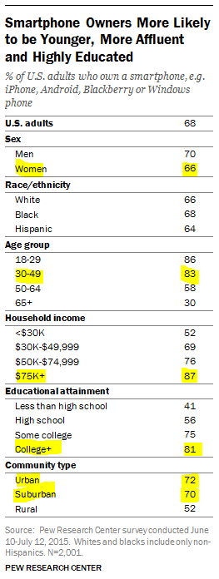

# **User Scenarios**

**The following are a few scenarios that show how the users might need to access and use our website.**

### **User Scenario 1 – Professional Woman Searches for Scarves & Gloves Needed for a Business Trip**

**Carol is a 42 year old executive in the finance industry, located in So Cal. She is very busy and often travels. Winter is approaching and Carol needs to add winter work clothes for upcoming trip to the cold mid-West. During lunch at her computer desk, she does a Google search and finds our website – which she quickly reviews, but runs out of time before purchasing a product. However, while between meetings she has a few minutes, and she pops up our website on her mobile phone – which she then uses to purchase several items.**

### **User Scenario 2 –A Busy Working Mother Prepares for Winter**

**Janet is a 26 year working mother of 3 kids, and lives in Ann Arbor, MI. She works full-time while juggling her children’s sports, music and dance lessons during the weekends. Janet is at her daughter’s soccer game – and she is cold; Autumn has arrived. Janet realizes she needs to quickly get more winter clothes. So at half-time, she opens her mobile phone, a Samsung 7, and starts searching. She finds our website – and quickly purchases some scarves, and gloves. She remembers that her best friend and co-worker is having a birthday – so she takes advantage of our website and orders some fashionable winter clothes and accessories.**

# **Web Browser Test**

**The web site was tested on the following browsers, all running on Windows ??, with results as shown:**

**Mozilla Firefox:  Passed (Tested on version 52+)   
Google Chrome:  Passed (Tested on version 64+)   
MS Internet Explorer:  Failed (Tested on version 11)**

**The failure on IE is with the 3 images that used the “srcset method” to set image size based on browser width. This HTML5 feature is NOT supported in IExplorer.**

# **How Responsive is the Web Site?**

**The following tool was used to test the how responsive the web design is (3):**

<http://responsivedesignchecker.com/>

**The first website that was evaluated, was the last website that was developed (for homework assignment #8):**

<https://jctoll.github.io/homework8_jscode/index.html>

**TEST #1 – NARROW MONITORS ~ MOBILE SMARTPHONE DEVICES**

**This was first tested on small and narrow monitors – smartphone devices. This is the critical test because due to our research, we expect that 75% of our users will access the website using their smartphones. The “Samsung Galaxy (360 x 640) was selected as a default phone. A snapshot (bitmap) of the tool’s test is shown below. Three (3) main issues were identified, and fixed as described below.**

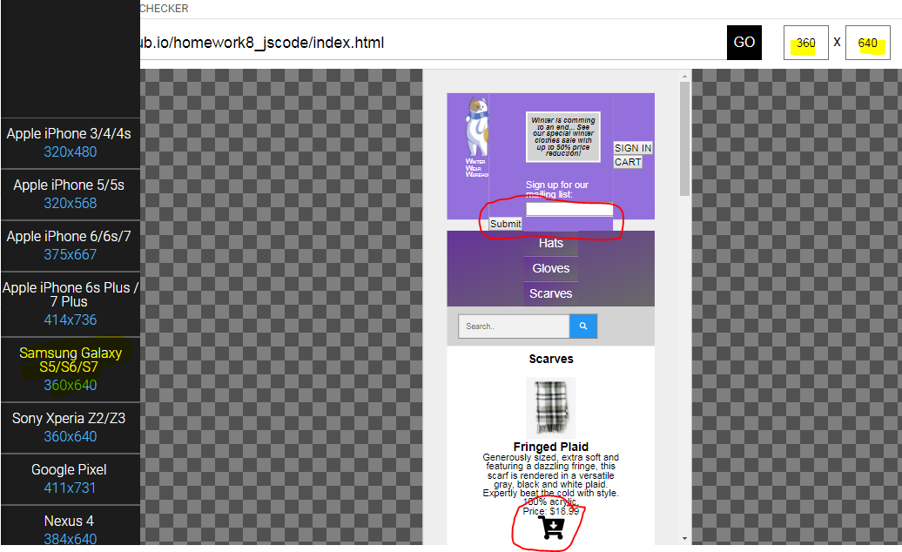**`**

**Issue #1 – Mailing list “Submit” button gets pushed down and over to the left (see the circled area in red). This only happens when the width is < 450 px. The format works great for wider screens.**

**The code was evaluated, and the problem was identified: the Submit button was NOT enclosed by the <label> </label> attribute. This was fixed, and now it works better as shown below.**

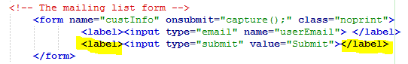

**Issue #2 – Left and Right header boxes have a gap**

**When the window is narrowed, and the “Submit” button moves down, this expands the center header (header.mailing) box – which then creates the white gaps on the left (header.logo) and right header (header.signin) boxes.**

**To solve this, the min-height was changed for all 3 header boxes, from:**

**min-height: 170px;**

**to:**

**min-height: 180px;**

**This removed the white gaps – as shown in the figure below.**

**Issue #3 – The cart icon appears to be too large when displayed on a smaller device – like a mobile phone. The cart icon is defined by a Font Awesome cart icon – and I originally defined the size with a “fa-2x” as shown below.**

**<i class="fas fa-cart-arrow-down fa-2x" onclick="updateCart('Fringed Plaid')"></i>**

**The “…fa-2x” was changed to “…fa-lg” - the “large” icon seems to size much better for all monitor widths. The fix is shown below.**

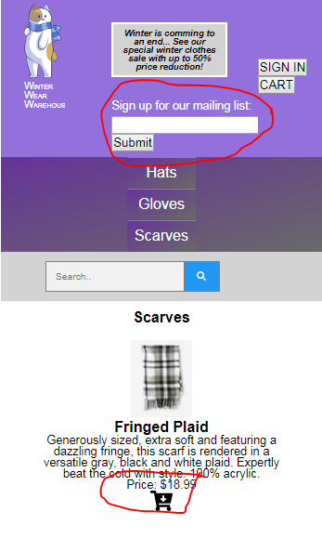

**TEST #2 – MEDIUM WIDTH MONITORS ~ TABLET DEVICES**

**The website was then test on Apple iPad Mini (768x1024). This size is a typical size for many tablet devices including Amazon Kinde., Samsung Galaxy, etc.**

**The website looks really good on tablets. No improvement were needed. An example of how it looks on a tablet is shown below.**

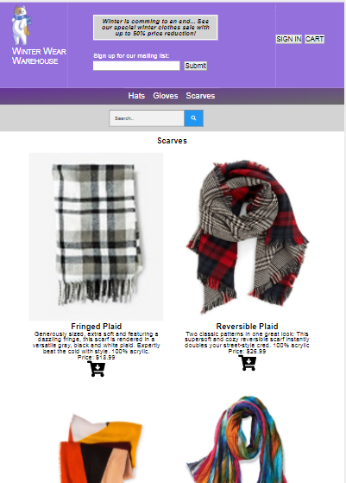

**TEST #3 – LARGE WIDTH MONITORS ~ TABLET DEVICES**

**The website was then test for a 19” monitor ~ 1440 X 900. This size is a typical size for many desktop computers used in businesses. The website looks really good on desktops – as shown below.**

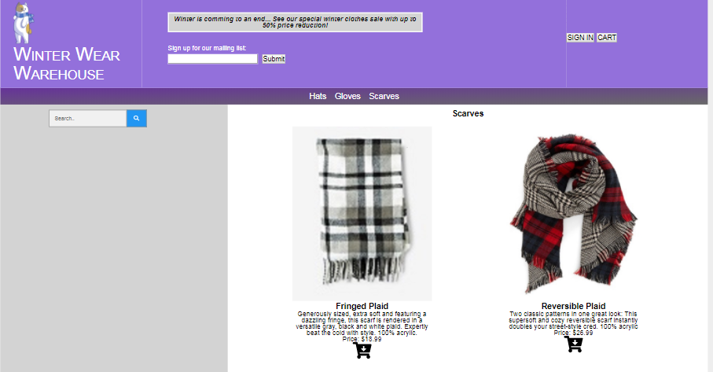

After fixing the website responsiveness issues for smartphone devices (narrow monitors), the final website can be opened from:

<https://jctoll.github.io/winter_wear_warehouse/index.html>

# References & Websites

1. Website criteria Guide: <http://www.websitecriteria.com/website_writing_guide_before_you_begin_to_write/identify_the_intended_audience.html>
2. Demographics of Device Ownership: <http://www.pewinternet.org/2015/10/29/the-demographics-of-device-ownership/>
3. How Responsive is your Website: <http://responsivedesignchecker.com/>
4. Virtualization and Emulation: <http://jpc.sourceforge.net/oldsite/Emulation.html>
5. Smartphone ownership: http://www.pewglobal.org/2016/02/22/smartphone-ownership-and-internet-usage-continues-to-climb-in-emerging-economies/