Project Events
Contents
1 Summary: 3
2 Workflow: Below is a high-level example workflow for project data tracking. 4
3 High level architecture 5
4 Project Sample tracking 6
5 Key features 6
5.1 Internal web site deployment 6
5.2 External web site deployment 6
5.3 Data migration from internal to external web site 6
6 Admin functions 7
6.1 Project, sample and event attributes 7
6.1.1 Predefined data type support 7
6.1.2 Predefined attributes 7
6.1.3 Predefined events 7
6.2 Project setup 7
6.2.1 Setup project: 7
6.2.2 Setup project attribute 8
6.3 Sample setup 8
6.4 Event setup and customization 9
7 User functions 10
7.1 Generating event template file 10
7.2 Sample Loading 10
7.3 Adding Event 10
7.4 Project, Sample and Events details 11
7.5 Reports 11
8 Schema 14
9 FAQ 15
10 Questions 16

Summary:
Project Sample tracking application allows Project managers, PIs and users to setup project and customize project based on project requirement Project web site design is data driven principals which will allow users to customize attributes and events without any code change.
Project sample tracking application has web site which allows users to upload, download, view and edit data. There are set of scripts that will allow users to bulk load data using scripts or integrate this application with other applications. We are planning to release web services in future.

Workflow: Below is a high-level example workflow for project data tracking.
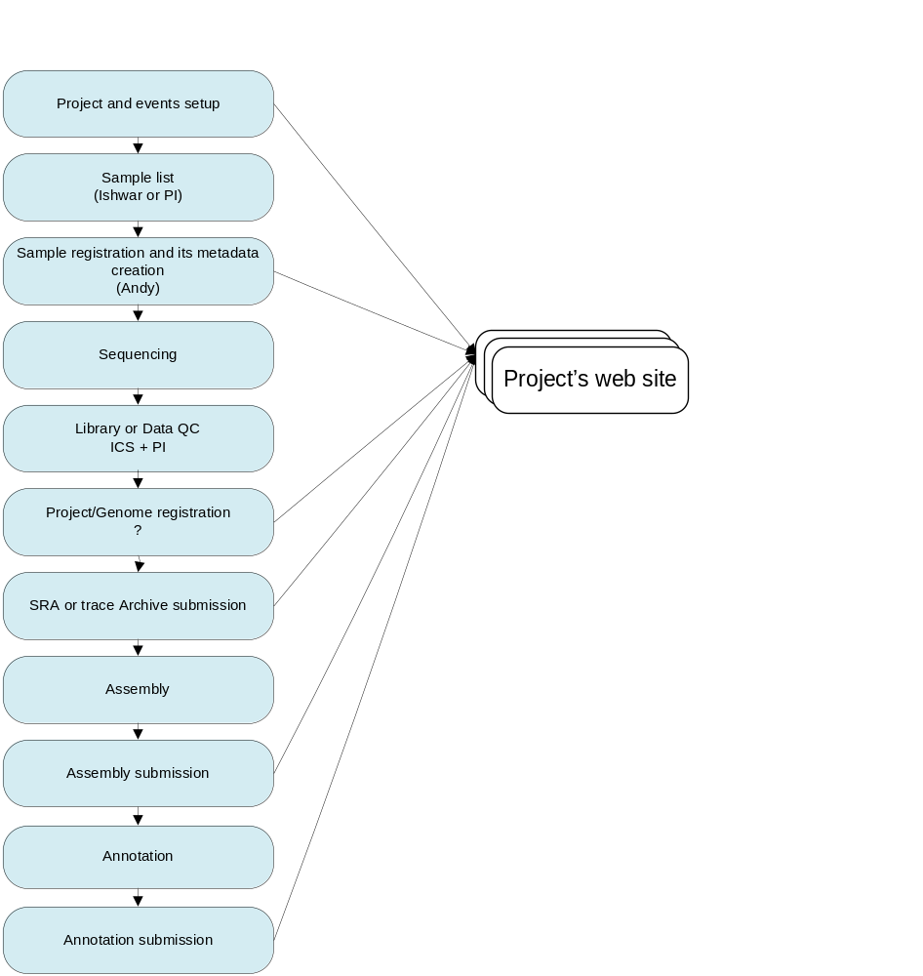

High level architecture
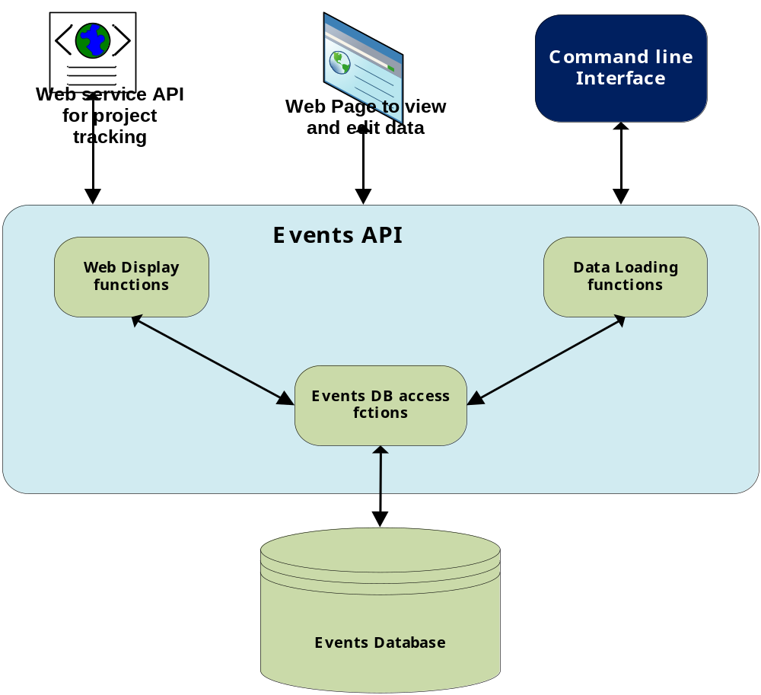

Project Sample tracking
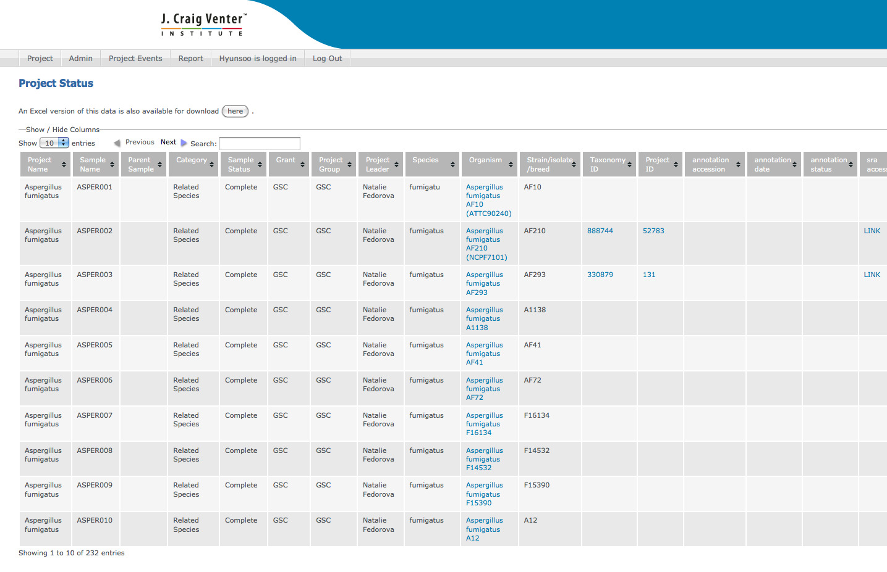

Key features
Command line utilities are located at /usr/local/devel/JTC/prod/ProjectWebSite/scripts/

Internal web site deployment
Database: mysql-lan-pro, schema: ifx_projects
External production web site home page:
http://projectsampletracking-int.jcvi.org/projectWebsites/

External web site deployment
Database: mysql-dmz-pro, schema: ifx_projects
External production web site home page: http://projectsampletracking.jcvi.org/projectWebsites

Data migration from internal to external web site
All data (project and samples) marked as public will be pushed to external web site (on DMZ) on daily basis. The ETL process will check create and modify dates to push only newly created or updated data on daily basis.
Command to export data: push_ext.sh

Security and data accessibility
Project can be configured as secured or non-secured project. Users have to login with pre-registered account before accessing any secured data. Any Unsecured project’s data will be publicly accessible.
By default project will be marked as non-secured and non-pubic. Non-public data will not be published at external web site, and can only be accessed internally at JCVI.

Admin functions

Project, sample and event attributes

Predefined data type support
  - string
  - date
  - int
  - float
  - url

Predefined attributes
There are number of predefined attributes which can be used to setup project, sample or event attributes. New attributes can be easily added to customize project setup.

Predefined events
There are some predefined events like sample update, project update that are used for some of administrative events.

Project setup
Project setup and project attributes will allow users to setup project and define project attributes that need to be tracked. For setting up project, user need project name, parent project if there is, if the project is secure or not, and if the project is public or not
    - Web Interface
Using web interface, users can dynamically add new attributes or select an attribute from list of predefined attributes.
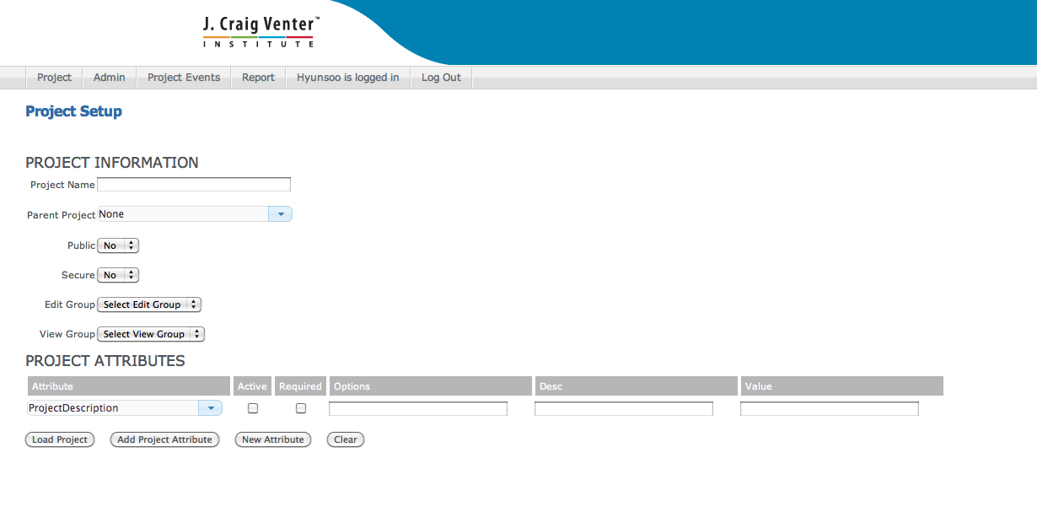
For setting up a new attribute, use “Add Attribute” pop-up by clicking “New attribute” button in project setup page. The dropdown list in “Attribute” column in “Project Attributes” section will include newly added attribute dynamically as user adds new one. All attributes in “Project Setup” process belong to “Project Registration” event. User should add attributes through “Event Meta Setup” page using appropriate event type, if new attribute should not belong to “Project Registration” event type.
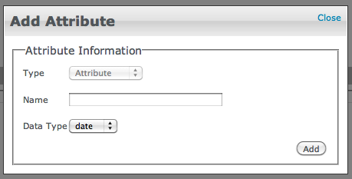

Command Line Tool

Setup project:
For setting up project create a file with "_Project.tsv" and load the data using load_single command.
Example file:
ProjectName | ParentProjectName | ProjectLevel | Public | Secure
TEST100 |  | 1 | 0 | 1
Command to load file: load_single.sh TEST100_Project.tsv

Setup project attribute
Project attributes allow users to define all project attributes that users would like to track at project level.
File should be suffixed with " _ProjectMetaAttributes.tsv" and below is an example of file format.
Example file:
ProjectName | DataType | Required | AttributeName | AttributeDescription | PossibleValues
TEST100 | string | T | ProjectDescription
TEST100 | string | T | GrantName
TEST100 | int | T | GrantAccountingCode
TEST100 | string | F | ProjectGroup
TEST100 | string | F | Collaborator
TEST100 | string | T | ProjectStatus
TEST100 | string | T | ProjectURL
TEST100 | string | F | ProjectReferences
TEST100 | date | F | ProjectEndDate
Command to load file: load_single.sh TEST100_ProjectMetaAttributes.tsv

Sample setup
Sample setup will allow users to configure and customize sample level attribute. All the attributes that users would like to track at sample level should be defined as sample attribute.
    - Web Interface
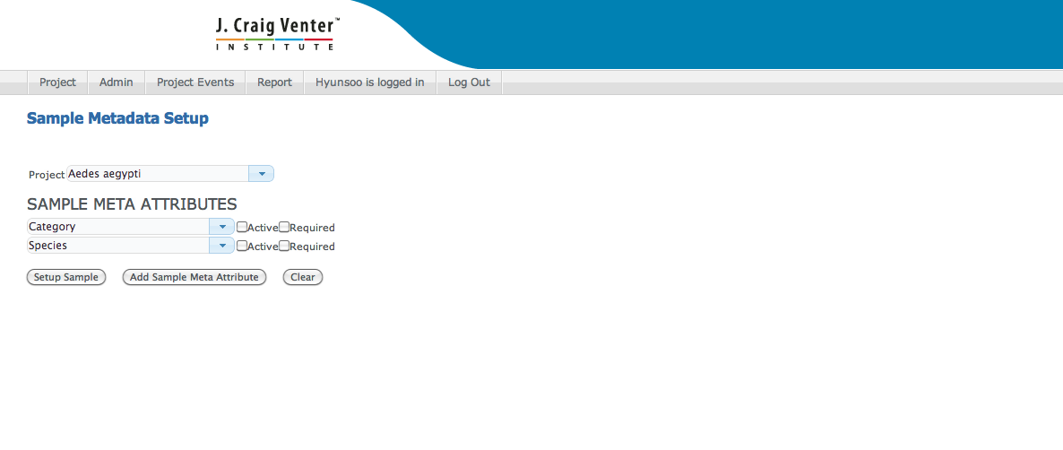
    - Command Line Tool
File should be suffixed with " _SampleMetaAttributes.tsv" and below is an example of file format.

ProjectName | DataType | Required | AttributeName | PossibleValues
TEST100 | string | T | SampleDescription
TEST100 | string | F | NCBITaxonID
TEST100 | string | F | DataURL
TEST100 | string | T | ContactFirstName
TEST100 | string | T | ContactLastName
TEST100 | string | T | Public | T;F
TEST100 | int | F | EstimatedGenomeSize
TEST100 | string | T | Genus
TEST100 | string | T | Species
TEST100 | string | F | Strain
TEST100 | string | T | OrganismName
TEST100 | string | F | Taxonomy
TEST100 | string | F | References
TEST100 | string | F | SequencingCenter
TEST100 | string | F | SequencingCenterURL
TEST100 | string | F | SequencingMethod
TEST100 | int | F | SequencingDepth
TEST100 | string | F | SequencingTechnology | Titanium 454;GSFLX;ABI SOLID;Illumina;Sanger
TEST100 | string | F | SubmittingOrganization
TEST100 | string | F | SubmittingCenterURL
TEST100 | string | F | ConsortiumName
TEST100 | string | F | ConsortiumURL
TEST100 | string | F | SourceOfDNA
TEST100 | string | F | LocusTagPrefix
TEST100 | string | F | Replicon
TEST100 | string | F | NCBIProjectID
Command to load file: load_single.sh TEST100_SampleMetaAttributes.tsv

Event setup and customization
Event setup will allow project administrator to setup event and its attributes that will be for adding events or modifying project or sample data. A event file can be used to load all events or events can be loaded one at a time.
In following examples four different events (ProjectRegistration, SampleRegistration, ShortReadArchive, WGS) have been loaded using one file. File should be suffixed with " _EventMetaAttributes.tsv" and below is an example of file format.
Data driven data model and design have been used so that projects web site can be customized based on different project requirement.
ProjectName | EventName | AttributeName | DataType | Required | AttributeDescription | PossibleValues | SampleRequired
TEST100 | ProjectRegistration | GrantMilestone | string | T |  |  | F
TEST100 | ProjectRegistration | ProjectDescription | string | T |  |  | F
TEST100 | ProjectRegistration | GrantName | string | T |  |  | F
TEST100 | ProjectRegistration | GrantAccountingStart | date | T |  |  | F
TEST100 | ProjectRegistration | GrantAccountingCode | int | T |  |  | F
TEST100 | ProjectRegistration | ProjectGroup | string | F |  |  | F
TEST100 | ProjectRegistration | ProjectStatus | string | T |  |  | F
TEST100 | ProjectRegistration | ProjectURL | string | T |  |  | F
TEST100 | ProjectRegistration | ProjectReferences | string | T |  |  | F
TEST100 | ProjectRegistration | Collaborator | string | F |  |  | F
TEST100 | SampleRegistration | SampleMW | float | F |  |  | T
TEST100 | SampleRegistration | SampleDescription | string | T |  |  | T
TEST100 | SampleRegistration | StrainName | string | T |  |  | T
TEST100 | SampleRegistration | ContactFirstName | string | T |  |  | T
TEST100 | SampleRegistration | ContactLastName | string | T |  |  | T
TEST100 | SampleRegistration | Public | string | T |  | T;F | T
TEST100 | SampleRegistration | EstimatedGenomeSize | int | F |  |  | T
TEST100 | SampleRegistration | Genus | string | T |  |  | T
TEST100 | SampleRegistration | Species | string | T |  |  | T
TEST100 | SampleRegistration | Strain | string | F |  |  | T
TEST100 | SampleRegistration | OrganismName | string | T |  |  | T
TEST100 | SampleRegistration | Taxonomy | string | F |  |  | T
TEST100 | ShortReadArchive | sra accession | string | T |  |  | T
TEST100 | WGS | reference | string | T |  |  | T
Command to load file: load_single.sh TEST100_EventMetaAttributes.tsv

User functions
Most of event can be loaded through web or through command line interface. For bulk load and integration we recommend users to load data through command line interface.

Generating event template file
Based on project and events, template might be different. Users can download template file using web or using command line interface.
User can build template file using web page “Template Download” (should be renamed as template builder).
User can build template file using command line utility make_template.sh

Sample Loading
Sample loading allows user to load sample names in system. Samples names might be a prerequisite for some of the event if “SampleRequired” field is configure as “T” (true) for event.
Samples can be loaded through command line interface using load_single.sh script.
Sample data file should be suffixed with “_Sample.tsv” and below is an example data file.
SampleName | ProjectName | Public
Sample_1_FOR_TEST100 | TEST100 | 0

Adding Event
All project events can be loaded or entered using web or using command line. Users can load data files using “Event Upload” page (In menu). Users can add event using web page “Event Loader”.
Also users can add new events using command line interface load_single.sh. Again users’ can download event template file using “make_template.sh” or “Template Download” page.
For loading data using command line file should be suffixed using “_<EventName>_EventAttributes.tsv”, where EventName should be actual event name that you are loading.
Example and sample data file below for loading WGS event.
Command: load_single.sh TEST100_WGS_EventAttributes.tsv
ProjectName | SampleName | AttributeName | AttributeValue
TEST100 | Sample_1_FOR_TEST100 | reference | Joe, Chris

Project, Sample and Events details
Users can view latest Project, Sample and Events’ detail using web page “Event detail”. Below is screenshot of event detail page.
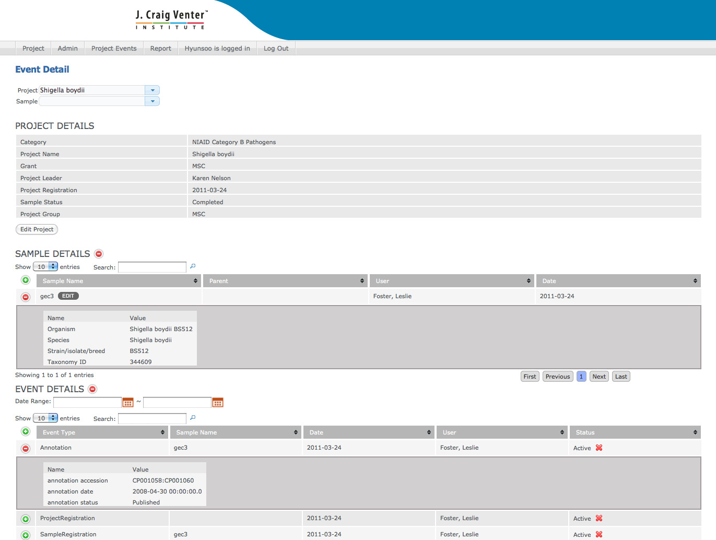

Reports
Users can build custom report or tabular output using “Event Report” page. Event Report page allow users to select attributes at project, sample and event level to build custom report.
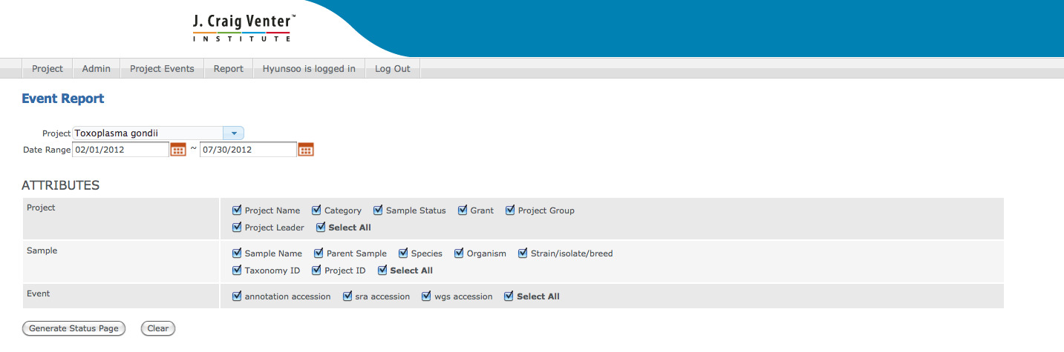

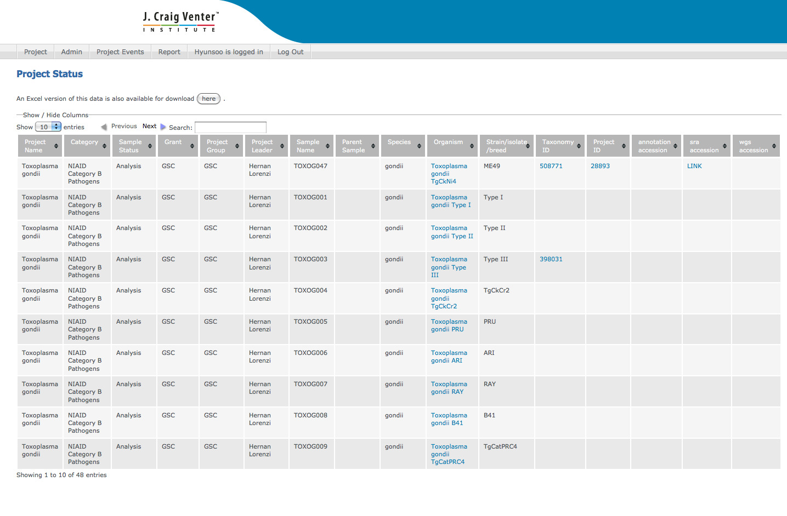

Schema
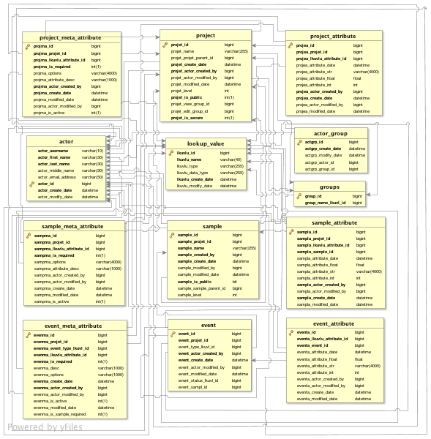

FAQ
  - Q: How can I customize it for my application?
A:

Questions
- How Sample update and project update events are handled? Because these events are not defined in event_meta_attribute.
- Change “Event Loader” to “Add new Event”
- Load_single should be changed to take event type on command line so that we can remove file naming constraints. ProjectSetup, ProjectAttributeSetup, SampleSetup and SampleAttributeSetup should be documented as predefined events that can be used for project and sample setup.
- Admin functions (Project setup, project attribute setup and event setup) and should be only allowed to admin role so that we certain users can setup new projects.

