Project Events
Contents
1 Background: 2
2 Summary: 2
3 Workflow: High-level workflow project data tracking. 3
4 High level architecture 4
5 Use cases 4
6 Managing publications 8
7 Development plan 8
8 Appendix A 8

Background:
Projects and grants require sequencing centers to provide sample information, its progress and updates on web site. Right now data is tracked in Events System (ES); ES is a database and series of web pages used to track events that occur during the course of a genomic sequencing project. Events system is very flexible but its loose design makes it very hard to support and maintain. Projects’ tracking is also lacking metadata which can describe attributes so that application can validate these attributes based on different event type. Projects metadata is critical since each project in unique and has different tracking requirements.

Summary:
The goal of this project is to enhance existing application and provide user interfaces and APIs to minimize manual tasks and operations. Following are some of high level tasks.
- ES should allow Project based attributes configuration and validation.
- All the major events (project tracking, project registration, Trace/SFF data submission, WGS submission, Assembly submission and annotation submission) and its data attributes should be tracked in database.
- Provide well defined APIs so that other groups can integrate with ES system as required.
- Provide web interface where users can view and edit data as required. Existing web interface just allow users to view data.
- Redesign web site to produce dynamic pages using JCVI’s template page.

Workflow: High-level workflow project data tracking.
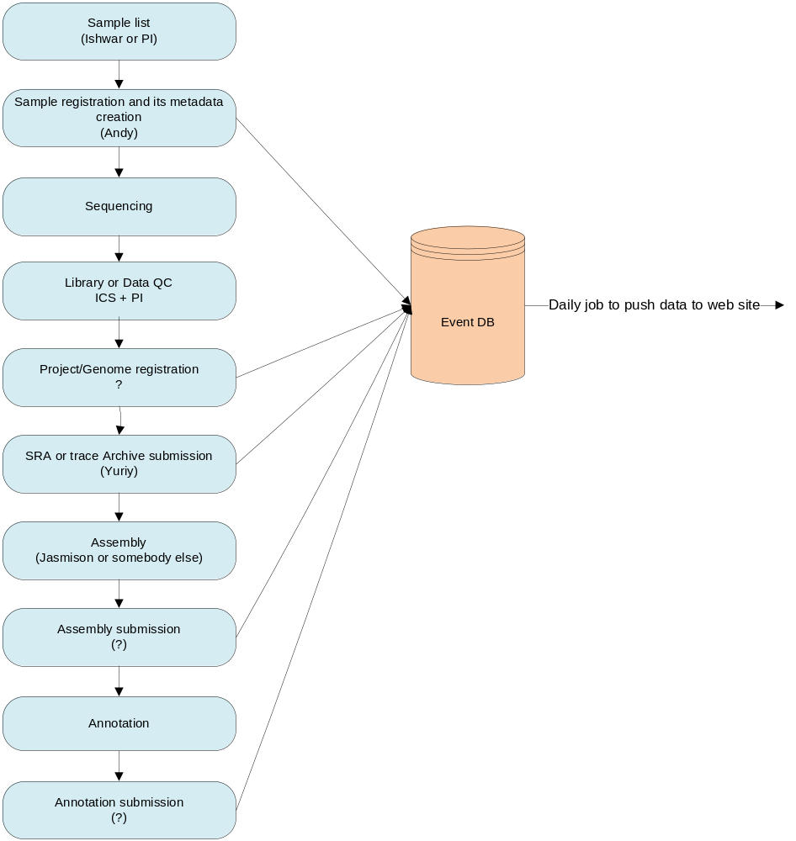

High level architecture
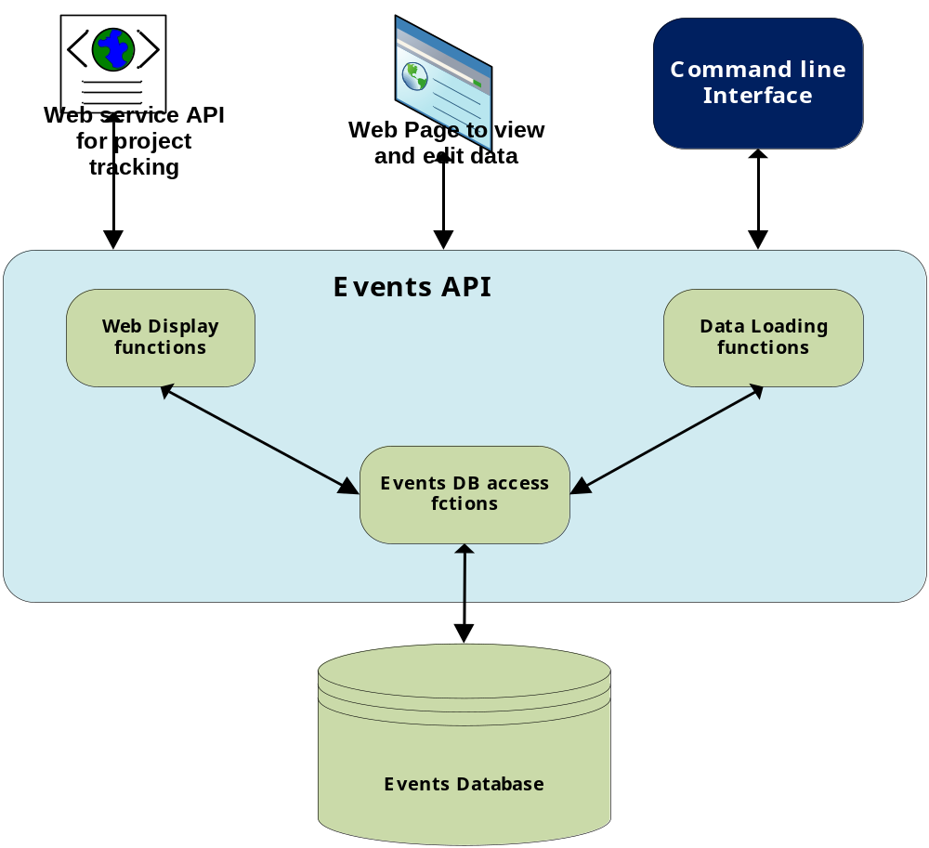

Use cases
  - Generic events: For all use cases following data will be captured and tracked for event history. Following attributes will not be repeated in other use cases.
    - Event User: person who added or modified the data
    - Event Date:
    - Event History: history will track any data changes

  - Project setup: Use case will allow project administrator (PI or project manager) to identify and customize events attributes and its metadata required for a project. All the other API and use cases will use this attribute metadata to validate and populate data. See example in Appendix A.
    - Event types: Following events types will be supported but system will allow users to add new event type as required for projects. See the individual use cases for list of attributes supported. Again user can add or remove these attributes as required.
      - Generic Project tracking
      - Genbank Registration
      - Trace ( including SRA) Archive
      - Sequence Submission
      - Assembly Archive
      - Annotation

  - Generic Project Tracking: Goal of this use case is to capture and track all the critical data related to genome/project/sample. Following attributes will be tracked and interface will allow users to update data as required. All events' type will be tracked based on unique sample identifier. Right now events are tracked base on combination of project db and Event type. Project name and Sample identifier are key attributes to track other information and most of the API and interface will required these two attributes to query, insert or update data.
    - Project Name (Required): E.g., Influenza, Toxoplasma gondii.
    - Sample Identifier (Required): Human readable identifier which will not change once the identifier is assigned. All the data will be tracked based on this identifier.
    - Genome project id: NCBI’s genome project ID. ID will be assigned after project registration.
    - Grant Name (Required): Grant name like GSC, MSC or HMP.

    - Project Group (Required): System will assign a unique project ID based on project name. Right now we are using project DB name for grouping. Is that right strategy? E.g., gyp14. Right strategy should be to use grant name for grouping. Eg. GSC, MSC, HMPU54, HMP16s
    - Project Status: Initially “selected” and then it will change based on project status like “Sequencing”, “Data submitted”, “Completed”
    - Project URL: External project URL if any. Like GSC, HMP etc.
    - Category (Required): Pathogen category. Default as “Other”.
    - Collaborator: Could be an individual or an institute.
    - Collaborator URL:
    - Contact's First Name
    - Contact's Last Name
    - Contact’s email
    - Comment
    - Estimated Genome Size(Mb)
    - Genus
    - Species
    - Strain/isolate/breed
    - Organism (Required): This will be displayed at external web site.
    - Taxonomy
      - Taxonomy source: NCBI, UniProt, HOMD (Human Oral Microbiome Database)
      - Taxonomy ID (NCBI Taxonomy ID)
    - Data URL: If other then project URL.
    - References
    - Sequencing Center
    - Sequencing Center URL
    - Sequencing Method:
    - Sequencing Depth
    - Sequencing Technology
    - Submitting Organization
    - Submitting Center URL
    - Consortium Name
    - Consortium URL
    - Source of DNA
    - Locus Tag Prefix
    - Replicons: There can be many replicons for a sample. User can just add the columns and suffix the header with N = n, where is the nth replicon.
      - Replicon Name N (=1..n)
      - Replicon type N (=1..n)
      - Replicon Size (Mb) N (=1..n)
    - Sample Description (Required): Brief description of the importance of this organism to the scientific world. Sample description will be used for sample’s web page.
    - Is public: Data will be loaded on external web site only if is_public is set to “public”.

  - Taxonomy: Taxonomy registration and update sample data
    - Sample Identifier (Required):
    - Genus:
    - Species:
    - Strain/isolate/breed:
    - Organism Name:

  - Genbank Registration (Genome Project Registration): Use case captures all the data required for registration and the data that will be updates after successful registration.
    - Project Name (Required):
    - Sample Identifier(Required):
    - Contact's First Name :
    - Contact's Last Name :
    - Data URL :
    - Sample Description :
    - Estimated Genome Size Sample:
    - Locus Tag Prefix:
    - Organism Name :
    - Project ID:
    - Project Status:
    - Project URL:
    - References
    - Sequencing Center:
    - Sequencing Depth:
    - Sequencing Method:
    - Sequencing Technology:
    - Source of DNA:
    - Strain/isolate/breed:
    - Submitting Organization:
    - Submitting Organization URL:

  - Trace Archive: Use case captures Trace archive data submission status and its accession numbers.
    - Project Name (Required)
    - Sample Identifier(Required):
    - Data Bank URL: like for SRA http://www.ncbi.nlm.nih.gov/sra http://eutils.ncbi.nih.gov/Traces/trace.cgi
    - File name
    - References
    - Submission count
    - Submission name
    - Submission prefix
    - Status: submitted
    - Submission date:
    - Read Count
    - Accession numbers

  - Sequence Submission (WGS): (What about other kinds?) Use case captures Assembly archive data submission status and its accession numbers.
    - Project Name (Required)
    - Sample Identifier (Required):
    - Data Bank URL:
    - File name
    - Reference
    - Accession numbers

  - Assembly Archive: Use case captures Assembly archive data submission status and its accession numbers.
    - Project Name (Required)
    - Sample Identifier(Required):
    - Data Bank URL:
    - File name
    - References
    - Status:
    - Submission date:
    - Accession numbers
    - Assembly stats:
      - Coverage
      - N50Scaffolds
      - Contigs gr 500bp
      - Avg Read Length
      - Num Bases
      - Genome Size
      - N50Contig
      - Scaffolds
      - Totals of Reads
      - Assembler

  - Annotation submission: Use case captures Annotation archive data submission status and its accession numbers.
    - Project Name (Required)
    - Sample Identifier (Required):
    - Data Bank URL:
    - Accession start
    - Accession end:
    - Object Type
    - Reference

Managing publications
  - All the publication will be managed centrally at http://www.jcvi.org/cms/publications/listing/. Publications will be tagged based on project Name so that we can group and display project specific publications of projects’ specific web site. Users can tag publication for multiple projects.

Development plan
  - Release 0: Base release - 2 Week
    - Complete knowledge transfer from Seth.
    - Understand all existing APIs and scripts.
    - Load all sample data in events database and populate production web site pages based on Events database (not static files).
    - Change static sample page to dynamic page. Sample page should be populated based on sample information in Events database.
  - Release 0.1 - 4 Week
    - Customize existing sample status page based on individual project requirements.
    - Provide new API which allows users to customize project’s attributes metadata, and change existing Project Events API to validate data based on project attributes metadata.
    - Provide command line APIs for six events described in use case section (5.2.1).
    - Manage publication through publication management system. Project’s web site will be populated based on project tagging in publication system.
  - Release 0.2 - 5 Week
    - Provides web site which will allow users to view and edit the data.
    - Provide XML web service for integration with other services.

Appendix A
A sample tracking attributes required for GSC grant.
