[SLIDER] file: A- Slider
- PureLight.png
  - Header: BMAI Pure Light

- COROS.png
  - Header: COROS PACE 3

- PG01.png
  - Header: Sport Bone Conduction Headphone

- River 2 pro.png
  - Header: EcoFlow River 2 Pro

[FEATURED PRODUCT CATEGORIES] file: B- Featured Product Categories
Size: 600*1000
- Footwear.jpg > Sport Watch.jpg > Apparel.jpg > Accessories.jpg > Outdoor.jpg

[UNIQUE SELLING POINTS] file: C- Unique Selling Point

- Free Shipping.png
  - Header: FREE SHIPPING
  - Sub-Header: Fast and reliable delivery

- Customer Support.png
  - Header: CUSTOMER SUPPORT
  - Sub-Header: If you have any questions.

- Best Quality.png
  - Header: BEST QUALITY
  - Sub-Header: Best Quality Guaranteed

[PRODUCT HIGHLIGHT] file: D- Product Highlight
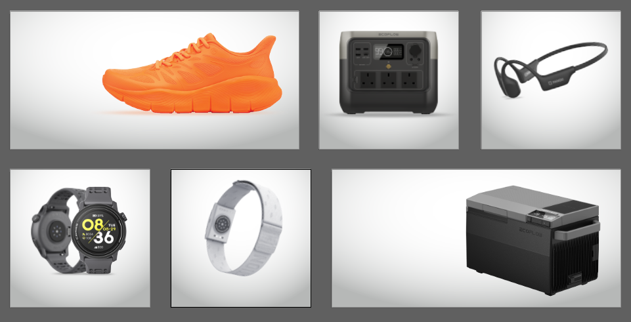
- Bmai.jpg
  - Header: Every step is beyond.
  - Sub-Header: BMAI Pure Light

- Power Station.jpg
  - Header: Power a new world.
  - Sub-Header: EcoFlow River 2 Pro

- Sport Bone Conduction Headphone.jpg
  - Header: Value and safety in mind
  - Sub-Header: Sport Bone Conduction Headphone

- Smart Watch.jpg
  - Header: For multi-sport athletes who train hard and move fast.
  - Sub-Header: COROS Pace 3

- Heart Rate Monitor.jpg
  - Header: Precise data from the comfort of your arm.
  - Sub-Header: COROS Heart Rate Monitor

- Smart Devices.jpg
  - Header: Get Chillin. Get Movin.
  - Sub-Header: EcoFlow Glacier

[SPECIAL HIGHLIGHT SECTION] file: E- Special Highlight
- Image1.jpg > image2.jpg > image3.jpg

- Image4.png

- Content:

- SUPER LITE RB.png
  - super lightweight thick outsole

- FLOWSOLE SYSTEM.png
  - simulate the force line direction of correct gait cycle motion.

- BREATHABLE WRAPPED UPPER.png
  - 2mm Three Layers Breathable Meshmm Seamless Fuse Toe Box

- 35% HEMP TECHNOLOGY INSOLES.png
  - inhibit bacteria and prevent odor, absorb moisture and perspire, and improve cushioning comfort.

- FOAM4+.png
  - EVA material physical foaming technology, the ultra-light foam midsole adopts the third generation of mixed EVA physical foaming technology.

- WIDE SHOE LAST.png
  - Wide shoe last suitable for most people

