Real-Time FM Summarizer

Sponsored by: Trideum
dminton@trideum.com

Team
Cole Pethel
Daniel Huynh
JC Williams
William Zou

February 2, 2026



Executive Summary

Project Purpose

This project proposes the development of a real-time Digital Signal Processing (DSP) and Natural Language Processing (NLP) pipeline. By integrating Software Defined Radio (SDR) hardware with automated transcription and summarization models, the software will demodulate FM broadcast signals to generate concise, low-latency textual summaries that will be available on a website. This serves as a critical proof of concept for wide-band spectrum monitoring and automated intelligence gathering in complex signal environments.

Technical Challenges and Mitigation

The primary technical hurdle is minimizing latency to achieve near-real-time data processing. Given the existing hardware constraints, we cannot guarantee true real-time execution. To mitigate this, our strategy focuses on optimizing the signal processing pipeline. By implementing highly efficient demodulation algorithms we aim to significantly reduce computational overhead and improve data throughput speeds.

Methodologies

The proposed pipeline utilizes polyphase filtering and VAD to achieve computationally efficient FM demodulation. A lock-free asynchronous architecture mediates the flow between real-time signal acquisition and high-latency NLP summarization, ensuring zero-drop data transmission. The backend is built on SQLite3 and C++ Crow, providing a space-efficient and high-performance framework for real-time intelligence delivery via a web interface.

Real-World Utility

Beyond a proof of concept, this system provides a scalable framework for automated Spectrum Intelligence (SPECINT). In emergency response scenarios, it serves as an autonomous monitoring node that converts disparate FM broadcasts into a centralized, searchable intelligence database. For tactical environments, the integration of VAD and NLP summarization acts as a cognitive filter, reducing 'listener fatigue' by providing high-confidence alerts based on mission-critical keywords. Furthermore, the efficiency of the polyphase-driven DSP pipeline enables deployment on low-power, edge-computing hardware, making it suitable for field operations where power and bandwidth are constrained

Statement of the Problem

We are solving this problem to create a fast resource efficient solution to the otherwise time and labor-intensive task of manually scanning radio frequencies for valuable information.

Objectives

Our objective is to create a pipeline from the SDR through SST and LLM and the display it on a website.

Technical Approach
I don’t expect this to be “ironed out” right now, but please provide as much thought and detail here as you can.

Project Schedule
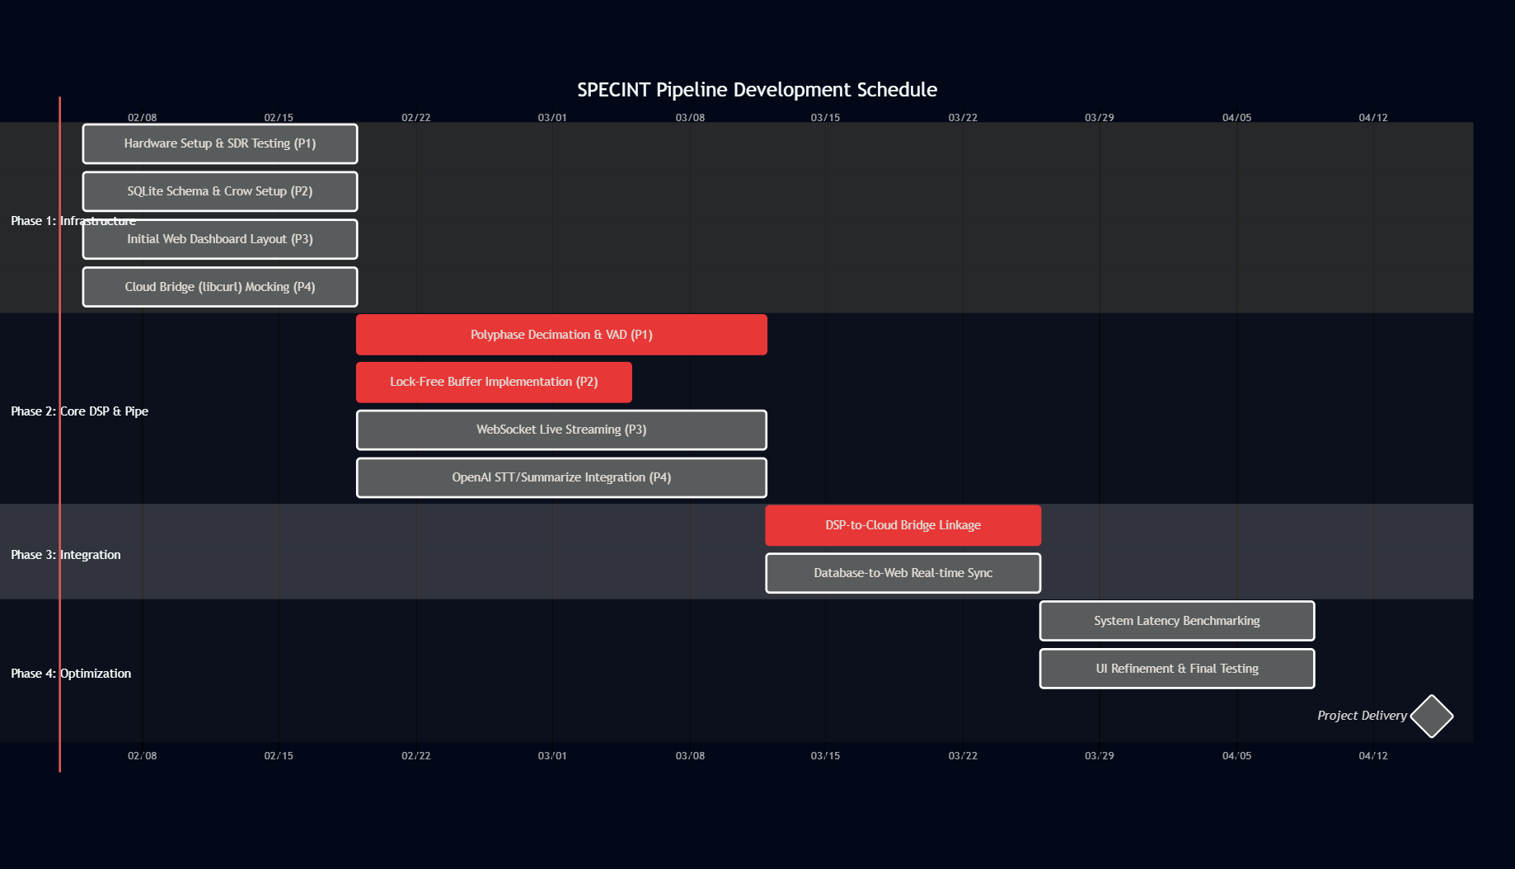
I had AI make a rough estimate of the schedule, this might be off in a couple areas.

Deliverables

system will automate speech-to-text (STT) transcription and NLP-driven content summarization, with a maximum end-to-end latency of 300 seconds (5 minutes) from signal ingress to web dashboard visualization.

Budget

Component | Model Selection | Justification | Cost (Est.)
SDR Receiver | SDRplay RSPdx-r2 | Features 14-bit ADC @ 6MHz and integrated preselection filters to prevent front-end overload/intermodulation in dense signal environments. | $240
Antenna | Comet DS-150S Discone | Provides high-gain, omnidirectional coverage across the target FM spectrum. | $162
Transmission Line | DXE-400MAX (Low-Loss Coax) | Replaces standard RG-58 to minimize signal attenuation and maintain 50-ohm impedance matching. | $45
Interconnects | Superbat UHF to SMA Adapters | Facilitates low-loss connection between the PL-259 coax termination and the SDR’s SMA input port. | $11
Total Capital Expenditure (CapEx) |  |  | $458

Communication and Coordination with Sponsor
We will meet with our sponsor bi-weekly.

Special Topics
None.

Team Qualifications
Mostly going to be collaborative.

Table of Contents
Executive Summary 2
Objectives 3
Technical Approach 3
Project Schedule 3
Deliverables 3
Budget 3
Communication and Coordination with Sponsor 3
Special Topics 3
Team Qualifications 3

