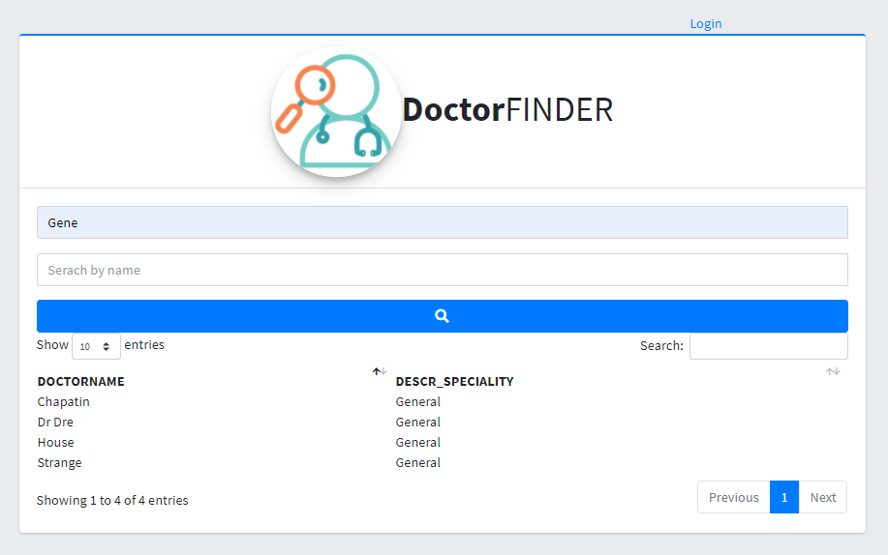

# **Introduction**

Doctor finder, is a project which aims to reflect the knowledge acquired in the Full Stack developer course.

This Project allows the search of doctors registered in the database.

# **Product details**

This Project is developed under the MVC work scheme, connecting to a SQL Server database, as well as managing frameworks such as Bootstrap, as well as Microsoft's Entity Framework. It has to be installed on top of IIS services.

## Index page

On this page you could find any register doctor on the database.



## Login page

On this page you could access if you are and admin user, to add new Doctors or specialties.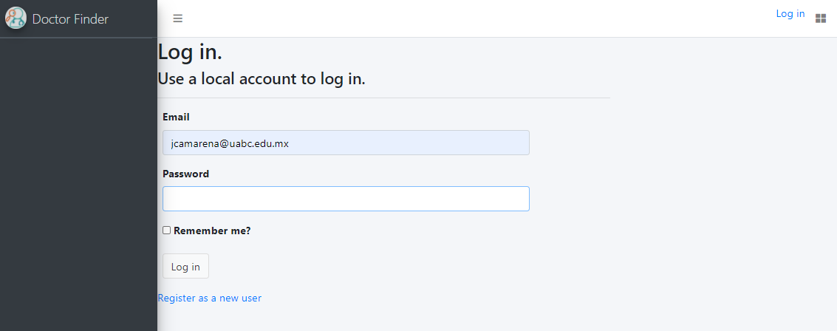

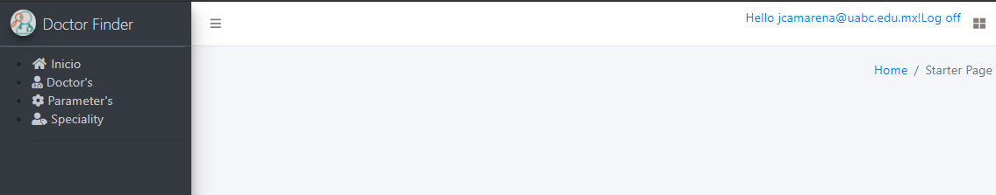

## Doctor catalog

On this catalog the user can create, edit or delete doctors to the list.

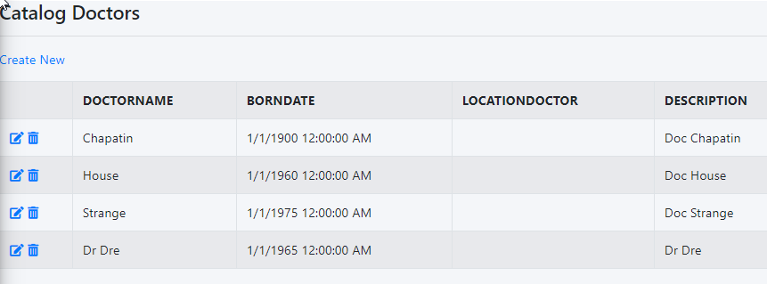

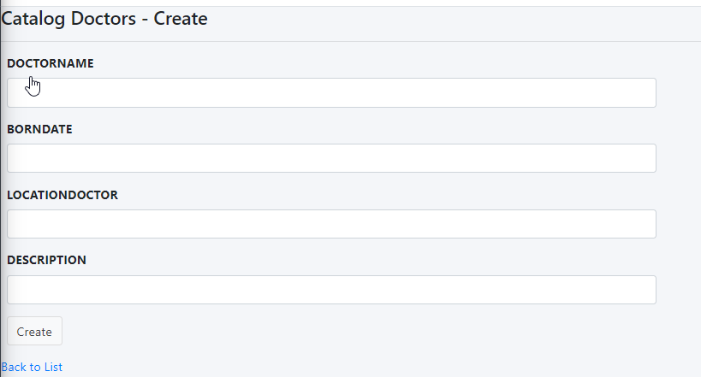

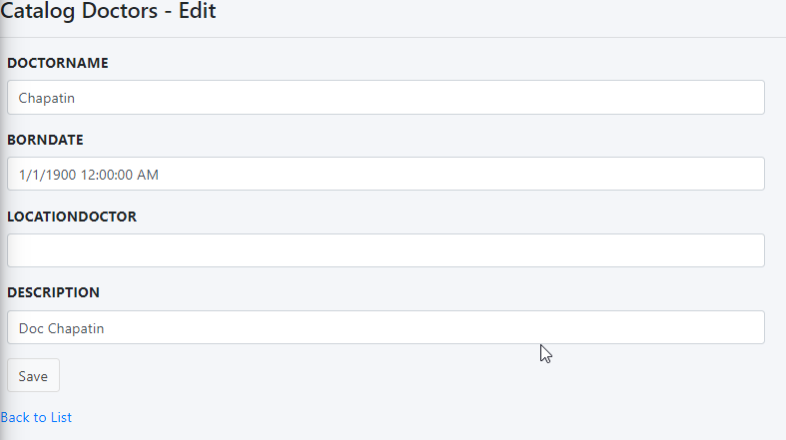

## Parameter catalog

On this catalog the user can create, edit or delete parameters to the list.

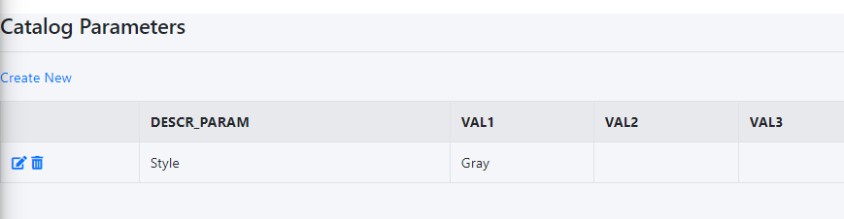

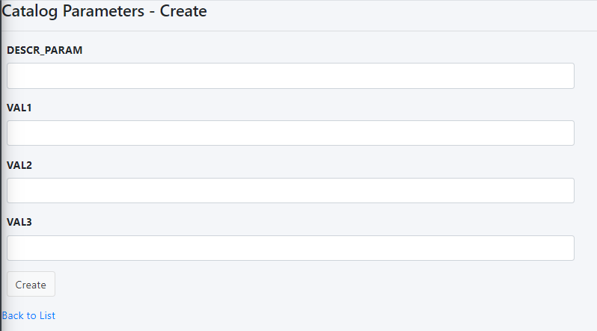

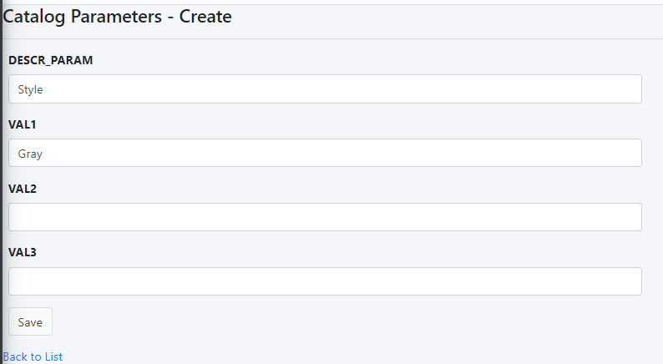

## Speciality catalog

On this catalog the user can create, edit or delete speciality to the list.

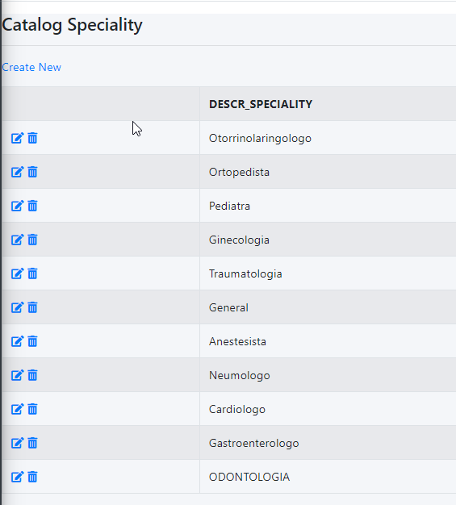

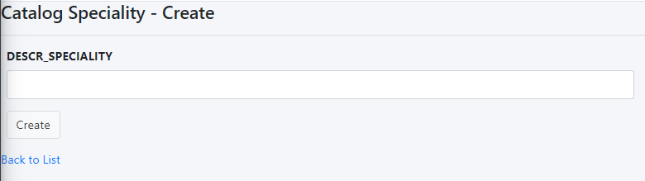



# End Users

Users can be found doctors on this window; this search is via string and



# Requirement’s

## Technical

-IIS Windows server

-SQL Server Databases