**Pokémon Trading Card Game Manual**

**Jackson Campbell**

**Table of Contents:**

Pokémon Included

Trainer Cards Included

Game Setup

Turn Order

Win Condition

# Pokémon Included

* Audino
  + Has 80 Base HP
  + Colorless
  + Retreat Cost: 2 Energy
  + Attack: Doubleslap
    - Doubleslap flips two coins. For each time the coins land on heads, deal 30 damage.
  + 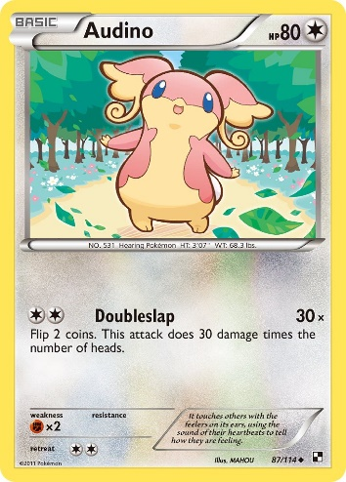
* Bidoof
  + Has 60 Base HP
  + Colorless
  + Retreat Cost: 3 Energy
  + Attack: Hyper Fang
    - Hyper Fang flips a coin. If tails, the attack does nothing. Otherwise, deal 40 damage.
  + 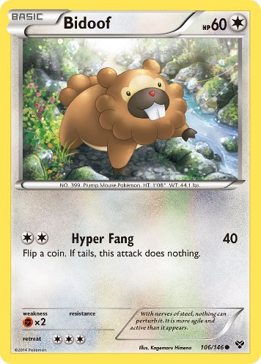
* Drampa
  + Has 130 Base HP
  + Colorless
  + Retreat Cost: 2 Energy
  + Attack: Dragon Pulse
    - Deal 80 Damage, then discard the top two cards in your deck.
  + 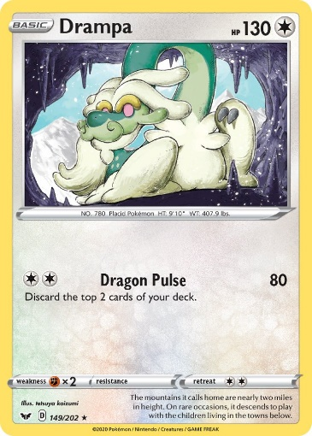
* Lugia
  + Has 120 Base HP
  + Colorless
  + Retreat Cost: 2 Energy
  + Attacks: Gust & Aeroblast
    - Gust: Deal 30 Damage
    - Aeroblast: Flip 2 coins. Initially deal 80 damage, but for each heads, deal an additional 20 damage.
  + 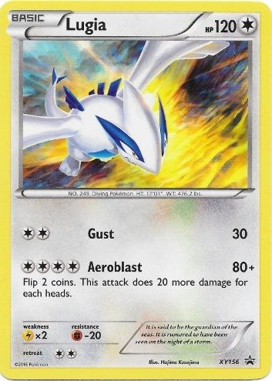

# Trainer Cards Included

* Poke Ball
  + Item Card
  + Flips a coin, if heads, searches through the deck for the first Pokémon and adds it to your hand. Then, shuffle the deck.
  + 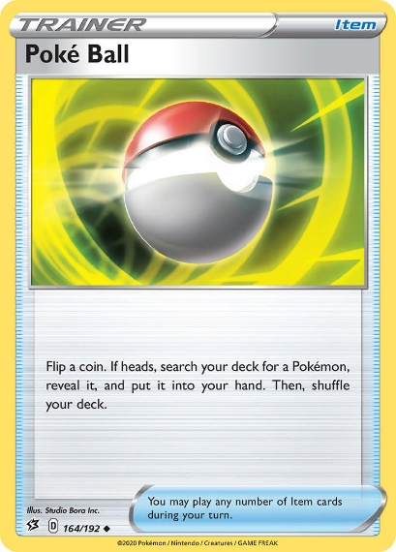
* Potion
  + Item Card
  + Heal 30 damage to 1 one of your Pokémon
  + 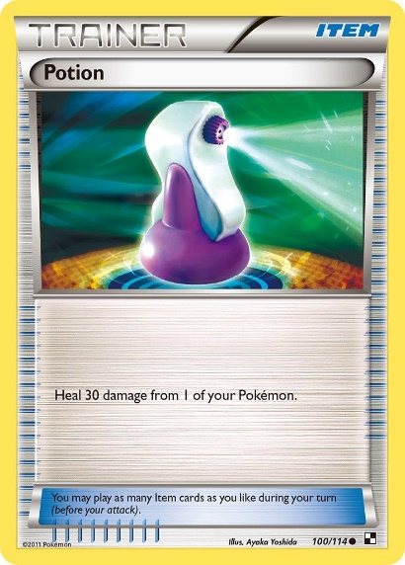
* Switch
  + Item Card
  + Switches the Active Card for one of your Benched Pokémon
  + 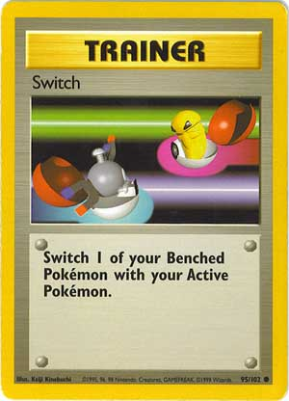
* Professor Oak
  + Supporter Card
  + Discard your current hand and draw 7 cards.
  + 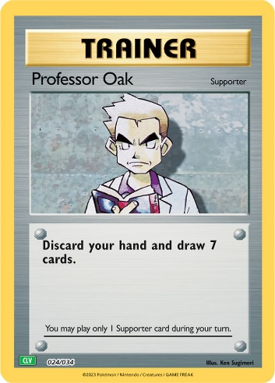

# Game Setup

To set the game up, do the following for each player:

* Create your deck of 60 Cards
  + Presumably around 3-4 Pokémon, 4-5 Trainer Cards, and the rest of the deck with energy.
  + After creating, shuffle your deck.
* Draw your starting hand of 7 cards
  + If you do not have a Pokémon within your hand, you must return your cards back to your deck, shuffle, and draw 7 cards again. Do this until you have a Pokémon to start with!
* Draw your prize pool by taking the top six cards of your deck.
* Set your active Pokémon and afterwards set any Pokémon you would like to your bench.
* You can now begin playing!

# Turn Order

During each turn, the player can do the following after drawing a card:

1. Set Pokémon to their bench.
   1. If a player has Pokémon in their hand, they can set them to their bench if they do not currently have 5 benched Pokémon.
2. Attach Energy to a Pokémon
   1. You are allowed to attach one Energy per turn, and if you have already attached one, you cannot do so again unless attached through other means.
3. Play Trainer Cards
   1. If the card played is a Supporter, they can no longer play another Supporter card during their turn.
   2. The player can play as many Item cards as they choose.
4. Retreat their Active Pokémon
   1. A player can retreat their Active Pokémon given they have enough energy to cover the retreat cost.
   2. Once retreated, the card will enter the bench and a new Pokémon from the bench will be chosen to be the new Active Pokémon.

Once completed, the turn will then move to the attacking phase, given enough energy to do so. If you do not have enough energy, the turn will simply be completed, and the game will move forward to the next player.

Otherwise, you may choose your attack, and deal damage to the Opponent to try and knock out their current Active Pokémon (or deal damage to their bench if a card calls for it). Once a Pokémon has been knocked out, the player who knocked the Pokémon out can take a prize card!

# Win Condition

To win the game, simply take all your prize cards before your Opponent can take theirs. Defeat each of your Opponent’s Pokémon to receive a prize card and take all six to win!

Optional win conditions to be programmed in:

* Knocking out all your Opponent’s Pokémon in play (Active + Bench)
* Decking Out: Running out of cards in your/your Opponent’s deck.