Jose Capestany

Kyler Begay

CS126L Section 1

2/5/2016

Lab 1: Mad Libs

**1. Problem Statement**

The purpose of this lab is to create a mad lib. In order to do this we need to create a mad lib before we can implement the code. The mad lib requires at least twelve words to be inserted and at least ten sentences. After we have created a mad lib offline we need to ask the user what words will go into the mad lib and save them as variables to be used later. Then, we need to put the words the user gave us into sentences and display those sentences back to the user.

**Requirements:**

* 12 inputs (one for each word)
* 10 prints (one for each sentence)
* Adding inputs to strings with +

**2. Planning**

For the planning we created our own mad lib prior to coding. We made sure to include multiple types of words, such as adjectives, nouns, or verbs, for greater comedic effect. Once the mad lib was created we assigned a variable name for each word that would allow us to easily identify it and any errors in the coding. All variables start with where it is in the mad lib followed by what type of word it should be. We will ask the user for all words at the beginning of the program and then print out the sentences at the end of the program. We will mix strings and the words together in the print function to make a sentence instead of putting them together first and then printing sentence.

**3. Implementation and Testing**

We asked the users for inputs and stored them in appropriately named variables and the used the print function and the + operand to comping strings and the words inputted. We then printed the new sentences in appropriate order.

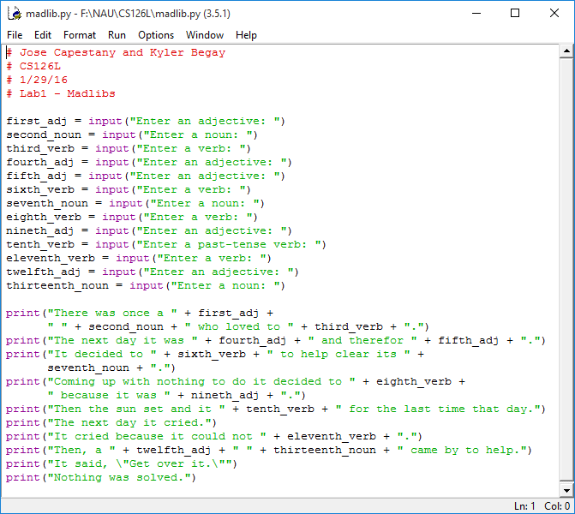

*Picture of Source Code*

Running the program causes python to ask the user thirteen words and after the user does say prints out the mad lib.

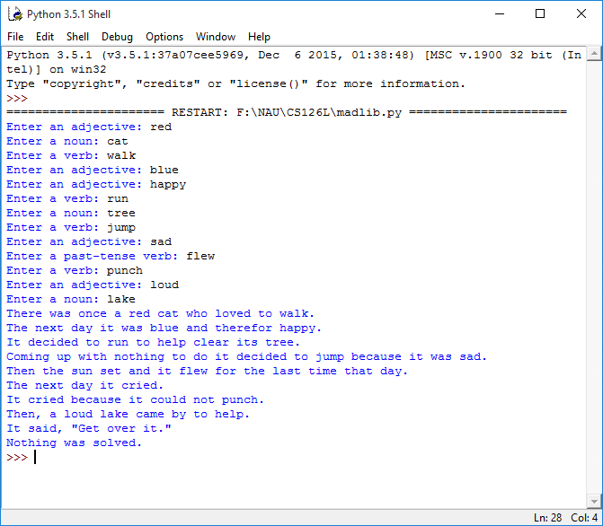

*Results from the Program*

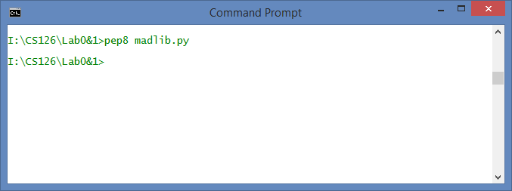

*Showing pep8 Compliance*

**4. Reflection**

This project was very simple. It taught us the basics of formatting and how strings work in python. There are probably very little improvements that could be made to this program. The program did its job and we believed it did it elegantly. Overall, this lab taught us that python will do exactly what it is told and we have to make sure we are telling it what we want to do.