Jose Capestany

CS126L Section 4

4/22/2016

Lab 10: Casino Night

**1. Problem Statement**

The purpose of this lab is to create two classes for a fun night at the casino. The first class is all about drawing a card from the deck and having properties based on the card.

**Requirement:**

* **Get suit**
* **Get rank**
* **Get value**
* **Flip the card face up/down**
* **Get card**

The second class is all about having an amount in poker chips and to be able to add or subtract money.

**Requirement:**

* **Withdraw**
* **Deposit**
* **Print amount in poker chips**

**2. Planning**

For planning the Card class I came up with the various logic to set all the properties in __init__. One of these is using a set to reference all needed information and using modulus to set the value of the card. The other methods would just retrieve their property. For the ChipBank class, I just set the value as the one inputted and then do all the math in relevant methods.

**3. Implementation and Testing**

I implemented the Card class by taking the given number and running it through if statements. This is designed to set its suit. I did not program the code to deny the user if they typed a number not in 0-51 as I like to believe everyone does everything correctly. I then used a modulus command to then set its rank and value by using a set I defined in the beginning. I used a set so the order never changes, just in case. I then set the different properties of the card. The methods are pretty self-explanatory. For the ChipBank class, I set the value as the value entered. For __str__, I used integer division to find how many of each chip there is and then print a string with the value and number of chips. For withdraw, I set the amount to withdraw equal to the value if it is greater than the value so it never withdraws too much.

C:\Users\Jose Capestany\Downloads\Capture (1).PNG

*Showing pep8 Compliance*

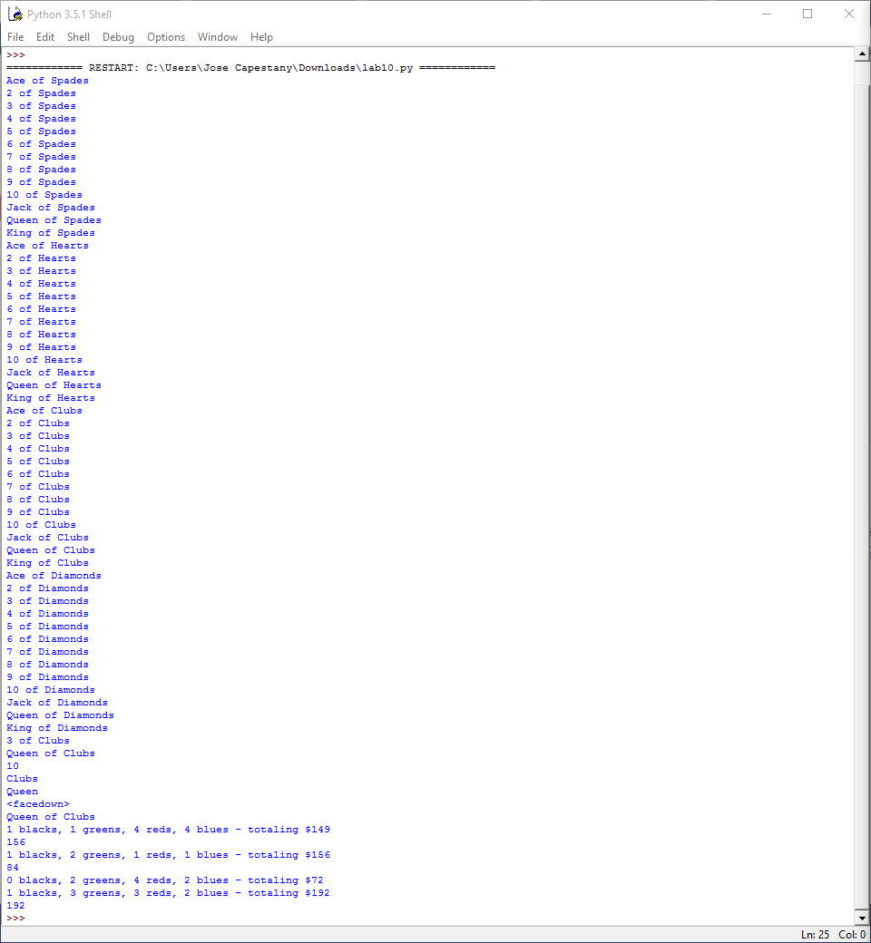

*Results from the Program*

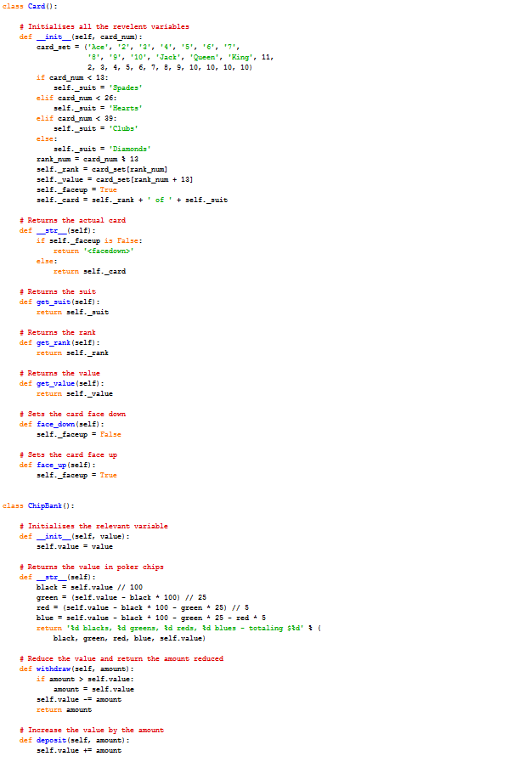

*Source Code*

**4. Reflection**

This lab was really easy. I didn’t really have difficulty implementing the classes as I used techniques we used in previous lab. It is interesting to me as I do love poker and I might modify this program later on to play Texas Hold’em. The lab says not to use for or while loops. While I did comply with this, I don’t really see how either of them would make the lab easier to program.