Jose Capestany

CS126L Section 4

4/29/2016

Lab 11: RPG

**1. Problem Statement**

The purpose of this lab is to create two fighters and have them fight it out to death. The two fighters have different classes which need to be implemented via classes.

* **Create a Wizard and Fighter class**
* **Create an Adventurer class as the base class**
* **Take and deal damage**
* **Calculate initiative and damage**

**2. Planning**

For planning the adventurer class, I decided what methods to create. I planned the standard setters and getters. I also planned how to create the is_alive, initiative, and take_damage methods. For the Attack class I will use the DiceRoller class. The Wizard and Fighter classes will be almost the same sans their initial values and their signature attack.

**3. Implementation and Testing**

The implementation of the classes were fairly simple. The Attack class relies on just the DiceRoller class, and that is already implemented. For the take_damage method, I just reduced the incoming damage by the amount of armor or resistance. If it is less than zero I set it to zero because there is no negative damage. I then reduce HP by the amount of damage. I set HP to zero if it is less than zero because there is no negative HP. The Wizard and Fighter classes were very easy as all I did was input the appropriate values into the methods that are in the Adventurer subclass



*Showing pep8 Compliance*

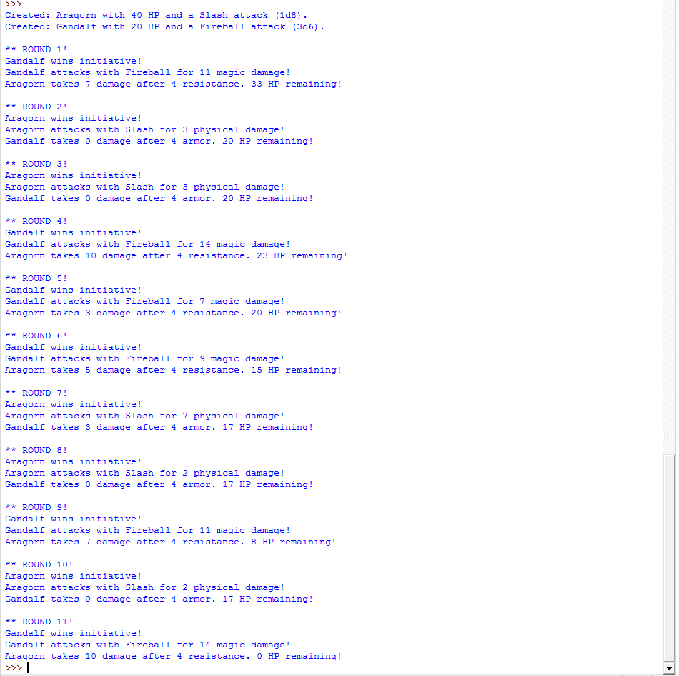

*Results from the Program*

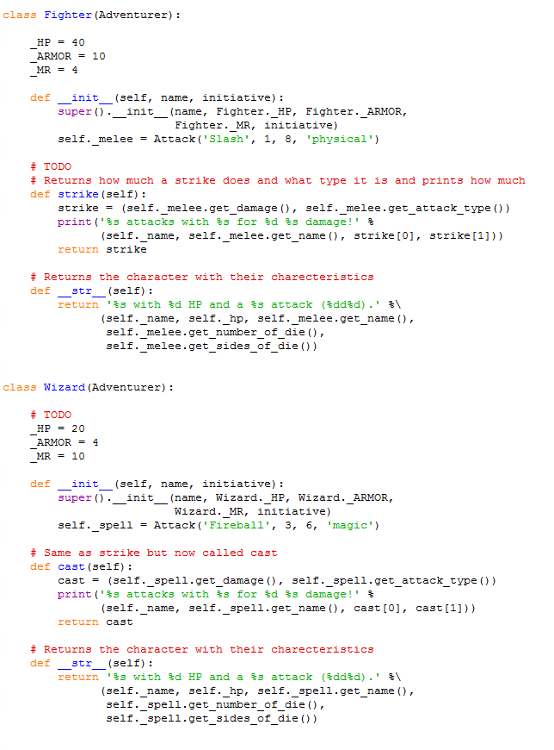

*Sample of Source Code*

**4. Reflection**

This lab was really long, but it was very fun. I did enjoy running the program multiple times just to see who would win the battle. Gandalf kept winning because I gave him a much higher initiative. I then nerfed his initiative, but he stills wins most of the time. This could be used to make a fully-fledged RPG, but it would take a lot of effort.