Jose Capestany

Adam Douglass

CS126L Section 1

2/12/2016

Lab 2: Gamebook

**1. Problem Statement**

The purpose of this lab is to create a gamebook. In order to do this we need to create a story before we can implement the code. The gamebook requires at least one choice that has three different outcomes and one numerical comparison. Once we come up with a story for the gamebook we need to ask the user for input to decide which outcome will happen.

**Requirements:**

* At least three different choices
* One numerical comparison
* One choice must have three different outcomes

**2. Planning**

For the planning we created our own gamebook prior to coding. We made sure to have a variety of options in the choices the user makes and to tell an interesting and funny story. We planned for the story to print out to the user and the user is then prompted for his choice. Then depending on the user’s choice the next portion of the story is printed to the user. We plan on using one big *if* block to accomplish all of this.

**3. Implementation and Testing**

When asking the user for choices we stored them in appropriately named variables and then ran conditional statements inside the *if* block to determine what the next part of the gamebook should be printed.

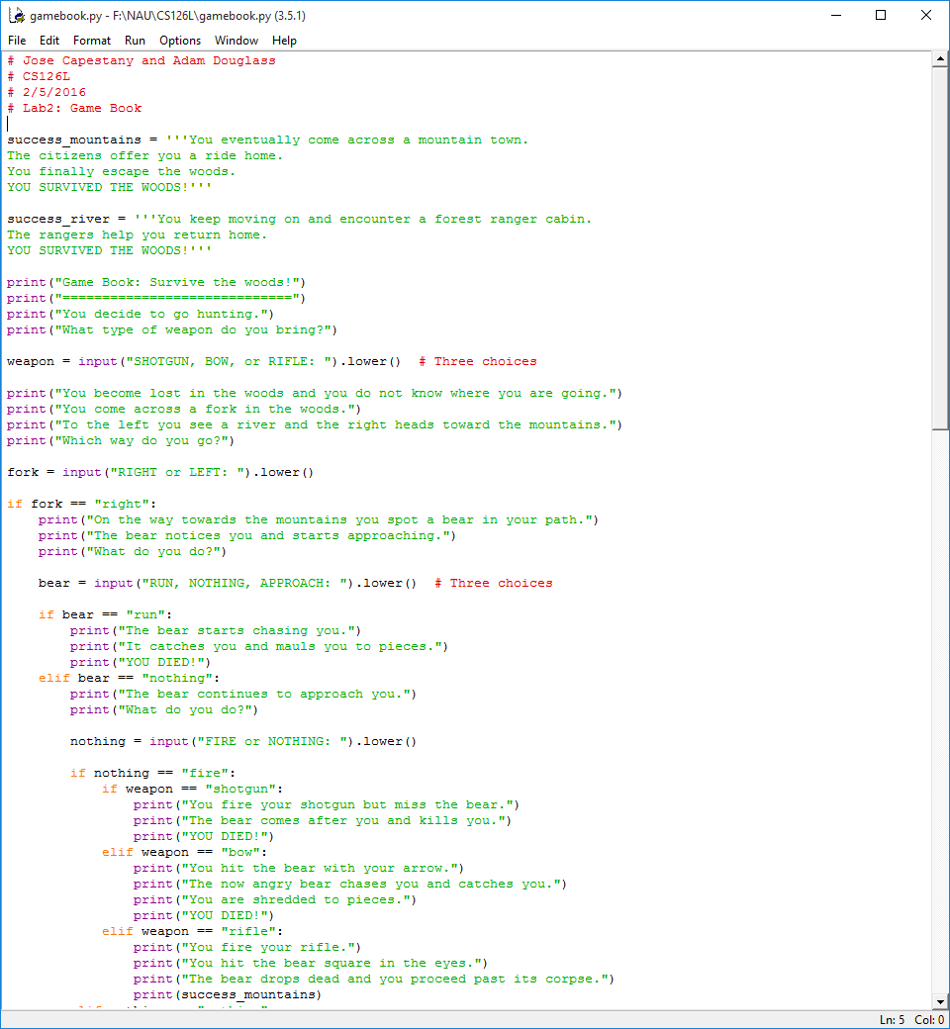

*Portion of Source Code*

Running the program cause the user to play out the gamebook about a hunter’s travel through the woods.

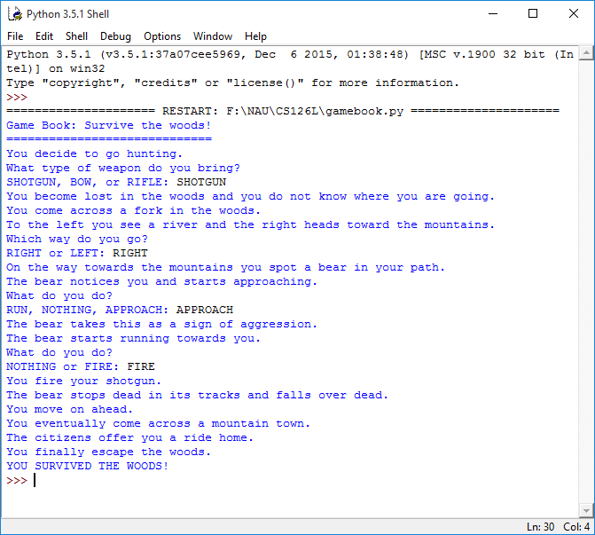

*Results from the Program*

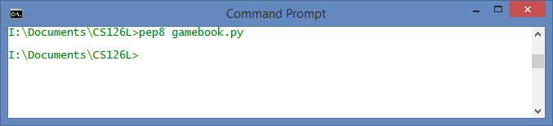

*Showing pep8 Compliance*

**4. Reflection**

This project was very fun. It also managed to teach us how *if* statements work and how to implement them to receive a desired result. Although the program is very long, we do not believe there is any way to simplify this program because most of the program is just strings. The program did its job and it provides entertainment for the user. Overall, this lab is an introductory into using *if* statements and how they function and how we can implement them in future codes.