Jose Capestany

Kyler Begay

CS126L Section 1

2/19/2016

Lab 3: Math Quiz

**1. Problem Statement**

The purpose of this lab is to create a math quiz. The user will tell us how many questions he wants to answer, the difficulty of the question, and we have to tell the user how well he did at the very end. The questions will be random and will use random integers for each problem.

**Requirements:**

* 3 difficulties (beginner, intermediate, advanced)
* User asks for # of questions and chooses difficulty
* The advanced difficulty needs at least 2 operands
* Numbers are random integers
* Random question
* Beginner is only + or – with integers ranging from [1,10]
* Intermediate is -,+,*,/ with integers ranging from [1,25]
* Advanced is -,+,*,/ with integers ranging in a reasonable range
* Display how well the user did

**2. Planning**

For the planning we needed to come up with five problems for the advanced difficulty before coming to lab. We used randint to choose problems randomly and to also choose random integers for the problems. We also rounded any problem that involves division to three decimal places and told the user to do the same. We implemented a counter to count how many problems were answered correctly and then used comparisons at the end to figure out what to say to the user.

**3. Implementation and Testing**

We asked the user for the number of questions and the difficulty in the beginning. Then depending on the difficulty it will go down to the correct conditional branches and repeat itself however many times the user told it to.

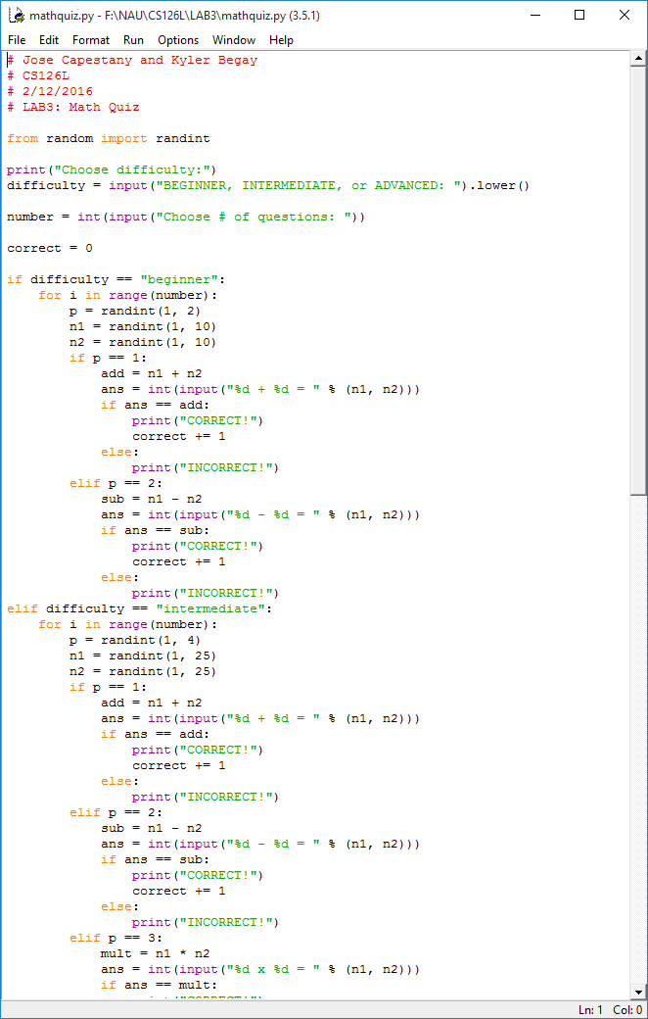

*Portion of Source Code*

Running the program causes python to ask the user problems based on difficulty chosen and the tell the user how well he did.

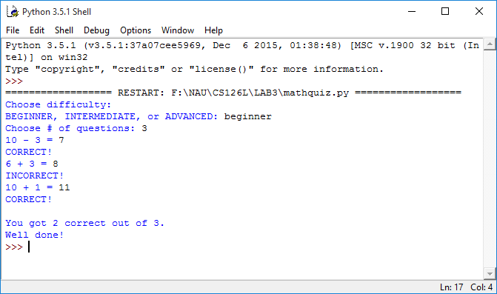

*Results from the Program*

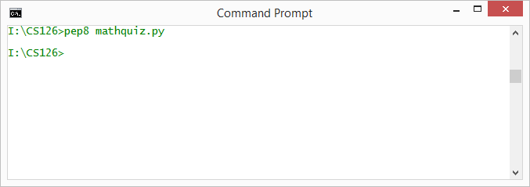

*Showing pep8 Compliance*

**4. Reflection**

This project was pretty simple. It taught us how to use *while* and counters in programs. This program could probably be better if we lowered the difficulty difference between intermediate and advanced. Other than that, the program does its job very well.