Jose Capestany

Colin Sperie

CS126L Section 4

2/26/2016

Lab 4: Grade Calculator

**1. Problem Statement**

The purpose of this lab is to calculate our individual grades in three different categories and to also find out our overall grade. In order to do this we are required to create three functions and use them to help calculate the grade.

**Requirements:**

* 3 different functions
* Grades are given to us
* Display grade in individual categories
* Display overall grades using weighted values
* Display percentage of each category and overall

**2. Planning**

For planning we had to figure out how were to find the correct numbers. We realized we needed to figure out the percentage of a category before we applied the weights so we can find the letter grade for that section. Once we find the letter grade of each section we can then apply the weights to each of them and then add them together for the overall grade. We would then find the overall letter grade also. Creating functions to do the process for us will greatly reduce the length of code.

**3. Implementation and Testing**

Once we knew what we were going to do, we then went to work. We created the three functions to fulfill the requirements and to help make the program easier to use. The first function was simple. We found the percentage by dividing points earned with points possible. The second function was also simple. We compared a percentage and assigned the appropriate letter grade. The last function was solved by multiplying the percentage with the given weight to find the weighted score. We then used the first two functions to figure out the individual sections grade and percentage. We then used the last function in conjunction with the previous results to find the overall grade.

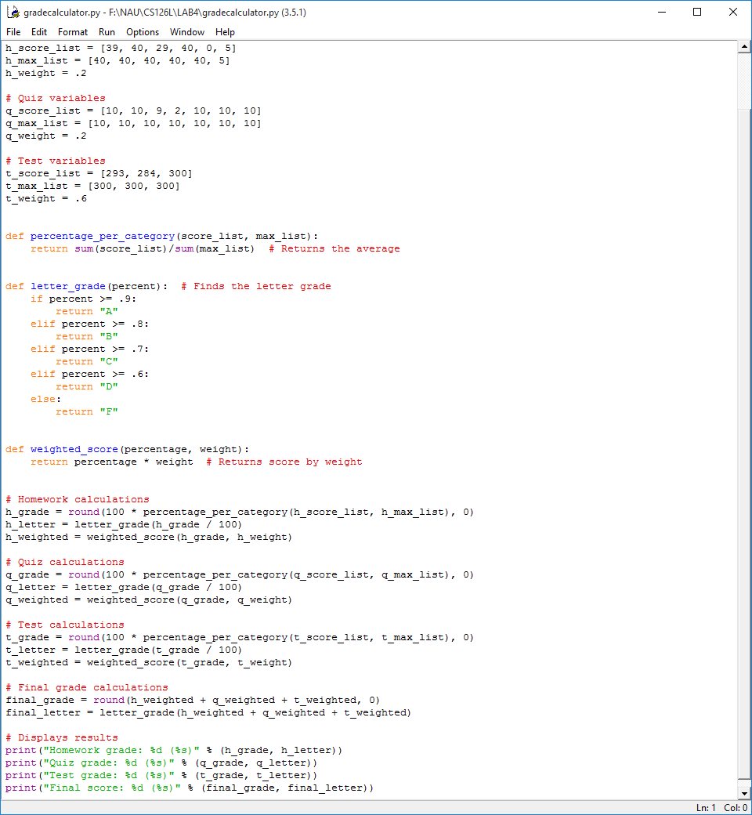

*Source Code*

Running the program causes python to calculate the grades based on the scores.

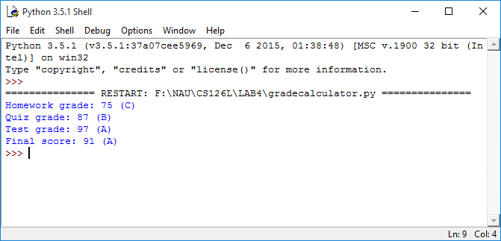

*Results from the Program*

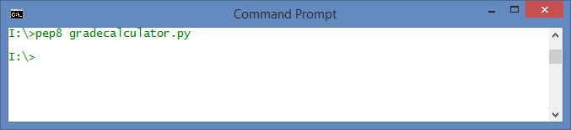

*Showing pep8 Compliance*

**4. Reflection**

This project was pretty straight forward. It would probably be easier if the final calculations at the end of the program were made into functions to minimize the amount of code needed. Other than that this project went very well.