Jose Capestany

Jackson Pergiel

CS126L Section 4

3/10/2016

Lab 5: Undeadbook

**1. Problem Statement**

The purpose of this lab is to create four different functions. There is a program that is ran and uses the functions we defined to create an undead version of Facebook. The four functions we need to define are *update, like, unlike,* and *display*.

**Requirements:**

* 4 different functions
* Update takes four parameters and returns a unique ID
* Like adds a user to the likes if not already liked
* Unlike removes a user from the likes
* Display displays a post

**2. Planning**

For planning we decided that to we should work from the bottom up. We decided to make a dictionary for the update function so it can easily be assigned and read. We made the like function a list with names to easily track who has liked the post. For unlike we plan to remove names from the like list. For the display function, we will just call the values by using the dictionaries we will make with the update function.

**3. Implementation and Testing**

Once we finished our planning we started with the update function. It was fairly simple as we just used the parameters entered and assigned them to the dictionary in the list. The unique ID is given by the length of the list before the dictionary is added. This way the first update will have a value of 0 and we can then call the dictionary using book[ID] (*book is the list)*. For the like function we used the unique ID for the post and checked the Likes list in the dictionary. We used conditionals to add the user if he was not already present. For the unlike function we did the same thing, remove a user if his name is in the Likes list. For the display function we just printed each category in the dictionary in a pretty way. We used the *len* function to display number of likes instead of who liked the post.

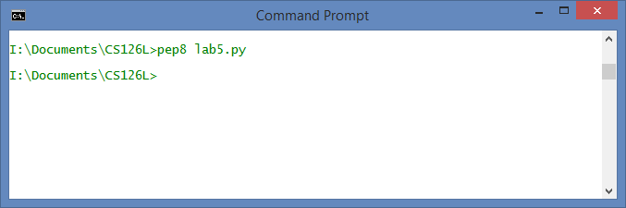

*Showing pep8 Compliance*

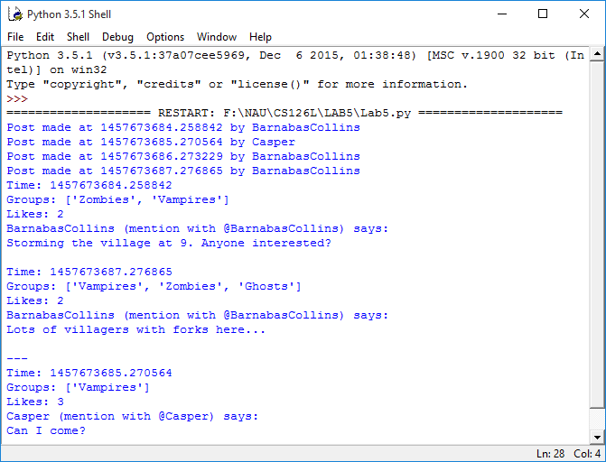

*Results from the Program*

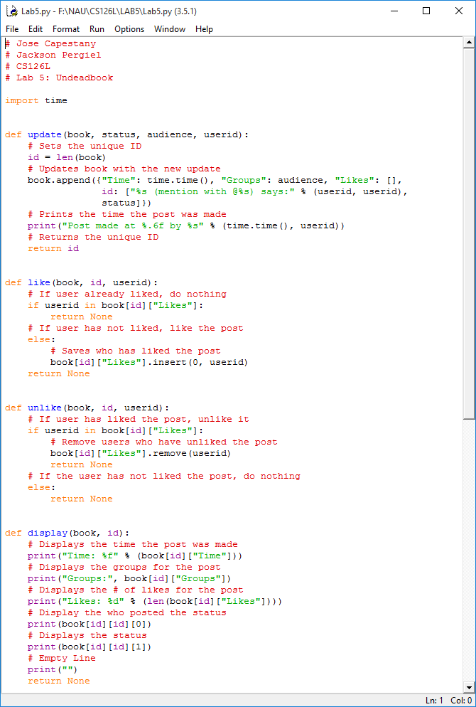

*Source Code*

**4. Reflection**

This project was a little rough in the beginning. It was rough because we did not know how to handle the Like and Unlike functions. We were trying to make them counters instead of lists. Once we made them lists the rest of the code was pretty easy to figure out.