Jose Capestany

Cameron Meier

CS126L Section 4

3/25/2016

Lab 6: Banners

**1. Problem Statement**

The purpose of this lab is to create a function that will take in a word and output a banner made of pounds that look like the letter. There also needs to be another variable for determining if the banner should be horizontal or vertical.

**Requirements:**

* Needs to be a function
* Takes in a word and another input
* Case does not matter
* Output vertical or horizontal

**2. Planning**

For planning we needed to come up with how the letters would look like. We decided that each letter would be in a 4 by 3 grid. We knew that we would have to input each individual letter in the dictionary. We also know that there needs to be a space between the letters, so we added a blank line above and to the right of each letter. This way the space is present whether it is vertical or horizontal.

**3. Implementation and Testing**

The first thing we did was create the function. It would take in a string and then change it to all lowercase. In order to more easily create a loop we created a dictionary with the letters and their specific representation. We split each letter by rows and put it in a list that can be called using a letter as a key value in the dictionary. For displaying it we need to figure out if it should be vertical or horizontal. We made the default value 1, so a user would just need to enter a string for the function to work vertically. In order to print horizontally, the user would need to input a 0 for the vertical input of the function as our code checks to see if the value is true for vertical. For vertical, the code will print each row of a letter and then move on to the next letter. For horizontal, the code will print the first row of each letter and then move on the next row.

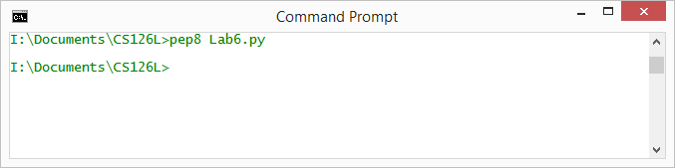

*Showing pep8 Compliance*

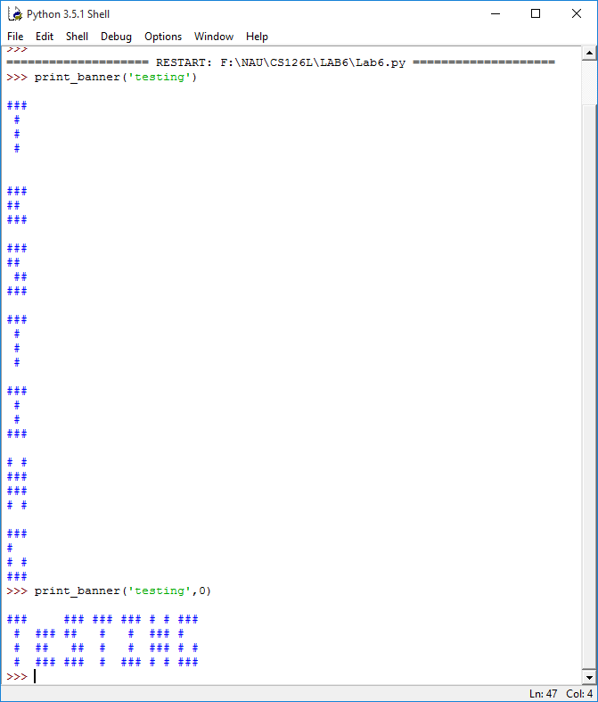

*Results from the Program*

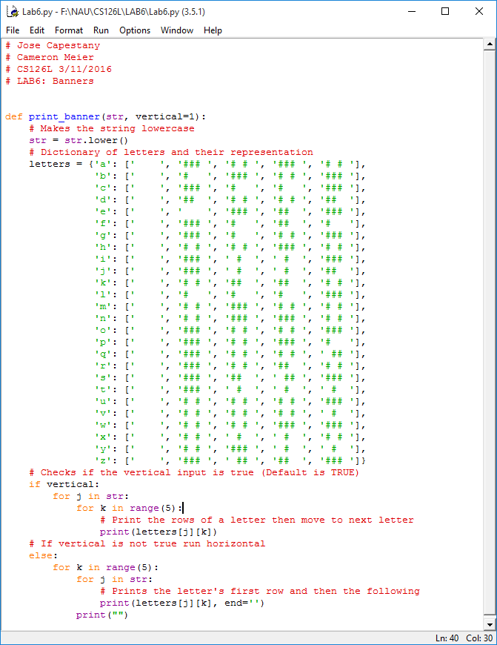

*Source Code*

**4. Reflection**

This project was fairly easy. The hardest part was making the dictionary correctly. It did take us a while to figure out how to call rows correctly and how to format the *for* loop, but when we figured out the syntax it was pretty straightforward from there on out.