Cameron Meier & Jose Capestany

3/25/16

CS 126L-4

**Lab 7: Game Show**

**Problem Statement:**

The purpose of this lab was to create a program that simulated a game show. The program should present the user with a title screen which would ask the user to either play the game, view the credits, or quit. While the credits and quit options are fairly self explanatory, the play option should trigger a series of for loops and while loops which will ask the user a series of multiple choice questions, take in user input for each question, and keep score of how many questions the user answers right and wrong. On top of designing a game show, this lab was also meant to help us:

* Practice writing programs that take in and use user input
* Practice writing programs that make use of for loops and while loops
* Work as a pair-programing team
* Write a report that coherently catalogues our problem solving process

**Planning:**

The first thing we did was import random so we could randomise the order of the questions. Next we defined the function that would present the user with the main menu. The main menu would prompt the user to either play the game, view the credits, or quit. Using an if, elif, else statement we ensured that any invalid input would simply return the user to the main menu. If the user chose to view the credits, the view_credits function would be called which would use a print statement to print the game credits and then return the user to the main menu. If the user chooses to quit, the quit_game function would activate which would use a print statement to print “Thank you for playing our game!” and end the program. Next we defined the play_game function which would be called if the user chooses to play the game. Within the play_game function we created a variable named prize and set it equal to zero.

**Implementations and Testing:**

We then implemented what we sought out to do in the planning phase. We implemented the four functions and we defined them to take no parameters. Depending on which option the user selected it would then run that function. For the the view_credits function we simply used a print function. If the quit_ game function is called we thank them using a print statement and that would be it. The play_game function uses nested loops in order to accomplish what we planned. We used conditionals as well as *for* and *while* loop.

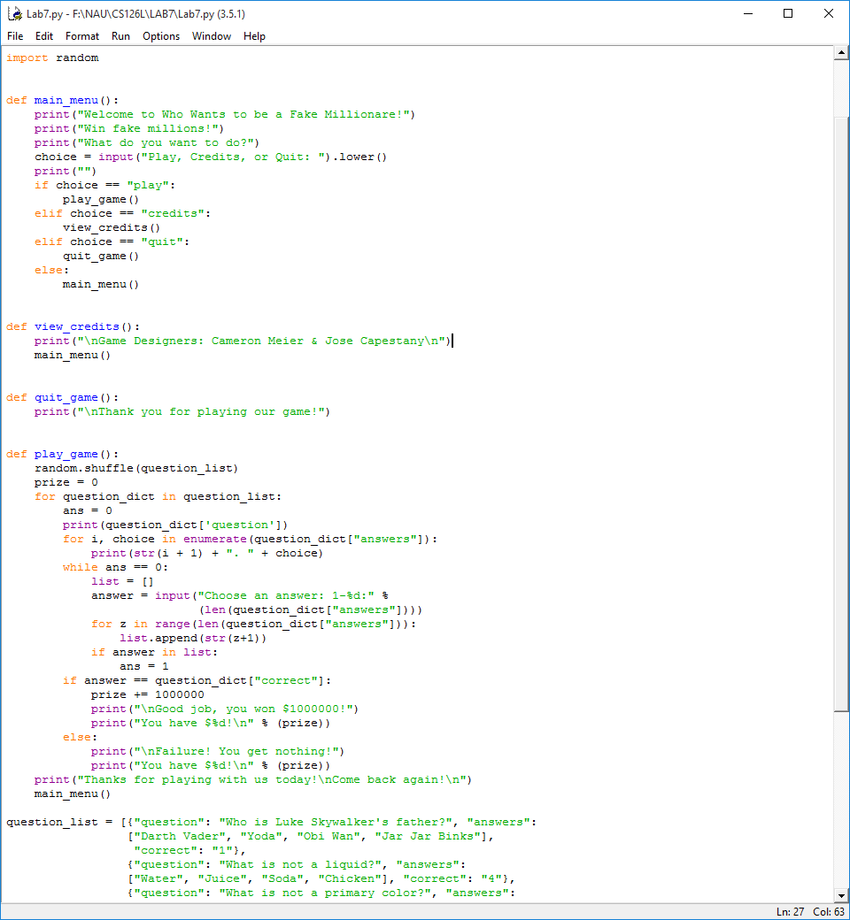

*Sample of Source Code*

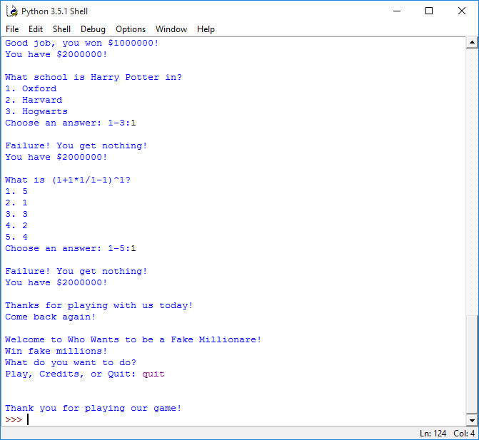

*Sample Running of the Program*



pep8 Compliance

**Conclusion:**

We believed we accomplished the objective fairly well by using functions that take no parameters. By using this, the user does not need to enter any commands. They simply have to follow what the program tells them what to do. There probably could have been an easier way to make sure the user enters a valid option than just creating a list, and comparing it to the list. Overall, this program was a good introduction on for and while loops that also teaches us how to implement them.